A Project Report
ON
CLASSFLOW: A WEB-BASED ACADEMIC MANAGEMENT SYSTEM

CSE 400: Software Development Project IV
SUBMITTED BY:
Name | ID | Intake
Tarikul Islam | 22235103242 | 51
Shahadat Hossain Shuhan | 22235103353 | 51
Ali Akbar Rakib | 22235103237 | 51
S M Tanbin Tazim | 22235103237 | 51
Al Mamun Shikdar | 22235103237 | 51
SUPERVISED BY:
Ms. Sabiha Firdaus
Assistant Professor,
Department of CSE
DEPARTMENT OF COMPUTER SCIENCE AND ENGINEERING
BANGLADESH UNIVERSITY OF BUSINESS AND TECHNOLOGY (BUBT)
08/20/2026

Abstract
ClassFlow is a full-stack, web-based education management platform designed to centralize the day-to-day academic operations of students, instructors, and class administrators into a single, structured digital workspace. Traditional class coordination in many institutions still relies on scattered tools — messaging apps, spreadsheets, and paper notices — for sharing updates, tracking exam and viva schedules, managing class members, and coordinating study groups, which leads to miscommunication, lost information, and inefficient administration.
The proposed system addresses this problem by offering a unified platform where a class can be created or joined through a unique class code, announcements and materials can be posted and pinned, members and faculty can be managed with role-based access control, weekly routines can be scheduled, and an AI agent system can post updates on behalf of instructors. Real-time browser push notifications keep every member informed of important events, while a dedicated dashboard provides a consolidated overview of all enrolled classes.
The system is built using a modern monorepo architecture with a Next.js 16 (React 19, TypeScript) front-end and a NestJS 11 back-end, connected through RESTful APIs and backed by MongoDB Atlas for persistent storage. Authentication is implemented using JWT with HTTP-only cookies and OTP-based email verification, and media assets are managed through Cloudinary. The user interface is developed using Tailwind CSS, shadcn/ui, and Framer Motion to provide a clean, responsive, and accessible experience across both desktop and mobile devices.
This report documents the complete development lifecycle of ClassFlow— from problem identification and requirement analysis, through system design (use case, context-level, data flow, and database schema diagrams), to implementation, deployment, and evaluation — and concludes with the limitations of the current system and directions for future work.

List of Figures
Sl. No. | Figure Name | Page
1 | System Architecture Diagram | 9
2 | Use Case Diagram | 10
3 | Context Level Diagram (DFD-0) | 11
4 | Data Flow Diagram (DFD Level-1) | 12
5 | Database Schema / ER Diagram | 13
6 | Authentication Flowchart | 14

Table of Contents
Abstract 2
List of Figures 3
Table of Contents 4
Chapter 1 6
1.1 Problem Specification/Statement 6
1.2 Objectives 6
1.3 Scope 6
1.4 Organization of Project Report 7
Chapter 2 8
2.1 Existing System Analysis 8
2.2 Supporting Literatures 8
Chapter 3 10
3.1 Technology & Tools 10
3.2 Model & Diagram 10
3.2.1 Model (SDLC) 10
3.2.2 System Architecture 11
3.2.3 Use Case Diagram 11
3.2.4 Context Level Diagram 12
3.2.5 Data Flow Diagram 13
3.2.6 Database Schema 14
3.2.7 Algorithms/Flowchart 15
Chapter 4 17
4.1 Interface/Front-End Design 17
4.2 Back-End 17
4.3 Modules/Features 17
Class Management 17
Member & Role Management 18
AI Agent System 18
Notifications 18
Authentication & Profiles 18
Dashboard 18
Chapter 5 19
5.1 System Requirement 19
5.1.1 Hardware Requirement 19
5.1.2 Software Requirement 19
5.2 User Interfaces 19
5.2.1 Panel A — Dashboard & Class Management 19
5.2.2 Panel B — Members, Faculty & Agents 20
5.2.3 Login Credentials 20
Chapter 6 21
6.1 Conclusion 21
6.2 Limitations 21
6.3 Future Works 21
References 23
Appendix A 24
Project Repository & Live Demo 24
Folder Structure (Overview) 24

Chapter 1
INTRODUCTION

1.1 Problem Specification/Statement
Managing the daily operations of an academic class — sharing notices, scheduling exams and viva sessions, tracking who is enrolled, organizing group work, and keeping faculty assignments up to date — is still handled manually or through a fragmented mix of tools such as Facebook groups, WhatsApp, and spreadsheets in most institutions. This scattered approach causes important announcements to be missed, makes it difficult to track class membership and permissions, and leaves no structured record of routines, updates, or notifications. Students frequently report confusion over exam dates and class changes, while instructors struggle to manage multiple sections and communicate consistently. ClassFlow Prime was undertaken to solve this problem by building a single, centralized digital workspace purpose-built for academic class management.

1.2 Objectives
- To design and develop a centralized web platform for creating, joining, and managing academic classes through unique class codes.
- To provide a structured way to post, pin, and track class announcements and materials.
- To implement role-based access control for members, faculty, and class administrators.
- To build a routine/schedule management module for day-of-week and period-based class timing.
- To introduce an AI agent system capable of posting updates on behalf of instructors.
- To deliver real-time notifications through the Web Push API so that no important update is missed.
- To ensure secure authentication using JWT, HTTP-only cookies, and OTP-based email verification.
- To provide a responsive, accessible, and visually polished interface usable on both desktop and mobile devices.

1.3 Scope
The scope of ClassFlow covers the complete lifecycle of class-based academic coordination: user registration and authentication, class creation and enrollment, posting and management of class updates, member and faculty management, group formation, routine scheduling, an AI-driven agent system for automated updates, a centralized notification system, and user profile management. The project delivers both the front-end (Next.js) and back-end (NestJS with MongoDB) components, along with deployment on Vercel. The scope does not, at this stage, include grading/examination automation, video conferencing, or third-party LMS integration — these are identified as potential future work.

1.4 Organization of Project Report
This report is organized into six chapters. Chapter 1 introduces the problem, objectives, and scope of the project. Chapter 2 discusses existing systems and the supporting literature/technologies used. Chapter 3 presents the system analysis and design, including the development model, system architecture, use case diagram, context-level diagram, data flow diagram, database schema, and flowchart. Chapter 4 describes the implementation of the front-end, back-end, and feature modules. Chapter 5 serves as a user manual covering system requirements and the user interface. Chapter 6 concludes the report with a summary of findings, limitations, and future work, followed by References and Appendix.

Chapter 2
BACKGROUND

2.1 Existing System Analysis
Most institutions currently rely on a combination of general-purpose tools for class management. Facebook groups and WhatsApp/Messenger are commonly used to broadcast notices, but they are not designed for academic workflows — messages are easily buried, there is no concept of a class routine, and access control is limited to “admin” roles with no distinction between instructor and student privileges. Google Classroom offers a more structured alternative with assignments and announcements, but it lacks fine-grained routine/exam-schedule management, does not support an AI-agent-based update system, and is tied to a Google Workspace ecosystem that many smaller institutions do not use. Spreadsheet-based systems (e.g., Google Sheets for routines or member lists) provide structure but require manual updates and offer no real-time notification capability.
Analysis of these existing approaches reveals three recurring shortcomings: (1) fragmentation — communication, scheduling, and member management live in separate, disconnected tools; (2) lack of role-based structure — most chat-based tools do not differentiate between student, instructor, and admin permissions; and (3) absence of real-time alerting — users must actively check the tool rather than being notified. ClassFlow Prime is designed specifically to close these gaps by unifying updates, routines, membership, and notifications inside one role-aware platform.

2.2 Supporting Literatures
The development of ClassFlow draws on established practices in modern full-stack web engineering. The front-end is built with Next.js 16 and React 19, chosen for their server-side rendering capabilities, file-based App Router, and strong TypeScript support, which together improve performance and maintainability. Redux Toolkit is used for predictable, centralized state management across the application, while Tailwind CSS 4, shadcn/ui, and Radix UI provide a consistent, accessible, and rapidly composable design system; Framer Motion adds fluid, purposeful animation.
On the server side, NestJS 11 was selected for its modular, decorator-based architecture inspired by Angular, which enforces separation of concerns through controllers, providers, and modules and integrates naturally with TypeScript. MongoDB, accessed through the Mongoose ODM, was chosen as a flexible, document-oriented database well suited to the evolving, nested data structures of classes, members, updates, and notifications. Authentication follows the JSON Web Token (JWT) standard combined with Passport.js strategies and bcrypt password hashing, which is a widely adopted approach for stateless, secure session management. Real-time alerting is implemented with the standard Web Push API, and Swagger (NestJS Swagger module) is used to auto-generate REST API documentation, following common industry practice for API-first back-end development.

Chapter 3
SYSTEM ANALYSIS & DESIGN

3.1 Technology & Tools
Layer | Technology
Frontend | Next.js 16, React 19, TypeScript 5
Backend | NestJS 11, Node.js, TypeScript 5
Database | MongoDB 9 (Mongoose ODM)
State Management | Redux Toolkit, React Redux
UI Framework | Tailwind CSS 4, shadcn/ui, Radix UI
Animation | Framer Motion
Icons | Lucide React
Media Storage | Cloudinary
Authentication | JWT (Passport.js), bcrypt
Email | Nodemailer, Handlebars templates
Push Notifications | Web Push API
Validation | class-validator, class-transformer
API Documentation | Swagger (NestJS Swagger)
Deployment | Vercel (frontend + serverless backend)
CI/CD | GitHub Actions, Semantic Release

3.2 Model & Diagram

3.2.1 Model (SDLC)
The project follows an Agile/Iterative model of the Software Development Life Cycle (SDLC). Requirements were broken down into modules — authentication, class management, routine, agent, dashboard, profile, and notification — and each module was designed, implemented, and tested in short, incremental cycles. This approach allowed features to be added and refined continuously (reflected in the project's 218+ commits), made it possible to validate individual modules early, and kept the system flexible enough to accommodate new features such as the AI agent system without disrupting already completed modules.

3.2.2 System Architecture
ClassFlow Prime follows a three-tier, monorepo architecture consisting of a client layer, an application (frontend + backend) layer, and a data/external-services layer. The Next.js frontend communicates with the NestJS backend over RESTful APIs; the backend is organized into feature modules (auth, class, agent, routine, dashboard, profile, notification) that each interact with MongoDB Atlas through Mongoose. External services — Cloudinary for media, the Web Push API for notifications, and an SMTP provider (via Nodemailer) for OTP/email — are integrated directly into the relevant backend modules.
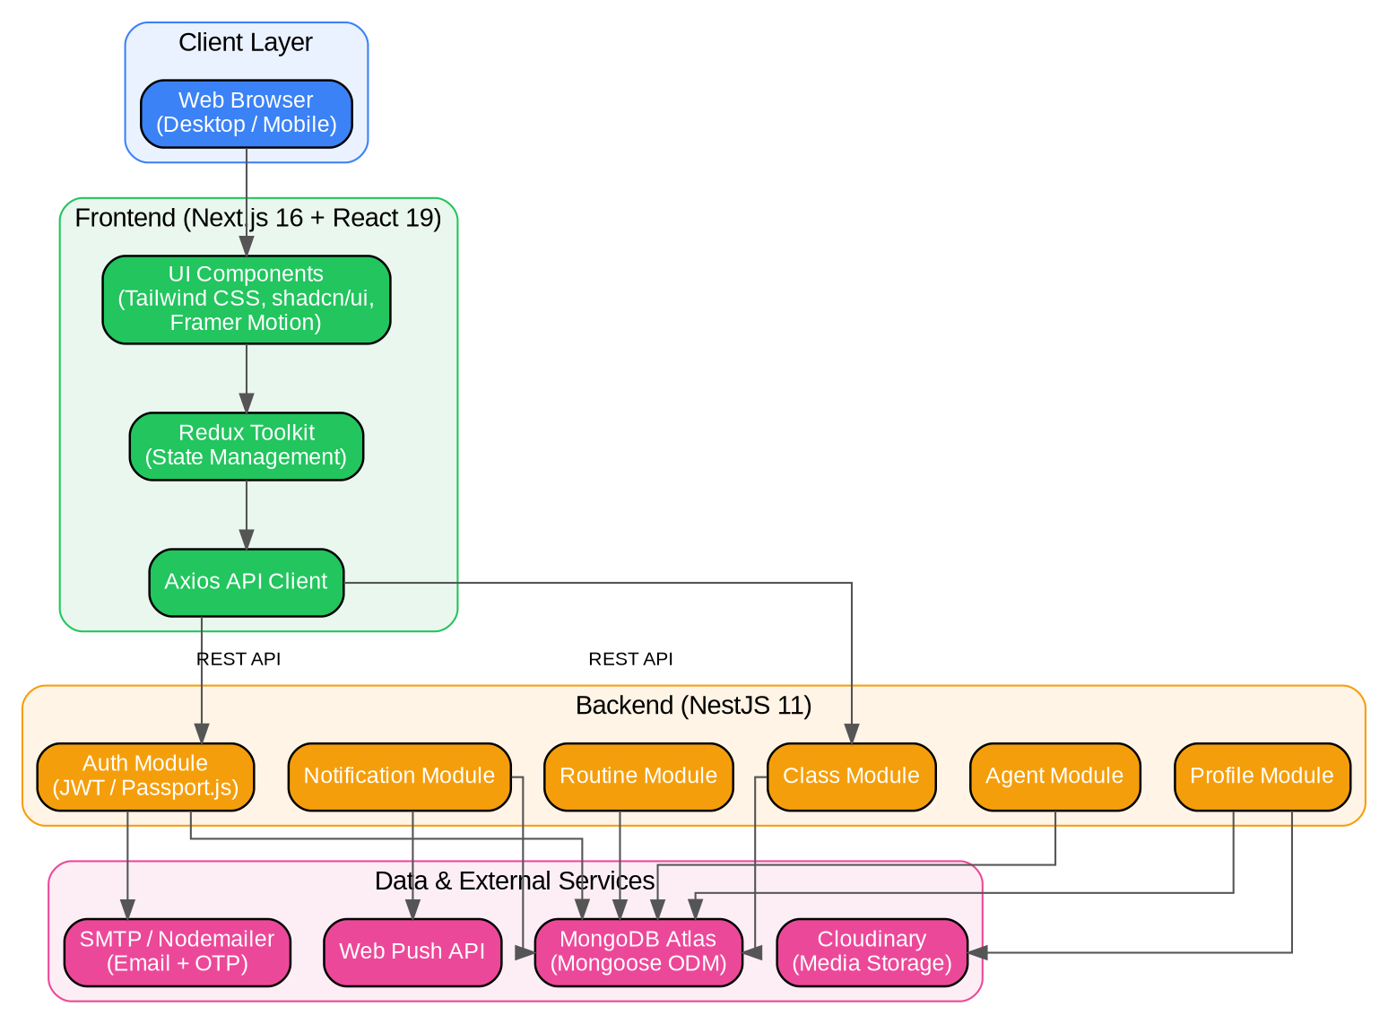
Figure 1: System Architecture Diagram

3.2.3 Use Case Diagram
Three primary actors interact with the system: the Student, the Instructor/Faculty member, and the Class Admin. Students can sign up, sign in, create or join classes, post/view updates, view notifications, and manage their profile. Instructors additionally manage members, routines, and AI agents, while Class Admins hold the broadest permissions, including faculty assignment and class settings management.
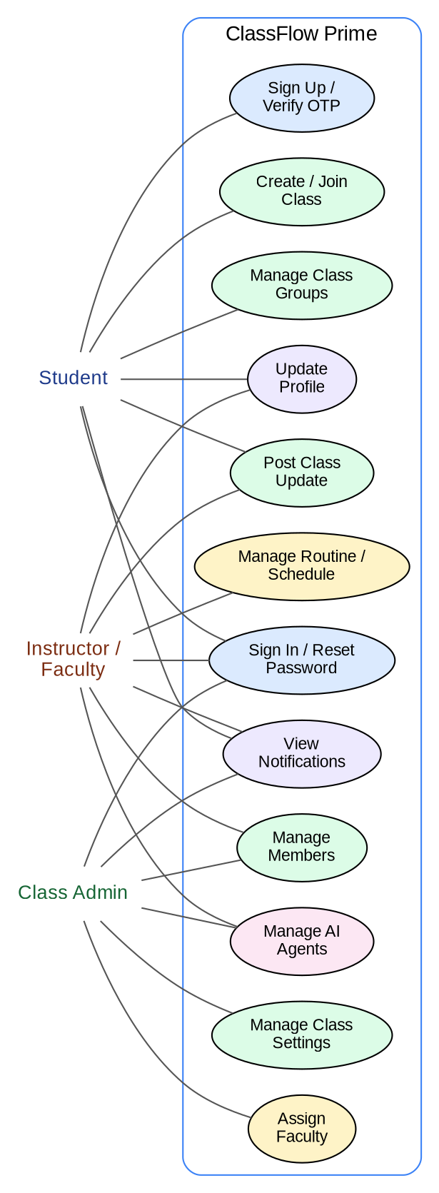
Figure 2: Use Case Diagram

3.2.4 Context Level Diagram
The context-level diagram (DFD-0) treats ClassFlow Prime as a single process and shows the flow of information between the system and its three external entities — Student, Instructor/Faculty, and Class Admin.
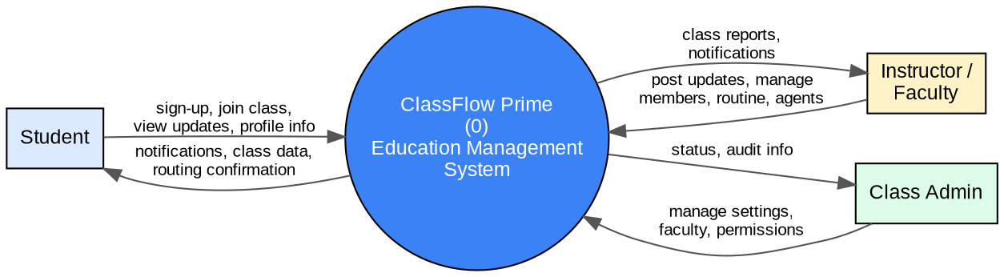
Figure 3: Context Level Diagram (DFD-0)

3.2.5 Data Flow Diagram
The Level-1 Data Flow Diagram decomposes the system into five major processes — Authentication & Profile, Class Management, Routine & Faculty, AI Agent Management, and Notification Service — each interacting with its own data store (Users, Classes, Routines, Agents, Notifications).
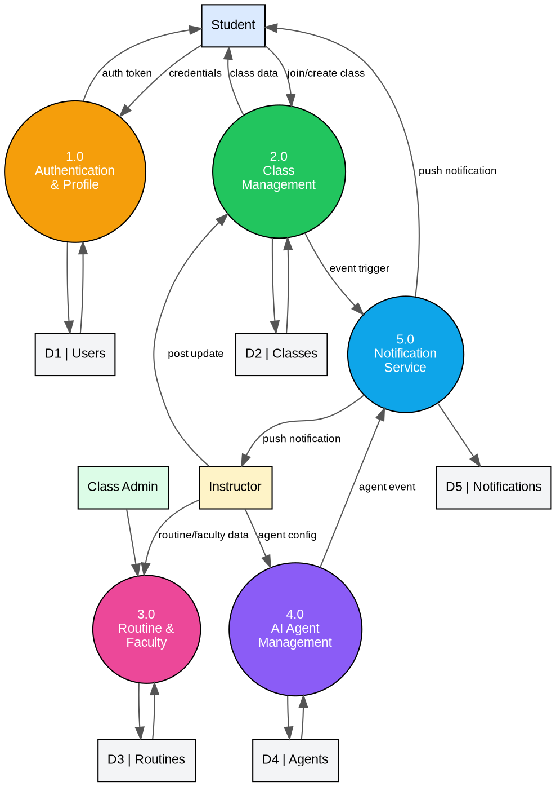
Figure 4: Data Flow Diagram (DFD Level-1)

3.2.6 Database Schema
The MongoDB data model is centered on the User and Class collections. A Member document links a User to a Class with an associated role; Update, Routine, and Agent documents are each scoped to a specific Class; and Notification documents are scoped to a specific User. This design keeps class-scoped data isolated while allowing efficient role-based queries.
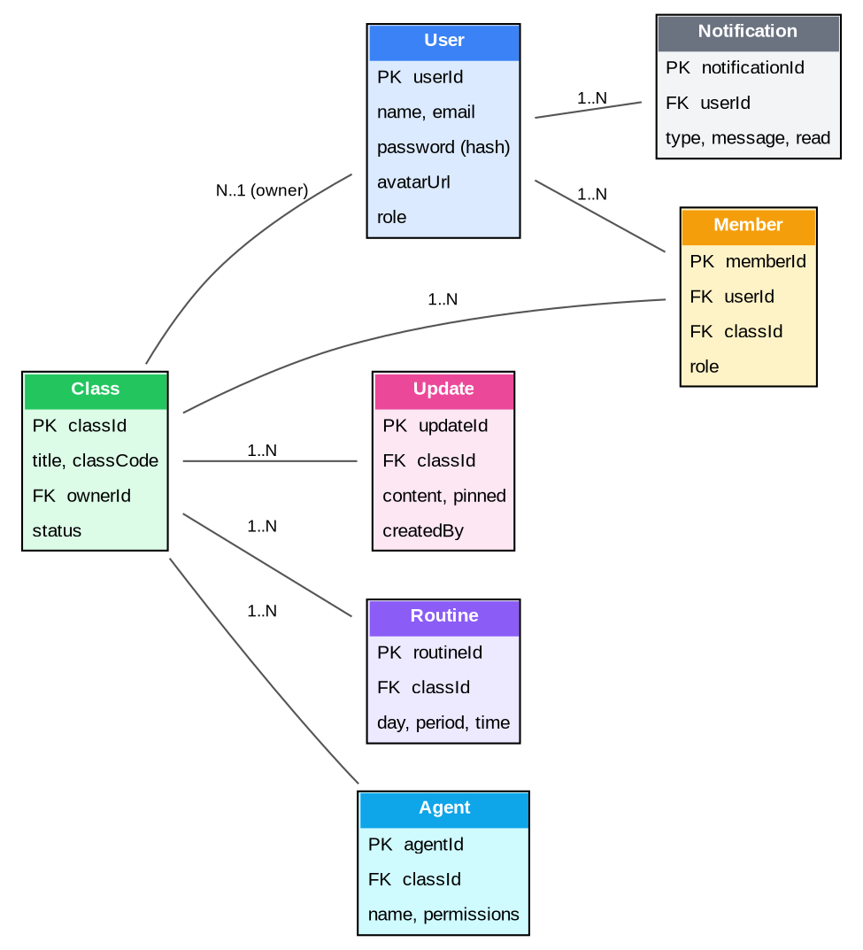
Figure 5: Database Schema / ER Diagram

3.2.7 Algorithms/Flowchart
The flowchart below illustrates the authentication algorithm used for sign-in and sign-up. New users are routed through OTP verification via email before a JWT is issued; returning users are validated directly against stored credentials. On success, a JWT is generated and stored in an HTTP-only cookie before the user is redirected to the dashboard.
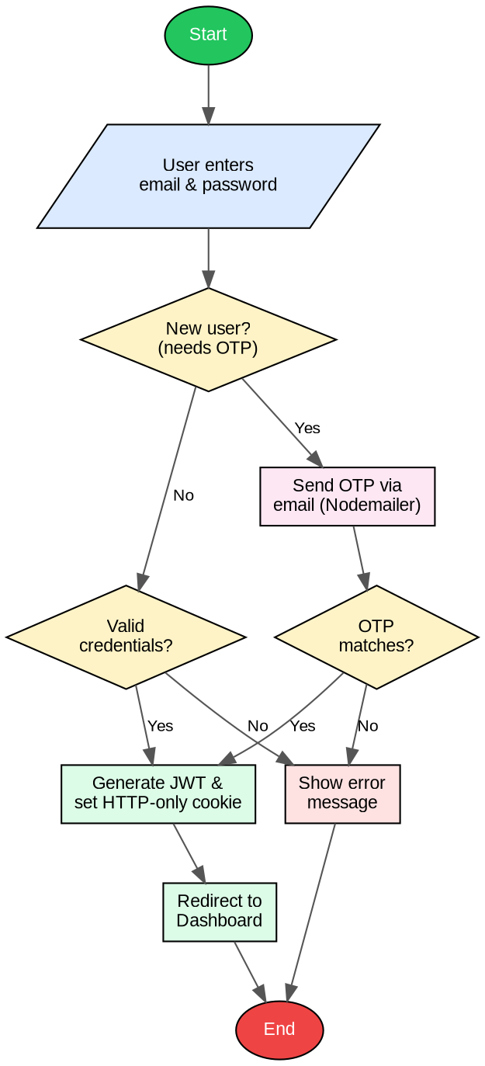
Figure 6: Authentication Flowchart

Chapter 4
IMPLEMENTATION

4.1 Interface/Front-End Design
The front-end is implemented in Next.js 16 using the App Router, with pages organized under route groups such as (auth) for sign-in/sign-up/forgot-password flows and (main) for the dashboard, classes, profile, and notification pages. Reusable UI components are built with Tailwind CSS 4 and shadcn/ui (on top of Radix UI primitives) to ensure accessibility and visual consistency, while Framer Motion is used for page transitions and micro-interactions. Redux Toolkit manages global state such as the authenticated user, enrolled classes, and notification counts, and a dedicated Axios-based API client (under src/api) handles all communication with the backend, including Cloudinary uploads for avatars and cover images.

4.2 Back-End
The back-end is built with NestJS 11 following a modular, decorator-driven architecture. Each feature — auth, class, agent, routine, dashboard, profile, and notification — is implemented as an independent NestJS module containing its own controllers, services (providers), and DTOs, validated using class-validator and class-transformer. Cross-cutting concerns such as authentication guards, role/permission decorators, and request-logging interceptors live in a shared common/ directory, while database, mail, and Cloudinary integrations are isolated inside an infrastructure/ layer. Authentication uses Passport.js JWT strategies with bcrypt-hashed passwords and HTTP-only cookies; OTP emails are generated with Handlebars templates and sent through Nodemailer. The REST API is documented automatically using the NestJS Swagger module, and MongoDB Atlas is accessed through Mongoose schemas that map directly to the entities shown in the database schema diagram.

4.3 Modules/Features

Class Management
- Create & Enroll — create new classes or join existing ones via class codes.
- Class Updates — post announcements, share materials, pin important updates, and track read status.
- Class Groups — organize students into groups within a class for collaborative work.
- Class Settings — manage join permissions, regenerate class codes, leave or delete classes.
- Routine Management — create, edit, and delete class schedules with day-of-week and period-based time slots.

Member & Role Management
- Member Management — view, add, and revoke class members with role-based access control.
- Faculty Assignment — assign and manage faculty members per class with dedicated roles.
- Role-Based Guards — fine-grained permissions using class roles, agent permissions, and user roles.

AI Agent System
- Agent Management — create, manage, and delete AI agents per class.
- Agent-Powered Updates — agents can post class updates on behalf of instructors.
- Agent Search — search and discover agents across enrolled classes.

Notifications
- Push Notifications — real-time browser push notifications via the Web Push API.
- Notification Center — filter, read, and manage all notifications grouped by date.
- Notification Types — class updates, member changes, faculty assignments, and more.

Authentication & Profiles
- Secure Auth — JWT-based authentication with HTTP-only cookies.
- Email Verification — OTP-based email verification during sign-up.
- Password Reset — forgot-password flow with OTP verification.
- Profile Management — update personal info, upload avatars (Cloudinary), manage preferences.

Dashboard
- Overview Dashboard — unified view of enrolled classes, recent activity, and quick actions.
- Class Cards — themed cards with cover images, status badges, and metadata.

Chapter 5
USER MANUAL

5.1 System Requirement

5.1.1 Hardware Requirement
Component | Minimum Requirement
Processor | Dual-core 2.0 GHz or higher
RAM | 4 GB (8 GB recommended)
Storage | 500 MB free disk space
Network | Stable broadband internet connection
Display | Any device with a modern web browser (desktop or mobile)

5.1.2 Software Requirement
Component | Minimum Requirement
Operating System | Windows / macOS / Linux (any OS supporting a modern browser)
Browser | Latest Chrome, Firefox, Edge, or Brave (with Web Push support)
Runtime (development) | Node.js 18+
Database | MongoDB Atlas account or local MongoDB instance
Media Storage | Cloudinary account

5.2 User Interfaces
The application exposes a set of role-aware panels. Representative routes are summarized below; screenshots of the live deployment (https://classflow-prime.vercel.app) should be inserted here for the submitted copy of this report.

5.2.1 Panel A — Dashboard & Class Management
- / — Dashboard: overview of enrolled classes, recent activity, and quick actions.
- /classes — My Classes: list with search and filter (Active / Ended / Upcoming / All).
- /classes/create — Create a new class.
- /classes/enroll — Join a class via class code.
- /classes/[classId]/updates — Class updates feed.
- /classes/[classId]/routine — Class routine/schedule management.

5.2.2 Panel B — Members, Faculty & Agents
- /classes/[classId]/members — Class member management.
- /classes/[classId]/groups — Class group management.
- /classes/[classId]/faculty — Faculty assignment management.
- /classes/[classId]/agent — AI agent management.
- /classes/[classId]/settings — Class settings (join code, delete, leave).
- /profile — User profile, preferences, enrolled classes.
- /notifications — Notification center with filters.

5.2.3 Login Credentials
For demonstration/evaluation purposes, use the sign-up flow at /sign-up to create a new account (OTP verification is required), or use the following test account if seeded on the deployed instance:
Field | Value
Email | Tarikulislam3639@gmail.com
Password | 123456
Role | Student / Instructor / Admin (as applicable)

Chapter 6
CONCLUSION

6.1 Conclusion
ClassFlow Prime successfully demonstrates how a modern full-stack architecture — Next.js on the front-end and NestJS with MongoDB on the back-end — can be used to unify the previously fragmented tasks of academic class management into a single, coherent digital workspace. Through the development of this project, core software engineering practices were applied end-to-end: requirement analysis, modular system design, RESTful API development, secure authentication, role-based access control, real-time notifications, and responsive UI design. The resulting platform provides students, instructors, and class administrators with a centralized, role-aware system for handling updates, routines, membership, and communication, and its modular architecture (organized around clearly separated auth, class, agent, routine, dashboard, profile, and notification modules) proved effective for iterative, feature-by-feature development.

6.2 Limitations
- The current system does not support automated grading, assignment submission, or examination workflows beyond viva/exam scheduling.
- There is no built-in video conferencing or live class feature; the platform focuses on asynchronous coordination.
- The AI agent system currently automates posting of updates but does not yet support broader conversational or grading assistance.
- Push notifications require browser permission and are not delivered through native mobile apps (no dedicated iOS/Android client yet).
- The system has been tested primarily on a single deployment (Vercel + MongoDB Atlas) and has not yet been evaluated at large institutional scale.

6.3 Future Works
- Integrate assignment submission and automated/semi-automated grading modules.
- Add real-time chat and/or video conferencing for live class sessions.
- Extend the AI agent system with conversational assistance for FAQs and study support.
- Develop native mobile applications (iOS/Android) for improved push-notification delivery and offline access.
- Add analytics dashboards for instructors to track engagement and attendance trends.
- Support integration with third-party LMS platforms (e.g., Google Classroom, Moodle) for institutions with existing infrastructure.

References
"ClassFlow Prime." GitHub, github.com/Tarikul3639/classflow-prime.
"Next.js Documentation." Vercel, nextjs.org/docs.
"NestJS — A Progressive Node.js Framework." NestJS, nestjs.com.
"MongoDB Documentation." MongoDB, Inc., www.mongodb.com/docs.
"What Is a Data Flow Diagram." Lucidchart, www.lucidchart.com/pages/data-flow-diagram.
"Use Case Diagram Tutorial." Creately, creately.com/guides/use-case-diagram-tutorial.
"What Are Database Schemas?" Educative, www.educative.io/blog/what-are-database-schemas-examples.

Appendix A

Project Repository & Live Demo
- Source Code (GitHub): https://github.com/Tarikul3639/classflow-prime
- Live Demo: https://classflow-prime.vercel.app
- Author Portfolio: https://tarikul-islam.me

Folder Structure (Overview)
classflow-prime/
├── images/
├── server/ # NestJS backend
│ ├── config/
│ ├── common/
│ ├── infrastructure/
│ └── modules/
│ ├── auth/
│ ├── class/
│ ├── agent/
│ ├── routine/
│ ├── dashboard/
│ ├── profile/
│ └── notification/
├── web/ # Next.js frontend
│ ├── app/ # App Router pages
│ ├── components/
│ ├── hooks/
│ ├── store/
│ ├── types/
│ ├── utils/
│ └── api/
├── .github/
│ └── workflows/ # CI/CD
└── README.md

