
Bangladesh University of Business and Technology
Department of Computer Science and Engineering

CSE 498A: Capstone Project/Thesis

PROPOSAL

Semester: Spring 2025

Title: A Low-Cost Vision-Based Autonomous Navigation System for Mobile Robots Using Deep Learning and Geometric-AI Perception

Submission Date: 3th April, 2025

TEAM MEMBERS

Full ID | Full Name | Intake/Section
22235103242 | Tarikul Islam | 51/05
22235103227 | Sultan Ahmmed | 51/05
22235103247 | Md Soykot Ahamed | 51/05
22235103237 | Ali Akbar Rakib | 51/05
22235103235 | Suraia Islam | 51/05

SUPERVISOR & COURSE TEACHER APPROVAL

SUPERVISOR’S SIGNATURE WITH DATE  ________________________________  Md. Mahbub-Or-Rashid  Assistant Professor  Department of CSE, BUBT | COURSE TEACHER’S SIGNATURE WITH DATE  ________________________________  Dr. Muhammad Aminur Rahaman  Assistant Professor  Department of CSE, BUBT

1. Introduction

1.1 Problem Statement
Autonomous mobile robots are increasingly deployed in industrial, service, and domestic environments where they must navigate safely without human intervention. Conventional navigation systems typically rely on expensive sensor suites such as LiDAR, stereo depth cameras, and multi-sensor fusion architectures to perceive the environment. Although these approaches deliver high localization and mapping accuracy, their significant cost, weight, and computational overhead render them impractical for low-resource, cost-sensitive deployment scenarios such as developing-country logistics, low-cost delivery robots, and educational robotics platforms [1][2].
Vision-based navigation using only an RGB camera presents a compelling low-cost alternative; however, existing deep learning solutions suffer from two critical shortcomings. First, they demonstrate substantial performance degradation under varying lighting conditions — including overexposure, dim lighting, and flickering environments — that are common in real-world deployments. Second, they lack robustness against dynamic obstacles, which are omnipresent in human-shared spaces [3][4]. There is therefore an urgent need for a lightweight, cost-effective, and simulation-validated navigation framework that uses only an RGB camera input while maintaining acceptable navigation performance quantified through measurable metrics.

1.2 Motivation
This research is motivated by the convergence of three key trends in modern robotics and artificial intelligence. First, the proliferation of low-cost embedded computing platforms (e.g., NVIDIA Jetson Nano, Raspberry Pi 5) has made it technically feasible to deploy neural network inference on small, mobile robot platforms — but only if the navigation model is sufficiently lightweight to run in real time on constrained hardware [5]. Second, the economic imperative for affordable autonomous systems is acute in developing regions, where LiDAR-equipped robots remain prohibitively expensive. A camera-only navigation solution could democratize autonomous robotics by reducing per-robot sensor costs from thousands of dollars to tens of dollars. Third, the maturation of physics-based robot simulators — particularly Gazebo integrated with ROS — has reduced the barrier to rigorous navigation research. Simulation-trained policies have recently been shown to surpass real-data-trained policies in success rate [6], validating the simulation-first research paradigm adopted in this work [7][8].

1.3 Overview
This project proposes a lightweight deep learning-based vision-only autonomous navigation framework for a differential-drive mobile robot. The system integrates a MobileNetV2 CNN backbone for visual feature extraction with a navigation policy trained via either Supervised Imitation Learning or Deep Reinforcement Learning using Proximal Policy Optimization (PPO). The complete framework is implemented within the ROS (Robot Operating System) middleware and deployed in a Gazebo simulation environment configured with three distinct environmental conditions: standard lighting, degraded lighting, and dynamic obstacle scenarios. Performance is evaluated using two standardized metrics — Collision Rate (CR) and Navigation Success Rate (NSR) — across 100 independent episodes per condition, providing a rigorous and reproducible assessment of real-world navigational viability [9][10][11].

2. Objectives
The primary objectives of this project are:
- Lightweight Vision-Only Navigation: To design and implement a CNN/DRL-based navigation framework that processes only monocular RGB camera input without reliance on LiDAR, depth cameras, or GPS.
- Imitation Learning Baseline: To collect expert teleoperation data in Gazebo and train a MobileNetV2-based regression policy for supervised imitation learning as a comparison baseline.
- DRL Policy with PPO: To train a Proximal Policy Optimization (PPO) agent using a well-engineered reward function that encourages goal-reaching while penalizing collisions and unnecessary rotation.
- Multi-Condition Simulation Evaluation: To implement and rigorously test the system in three Gazebo environments — standard lighting, degraded lighting, and dynamic obstacles — using CR and NSR as primary metrics.
- Cost-Performance Analysis: To analyze the trade-off between computational cost and navigation accuracy, validating real-time inference on a simulated CPU-only embedded platform.
- Sim-to-Real Transfer Analysis: To identify key sim-to-real transfer challenges and propose concrete domain randomization and augmentation strategies for physical robot deployment.

3. Methodology
The proposed framework follows a structured end-to-end pipeline represented in Figure 1:
- Data Preprocessing: Camera frames are standardized through resolution normalization (224×224 pixels) and normalized to [−1, 1]. Data augmentation — including random brightness (factor 0.5–1.5), contrast adjustment (factor 0.8–1.2), and Gaussian noise (σ = 0–0.02) — is applied to simulate the photometric variation present in degraded lighting environments.
- Visual Feature Extraction (MobileNetV2): A lightweight MobileNetV2 CNN backbone, pre-trained on ImageNet and fine-tuned during policy training, processes raw RGB frames and outputs a 1280-dimensional feature vector via global average pooling. Depthwise separable convolutions reduce computation by a factor of 8–9 versus standard convolutions, enabling real-time deployment on embedded hardware.
- Navigation Policy — Approach A (Imitation Learning): A regression head (FC layers: 256 → 64 units, ReLU) appended to the backbone predicts continuous linear and angular velocity commands from 5,000 expert teleoperation episodes (~50,000 training samples) collected in the standard Gazebo environment.
- Navigation Policy — Approach B (PPO-DRL): A PPO policy network trained through autonomous Gazebo interaction using the reward R(s,a) = +100 (goal reached) − 50 (collision) + 1.0 × Δd − 0.01 × |ω|. Training begins in Environment 1 and progressively incorporates Environments 2 and 3 once a 70% NSR baseline is achieved.
- Goal Conditioning: The policy is conditioned on a two-dimensional relative goal vector [distance_to_goal, bearing_angle_to_goal] in the robot's local frame, computed at each 10 Hz control step, eliminating the need for global localization.
- Simulation & Evaluation: The complete pipeline is deployed in ROS Noetic + Gazebo 11. Three environments are tested: (E1) standard indoor 10 m × 10 m with 10–15 static obstacles at 500 lux; (E2) degraded lighting at 20% ambient intensity with randomized point lights; (E3) dynamic obstacles — three pedestrian agents at 1.0–1.5 m/s. Each condition runs 100 independent episodes. CR and NSR are compared between Approach A and Approach B using a two-proportion z-test (α = 0.05).
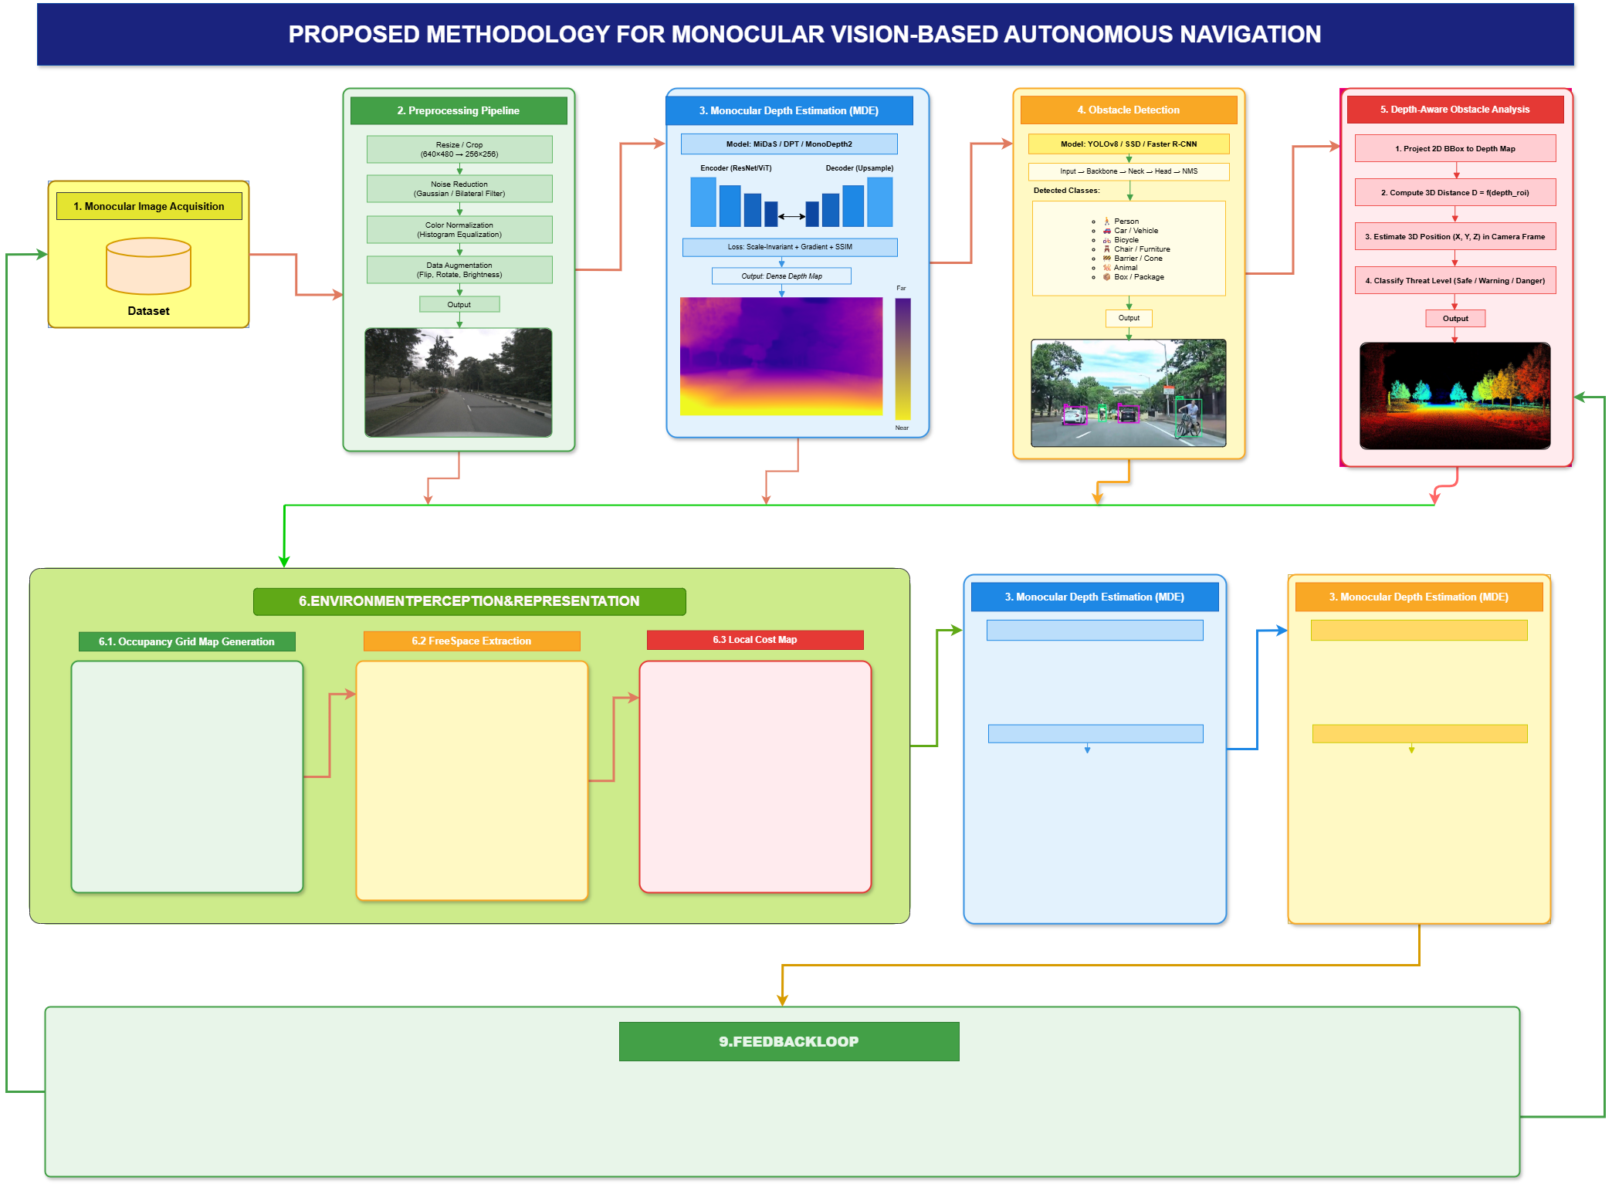
Figure 1: Proposed System Architecture for Vision-Only Autonomous Navigation

4. Expected Outcomes
- A fully functional deep learning navigation system (Imitation Learning and DRL/PPO variants) capable of autonomous goal-directed operation in a Gazebo simulation environment using only a single monocular RGB camera.
- Quantified CR and NSR results across three environmental conditions (standard lighting, degraded lighting, dynamic obstacles), providing the first systematic lighting-aware evaluation within a ROS–Gazebo framework.
- Demonstrated real-time inference at 10 Hz of an RGB-only, MobileNetV2-based navigation framework on a simulated resource-constrained CPU-only platform, validating embedded deployment feasibility.
- A comparative analysis between Imitation Learning and PPO-DRL policy approaches, identifying the superior paradigm for low-cost vision-only navigation under each environmental condition.
- Benchmark performance showing the vision-only framework achieves competitive CR and NSR against sensor-fused baselines from the reviewed literature, at a fraction of the hardware cost.

5. Complex Engineering Problem Mapping
Mapping with Knowledge Profile (WK):
- WK1 (Natural Science): Understanding camera optics, image formation geometry, and robot kinematics as foundational scientific principles.
- WK2 (Mathematics): Required for PPO reward function formulation, convergence optimization, and statistical hypothesis testing (z-test) of CR and NSR results.
- WK3 (Engineering Fundamentals): Image signal processing, lens distortion correction, coordinate frame transformation, and real-time embedded system constraints.
- WK4 (Specialist Knowledge): CNN architectures (MobileNetV2), deep reinforcement learning (PPO), imitation learning, and ROS middleware integration.
- WK5 (Engineering Design): Designing the end-to-end navigation pipeline including visual feature extraction, policy inference, goal conditioning, and velocity command output subsystems.
- WK6 (Engineering Practice): Practical use of PyTorch, Stable-Baselines3 (PPO), Gazebo 11 simulation, ROS Noetic, and embedded computing validation on NVIDIA Jetson Nano.
- WK7 (Comprehension): Understanding ethical implications of deploying autonomous systems in human-occupied environments and ensuring fail-safe collision avoidance behavior.
- WK8 (Research Literature): Reviewing and extending state-of-the-art in RGB-only navigation, sim-to-real transfer, and lightweight DRL for mobile robots.

Mapping with Complex Engineering Problems (WP):
- WP1 (Depth of Knowledge): Requires deep integration of computer vision, reinforcement learning, and real-time robotics systems engineering across multiple disciplines.
- WP2 (Conflicting Requirements): Balancing navigation accuracy, processing latency, hardware cost, and collision safety simultaneously under real-time constraints.
- WP3 (Depth of Analysis): Requires systematic ablation across three environmental conditions with statistical analysis to draw valid performance conclusions.
- WP4 (Familiarity of Issues): Monocular scale ambiguity and sim-to-real gap are recognized challenges, but their combined resolution within a low-cost ROS–Gazebo framework is an emerging research direction.
- WP5 (Applicable Codes): Must adhere to responsible AI deployment standards and robotic safety guidelines for systems operating near humans.
- WP6 (Stakeholder Involvement): Relevant to robotics engineers, logistics operators, healthcare practitioners, embedded hardware developers, and end-users in developing regions.
- WP7 (Interdependence): Perception, policy inference, goal conditioning, reward engineering, and evaluation modules are tightly coupled and co-dependent throughout the pipeline.

Mapping with Complex Engineering Activities (EA):
- EA1 (Range of Resources): Utilizes open-source deep learning models (MobileNetV2, PPO), Gazebo simulation environments, public robot datasets, and GPU computing infrastructure.
- EA2 (Level of Interactions): Manages integration between the visual perception module, DRL policy network, ROS computation graph, and Gazebo physics engine with real-time message passing.
- EA3 (Innovation): Introduces a systematic comparison of Imitation Learning and DRL/PPO approaches on a common ROS–Gazebo platform evaluated across three environmental conditions — a combination not previously reported in Q1/Q2 literature.
- EA4 (Consequences to Society): Reduces the cost barrier of autonomous navigation, enabling broader adoption in healthcare assistance, last-mile logistics, and accessible robotic mobility in developing regions.
- EA5 (Familiarity of Issues): Extends established DRL and computer vision navigation challenges through a novel low-cost simulation-first methodology with rigorous multi-condition environmental evaluation.

6. References
[1] Sharma, B., Jadhav, P., Paul, P., Krishna, K. M., & Singh, A. K. (2025). MonoMPC: Monocular vision based navigation with learned collision model and risk-aware model predictive control. IEEE Robotics and Automation Letters. https://arxiv.org/abs/2508.07387
[2] Kim, J., Sim, J., Kim, W., Sycara, K., & Nam, C. (2025). CARE: Enhancing safety of visual navigation through collision avoidance via repulsive estimation. arXiv:2506.03834.
[3] Ding, J., et al. (2023). Monocular camera-based complex obstacle avoidance via efficient deep reinforcement learning. IEEE Transactions on Cybernetics. https://arxiv.org/abs/2209.00296
[4] Taheri, H., Hosseini, S. R., & Nekoui, M. A. (2024). Deep reinforcement learning with enhanced PPO for safe mobile robot navigation. arXiv:2405.16266.
[5] Dang, T. V., Tran, D. M. C., & Tan, P. X. (2023). IRDC-Net: Lightweight semantic segmentation network based on monocular camera for mobile robot navigation. Sensors, 23(15), 6907.
[6] Suomela, L., et al. (2025). FAINT: Fast appearance-invariant navigation transformer trained on synthetic data. IEEE Robotics and Automation Letters. https://arxiv.org/abs/2509.11791
[7] Lin, Z., Tian, Z., Zhang, Q., Zhuang, H., & Lan, J. (2024). Enhanced visual SLAM for collision-free driving with lightweight autonomous cars. Sensors, 24(19), 6258.
[8] Salimpour, S., et al. (2025). Sim-to-real transfer for mobile robots with reinforcement learning: From NVIDIA Isaac Sim to Gazebo and real ROS 2 robots. arXiv:2501.02902.
[9] Suomela, L., et al. (2025). Learning vision-based omnidirectional navigation: A teacher-student approach using monocular depth estimation. IEEE Robotics and Automation Letters. https://arxiv.org/abs/2603.01999
[10] Wang, X., Tan, Y. R., Leong, W., Huang, S., Teo, R., & Xiang, C. (2025). GPS-denied IBVS-based navigation and collision avoidance of UAV using a low-cost RGB camera. IEEE Robotics and Automation Letters. https://arxiv.org/abs/2509.17435
[11] Sandström, E., et al. (2024). Deep reinforcement learning of mobile robot navigation in dynamic environments: A review. Sensors, 25(11), 3394.

