**Daffodil international university**

Department of Software Engineering, FSIT

Swe122: Software Engineering Project-1(Using c)

Project Report

Project Title: **word making**

**Submitted By**,

1. Md. Tarikul Islam Oashi (142-35-653)

2. Md. Delowar Hossain (142-35-676)

## Submitted To,

Kaushik Sarker

Department of SWE

Daffodil International University

**Acknowledgement**

At first we are grateful to the almighty Allah, who helped us to complete this project. In the process of doing and preparing our report, we would like to pay our gratitude and respect to some persons for their immense help and enormous co-operation. First of all we would like to express our gratitude to Kaushik Sarker, coordinator, faculty of Science and Technology for helping us to take right decision at right time and continuous encouragement on the topic. Secondly I would also like to thank my friends Nahid, Raihan,abid,aktar, and everybody who helped me a lot for doing my project. This application is developed by Code blocks v13.12 with GNU GCC compiler. The operating system is Windows 7Ultimate 64 bit Copyright **2014** Microsoft Corporation.

**ABSTRACT**

This study provides a summary of making a complete word. For our developing country it’s very essential to improve our vocabulary. Children’s are learning their lesson while they are playing this game. Type to complete the full word then go to the next level. It’s very simple to play and easy to learn.

**INDEX**

Title Page …………………………………………………………………………………………….. 1

Acknowledgement………………………………………………………………………………… 2

Abstract………………………………………………………………………………………………... 3

Table of Content……………………………………………………………………………………. 4

Introduction…………………………………………………………………………………………… 5

Design Application Interfaces………………………………………………………………... 6

Use Case Diagram………………………………………………………………………… 6

Overall Flow Diagram…………………………………………………………………… 7

How to play……………………………………………………………………………………………. 8

Design ……………………………………………………………………………………………………14

Game color code………………………………………………………………………….14

Game level word …………………………………………………………………………15

Border shape design ………………………………………………………………….. 15

Testing …………………………………………………………………………………………………. 16

Strong Point……………………………………………………………………………………………17

Weak point…………………………………………………………………………………………….17

Learning experience……………………………………………………………….. 18

Reference …………………………………………………………………………………………….. 19

Code …………………………………………………………………………………………………….. 20

**Introduction**

**Word games** [puzzles](http://en.wikipedia.org/wiki/Puzzle) are spoken or board games often designed to test ability with language or to explore its properties. Word games are generally engaged as a source of [entertainment](http://en.wikipedia.org/wiki/Entertainment), but have been found to serve an [educational](http://en.wikipedia.org/wiki/Education) purpose as well. For instance, young children can find enjoyment playing modestly [competitive](http://en.wikipedia.org/wiki/Competition) games such as [Hangman](http://en.wikipedia.org/wiki/Hangman_%28game%29), while naturally developing important language skills like spelling. Solving [crossword](http://en.wikipedia.org/wiki/Crossword) puzzles, which requires familiarity with a larger [vocabulary](http://en.wikipedia.org/wiki/Vocabulary), is a pastime that mature adults have long credited with keeping their minds sharp.

**Design Application Interfaces**

The application I have designed will have user interfaces but not graphical user interface. First program ask you for continue the game. After that, the game will start until the user failed. I show the flow chart diagram of this system.

**Use Case Diagram:**

A use case diagram is a graphic depiction of the interactions among the elements of a system. A use case is a methodology used in system analysis to identify, clarify, and organize system requirements. Use case diagram has some actor who are directly involves in the system. And some of activities which are done by these actors. In following, I am showing the use case diagram of word making game.

Figure-1: **Use case diagram of word making game.**

Start

Open

Play

Insert word

Game Over

View game level

Change level word

Close

Admin

User

View game score

Change background color

**Overall Flow Diagram:**

In flow diagram, I showed the overall process of the game .first open and start.

**Figure:** **Over flow diagram for word making game.**

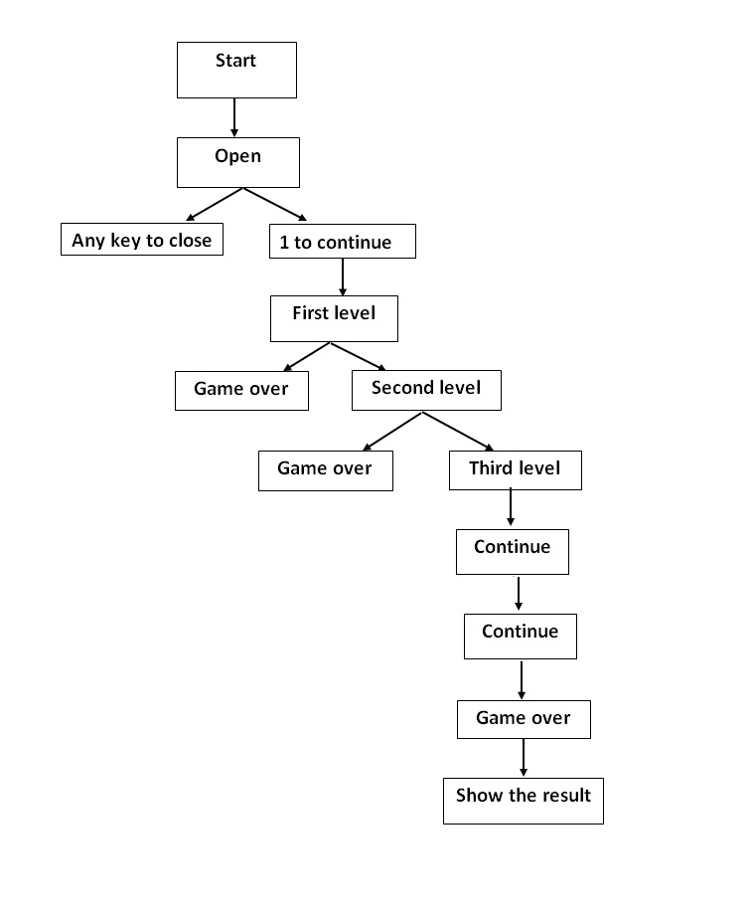

**How to play**

This is a very simple game to play. First a word come to the display randomly then user have to write as correct word. If the user to success to write the word completely then the second level sill start automatically and its continue until the user is wrong. When the user type press wrong word then the game will close and show the score. Every complete word have a 5 point.

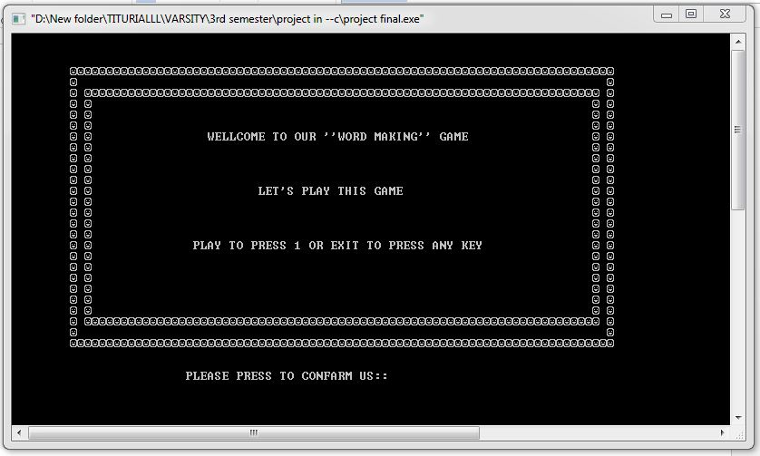

Figure-1: Main window of the game.

If we run start our game then the screen will show. Where press 1 to continue and any other key to abort.

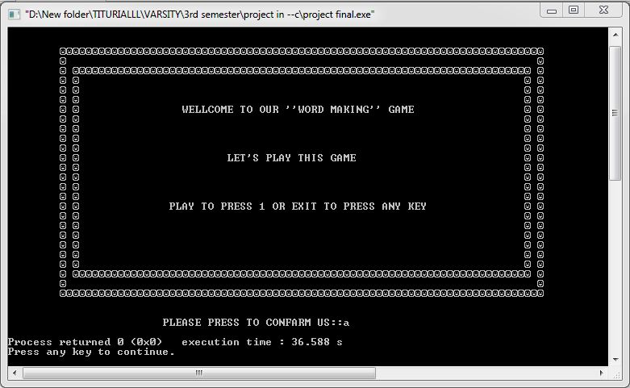

Figure 2*: Close Display in this game. When wrong input.*

If our input is wrong then the game screen will show this. And it’s always show when the user press wrong.

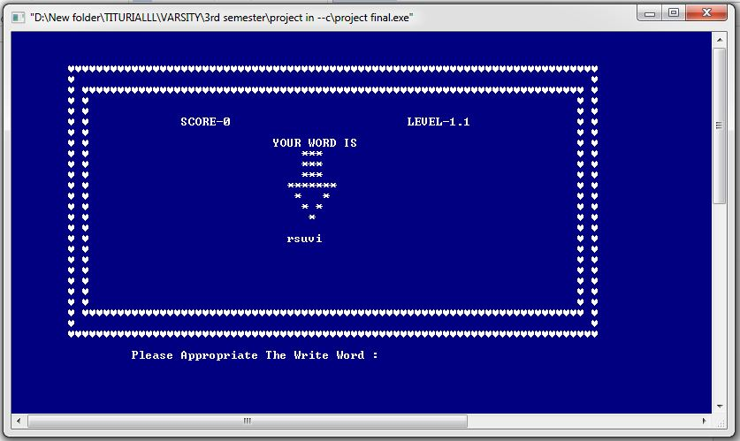

Figure-3: 1st level of the game

When we start the game the screen will show like that, there is a word with random alphabet that is RSUVI which is given word, the user must have to type the correct spell word which is VIRUS, when the answer is correct the next level will come automatically and it the game will show this screen

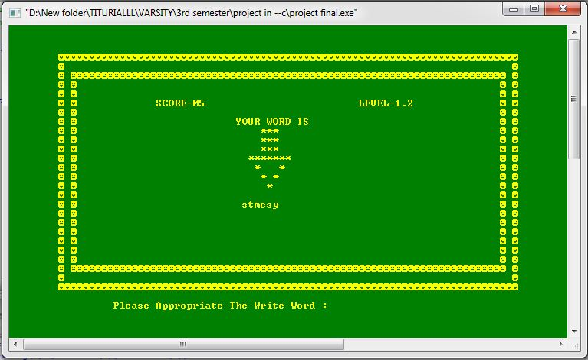

Figure-4: level-2

This is the next level of our game, here the word is STMESY which is wrong spell word are the correct spelled word is SYSTEM. If we success complete this level then we play the next level. And its continue until the user failed, if the user failed then the screen will show bellow.

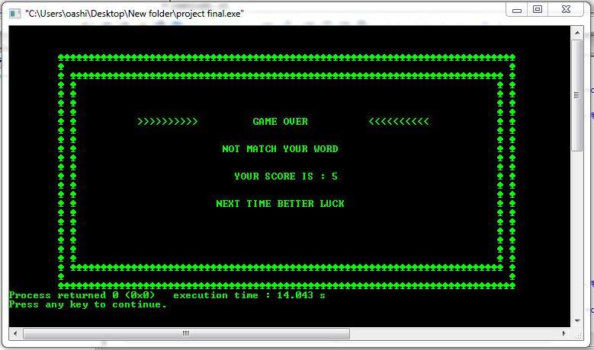

Figure-5: level 2 game over.

Here show the result which is 5.every level have a 5 marks, when a level is completed then the marks will add automatically.

**Design**

For a better look we change the color of every step of our game and how we do that and where

Its work that shown are bellow

**Game color code:**

|  |  |  |  |  |  |  |  |  |  |
| --- | --- | --- | --- | --- | --- | --- | --- | --- | --- |
| Level-1.1 | Level-1.2 | Level-1.3 | Level-1.4 | Level-2.1 | Level-2.2 | Level-2.3 | Level-2.4 | Level-3.1 | Level-3.2 |
| 1F | 2E | 7C | 3F | 4B | F1 | 5A | 6F | F4 | 8F |
| Level-3.3 | Level-3.4 | Level-4.1 | Level-4.2 | Level-4.3 | Level-4.4 | Level-5.1 | Level-5.2 | Level-5.3 | Level-5.4 |
| A9 | B0 | 9F | E9 | CF | F9 | DF | 57 | 0A | 7C |

**Game word:**

In this game we built a smaller version where the word is only 20 and its given on code, the word we use that are given bellow

**Game level word:**

|  |  |  |  |  |
| --- | --- | --- | --- | --- |
| Level-1.1 | Level-1.2 | Level-1.3 | Level-1.4 | Level-2.1 |
| Virus | System | Driver | Linux | Compile |
| Level-3.3 | Level-3.4 | Level-4.1 | Level-4.2 | Level-4.3 |
| Browser | Floppy | Machine | Language | Installer |
| Level-2.2 | Level-2.3 | Level-2.4 | Level-3.1 | Level-3.2 |
| Debug | Search | Binary | Software | Program |
| Level-4.4 | Level-5.1 | Level-5.2 | Level-5.3 | Level-5.4 |
| Application | Processor | Firmware | spyware | Interpreter |

**Border shape design:**

We try to give attractive looked n our game therefore we use some design in game border, how we apply it that are given bellow

**Border shape ASCII character:**

|  |  |  |  |  |  |  |  |  |  |
| --- | --- | --- | --- | --- | --- | --- | --- | --- | --- |
| Level-1.1 | Level-1.2 | Level-1.3 | Level-1.4 | Level-2.1 | Level-2.2 | Level-2.3 | Level-2.4 | Level-3.1 | Level-3.2 |
| 3 | 2 | 4 | 5 | 15 | 6 | 176 | 33 | 177 | 35 |
| Level-3.3 | Level-3.4 | Level-4.1 | Level-4.2 | Level-4.3 | Level-4.4 | Level-5.1 | Level-5.2 | Level-5.3 | Level-5.4 |
| 36 | 48 | 178 | 42 | 64 | 126 | 146 | 148 | 219 | 249 |

**Testing**

Testing is a most important part of an application. Without testing application are fail any time. When testing nobody can ensure it is 100% test prove application. To check the programs activity in every aspect I needed to test it with all possible inputs of data. I tested all the twenty level. To test a level with all possible inputs I first found the paths that the level could follow.

I test all level for possible output. I test all level word and wrong word. My program is case sensitive .when play the game I use small letter the program is pass but when input capital letter the program will fail. Every level is tested this thing when use capital letter the program fail.

When play this game I also tested integer type value the program will fail. All level are tested all real value some test fail and some test is pass. The integer type and capital letter type value is test fail. All small letter test is pass.

I also tested game level graphics .all game level font color and background color is pass .all level background color change automatically all font color is change automatically. I also test game over background color and font the test is pass.so the game graphics is tested pass.

Sound test is none. Do not use game sound. Also game time is none.

Game level number and game score is tested pass. I also tested the every level score come correctly. All level score show perfectly.

The environment test is also pass .This program is also run windows and Linux ,but do not tested mac or any operating system.do not show any wrong output any type of operating system.

**Strong point:**

We believe that our game have some strong point which are

1: Children learn with fun

2: It’s an on type of puzzle game which may make your brain sharp

3: Every level may change the colure therefore the user don’t feel the disturbances

4: It’s too much use on competition

**Weak point:**

1: The word is limited.

2:Don’t work with capital letter.

3:Don’t have a chance to save.

4: Only one chance to play the game.

**Learning experience**

We use to color in our project that is totally unknown to us before this project, now can handle the text color and the background color also but the main things that we can change both at a time. We learn how to work in a group.

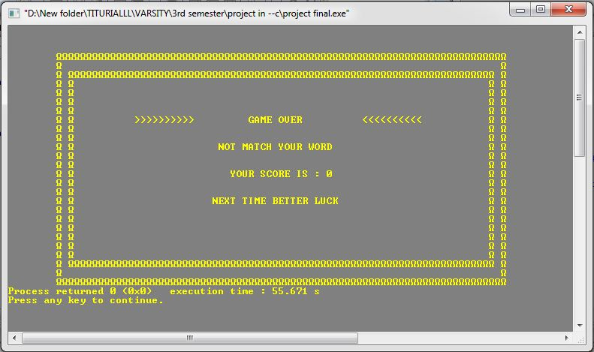

**Reference**

**Some of book:**

1. Teach yourself C (Herbert Schildt)
2. Computer programming(Tamim Shahariar Subin )

**Vedio titurial:**

1. Bangla c programming (sharif chawhary)(Youtube )
2. C programming (Tamim Shahariar Subin)
3. Bangla vedio titurial(BD Pathsala) (Youtube )

Many of YOUTUBE vedio titurial ..google search engine.

**Code**

**Code for the game:**

Int a,b, c🡨1;

{

Print(Border top );

Print (Border right);

Print(Border left);

Print(Bottom Border);

Print(WELL COME TO OUR GAME);**// Inside the all border**

Print(IF PLAY THE GAME TO PRESS 1 AND CLOSE THE PRESS ANY KEY); **// Inside the all border**

}

Scanf (int a);

If(a=1){

Function (change font color and background color);

Function (remove upper program print new program);

Print(Border top ); **// Inside the all border**

Print (Border right); **// Inside the all border**

Print(Border left); **// Inside the all border**

Print(Bottom Border); **// Inside the all border**

Print (score); **// Inside the all border**

Print(level number); **// Inside the all border**

Print (your word is ); **// Inside the all border**

Print(shape design ); **// Inside the all border**

Print (Word wrong from ); **// Inside the all border**

Scan(string ch );**// Outside the border**

Char ch1[80]🡨level one word ;

Char ch[80]

If(ch1=ch){

If(a=1){

Function (change font color and background color);

Function (remove upper program print new program);

Print(Border top ); **// Inside the all border**

Print (Border right); **// Inside the all border**

Print(Border left); **// Inside the all border**

Print(Bottom Border); **// Inside the all border**

Print (score); **// Inside the all border**

Print(level number); **// Inside the all border**

Print (your word is ); **// Inside the all border**

Print(shape design ); **// Inside the all border**

Print (Word wrong from ); **// Inside the all border**

Scan(string ch );**// Outside the border**

Char ch1[80]🡨level one word ;

Char ch[80]

**THIS IS CONTINUE FOR 20 TIMES BECAUSE WE HAVE 20 LEVEL**

}

Else{

Print(Border top ); **// Inside the all border**

Print (Border right); **// Inside the all border**

Print(Border left); **// Inside the all border**

Print(Bottom Border); **// Inside the all border**

Print (GAME OVER);

Print (NOT MATCH YOUR WORD);

Print (YOUR SCORE IS );

Print (THANK YOU FOR PLAY OUR GAME);

}

}

Else (program close)