**Code :**

#include<stdio.h>

#include<string.h>

int main()

{

char string[100];

int i;

printf("\n \"This C program for checking whether a given string is a single line comment or not\"\n");

for(i=0;i<2;i++){

printf("\n (%d) Enter a String : ",i+1);

gets(string);

int length = strlen(string);

if(string[0]=='/' && string[1]=='/'){

printf(" %s - It is a single line comment\n",string);

}

else{

printf(" %s - It is not a single line comment\n",string);

}

}

return 0;

}

**Output :**

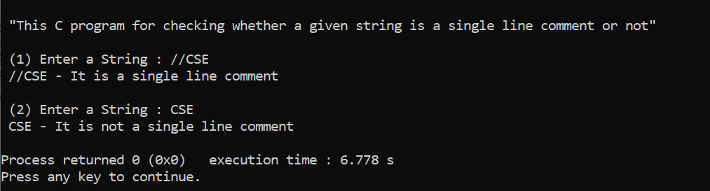

**Code :**

#include<stdio.h>

#include<string.h>

int main()

{

char string[100];

int i;

printf("\n \"This C program for checking whether a given string is a multi line comment or not\"\n");

for(int i=0;i<2;i++){

printf("\n (%d) Enter a String : ",i+1);

gets(string);

int length = strlen(string);

if(string[0]=='/' && string[1]=='*' && string[length-2]=='*' && string[length-1]=='/'){

printf(" %s - It is a multi line comment\n",string);

}

else{

printf(" %s - It is not a multi line comment\n",string);

}

}

return 0;

}

**Output :**

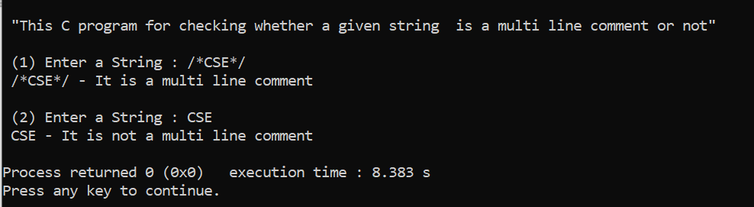

**Code :**

#include<stdio.h>

#include<string.h>

#include<ctype.h>

int main()

{

char a[100];

int flag,key,j,i=1;

char keyword[32][10]={

"auto","double","int","struct","break","else","long",

"switch","case","enum","register","typedef","char",

"extern","return","union","const","float","short",

"unsigned","continue","for","signed","void","default",

"goto","sizeof","voltile","do","if","static","while"

} ;

printf("\n \"This program for checking whether a given string is a valid identifier or not\"\n");

for(j=0; j<3;j++)

{

flag=key=0;

printf("\n (%d) Enter an identifier : ",j+1);

gets(a);

if(isalpha(a[0]) || a[0]=='_'){

flag=1;

}

for(i=1;i<strlen(a);i++)

{

if(!isdigit(a[i]) && !isalpha(a[i]) && !(a[i]=='_' ))

{

flag=0;

break;

}

}

for(i = 0; i < 32; i++) {

if(strcmp(a,keyword[i])==0) {

key = 1;

}

}

if(flag==1 && key==0){

printf("\n %s - It is a valid identifier\n",a);

}

else{

printf("\n %s - It is not a valid Identifier\n",a);

}

}

return 0;

}

**Output :**

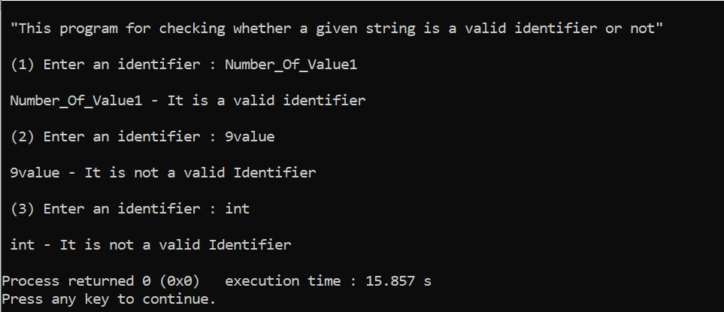

**Code :**

#include<stdio.h>

#include <stdlib.h>

#include<string.h>

#include<ctype.h>

int main()

{

char a[100];

int i=1,key,integer,floates,character,string,flag,j;

float floatNum=0;

int intNum=0;

char charNum;

char keyword[32][10]={

"auto","double","int","struct","break","else","long",

"switch","case","enum","register","typedef","char",

"extern","return","union","const","float","short",

"unsigned","continue","for","signed","void","default",

"goto","sizeof","voltile","do","if","static","while"

} ;

for(j=0;j<2;j++)

{

flag=key=integer=floates=character=string=0;

printf("\n (%d) Enter an identifier : ",j+1);

gets(a);

if(isalpha(a[0]) || a[0]=='_'){

flag=1;

}

for(i=1;i<strlen(a);i++)

{

if(!isdigit(a[i]) && !isalpha(a[i]) && !(a[i]=='_' ))

{

flag=0;

break;

}

}

for(i = 0; i < 32; i++) {

if(strcmp(a,keyword[i])==0) {

key= 1;

}

}

if(flag==1 && key==0)

{

printf("\n %s - It is valid identifier\n",a);

char str[100];

printf("\n To check whether the user input is of integer or float or single character or string data type\n");

printf("\n Enter a input : ");

gets(str);

for(i=0;i<strlen(str);i++)

{

if(isdigit(str[i]) && !isalpha(str[i]) )

{

integer=1;

}

else if(isalpha(str[i]) && str[1]!='\0' && !isdigit(str[i]))

{

string =1;

}

else if(str[i]=='.')

{

floates = 1;

}

else if(isalpha(str[0]) && str[1]=='\0')

{

character=1;

}

}

if(integer==1 && floates==0 && string==0 && character==0)

{

intNum = atof(str);

printf("\n The input %d is a integer number\n int %s = %d;\n",intNum,a,intNum);

}

else if(floates==1 && integer==1 && string==0 && character==0)

{

floatNum = atof(str);

printf("\n The input %f is a float number\n float %s = %f;\n",floatNum,a,floatNum);

}

else if(character==1 && integer==0 && floates==0 && string==0)

{

charNum = str[0];

printf("\n The input %c is a character \n char %s = \'%c\';\n",charNum,a,charNum);

}

else

{

printf("\n The input %s is a string \n char %s[] = \"%s\";\n",str,a,str);

}

}

else{

printf("\n %s - It is not a valid Identifier\n",a);

}

}

return 0;

}

**Output :**

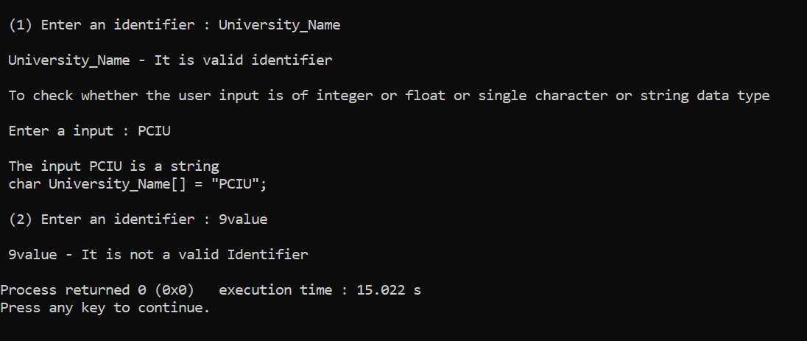

**Code :**

#include <stdio.h>

#include <string.h>

int main(){

int i,flag,len,left,right,invert,semi,j;

char string[100];

char array[100]="";

printf(" C program to check syntax of 'printf' function\n");

for(j=0;j<2;j++){

printf("\n (%d)Enter a String : ",j+1);

gets(string);

len=left=right=invert=semi=0;

len=strlen(string);

for(i=0;i<=5;i++){

array[i]=string[i];

}

if(strcmp(array,"printf")==0 ){

for(i=6;i<len;i++){

if(string[i]=='(')

left=left+1;

if(string[i]=='"')

invert=invert+1;

if(string[i]==')')

right=right+1;

if(string[i]==';')

semi=semi+1;

}

if(left==1 && right==1 && invert==2 && semi==1){

printf(" %s - Correct Syntax\n",string);

}

else if(left==0)

printf(" %s - Opening parenthesis absent after for keyword(syntax error)\n",string);

else if(invert!=2)

printf(" %s - Inverted comma absent(syntax error)\n",string);

else if(right==0)

printf(" %s - closing parenthesis absent at end(syntax error)\n",string);

else if(semi==0)

printf(" %s - semicolon absent at end(syntax error)\n",string);

}

else{

printf(" Error in printf keyword usage\n");

}

}

return 0;

}

**Output :**

