Tarina Snyman (601376)

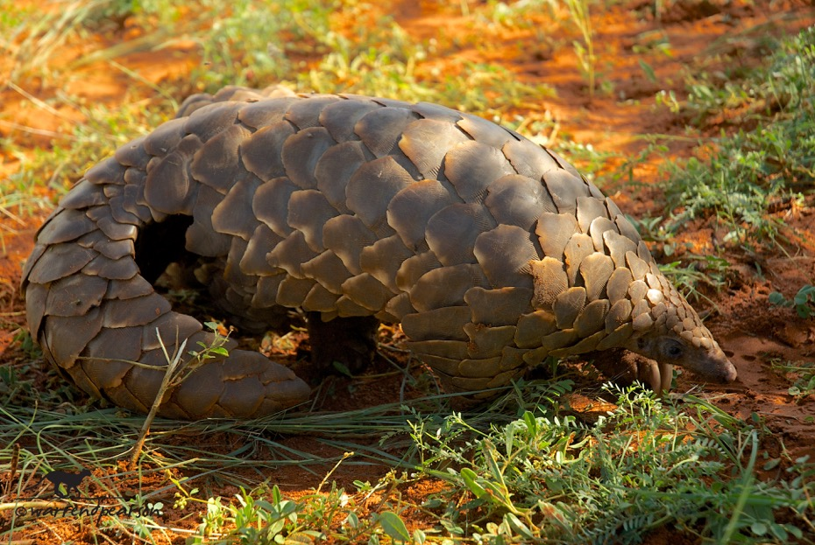

Figure 1 Temminck’s pangolin (Smutsia temminckii) by Warren Pearson (Pearson)

Evaluating the Effectiveness of Artificial Intelligence in the Conservation of Pangolins

Pangolins are one of the most trafficked mammals in the world and face severe threats including poaching and habitat loss (Wang, et al., 2022). The IUCN Red List lists all eight pangolin species as threatened, yet important behavioural characteristics are still unknown (Khwaja, et al., 2019). Machine learning, computer vision, deep learning, and other artificial intelligence (AI) technologies are becoming increasingly effective tools for wildlife conservation (Tuia, et al., 2022). Pangolin recognition models can be created by utilising AI to recognise and track pangolins in images or videos (Zhong, et al., 2025). Because of their size and terrestrial habitat, pangolins are ideal for camera trap monitoring, making AI a valuable tool for their conservation (Khwaja, et al., 2019). Additionally, AI can be used to monitor the illicit online trafficking of wildlife (Cardoso, et al., 2023).

Despite its potential, AI-driven pangolin monitoring faces challenges including small datasets, expensive labelling samples, and trouble identifying the different species because of their similar appearances and rarity (Zhong, et al., 2025). Tracking these elusive creatures is difficult with traditional approaches, and using AI solutions raises ethical questions due to the possibility of misuse by poachers (Fergus, et al., 2024). This research will be used to determine how effective AI would be in aiding pangolin conservation.

Traditional monitoring methods are time-consuming, labour-intensive, and susceptible to human error (Wang, et al., 2024), which makes AI technologies an important tool for improving pangolin conservation efficiency. Researchers can automate population tracking, detect illegal trade more efficiently, and quickly identify pangolins in photos and videos by developing effective AI-driven pangolin recognition models (Zhong, et al., 2025).

Advancements in artificial intelligence, particularly deep learning have significantly enhanced pangolin conservation efforts by improving wildlife recognition, population estimation, and conservation assessments (Zhong, et al., 2025). AI-powered drones with thermal and infrared photography can evaluate habitat conditions, identify unlawful hunting, and track pangolins in real time (Cardoso, et al., 2023). AI models can also monitor online platforms for illegal wildlife trade (Di Minin, et al., 2018). By lowering human interference, enhancing data collecting, and producing more potent pangolin population protection tactics, these technologies can strengthen conservation efforts.

The main objective of this research is to evaluate the effectiveness of AI-driven solutions in pangolin conservation. This study aims to achieve the following specific objectives:

* To analyse how well AI-driven tools improve pangolin tracking and poaching detection.
* To investigate the current limitations of AI in pangolin conservation.
* To examine the ethical concerns that may arise from using AI to monitor pangolins.
* To compare AI-driven conservation techniques with traditional monitoring methods to determine their relative advantages and limitations.

With these specific objectives in mind the following research questions can be asked:

* How effective are AI-driven solutions in tracking pangolins and detecting poaching activities?
* What are the key limitations and challenges affecting the use of AI in pangolin conservation?
* What ethical concerns arise from using AI for pangolin monitoring?
* How do AI-based conservation methods compare to traditional tracking and monitoring techniques in terms of accuracy and efficiency?

# References

Cardoso, A. S. et al., 2023. Detecting wildlife trafficking in images from online platforms: A test case using deep learning with pangolin images. *Biological Conservation,* Volume 279.

Di Minin, E., Fink, C., Hiippala, T. & Tenkanen, H., 2018. A framework for investigating illegal wildlife trade on social media with machine learning. *Conservation Biology,* 33(1), pp. 210-213.

Fergus, P., Chalmers, C., Longmore, S. & Wich, S., 2024. Harnessing Artificial Intelligence for Wildlife Conservation. *Conservation,* Volume 4, pp. 685-702.

Khwaja, H. et al., 2019. Pangolins in global camera trap data: Implications for ecological monitoring. *Global Ecology and Conservation,* Volume 20.

Pearson, W., n.d. *Photo-Gallery.* [Online]   
Available at: https://pangolinsg.org/pangolins/photo-gallery/  
[Accessed 16 02 2025].

Tuia, D. et al., 2022. Perspectives in machine learning for wildlife conservation. *Nature Communications,* 12(1).

Wang, K. et al., 2024. Automatic Identification of Pangolin Behavior Using Deep Learning Based on Temporal Relative Attention Mechanism. *Animals,* 14(7).

Wang, X.-M.et al., 2022. To Save Pangolins: A nutritional Perspective. *Animals,* 12(22).

Zhong, J., Wei, S., Chen, Q. & Niu, B., 2025. Unlocking the power of artificial intelligence for pangolin protection: Revolutionizing wildlife conservation with enhanced deep learning models. *Expert Systems with Applications,* Volume 267.