WISHORA

INTRODUCTION
Wishora is a full-stack web application designed to simplify gift registry and wish list management. It allows users to create occasion-based wish lists, add items with links and descriptions, and share them with friends and family through a single unique URL. A built-in reservation system ensures no gift is chosen twice, while keeping the gifter's identity a surprise.
Built using React (Vite), Node.js, Express.js, and MongoDB Atlas, the application features secure JWT-based authentication, a cinematic dark-themed UI with smooth animations, and a fully responsive design. Wishora aims to transform the gift-giving experience into something elegant, organized, and effortless.

SCENARIO BASED CASE STUDY:
Scenario: Priya is celebrating her 25th birthday and expects gifts from her friends and family. Her friends are unsure what to buy her, and multiple people end up gifting the same things. Priya also feels awkward directly telling people what she wants.
How Wishora Solves It: Priya signs up on Wishora and creates a wish list for her birthday occasion. She adds items like a perfume, a book, and wireless earbuds — each with a product link and a short description. Once done, she copies the shareable link and sends it to her WhatsApp group.
Her friends open the link, log in, and browse her wish list. Her friend Rahul decides to gift the earbuds and clicks "I'll Gift This" — the item is instantly marked as Taken. When Priya's cousin Sneha opens the same list, she can see the earbuds are already reserved, so she picks the perfume instead. Neither Rahul nor Sneha can see who reserved what — the gifter's identity stays hidden until the birthday.
On Priya's birthday, every gift is different, every surprise is intact, and no one wasted money on duplicates.

SYSTEM REQUIREMENTS:
Software Requirements:
To ensure smooth development, deployment, and usage of the Wishora Web Application, certain system prerequisites must be met. These requirements are categorized into software, setup, and hardware specifications, all of which contribute to building a robust and scalable wishlist platform.
1. Software Requirements
These are the essential tools and platforms required to develop, test, and run the application efficiently.
- Operating System: Windows 10/11, macOS, or Linux — Supports cross-platform development and testing.
- Node.js (v18 or above): Provides the runtime environment for the backend server and handles API routing. 👉 Download Node.js
- npm (v8 or above): A package manager required to install dependencies for both React frontend and Express backend.
- React.js (via Vite): A JavaScript library for building dynamic, cinematic, and responsive user interfaces.
- MongoDB Atlas: A cloud-based NoSQL database used to store users, wishlists, and reservation data. 👉 mongodb.com/atlas
- Express.js: A lightweight web framework for building RESTful APIs on the backend.
- Browser: Google Chrome / Firefox (latest version) — For rendering and testing the UI in real-time.
- Visual Studio Code: Preferred code editor with built-in Git and terminal support.
- Postman: Tool for testing backend APIs during development.
2. Hardware Requirements
Describes the minimum and recommended specifications needed to support the development and usage of the application.
- Processor: Intel Core i5 (8th Gen or above) / AMD Ryzen 5 or better — Ensures fast compilation of React/Vite builds and smooth multitasking during development.
- RAM: Minimum 8 GB (16 GB recommended) — Required for running the React dev server, Node.js backend, and browser simultaneously.
- Storage: At least 1 GB free space — Required for package installations, project files, and MongoDB Atlas connections.
- Internet Connection: Stable broadband required — MongoDB Atlas is cloud-hosted and requires an active internet connection at all times.
- Display: 1366x768 or higher — Recommended for optimal coding experience and application layout visualization.

PROJECT ARCHITECTURE:
Technical Architecture:
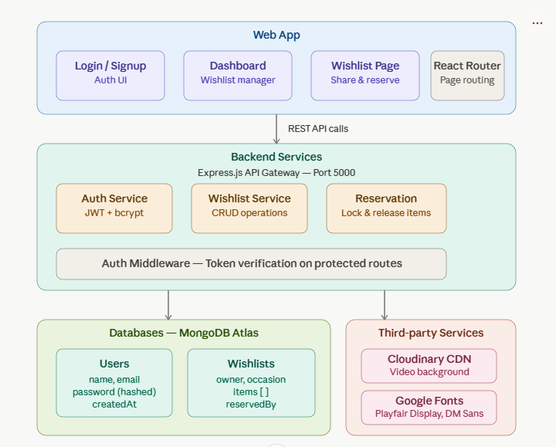
The Wishora application follows a three-tier client-server architecture, consisting of a Web App layer, a Backend Services layer, and a Database/Third-party Services layer. Each tier has a specific responsibility and communicates with the others through well-defined interfaces.
1. Web App Layer (Frontend)
The topmost layer represents the React-based frontend built using Vite. It consists of four main components — the Login/Signup page for user authentication, the Dashboard for managing wishlists, the Wishlist Page for viewing and reserving items, and React Router for handling client-side page navigation. All user interactions originate from this layer, which communicates with the backend exclusively through REST API calls made to port 5000.
2. Backend Services Layer
The middle layer is powered by Node.js and Express.js, acting as the central API Gateway. It contains three core services — the Auth Service, which handles user registration and login using JWT tokens and bcrypt password hashing; the Wishlist Service, which manages all CRUD operations for wishlists and items; and the Reservation Service, which controls the locking and releasing of wishlist items to prevent duplicate gift selection. Running beneath all three services is an Auth Middleware layer, which intercepts every protected route and verifies the JWT token before allowing access.
3. Database Layer (MongoDB Atlas)
The bottom-left section represents the cloud-based MongoDB Atlas database, which stores data in two main collections. The Users collection holds each user's name, email, hashed password, and account creation timestamp. The Wishlists collection stores the occasion name, the owner's reference, the list of items with their details, and the reservedBy field that tracks which user has claimed each gift.

4. Third-Party Services
The bottom-right section covers external services integrated into the application. Cloudinary CDN serves the cinematic video background displayed on the landing page. Google Fonts delivers the Playfair Display and DM Sans typefaces used throughout the UI for a premium visual experience.
ER Diagram:
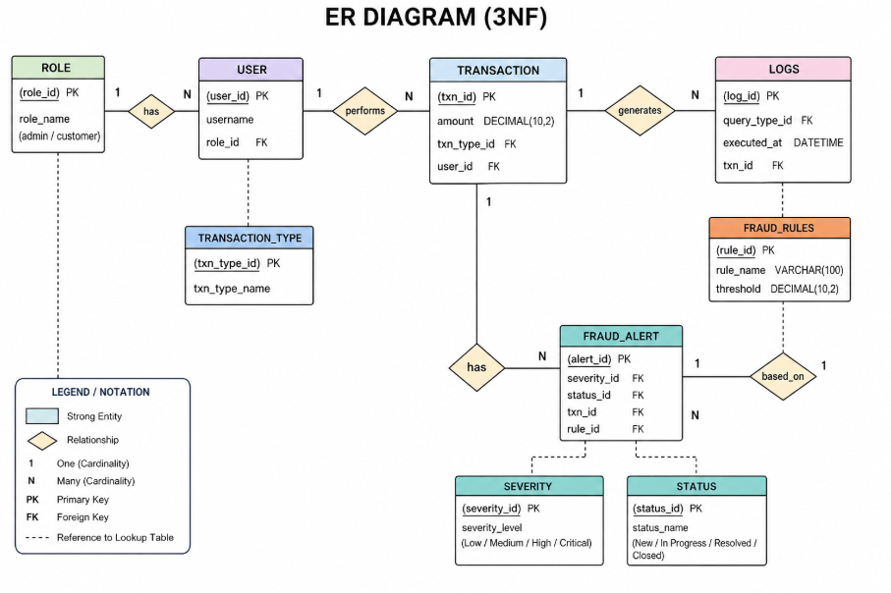
Entities:
- Users: The Users entity stores information about all registered users in the system. Each user can create multiple wishlists and may reserve items from other users' wishlists.

- Attributes:
- _id (Primary Key) – Unique identifier for each user
- name – Name of the user
- email – Unique email address of the user
- password – Encrypted password for authentication
- createdAt – Timestamp indicating when the account was created
Keys:
- Primary Key (PK): _id
- Foreign Key (FK): None

- Wishlist: The Wishlists entity represents collections created by users for specific occasions such as birthdays, festivals, or personal needs.
Attributes:
- _id (Primary Key) – Unique identifier for each wishlist
- userId (Foreign Key) – References the user who created the wishlist
- title – Name or occasion of the wishlistisPublic – Indicates whether the wishlist is public or private
- createdAt – Timestamp of wishlist creation
Keys:
- Primary Key (PK): _id
- Foreign Key (FK): userId → Users(_id)

- Items: The Items entity stores individual products or items that belong to a wishlist. Each item can optionally be reserved by another user.

Attributes:
- _id (Primary Key) – Unique identifier for each item
- wishlistId (Foreign Key) – References the wishlist it belongs to
- name – Name of the item
- productLink – URL of the product
- description – Details about the item
- status – Indicates availability (available/taken)
- reservedBy (Foreign Key, Optional) – References the user who reserved the item
Keys:
Primary Key (PK): _id
Foreign Keys (FK):
- wishlistId → Wishlists(_id)
- reservedBy → Users(_id) (nullable)
KEY FEATURES:
- User Authentication (JWT-based login/signup)
- Wishlist Creation for different occasions
- Add Items with links and descriptions
- Share Wishlist via public link
- Reservation System to prevent duplicate gifts
- Privacy Protection (gifter identity hidden)
- Cinematic UI with animations
- Responsive Design

ROLES AND RESPONSIBILITIES:

User:
● Registration and Account Management: Users are responsible for creating an account by providing their name, email, and password. They must ensure their credentials are secure and can update their details when required.
● Wishlist Creation: Users can create wishlists based on different occasions such as birthdays or events. They are responsible for naming the occasion and organizing their wishlist properly.
● Item Management: Users can add items to their wishlist by providing item name, product link, and description. They can also manage or update items as needed.
● Sharing Wishlist: Users can generate a unique shareable link and send it to friends and family for viewing and reserving gifts.
● Reservation Awareness: Users can view reserved items but cannot see who reserved them, maintaining the surprise element.
● Account Actions: Users can logout or delete their account if required.

Admin:
● No Admin Role Present: The Wishora application does not include an admin panel. All operations such as wishlist creation, item management, and sharing are handled directly by users themselves.

USER FLOW:
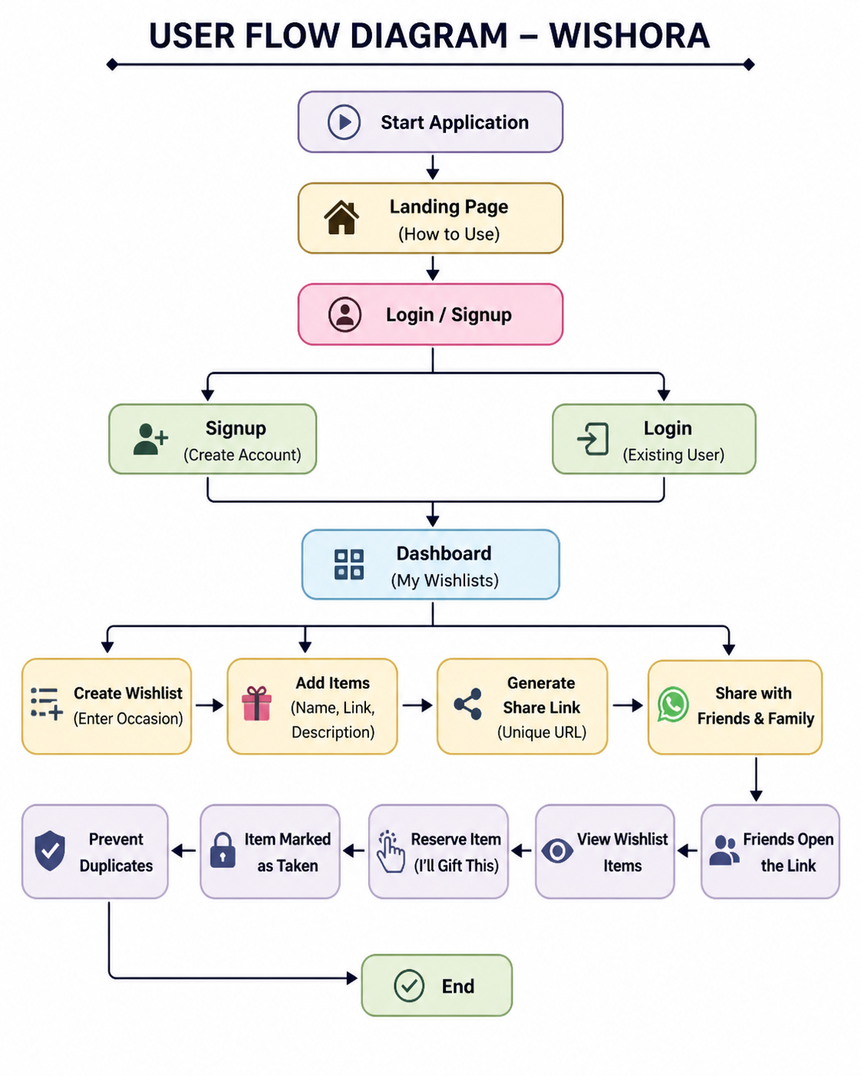

User Flow:
● Registration & Login – User creates an account or logs in using email and password.
● Dashboard Access – After login, user is redirected to the dashboard where they can manage wishlists.
● Wishlist Creation – User enters an occasion name and creates a wishlist.
● Item Addition – User adds items with product link and description to the wishlist.
● Share Wishlist – A unique URL is generated which can be shared with friends.
● Reservation by Others – Friends open the link, view items, and reserve gifts.
● Duplicate Prevention – Reserved items are marked and cannot be selected again.
● Logout / Delete Account – User can logout or delete their account anytime.

MVC PATTERN:
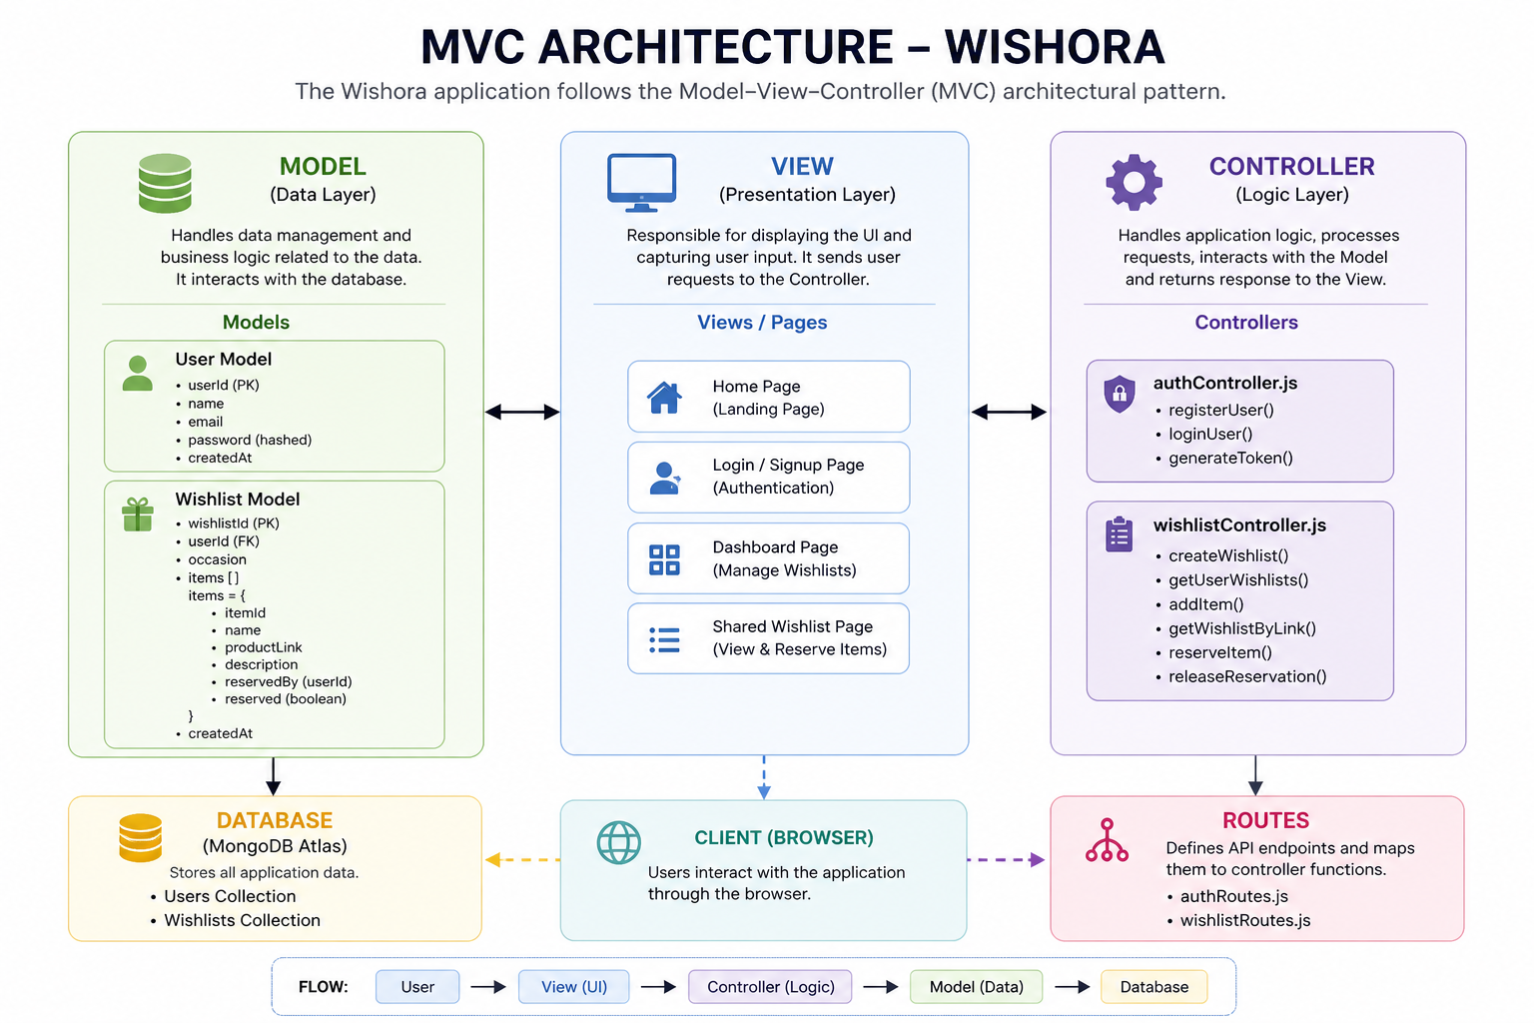
- The Wishora application follows the Model-View-Controller (MVC) architecture to ensure clean code structure, scalability, and maintainability.
- Model Layer(Data Layer):
The Model layer consists of database schemas defined using Mongoose. It includes User and Wishlist models, where wishlist contains embedded item details. This layer handles all database interactions such as storing users, wishlists, and reservation status.
- View Layer(Frontend):
The View layer is implemented using React (Vite). It includes components like Login/Signup pages, Dashboard, Wishlist view, and Shared Wishlist page. This layer is responsible for displaying UI and handling user interactions.
- Controller Layer:
The Controller layer contains business logic implemented in files such as authController.js and wishlistController.js. It processes incoming requests, interacts with models, and sends responses back to the frontend.
- Routes Layer:
Routes define API endpoints such as /auth and /wishlists. These routes connect frontend requests to appropriate controller functions.
- Middleware:
Authentication middleware verifies JWT tokens before allowing access to protected routes, ensuring secure communication between frontend and backend.

Advantages:
- Clear separation of concerns
- Easy scalability
- Better code maintainability
- Secure and modular backend design

BACKEND DEVELOPMENT:
Backend Reference Video:
https://drive.google.com/file/d/1LbjbcrRsBMdV4jXWALiX38hwJl5neIfm/view?usp=drive_link

Backend Structure:
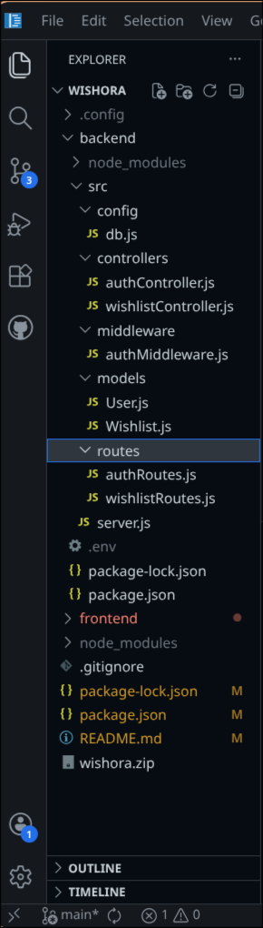

The backend of Wishora is built using Node.js and Express.js and follows a structured MVC pattern.

Controllers:
- authController.js – Handles user registration and login using JWT authentication.
- wishlistController.js – Handles creation of wishlists, adding items, and reservation logic.
Config:
- db.js – Manages MongoDB Atlas database connection.
Middleware:
- authMiddleware.js – Protects routes by verifying JWT tokens.
Models:
- User.js – Stores user details such as name, email, and password.
- Wishlist.js – Stores wishlist data including occasion and items.

Routes:
- authRoutes.js – Defines API routes for authentication.
- wishlistRoutes.js – Defines routes for wishlist and item operations.
Server:
- server.js – Entry point of backend, connects database and starts server.

The backend ensures secure authentication, efficient data handling, and proper API communication with the frontend.

DATABASE DEVELOPMENT:
Configure MongoDB:
- Install Mongoose in the Node.js project
- Create database connection using MongoDB Atlas
- Define schemas and models based on application requirements

Create Database Connection:
Before performing any backend operations, it is important to establish a connection with the database. The application connects to MongoDB Atlas using Mongoose, ensuring that all data operations such as storing users, wishlists, and items are handled efficiently and securely.

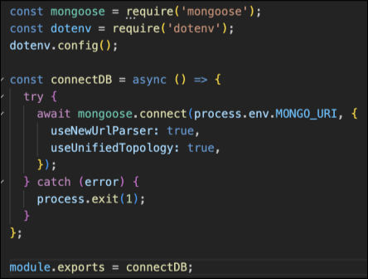

Create Schemas:
Schemas define how data is structured in the database. Based on the ER diagram, the following schemas are used in the Wishora application:
Wishora uses MongoDB Atlas as a cloud-based NoSQL database to store application data.

- User.js→ Schema/model for user accounts.
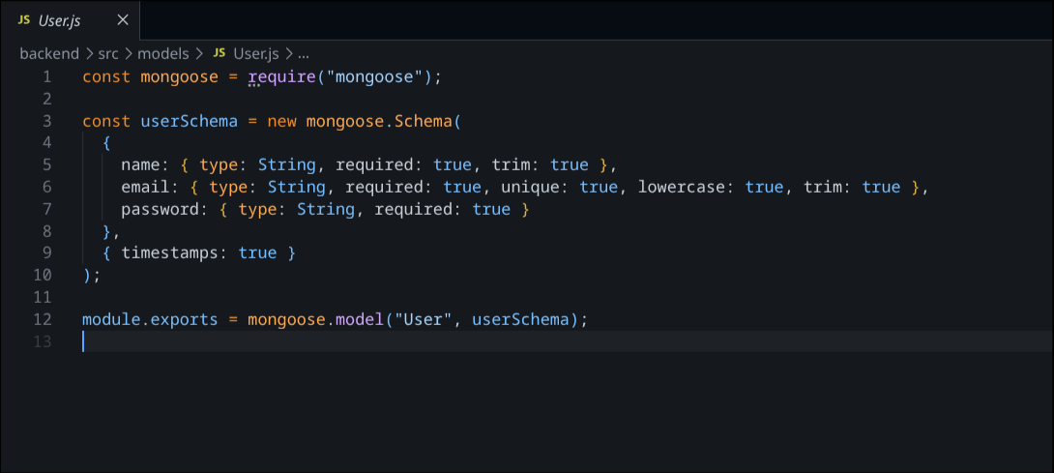

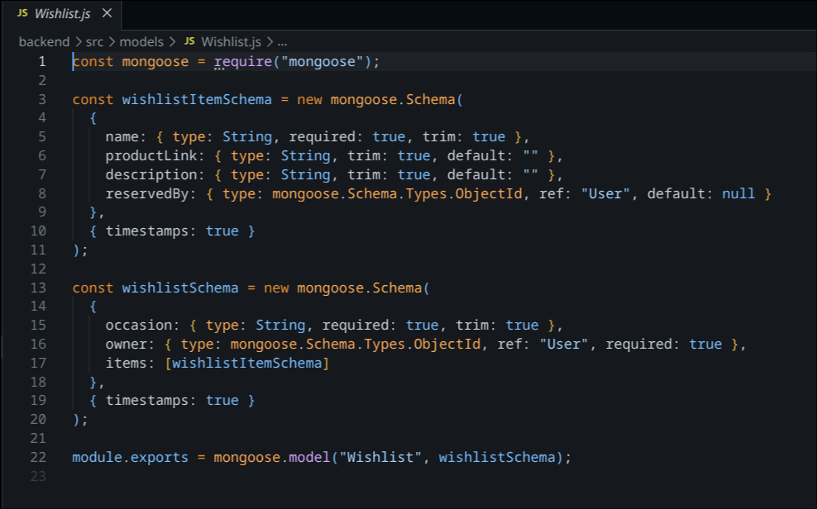
- Wishlist.js → Schema/model for user wishlist items.

Database Configuration:
Mongoose is used to connect the Node.js backend to MongoDB Atlas and define schemas.
Schemas:
User Schema:
Stores user information including name, email, password, and creation timestamp.
Wishlist Schema:
Stores wishlist details such as occasion name, user reference, and list of items.
Item Structure:
Items are embedded within the wishlist schema and include attributes like item name, product link, description, and reservation status.

Database Features:
- Flexible NoSQL structure
- Scalable cloud storage
- Fast data retrieval
- Secure user authentication data storage.
The database design ensures efficient handling of relationships between users, wishlists, and items.

Frontend Reference Video:
https://drive.google.com/file/d/10qYk37-CI7sEWbh7r7AQdvRDjymWcMLt/
view?usp=drive_link
The frontend of Wishora is developed using React with Vite for fast performance and smooth user experience.

Frontend Structure:
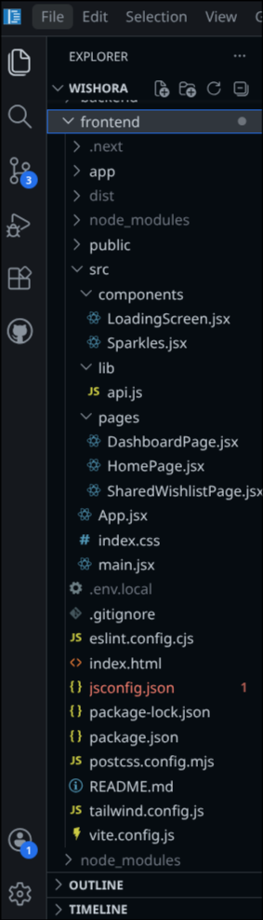

Components:
- LoadingScreen.jsx – Displays animated loading screen
- Sparkles.jsx – Adds visual animation effects
Pages:
- HomePage.jsx – Landing page with “How to Use” section
- DashboardPage.jsx – Main user dashboard for wishlist management
- SharedWishlistPage.jsx – Allows others to view and reserve items
Core Files:
- App.jsx – Main application component handling routing
- main.jsx – Entry point of the React application
- index.css – Global styling
Utilities:
- api.js – Handles API calls to backend
Features:
- Responsive UI design
- Dark theme interface
- Smooth animations using Framer Motion
- Real-time updates for wishlist and reservations
The frontend interacts with backend APIs to fetch and display data dynamically.

Output ScreenShots:
Landing Page:
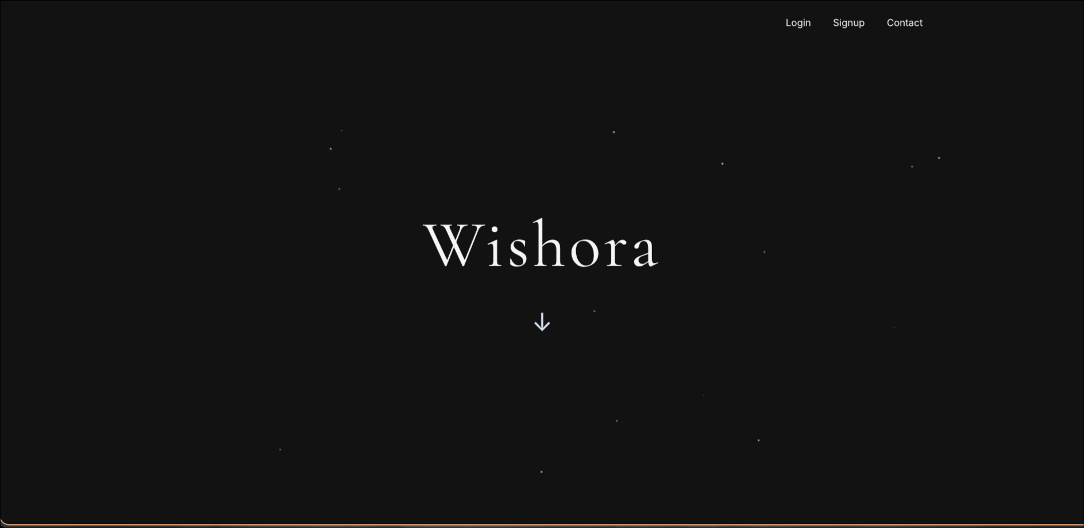
Login Popup UI:
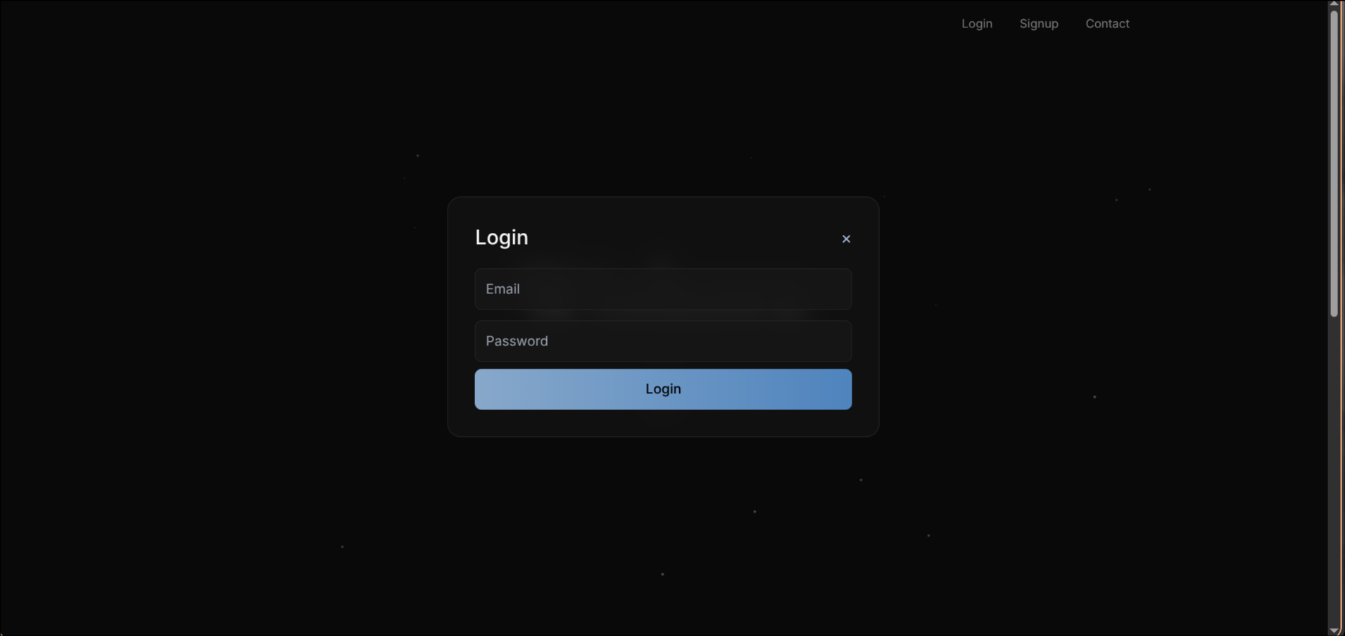

Signup Popup UI:
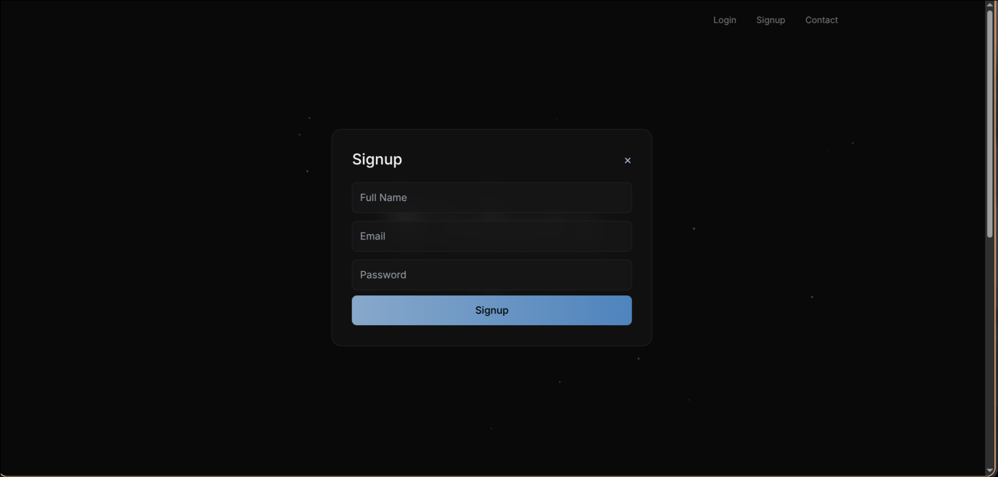
DashboardPage.jsx:
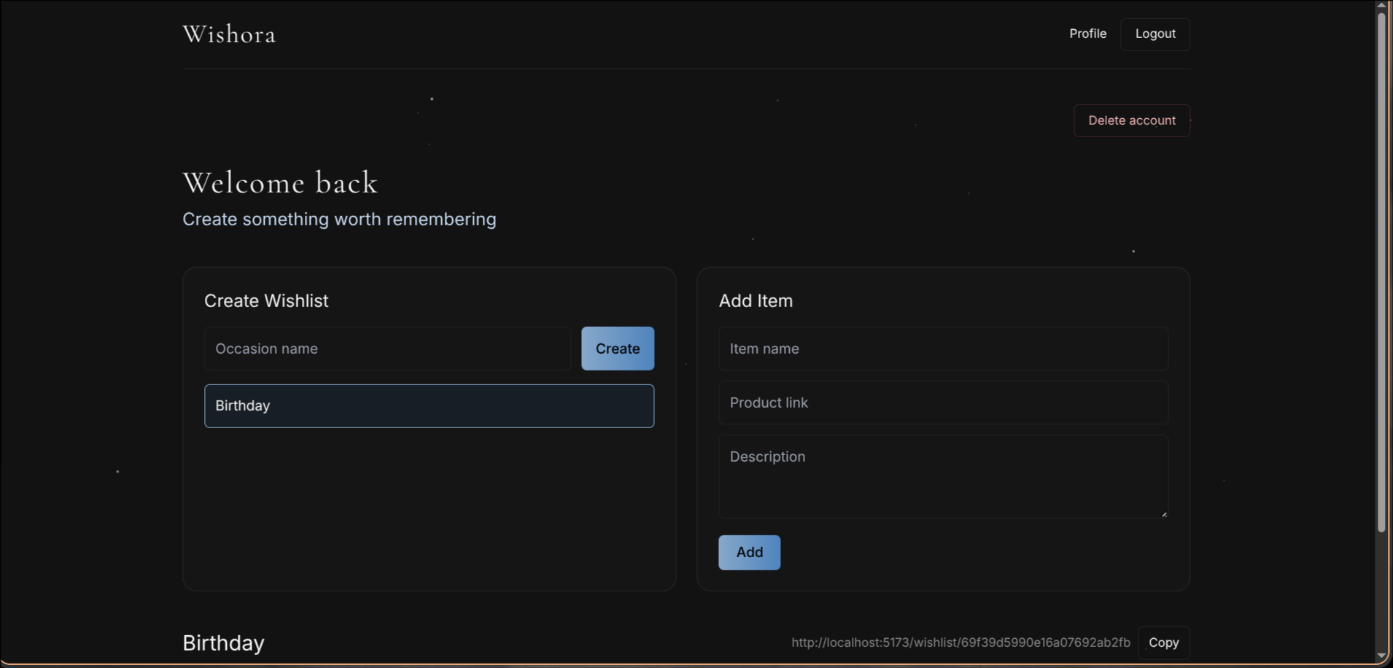

Create Wishlist Section:
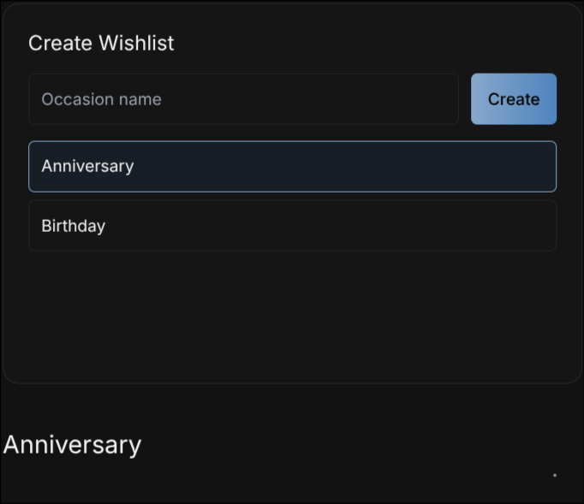
Add Item Section:
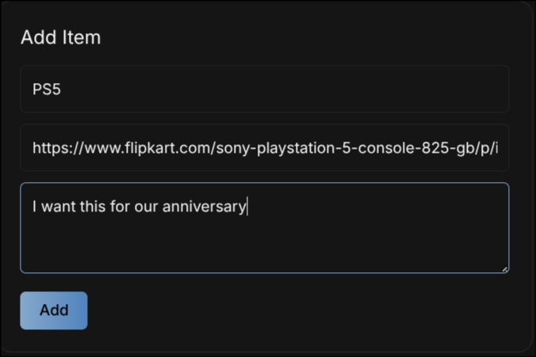

Wishlist Display Section:
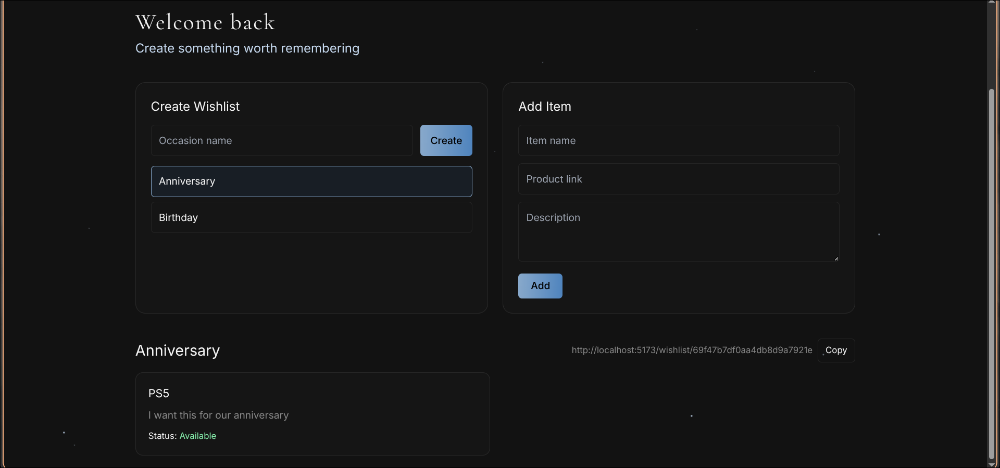
Item Status Feature:
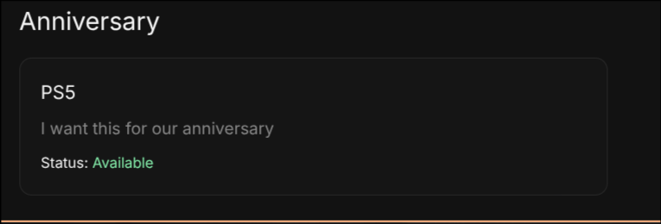
Share Wishlist Feature:


SharedWishlistPage.jsx:
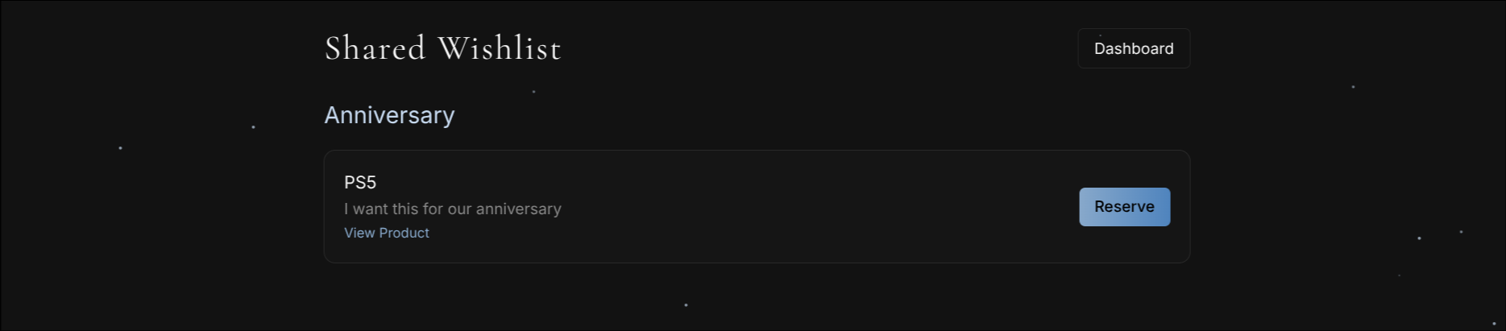
Logout Functionality:
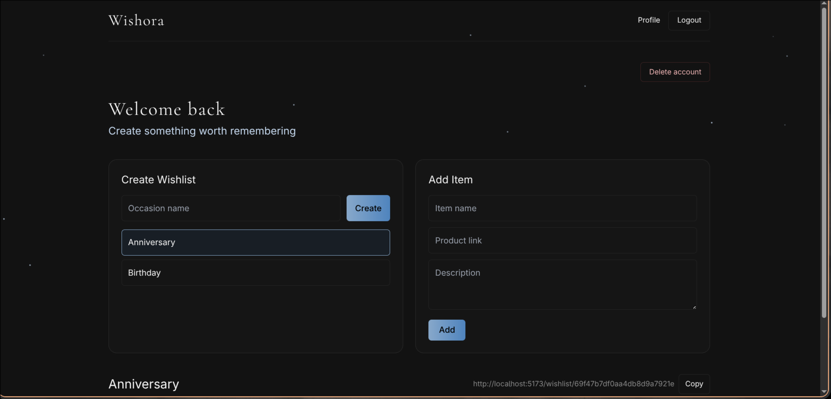
Delete Account Feature:

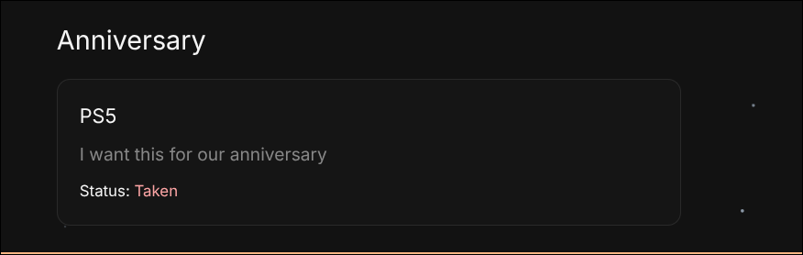
Reserved item status:

Demo Video Link:
https://drive.google.com/file/d/1yd2o1CeZhstoVymopZyd3tz1R9ih9CGG/view?usp=drive_link

Code Drive Link:
https://drive.google.com/drive/folders/1AzNM_y2tTzI7L8eBPynMM4NKQRp6u52o?usp=drive_link

