#include <iostream>

#include <bits/stdc++.h>

using namespace std;

/*

class node

{

public:

int data;

node* next;

node(int n)

{

data=n;

next=nullptr;

}

};

node* createn()

{

int n,a;

cout<<"Enter the number: ";

cin>>n;

vector<int> arr;

while(n!=0)

{

a=n%10;

arr.push_back(a);

n=n/10;

}

reverse(arr.begin(),arr.end());

node* head=new node(arr[0]);

node* mover=head;

for(int i=1;i<arr.size();i++)

{

node* temp=new node(arr[i]);

mover->next=temp;

mover=temp;

}

return head;

}

node* create()

{

int n;

cout<<"Enter the total number of elements: ";

cin>>n;

int * arr=new int[n];

for(int i=0;i<n;i++)

{

cout<<"Enter the "<<i+1<<" element: ";

cin>>arr[i];

}

node* head=new node(arr[0]);

node* mover=head;

for(int i=1;i<n;i++)

{

node* temp=new node(arr[i]);

mover->next=temp;

mover=temp;

}

return head;

}

void display(node* head)

{

node* temp=head;

while(temp!=NULL)

{

cout<<temp->data<<" ";

temp=temp->next;

}

}

node* inserthead(node* head)

{

int n;

cout<<"Enter the value of new head: ";

cin>>n;

node* temp=new node(n);

temp->next=head;

head=temp;

return head;

}

int main()

{

node* head=create();

display(head);

cout<<endl;

node* newhead=inserthead(head);

display(newhead)

cout<<endl;

node* digits=createn();

display(digits);

}

*/

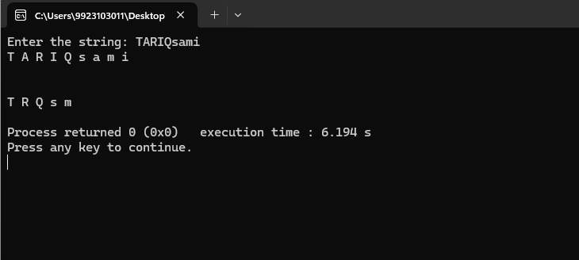

class node

{

public:

char data;

node* next;

node(char n)

{

data=n;

next=NULL;

}

};

node* create()

{

string n;

cout<<"Enter the string: ";

cin>>n;

vector<char> arr;

for(int i=0;i<n.length();i++)

{

arr.push_back(n[i]);

}

node* head=new node(arr[0]);

node* mover=head;

for(int i=1;i<n.length();i++)

{

node* temp=new node(arr[i]);

mover->next=temp;

mover=temp;

}

return head;

}

void removevowels(node* head)

{

vector<char> vowels;

vowels.push_back('a');

vowels.push_back('e');

vowels.push_back('i');

vowels.push_back('o');

vowels.push_back('u');

node* temp=head;

node* prev=NULL;

while(temp!=NULL)

{

if(find(vowels.begin(),vowels.end(),tolower(temp->data))!=vowels.end())

{

if(prev==NULL)

{

node* del=temp;

temp=temp->next;

head=del->next;

delete del;

}

else

{

node* del=temp;

temp=temp->next;

prev->next=del->next;

delete del;

}

}

else{

prev=temp;

temp=temp->next;

}

}

cout<<endl;

}

void display(node* head)

{

node* temp=head;

while(temp!=NULL)

{

cout<<temp->data<<" ";

temp=temp->next;

}

cout<<endl;

}

int main()

{

node* head=create();

display(head);

cout<<endl;

removevowels(head);

display(head);

}

Q3

class node

{

public:

char data;

node* next;

node(char n)

{

data=n;

next=NULL;

}

};

node* create(int n)

{

vector<char> arr;

char a;

for(int i=0;i<n;i++)

{

cout<<"Enter "<<i+1<<"character: ";

cin>>a;

arr.push_back(a);

}

node* head=new node(arr[0]);

node* mover=head;

for(int i=1;i<n.length();i++)

{

node* temp=new node(arr[i]);

mover->next=temp;

mover=temp;

}

return head;

}

void display(node* head)

{

node* temp=head;

while(temp!=NULL)

{

cout<<temp->data<<" ";

temp=temp->next;

}

cout<<endl;

}

int main()

{

node* list1=create(10);

node* list2=create(5);

}

Q4

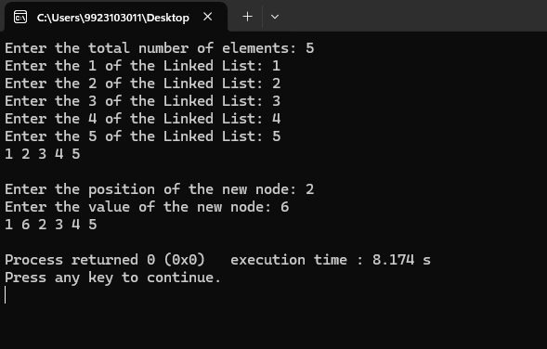

class node

{

public:

int data;

node* prev;

node* next;

node(int n)

{

data=n;

next=NULL;

}

};

node* create()

{

int n;

cout<<"Enter the total number of elements: ";

cin>>n;

vector<int>arr;

int ele;

for(int i=0;i<n;i++)

{

cout<<"Enter the "<<i+1<<" of the Linked List: ";

cin>>ele;

arr.push_back(ele);

}

node* head=new node(arr[0]);

node* mover=head;

for(int i=1;i<arr.size();i++)

{

node* temp=new node(arr[i]);

temp->prev=mover;

mover->next=temp;

mover=temp;

}

return head;

}

node* insertelement(node* head)

{

int n;

cout<<"Enter the position of the new node: ";

cin>>n;

int val;

cout<<"Enter the value of the new node: ";

cin>>val;

if(n==1)

{

node* temp=new node(val);

temp->next=head;

head->prev=temp;

head=temp;

return head;

}

node* temp=head;

int count=1;

while(temp!=NULL)

{

count++;

temp=temp->next;

if(count==n)

{

node* back=temp->prev;

node* newele=new node(val);

newele->prev=back;

newele->next=temp;

back->next=newele;

temp->prev=newele;

return head;

}

}

return head;

}

void display(node* head)

{

node* temp=head;

while(temp!=NULL)

{

cout<<temp->data<<" ";

temp=temp->next;

}

cout<<endl;

}

int main()

{

node* head=create();

display(head);

cout<<endl;

node* newhead=insertelement(head);

display(head);

}

Q5

class node

{

public:

int data;

node* prev;

node* next;

node(int n)

{

data=n;

next=NULL;

}

};

node* create()

{

int n;

cout<<"Enter the total number of elements: ";

cin>>n;

vector<int>arr;

int ele;

for(int i=0;i<n;i++)

{

cout<<"Enter the "<<i+1<<" of the Linked List: ";

cin>>ele;

arr.push_back(ele);

}

node* head=new node(arr[0]);

node* mover=head;

for(int i=1;i<arr.size();i++)

{

node* temp=new node(arr[i]);

temp->prev=mover;

mover->next=temp;

mover=temp;

}

return head;

}