**WEEK 1 LAB**

**MOHD TARIQ SAMI - 9923103011**

1. Write a C/C++ program to find the average of n numbers using arrays.

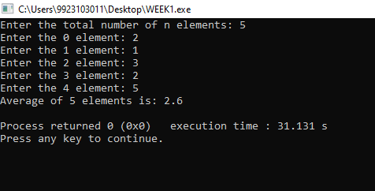

**#include <iostream>**

**using namespace std;**

**int main()**

**{**

**int n;**

**cout<<"Enter the total number of n elements: ";**

**cin>>n;**

**int *arr=new int[n];**

**float sum=0;**

**for(int i=0;i<n;i++)**

**{**

**cout<<"Enter the "<<i+1<<" element: ";**

**cin>>arr[i];**

**sum+=arr[i];**

**}**

**float avg=sum/n;**

**cout<<"Average of "<<n<<" elements is: "<<avg<<endl;**

**}**

1. Write a C/C++ program to find the frequency of each element in an array. Example: Input: array = {1, 2, 3, 5, 2, 9, 7, 3, 5}

Output: 1 occurs 1 times 2 occurs 2 times 3 occurs 2 times 5 occurs 2 times 7 occurs 1 times 9 occurs 1 times

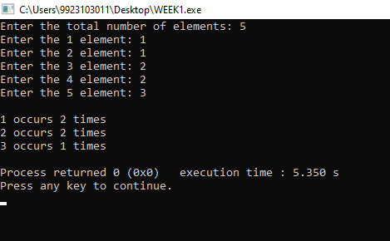

**int main()**

**{**

**int n;**

**cout<<"Enter the total number of elements: ";**

**cin>>n;**

**int *arr=new int[n];**

**map<int,int> m;**

**for(int i=0;i<n;i++)**

**{**

**cout<<"Enter the "<<i+1<<" element: ";**

**cin>>arr[i];**

**m[arr[i]]++;**

**}**

**cout<<endl;**

**map<int,int> ::iterator it=m.begin();**

**while(it!=m.end())**

**{**

**cout<<it->first<<" occurs "<<it->second<<" times"<<endl;**

**it++;**

**}**

**}**

1. Given an array, write a program in C/C++to left rotate the elements of the array by one. Example: Array

Elements before rotating: 1 2 3 4 5 6 7 Array Elements after rotating: 2 3 4 5 6 7 1

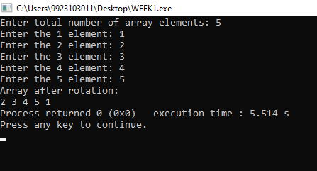

**int main()**

**{**

**int n;**

**cout<<"Enter total number of array elements: ";**

**cin>>n;**

**int *arr=new int[n];**

**for(int i=0;i<n;i++)**

**{**

**cout<<"Enter the "<<i+1<<" element: ";**

**cin>>arr[i];**

**}**

**int first=arr[0];**

**for(int i=0;i<n-1;i++)**

**{**

**arr[i]=arr[i+1];**

**}**

**arr[n-1]=first;**

**cout<<"Array after rotation: "<<endl;**

**for(int i=0;i<n;i++)**

**{**

**cout<<arr[i]<<" ";**

**}**

**}**

4. Write a C/C++ program to find the second smallest element in a one-dimensional array. Example: Input: Array size: 4 Elements: 32 54 -6 -15 Output:

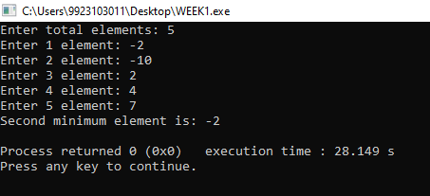

**int main()**

**{**

**int n;**

**int min=INT_MIN;**

**cout<<"Enter total elements: ";**

**cin>>n;**

**int *arr=new int[n];**

**for(int i=0;i<n;i++)**

**{**

**cout<<"Enter "<<i+1<<" element: ";**

**cin>>arr[i];**

**}**

**for(int i=0;i<n;i++)**

**{**

**for(int j=i;j<n;j++)**

**{**

**if(arr[j]<arr[i])**

**{**

**int temp=arr[i];**

**arr[i]=arr[j];**

**arr[j]=temp;**

**}**

**}**

**}**

**cout<<"Second minimum element is: "<<arr[1]<<endl;**

**}**

1. A dynamically created array stores following integer elements (odd and even integers). It is desired to print/display the elements of this array in such manner that it first prints all the even elements then it prints all the odd elements. Example: Input: 2 8 3 6 7 9 5 4 Output: 2 8 6 4 3 7 9

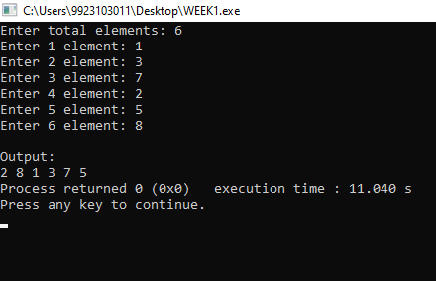

**int main()**

**{**

**int n;**

**cout<<"Enter total elements: ";**

**cin>>n;**

**int *arr=new int[n];**

**for(int i=0;i<n;i++)**

**{**

**cout<<"Enter "<<i+1<<" element: ";**

**cin>>arr[i];**

**}**

**cout<<endl<<"Output: "<<endl;**

**for(int i=0;i<n;i++)**

**{**

**if(arr[i]%2==0) cout<<arr[i]<<" ";**

**}**

**for(int i=0;i<n;i++)**

**{**

**if(arr[i]%2==1) cout<<arr[i]<<" ";**

**}**

**}**

1. Write a program without STL to create the dynamic array of user inputted length (n), assign values at different indices of the array, and as presented in above example, display the elements of this array. (Note: don’t enter the elements manually, rather use following statement in loop to randomly assign elements (in range between 0 and 99) in the array: A[i] = rand()%100, where A is an array).

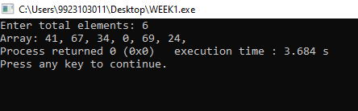

int main()

{

int n;

cout<<"Enter total elements: ";

cin>>n;

int *arr=new int[n];

for(int i=0;i<n;i++)

{

arr[i]=rand()%100;

}

cout<<"Array: ";

for(int i=0;i<n;i++)

{

cout<<arr[i]<<", ";

}

}

1. Considering that an integer variable, a float variable, a double variable, a character variable, and a pointer variable need 4, 4, 8, 1, and 8 bytes memory space respectively, what will be the output of following C++ programs
2. Size of o1: 4

Size of o2: 16

Size of abc is: 16

1. Size of o1 : 4

Size of o2 : 24

1. Size of o1 : 4

Size of o2 : 24

1. Size of o1 : 4

Size of o2 : 24

1. Size of o1 : 4

Size of o2 : 16

1. Size of o1 : 4

Size of o2 : 20

1. Analyze the correctness and output of following programs
2. 4.5
3. 5
4. 44
5. Error
6. 5
7. 4
8. 5
9. Garbage value