**DATA STRUCTURES LAB – 2024, week 0 b--------- MOHD TARIQ SAMI, 9923103011**

Q1

This code contains a class Sample with three member function declarations inside the class

That are defined outside the class and called through an object ‘obj’ inside the main function.

Yes, this code can be used as a skeleton as the member functions of the ‘sample’ class can be modified easily or replaced with new functionalities.

Q2

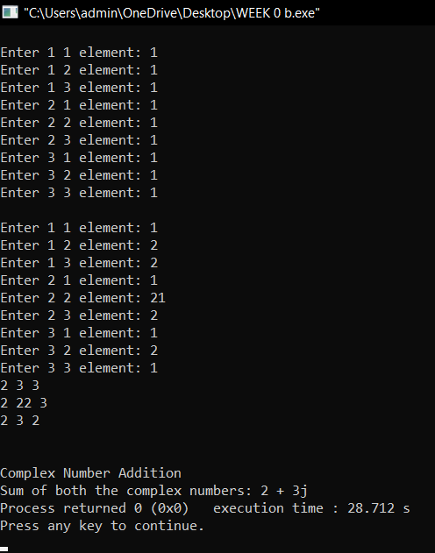

#include <iostream>

using namespace std;

class Complex

{

int r,i;

public:

Complex(){}

Complex(int real,int imag): r(real),i(imag){}

Complex operator+(Complex &a)

{

Complex temp(0,0);

temp.r=a.r+r;

temp.i=a.i+i;

return temp;

}

void display()

{

cout<<r<<" + "<<i<<"j";

}

};

class matrix

{

int n;

int **arr;

public:

matrix(){}

matrix(int size)

{

n=size;

arr=new int*[n];

for(int i=0;i<n;i++)

{

arr[i]=new int[n];

}

}

void input()

{

for(int i=0;i<n;i++)

{

for(int j=0;j<n;j++)

{

cout<<"Enter "<<i+1<<" "<<j+1<<" element: ";

cin>>arr[i][j];

}

}

}

matrix operator+(matrix &m)

{

matrix sum(n);

for(int i=0;i<n;i++)

{

for(int j=0;j<n;j++)

{

sum.arr[i][j]=(arr[i][j])+(m.arr[i][j]);

}

}

return sum;

}

void display()

{

for(int i=0;i<n;i++)

{

for(int j=0;j<n;j++)

{

cout<<arr[i][j]<<" ";

}

cout<<endl;

}

cout<<endl;

}

~matrix()

{

for(int i=0;i<n;i++)

{

delete [] arr[i];

}

delete []arr;

}

};

int main()

{

cout<<"Natural Numbers: "<<endl;

int num1,num2;

cout<<"Enter both the natural numbers: ";

cin>>num1>>num2;

cout<<"Sum is: "<<num1+num2<<endl;

cout<<"Addition of matrices: "<<endl;

matrix A(3);cout<<endl;

matrix B(3);

A.input();

cout<<endl;

B.input();

matrix C=A+B;

C.display();

cout<<endl<<"Complex Number Addition"<<endl;

Complex c1(1,2);

Complex c2(1,1);

Complex sum;

sum=c1+c2;

cout<<"Sum of both the complex numbers: ";

sum.display();

}

Q3

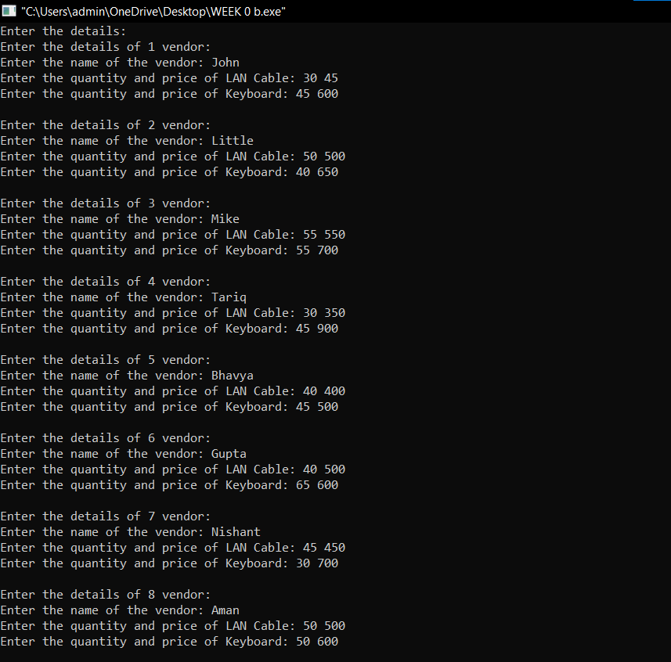

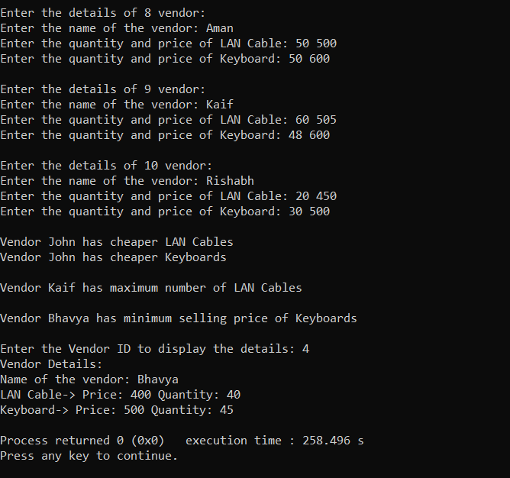

class vendor

{

string name;

int id,lp,kp,lq,kq;

public:

vendor(){}

void input(int n)

{

id=n;

cout<<"Enter the name of the vendor: ";

cin>>name;

cin.clear();

cin.ignore();

cout<<"Enter the quantity and price of LAN Cable: ";

cin>>lq>>lp;

cout<<"Enter the quantity and price of Keyboard: ";

cin>>kq>>kp;

}

void display()

{

cout<<"Name of the vendor: "<<name<<endl;

cout<<"LAN Cable-> Price: "<<lp<<" Quantity: "<<lq<<endl;

cout<<"Keyboard-> Price: "<<kp<<" Quantity: "<<kq<<endl;

}

friend void compare(vendor &v1,vendor &v2);

friend void maxLAN(vendor arr[]);

friend void minkeyboard(vendor arr[]);

};

void maxLAN(vendor arr[])

{

int max=INT_MIN;

string nn2;

for(int i=0;i<10;i++)

{

if((arr[i].lq)>max)

{

max=arr[i].lq;

nn2=arr[i].name;

}

}

cout<<"Vendor "<<nn2<<" has maximum number of LAN Cables"<<endl;

}

void minkeyboard(vendor arr[])

{

int min=INT_MAX;

string nn;

for(int i=0;i<10;i++)

{

if((arr[i].kp)<min)

{

min=arr[i].kp;

nn=arr[i].name;

}

}

cout<<"Vendor "<<nn<<" has minimum selling price of Keyboards"<<endl;

}

void compare(vendor &v1, vendor &v2)

{

if((v1.lq)>(v2.lq))

{

cout<<"Vendor "<<v2.name<<" has cheaper LAN Cables"<<endl;

}

else

{

cout<<"Vendor "<<v1.name<<" has cheaper LAN Cables"<<endl;

}

if((v1.kq)>(v2.kq))

{

cout<<"Vendor "<<v2.name<<" has cheaper Keyboards"<<endl;

}

else

{

cout<<"Vendor "<<v1.name<<" has cheaper Keyboards"<<endl;

}

}

int main()

{

vendor v[10];

cout<<"Enter the details: "<<endl;

for(int i=0;i<10;i++)

{

cout<<"Enter the details of "<<i+1<<" vendor: "<<endl;

v[i].input(i+1);

cout<<endl;

}

compare(v[0],v[7]);

cout<<endl;

maxLAN(v);

cout<<endl;

minkeyboard(v);

cout<<endl;

//display

int dd;

cout<<"Enter the Vendor ID to display the details: ";

cin>>dd;

cout<<"Vendor Details: "<<endl;

v[dd+1].display();

}

Q4

1. Error: x is private within the test class.
2. 1
3. Error: missing “ character
4. Error: stray ’/’ in program
5. Student’s Roll no.:0

Student’s Name: None

Student’s Percentage: 0

1. Size of per: 1