**15B17CI371 – Data Structures Lab**

**ODD 2024**

**Week 4-LAB A**

**Practice Lab**

**[CO: C270.2]**

**1. Write a program to find all occurrence of a key within a given array using**

**sequential search algorithm.**

**Test Case:**

**Input:**

**array = {16, 31, 15, 27, 9, 15, 39, 15, 17, 12}; Key: 15**

**Output:**

**Element found at index 2**

**Element found at index 5**

**Element found at index 7**

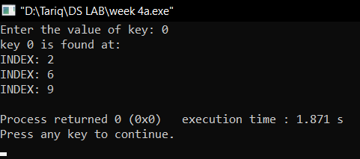

#include <iostream>

#include <bits/stdc++.h>

using namespace std;

int ssearch(int arr[],int n,int k)

{

vector<int> v;

for(int i=0;i<n;i++)

{

if(arr[i]==k)

{

v.push_back(i);

}

}

cout<<"key "<<k<<" is found at: "<<endl;

for(int i=0;i<v.size();i++)

{

cout<<"INDEX: "<<v[i]<<endl;

}

}

int main()

{

int arr[10]={7,10,0,2,4,6,0,5,2,0};

int n=sizeof(arr)/sizeof(arr[0]);

int k;

cout<<"Enter the value of key: ";

cin>>k;

ssearch(arr,n,k);

}

**2. Given an unsorted array and a number n, find if there exists a pair of**

**elements in the array whose product is given number n.**

**Input: arr[] = {5, 20, 3, 2, 50, 80}, n = 150**

**Output: Pair Found: (3, 50)**

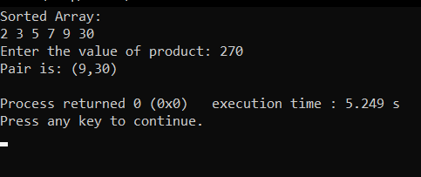

int part(int arr[],int low,int high)

{

int i=low;

int j=high;

int pivot=arr[low];

while(i<j)

{

while(arr[i]<=pivot && i<=high)

{

i++;

}

while(arr[j]>pivot && j>=low)

{

j--;

}

if(i<j)

{

swap(arr[i],arr[j]);

}

}

swap(arr[low],arr[j]);

return j;

}

void quicksort(int arr[],int low,int high)

{

if(low<high)

{

int p=part(arr,low,high);

quicksort(arr,low,p-1);

quicksort(arr,p+1,high);

}

}

void prod(int arr[],int n)

{

int p;

cout<<"Enter the value of product: ";

cin>>p;

int low=0;

int high=n-1;

while(low<=high)

{

int val=arr[low]*arr[high];

if(val==p)

{

cout<<"Pair is: ("<<arr[low]<<","<<arr[high]<<")"<<endl;

exit(0);

}

else if(p<val)

{

high--;

}

else

{

low++;

}

}

}

int main()

{

int arr[6]={30,3,2,5,7,9};

int n=sizeof(arr)/sizeof(arr[0]);

quicksort(arr,0,n-1);

cout<<"Sorted Array: "<<endl;

for(int i=0;i<6;i++)

{

cout<<arr[i]<<" ";

}

cout<<endl;

prod(arr,n);

}

**3. Given an unsorted array of integers, sort the array into a wave-like array.**

**An array arr[] is in wave form if arr[0] >= arr[1] <= arr[2] >= arr[3] <= arr[4]**

**>=...**

**Input: arr[] = {10, 90, 49, 2, 1, 5, 23}**

**Output: Pair Found: (10, 2, 90, 1, 49, 5, 23)**

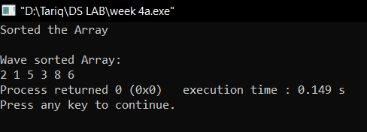

int part(int arr[],int low,int high)

{

int i=low;

int j=high;

int pivot=arr[low];

while(i<j)

{

while(arr[i]<=pivot && i<=high)

{

i++;

}

while(arr[j]>pivot && j>=low)

{

j--;

}

if(i<j)

{

swap(arr[i],arr[j]);

}

}

swap(arr[low],arr[j]);

return j;

}

void quicksort(int arr[],int low,int high)

{

if(low<high)

{

int p=part(arr,low,high);

quicksort(arr,low,p-1);

quicksort(arr,p+1,high);

}

}

int main()

{

int arr[6]={5,1,2,8,3,6};

int n=sizeof(arr)/sizeof(arr[0]);

quicksort(arr,0,n-1);

cout<<"Sorted the Array"<<endl;

cout<<endl;

for(int i=0;i<n-1;i=i+2)

{

/*cout<<arr[i]<<" ";*/

int temp=arr[i];

arr[i]=arr[i+1];

arr[i+1]=temp;

}

cout<<"Wave sorted Array: "<<endl;

for(int i=0;i<n;i++)

{

cout<<arr[i]<<" ";

}

}

**4. Perform the above-mentioned questions using binary and interpolation search**

**techniques as well. Try to figure out the differences not only in the algorithms**

**but also in the number of iterations, number of swaps, etc.**

**Q1**

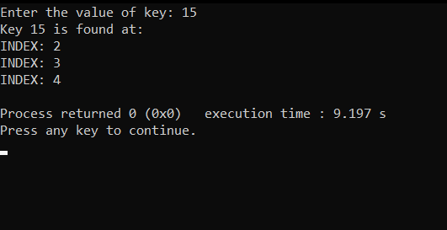

int binarySearch(int arr[], int low, int high, int k, bool findFirst) {

int result = -1;

while (low <= high) {

int mid = low + (high - low) / 2;

if (arr[mid] == k) {

result = mid;

if (findFirst) {

high = mid - 1;

} else {

low = mid + 1;

}

} else if (arr[mid] < k) {

low = mid + 1;

} else {

high = mid - 1;

}

}

return result;

}

void findAllOccurrences(int arr[], int n, int k) {

int first = binarySearch(arr, 0, n - 1, k, true);

if (first == -1) {

cout << "Key " << k << " is not found." << endl;

return;

}

int last = binarySearch(arr, 0, n - 1, k, false);

cout << "Key " << k << " is found at: " << endl;

for (int i = first; i <= last; ++i) {

if (arr[i] == k) {

cout << "INDEX: " << i << endl;

}

}

}

int main() {

int arr[10] = {16, 31, 15, 27, 9, 15, 39, 15, 17, 12};

int n = sizeof(arr) / sizeof(arr[0]);

sort(arr, arr + n);

int k;

cout << "Enter the value of key: ";

cin >> k;

findAllOccurrences(arr, n, k);

return 0;

}

Q2

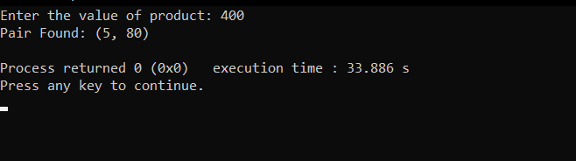

bool binarySearch(int arr[], int low, int high, int target) {

while (low <= high) {

int mid = low + (high - low) / 2;

if (arr[mid] == target) {

return true;

} else if (arr[mid] < target) {

low = mid + 1;

} else {

high = mid - 1;

}

}

return false;

}

void findPairWithProduct(int arr[], int n, int product) {

sort(arr, arr + n);

for (int i = 0; i < n; i++) {

if (product % arr[i] == 0) {

int complement = product / arr[i];

if (binarySearch(arr, 0, n - 1, complement)) {

cout << "Pair Found: (" << arr[i] << ", " << complement << ")" << endl;

return;

}

}

}

cout << "No pair found with product " << product << endl;

}

int main() {

int arr[] = {5, 20, 3, 2, 50, 80};

int n = sizeof(arr) / sizeof(arr[0]);

int product;

cout << "Enter the value of product: ";

cin >> product;

findPairWithProduct(arr, n, product);

return 0;

}