**15B17CI371 – Data Structures Lab**

**ODD 2024**

**Week 7-LAB B**

**Practice Lab**

**1.    Given an array,create a BST. Display in the following manner:**

**i.          Breadth-first traversal(level-order traversal)**

**ii.          Depth-First traversal(In-,pre-,post-order traversals)**

#include <iostream>

using namespace std;

class node

{

public:

int data;

node* left;

node* right;

node(int val)

{

data=val;

left=nullptr;

right=nullptr;

}

};

node* insertBST(node* root,int key)

{

if(root==NULL)

{

return new node(key);

}

if(root->data==key)

{

return root;

}

else if(root->data>key)

{

root->left=insertBST(root->left,key);

}

else

{

root->right=insertBST(root->right,key);

}

return root;

}

void inorder(node* root)

{

if(root!=NULL)

{

inorder(root->left);

cout<<root->data<<" ";

inorder(root->right);

}

}

void preorder(node* root)

{

if(root!=NULL)

{

cout<<root->data<<" ";

preorder(root->left);

preorder(root->right);

}

}

void postorder(node* root)

{

if(root!=NULL)

{

postorder(root->left);

postorder(root->right);

cout<<root->data<<" ";

}

}

int height(node* node) {

if (node == NULL)

return 0;

else {

int lheight = height(node->left);

int rheight = height(node->right);

return (lheight > rheight) ? (lheight + 1) :

(rheight + 1);

}

}

void printCurrentLevel(node* root, int level) {

if (root == NULL)

return;

if (level == 1)

cout << root->data << " ";

else if (level > 1) {

printCurrentLevel(root->left, level - 1);

printCurrentLevel(root->right, level - 1);

}

}

void printLevelOrder(node* root) {

int h = height(root);

for (int i = 1; i <= h; i++)

printCurrentLevel(root, i);

}

int main()

{

node* root=new node(7);

root=insertBST(root,3);

root=insertBST(root,2);

root=insertBST(root,5);

root=insertBST(root,6);

root=insertBST(root,1);

root=insertBST(root,0);

cout<<"Inorder: "<<endl;

inorder(root);cout<<endl;

cout<<"Preorder: "<<endl;

preorder(root);cout<<endl;

cout<<"Postorder: "<<endl;

postorder(root);cout<<endl;

cout<<"Level Order: "<<endl;

printLevelOrder(root);

}

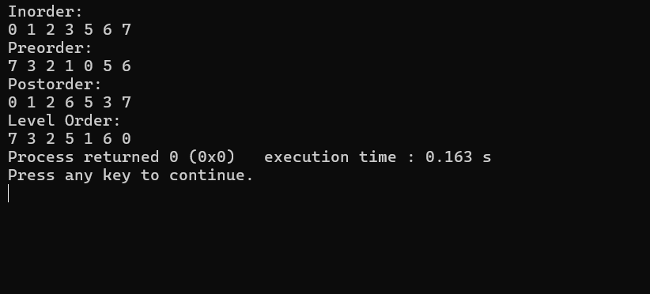

**2.    Given an integer n,return *all the structurally unique*BST'*s,which has exactly*n*nodes of unique values from* 1 *to* n. Return the answer in any order.**

**Input: n=3**

**Output: 5**

**Justification: [1,null,2,null],**

**[1,null,3,2],**

**[2,1,3],**

**[3,1,,null,null,2],**

**[3,2,null,1]**

#include <iostream>

#include <vector>

using namespace std;

struct TreeNode

{

int val;

TreeNode* left;

TreeNode* right;

TreeNode(int x) : val(x),left(NULL),right(NULL) {}

};

vector<TreeNode*> generateTrees(int start,int end)

{

vector<TreeNode*> trees;

if(start>end)

{

trees.push_back(nullptr);

return trees;

}

for(int i=start; i<=end; i++)

{

vector<TreeNode*> leftTrees=generateTrees(start,i-1);

vector<TreeNode*> rightTrees=generateTrees(i+1,end);

for(TreeNode* left : leftTrees)

for(TreeNode* right : rightTrees)

{

TreeNode* root=new TreeNode(i);

root->left=left;

root->right=right;

trees.push_back(root);

}

}

return trees;

}

vector<TreeNode*> generateTrees(int n)

{

if(n==0) return {};

return generateTrees(1,n);

}

void printPreorder(TreeNode* root)

{

if(!root)

{

cout<<"null";

return;

}

cout<<root->val<<" ";

printPreorder(root->left);

printPreorder(root->right);

}

int main()

{

int n;

cout<<"Input the value of n : ";

cin>>n;

vector<TreeNode*> result=generateTrees(n);

for(TreeNode* tree:result)

{

printPreorder(tree);

cout<<endl;

}

}

**Output :**

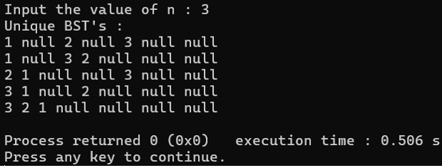

**3.    Definition of Lowest Common Ancestor(LCA): Let ‘*T’* be a rooted tree. The lowest common ancestor between two nodes ‘*n1’* and *‘n2’* is defined as the lowest node in *‘T’* that has both *‘n1’* and *‘n2’* as descendants(where we allow a node to be a descendant of itself). The LCA of *‘n1’* and *‘n2’* in *‘T’* is the shared ancestor of *‘n1’* and *‘n2’* that is located farthest from the root [i.e.,closest to *‘n1’* and *‘n2’*].**

|  |  |
| --- | --- |
|  | **Input:**  **root= [6,2,8,0,4,7,9,null,null,3,5]**  **p=2,q=8**  **Output: 6**  **Explanation: LCA of nodes 2,8 is 6.** |

**Assumption: Node may be a descendant of itself.**

#include <iostream>

using namespace std;

struct TreeNode

{

int val;

TreeNode* left;

TreeNode* right;

TreeNode(int x) : val(x),left(NULL),right(NULL) {}

};

TreeNode* lowestCommonAncestor(TreeNode* root,TreeNode* p,TreeNode* q)

{

if(!root||root==p||root==q)

return root;

TreeNode* left=lowestCommonAncestor(root->left,p,q);

TreeNode* right=lowestCommonAncestor(root->right,p,q);

if(left && right)

return root;

return left?left:right;

}

TreeNode* insertLevelOrder(int arr[],TreeNode* root,int i,int n)

{

if(i<n)

{

TreeNode* temp=new TreeNode(arr[i]);

root=temp;

root->left=insertLevelOrder(arr,root->left,2*i+1,n);

root->right=insertLevelOrder(arr,root->right,2*i+2,n);

}

return root;

}

TreeNode* findNode(TreeNode* root,int val)

{

if(!root||root->val==val)

return root;

TreeNode* leftSearch=findNode(root->left,val);

if(leftSearch)

return leftSearch;

return findNode(root->right,val);

}

int main()

{

int n,n1,n2;

cout<<"Input the number of nodes : ";

cin>>n;

int arr[n];

cout<<"Input the node values : ";

for(int i=0;i<n;i++)

cin>>arr[i];

cout<<"Input the value of node n1 : ";

cin>>n1;

cout<<"Input the value of node n2 : ";

cin>>n2;

TreeNode* root=insertLevelOrder(arr,root,0,n);

TreeNode* p=findNode(root,n1);

TreeNode* q=findNode(root,n2);

TreeNode* lca=lowestCommonAncestor(root,p,q);

if(lca)

cout<<"LCA: "<<lca->val;

else

cout<<"LCA not found";

}

**Outptut :**

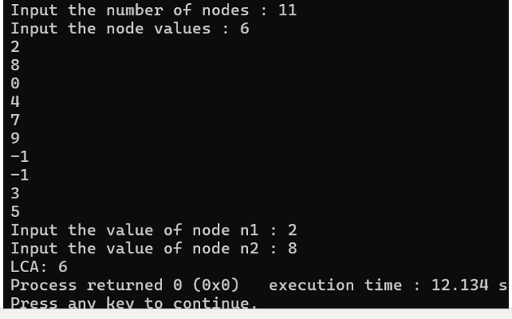

4.    Given a list that depicts the in-order traversal of a binary tree,develop the binary search tree itself. Example: “gdhbeiafjc” is the in-order traversal for the BST:

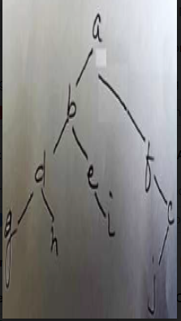

#include <iostream>

#include <string>

using namespace std;

struct TreeNode

{

char val;

TreeNode* left;

TreeNode* right;

TreeNode(char x):val(x),left(NULL),right(NULL) {}

};

TreeNode* buildTreeFromInorder(string& inorder,int start,int end)

{

if(start>end)

return nullptr;

int mid=(start+end)/2;

TreeNode* root=new TreeNode(inorder[mid]);

root->left=buildTreeFromInorder(inorder,start,mid-1);

root->right=buildTreeFromInorder(inorder,mid+1,end);

return root;

}

void printInorder(TreeNode* root)

{

if(!root)

return;

printInorder(root->left);

cout<<root->val<<" ";

printInorder(root->right);

}

int main()

{

string inorder="abcdefghij";

int n=inorder.size();

TreeNode* root=buildTreeFromInorder(inorder,0,n-1);

cout<<"In-order traversal of the constructed BST : ";

printInorder(root);

}

**Output :**

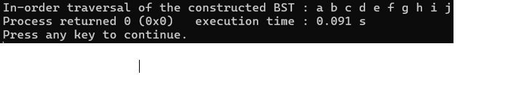

**Virtual Labs**



