Sukkur IBA University


Data Structure Algorithm

Name: Tariq Mehmood
CMS ID: 023-23-0127
Semester: 3rd
Section: E
Submitted by: Sir Riaz Hussain
Lab No: 07

Q1
public class TestSorting {

public static void main(String[] args) {
int[] descendingArray = {9, 8, 7, 6, 5, 4, 3, 2, 1};
int[] almostSortedArray = {1, 2, 3, 4, 6, 5, 7, 8, 9};

System.out.println("Sorting Descending Array:");
int[] arrayToSort = new int[descendingArray.length];

System.arraycopy(descendingArray, 0, arrayToSort, 0, descendingArray.length);
bubbleSort(arrayToSort);
printArray(arrayToSort);

System.arraycopy(descendingArray, 0, arrayToSort, 0, descendingArray.length);
selectionSort(arrayToSort);
printArray(arrayToSort);

System.arraycopy(descendingArray, 0, arrayToSort, 0, descendingArray.length);
insertionSort(arrayToSort);
printArray(arrayToSort);

System.out.println("\nSorting Almost Sorted Array:");
arrayToSort = new int[almostSortedArray.length];

System.arraycopy(almostSortedArray, 0, arrayToSort, 0, almostSortedArray.length);
bubbleSort(arrayToSort);
printArray(arrayToSort);

System.arraycopy(almostSortedArray, 0, arrayToSort, 0, almostSortedArray.length);
selectionSort(arrayToSort);
printArray(arrayToSort);

System.arraycopy(almostSortedArray, 0, arrayToSort, 0, almostSortedArray.length);
insertionSort(arrayToSort);
printArray(arrayToSort);
}

public static void bubbleSort(int[] array) {
int n = array.length;
for (int i = 0; i < n - 1; i++) {
for (int j = 0; j < n - i - 1; j++) {
if (array[j] > array[j + 1]) {
int temp = array[j];
array[j] = array[j + 1];
array[j + 1] = temp;
}
}
}
}

public static void selectionSort(int[] array) {
int n = array.length;
for (int i = 0; i < n - 1; i++) {
int minIndex = i;
for (int j = i + 1; j < n; j++) {
if (array[j] < array[minIndex]) {
minIndex = j;
}
}
int temp = array[minIndex];
array[minIndex] = array[i];
array[i] = temp;
}
}

public static void insertionSort(int[] array) {
int n = array.length;
for (int i = 1; i < n; i++) {
int key = array[i];
int j = i - 1;
while (j >= 0 && array[j] > key) {
array[j + 1] = array[j];
j--;
}
array[j + 1] = key;
}
}

public static void printArray(int[] array) {
for (int i : array) {
System.out.print(i + " ");
}
System.out.println();
}
}

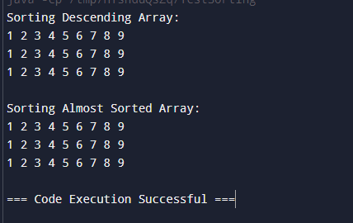

Q2
public class Task2 {

public static void main(String[] args) {
int[] array1 = {5, 8, 12, 1, 7};
int[] array2 = {4, 9, 3, 15, 6};

System.out.println("Array 1: ");
printArray(array1);

System.out.println("Array 2: ");
printArray(array2);

int[] mergedArray = new int[array1.length + array2.length];

for (int i = 0; i < array1.length; i++) {
mergedArray[i] = array1[i];
}

for (int i = 0; i < array2.length; i++) {
mergedArray[array1.length + i] = array2[i];
}

sortArray(mergedArray);

System.out.println("Merged and Sorted Array: ");
printArray(mergedArray);
}

public static void printArray(int[] array) {
for (int i = 0; i < array.length; i++) {
System.out.print(array[i] + " ");
}
System.out.println();
}

public static void sortArray(int[] array) {
for (int i = 0; i < array.length - 1; i++) {
for (int j = 0; j < array.length - i - 1; j++) {
if (array[j] > array[j + 1]) {
int temp = array[j];
array[j] = array[j + 1];
array[j + 1] = temp;
}
}
}
}
}
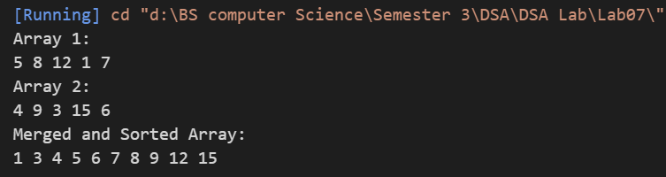
Q3
class Student{
String name;
String cmsid;
double gpa;
Student(String name,String cmsid,double gpa){
this.name=name;
this.cmsid=cmsid;
this.gpa=gpa;
}
void print(){
System.out.println("Name :"+name+" CMS ID :"+cmsid+" GPA :"+gpa);
}
}
public class Task3{
public static void main(String[] args) {
Student []student=new Student[3];
student[0]=new Student("Tariq","23-023-0127",3.8);
student[1]=new Student("Asad","23-023-0128",3.9);
student[2]=new Student("GMM","23-023-0129",4.0);
for(int i=0; i<student.length; i++){
student[i].print();
}
TopperOrder(student);
System.out.println("In Topper Order");
for(int i=0; i<student.length; i++){
student[i].print();
}

}
public static void TopperOrder(Student student[]){
for (int i=0; i<student.length-1; i++){
for(int j=0;j<student.length-i-1; j++){
if(student[j].gpa<student[j+1].gpa){
Student temp=student[j];
student[j]=student[j+1];
student[j+1]=temp;
}
}
}

}
}
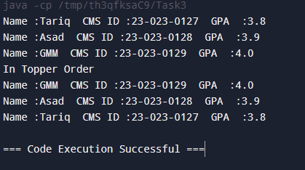
Q4
class Node {
int data;
Node next;

Node(int data) {
this.data = data;
this.next = null;
}
}

class LinkedList {
Node head;

public void insert(int data) {
Node newNode = new Node(data);
if (head == null) {
head = newNode;
return;
}
Node current = head;
while (current.next != null) {
current = current.next;
}
current.next = newNode;
}

public void printList() {
Node current = head;
while (current != null) {
System.out.print(current.data + " -> ");
current = current.next;
}
System.out.println("null");
}

public void insertionSort() {
if (head == null) {
return;
}
Node sorted = null;
Node current = head;
while (current != null) {
Node next = current.next;
sorted = sortedInsert(sorted, current);
current = next;
}
head = sorted;
}

private Node sortedInsert(Node sorted, Node newNode) {
if (sorted == null || sorted.data >= newNode.data) {
newNode.next = sorted;
return newNode;
} else {
Node current = sorted;
while (current.next != null && current.next.data < newNode.data) {
current = current.next;
}
newNode.next = current.next;
current.next = newNode;
}
return sorted;
}
}

public class Task4 {
public static void main(String[] args) {
LinkedList list = new LinkedList();
list.insert(4);
list.insert(2);
list.insert(5);
list.insert(1);
list.insert(3);

System.out.println("Linked list before sorting:");
list.printList();

list.insertionSort();

System.out.println("Linked list after sorting:");
list.printList();
}
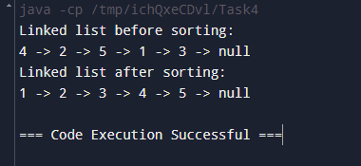
}

Q5
public class Task5 {
public static String reconstructSentence(String s) {
String[] words = new String[9];
int wordCount = 0;

// Manually split the sentence into words
for (int i = 0; i < s.length(); i++) {
StringBuilder word = new StringBuilder();
while (i < s.length() && s.charAt(i) != ' ') {
word.append(s.charAt(i));
i++;
}
if (word.length() > 0) {
words[wordCount++] = word.toString();
}
}

// Bubble sort to sort words based on the last character (index)
for (int i = 0; i < wordCount - 1; i++) {
for (int j = 0; j < wordCount - 1 - i; j++) {
if (words[j].charAt(words[j].length() - 1) > words[j + 1].charAt(words[j + 1].length() - 1)) {
String temp = words[j];
words[j] = words[j + 1];
words[j + 1] = temp;
}
}
}

// Build the original sentence
StringBuilder originalSentence = new StringBuilder();
for (int i = 0; i < wordCount; i++) {
// Remove the last character (index) from each word
for (int j = 0; j < words[i].length() - 1; j++) {
originalSentence.append(words[i].charAt(j));
}
if (i < wordCount - 1) {
originalSentence.append(" ");
}
}

return originalSentence.toString();
}

public static void main(String[] args) {
String shuffledSentence = "sentence4 a3 is2 This1";
String originalSentence = reconstructSentence(shuffledSentence);
System.out.println(originalSentence);
}
}
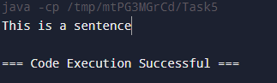
Q7
public class Task7{
public static void main(String[] args) {
int A[]={1,2,3,4,5,6};
int O[]=new int[A.length];
for(int i:A){
System.out.print(i+" ");
}
System.out.println();
int even=0, odd=1;
for(int i=0; i<A.length; i++){
if(A[i]%2==0){
O[even]=A[i];
even=even+2;
}
else{
O[odd]=A[i];
odd=odd+2;
}
}
System.out.println("Arrange order Even elements on Even index @ odd Elements on odd index ");
for(int i:O){
System.out.print(i+" ");
}
}
}
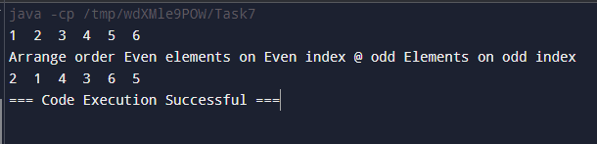
Q9
class Node {
int data;
Node next;
Node (int data) {
this.data = data;
this.next = null;
}
}

public class Task9 {
Node head1;
Node head2;
Node head3;

public void addtoFrontL1(int data) {
Node newNode = new Node(data);
if (head1 == null) {
head1 = newNode;
} else {
newNode.next = head1;
head1 = newNode;
}
}

public void addtoFrontL2(int data) {
Node newNode = new Node(data);
if (head2 == null) {
head2 = newNode;
} else {
newNode.next = head2;
head2 = newNode;
}
}

public void mergeLists() {
Node temp1 = head1;
Node temp2 = head2;
Node tail = null;

while (temp1 != null && temp2 != null) {
Node newNode;
if (temp1.data <= temp2.data) {
newNode = new Node(temp1.data);
temp1 = temp1.next;
} else {
newNode = new Node(temp2.data);
temp2 = temp2.next;
}

if (head3 == null) {
head3 = newNode;
tail = head3;
} else {
tail.next = newNode;
tail = newNode;
}
}

while (temp1 != null) {
Node newNode = new Node(temp1.data);
tail.next = newNode;
tail = newNode;
temp1 = temp1.next;
}

while (temp2 != null) {
Node newNode = new Node(temp2.data);
tail.next = newNode;
tail = newNode;
temp2 = temp2.next;
}
}

public void displayMerged() {
if (head3 == null) {
System.out.println("Merged list is empty");
return;
}
Node temp = head3;
while (temp != null) {
System.out.print(temp.data + " > ");
temp = temp.next;
}
System.out.println("null");
}

public static void main(String[] args) {
Task9 list = new Task9();
list.addtoFrontL1(5);
list.addtoFrontL1(20);
list.addtoFrontL1(15);
list.addtoFrontL2(10);
list.addtoFrontL2(30);
list.addtoFrontL2(25);
list.mergeLists();
list.displayMerged();
}
}

