DATABASE SYSTEMS LAB
Project Proposal

Project Title:
SkillMatch: A Relational Platform for Skill-Based Recruitment and Candidate Evaluation

Submitted By: | Tariq Jamil
Class / Group: | BCS (Group-A), 4th Semester
Submitted To: | Sir Ali Hassan
Date: | May 6, 2026

Database Systems Lab | BCS Group-A

Version Control
The following table tracks all versions and milestones of this project proposal.
Version | Milestone | Date | Author | Remarks
1.0 | Initial Project Proposal | May 6, 2026 | Tariq Jamil | First Draft
1.1 | ERD & Schema Design | — | — | —
1.2 | Final Submission | — | — | —

Entity Relationship Diagram (ERD)
The diagram below illustrates all entities in the SkillMatch database and their relationships. Junction tables (USER_SKILL, TEST_RESULT, APPLICATION) resolve many-to-many associations.
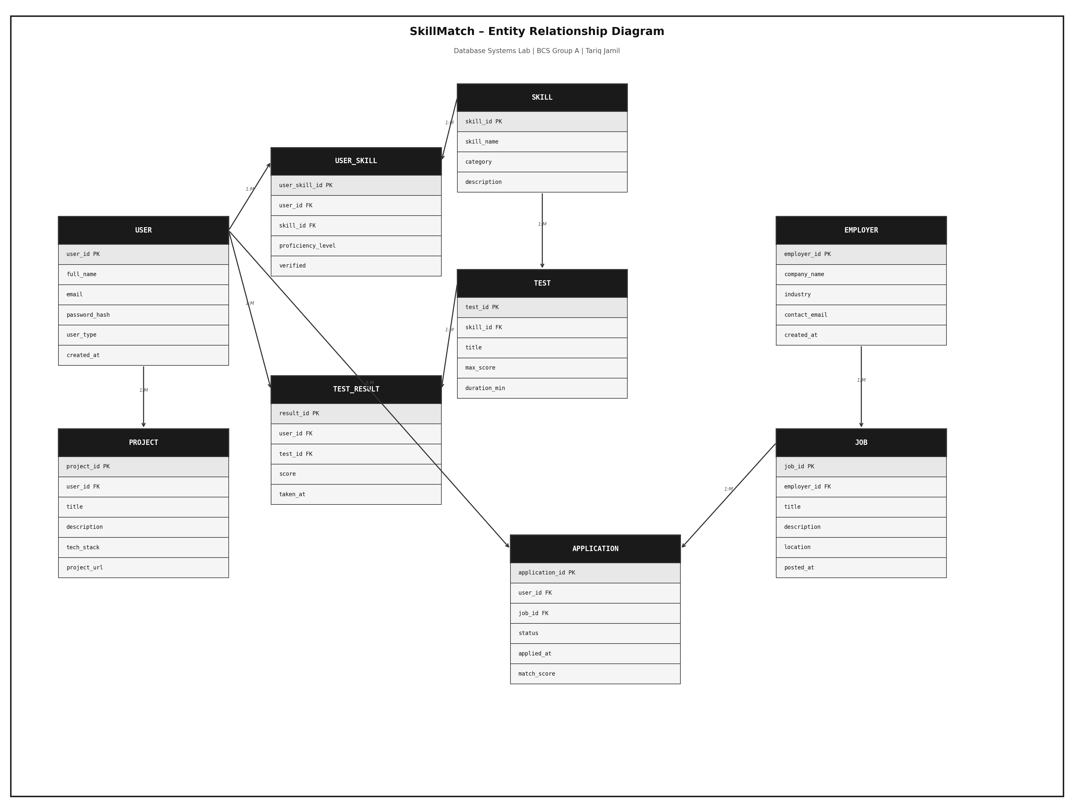
Figure 1 – SkillMatch Entity Relationship Diagram

1. Schema Description
This section describes all relational tables in the SkillMatch database, including their primary keys, foreign keys, attributes, and purposes.

Table: USER
Stores all registered users. The user_type field distinguishes candidates from employers.
Field | Type / Constraint | Description
user_id | INT, PRIMARY KEY, AUTO_INCREMENT | Unique identifier
full_name | VARCHAR(100), NOT NULL | Candidate or employer full name
email | VARCHAR(150), UNIQUE, NOT NULL | Login credential
password_hash | VARCHAR(255), NOT NULL | Bcrypt-hashed password
user_type | ENUM('candidate','employer') | Role discriminator
created_at | DATETIME, DEFAULT NOW() | Account creation timestamp

Table: SKILL
Master catalog of all skills recognized by the platform.
Field | Type / Constraint | Description
skill_id | INT, PRIMARY KEY, AUTO_INCREMENT | Unique identifier
skill_name | VARCHAR(100), UNIQUE, NOT NULL | Standardized skill label (e.g., Python)
category | VARCHAR(80) | Domain (e.g., Backend, Design)
description | TEXT | Optional detail about the skill

Table: USER_SKILL
Junction table resolving the Many-to-Many relationship between USER and SKILL.
Field | Type / Constraint | Description
user_skill_id | INT, PRIMARY KEY, AUTO_INCREMENT | Unique identifier
proficiency_level | ENUM('beginner','intermediate','expert') | Self-reported or verified level
verified | BOOLEAN, DEFAULT FALSE | True once a test has been passed
user_id | INT, FOREIGN KEY → USER(user_id) | References USER(user_id)
skill_id | INT, FOREIGN KEY → SKILL(skill_id) | References SKILL(skill_id)

Table: PROJECT
Portfolio entries owned by a candidate user.
Field | Type / Constraint | Description
project_id | INT, PRIMARY KEY, AUTO_INCREMENT | Unique identifier
title | VARCHAR(200), NOT NULL | Project display name
description | TEXT | Summary of work done
tech_stack | VARCHAR(255) | Comma-separated technologies used
project_url | VARCHAR(500) | GitHub or live link
user_id | INT, FOREIGN KEY → USER(user_id) | References USER(user_id)

Table: TEST
Assessment definitions tied to a specific skill.
Field | Type / Constraint | Description
test_id | INT, PRIMARY KEY, AUTO_INCREMENT | Unique identifier
title | VARCHAR(200), NOT NULL | Test name
max_score | INT, DEFAULT 100 | Maximum achievable score
duration_min | INT | Allowed time in minutes
skill_id | INT, FOREIGN KEY → SKILL(skill_id) | References SKILL(skill_id)

Table: TEST_RESULT
Records each attempt a user makes on a test.
Field | Type / Constraint | Description
result_id | INT, PRIMARY KEY, AUTO_INCREMENT | Unique identifier
score | DECIMAL(5,2) | Score achieved by the candidate
taken_at | DATETIME, DEFAULT NOW() | Timestamp of submission
user_id | INT, FOREIGN KEY → USER(user_id) | References USER(user_id)
test_id | INT, FOREIGN KEY → TEST(test_id) | References TEST(test_id)

Table: EMPLOYER
Employer profiles distinct from general USER records.
Field | Type / Constraint | Description
employer_id | INT, PRIMARY KEY, AUTO_INCREMENT | Unique identifier
company_name | VARCHAR(150), NOT NULL | Registered company name
industry | VARCHAR(100) | Sector or domain
contact_email | VARCHAR(150), UNIQUE | Official contact address
created_at | DATETIME, DEFAULT NOW() | Profile creation date

Table: JOB
Job postings published by employers.
Field | Type / Constraint | Description
job_id | INT, PRIMARY KEY, AUTO_INCREMENT | Unique identifier
title | VARCHAR(200), NOT NULL | Job designation
description | TEXT | Full job description
location | VARCHAR(150) | Remote or city name
posted_at | DATETIME, DEFAULT NOW() | Listing date
employer_id | INT, FOREIGN KEY → EMPLOYER(employer_id) | References EMPLOYER(employer_id)

Table: APPLICATION
Junction table resolving the Many-to-Many relationship between USER and JOB.
Field | Type / Constraint | Description
application_id | INT, PRIMARY KEY, AUTO_INCREMENT | Unique identifier
status | ENUM('pending','reviewed','accepted','rejected') | Current state of the application
applied_at | DATETIME, DEFAULT NOW() | Submission timestamp
match_score | DECIMAL(5,2) | Algorithmic compatibility score
user_id | INT, FOREIGN KEY → USER(user_id) | References USER(user_id)
job_id | INT, FOREIGN KEY → JOB(job_id) | References JOB(job_id)

Proposed Technology Stack
Component | Technology
Frontend | React.js (Vite)
Backend | Node.js / Express.js or FastAPI
Database | MySQL
Authentication | JWT (JSON Web Tokens)
Security | Bcrypt (password hashing)

