|  |  |  |  |  |  |  |  |  |
| --- | --- | --- | --- | --- | --- | --- | --- | --- |
| **Sukkur IBA University**  **Software Design Specification (SDS)**  **For**  **A Web-based Final Year Project (FYP) Management System**  **Version 1.4**   |  |  | | --- | --- | | **Project Code** | **F17133** | | **Supervisor** | **Sir Khalid Hussain** | | **Project Team** | **Suhail Ahmed**  **Tarique Hassan**  **Muhammad Ahsan** | | **Submission Date** |  | |

|  |  |
| --- | --- |
| *Project Code* |  |
| *Supervisor* |  |
| *Co-Supervisor* |  |
| *Project Manager* |  |
| *Project Team* |  |
| *Submission Date* |  |

1. Introduction of Design Document

2. Entity Relationship Diagram (ERD)

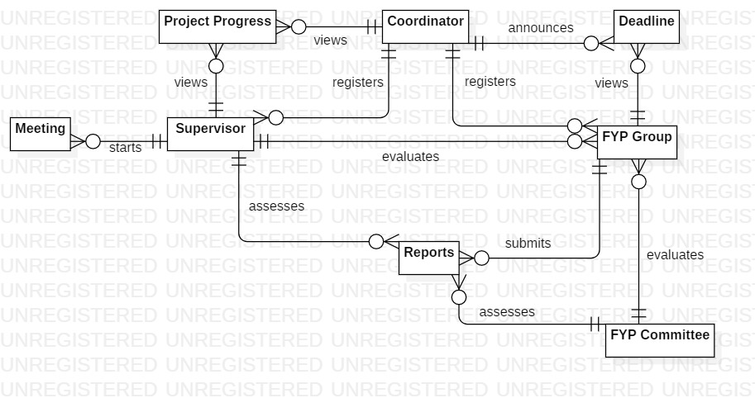

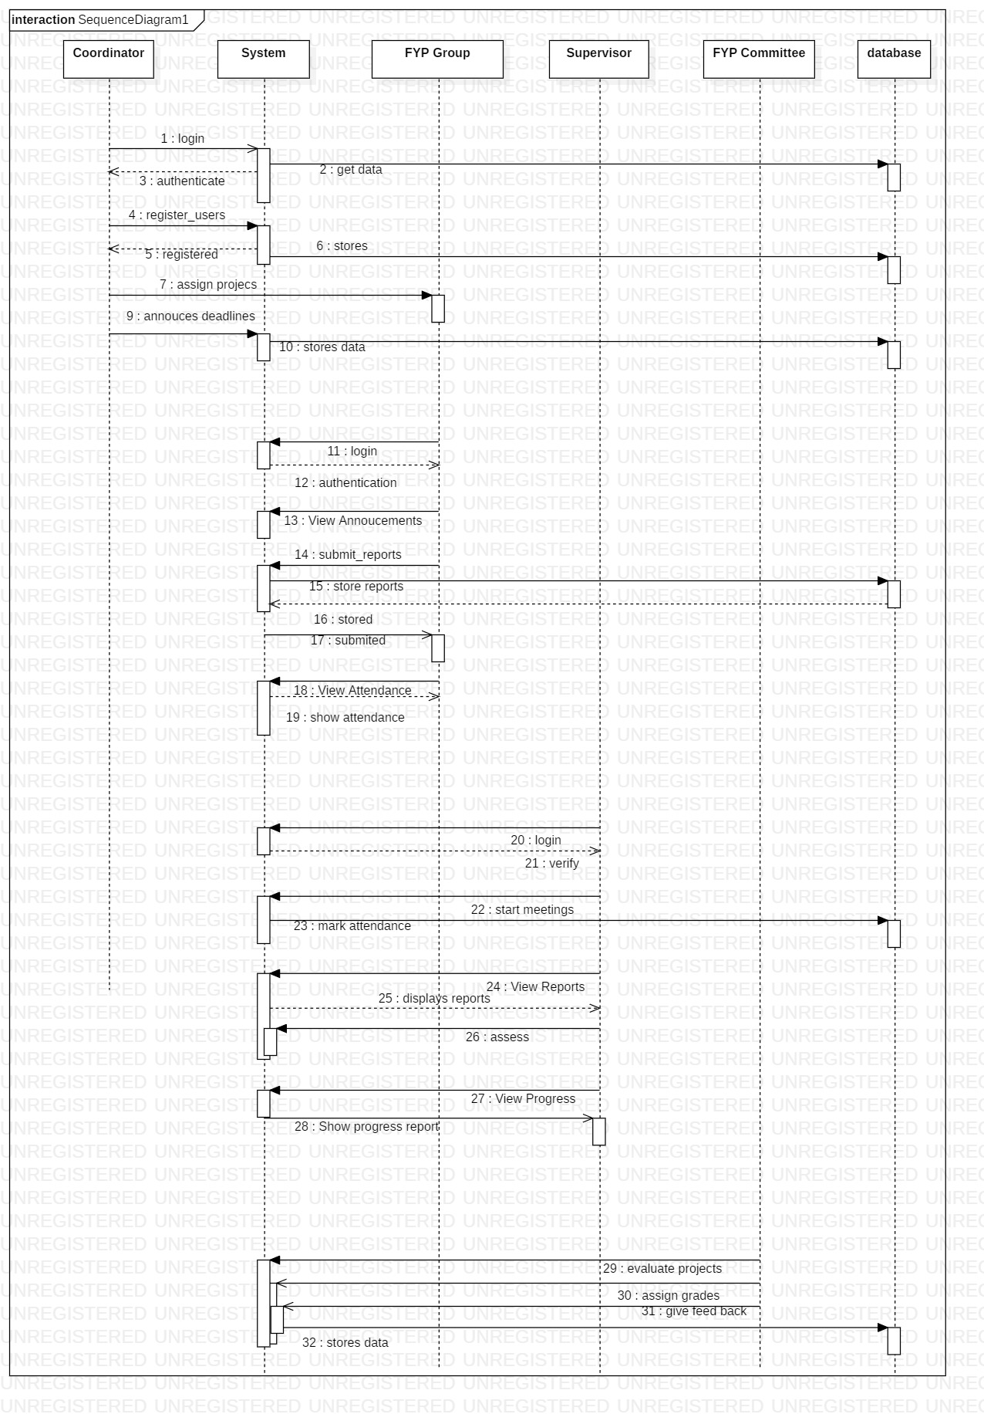3. Sequence Diagrams

4. Architecture Design Diagram

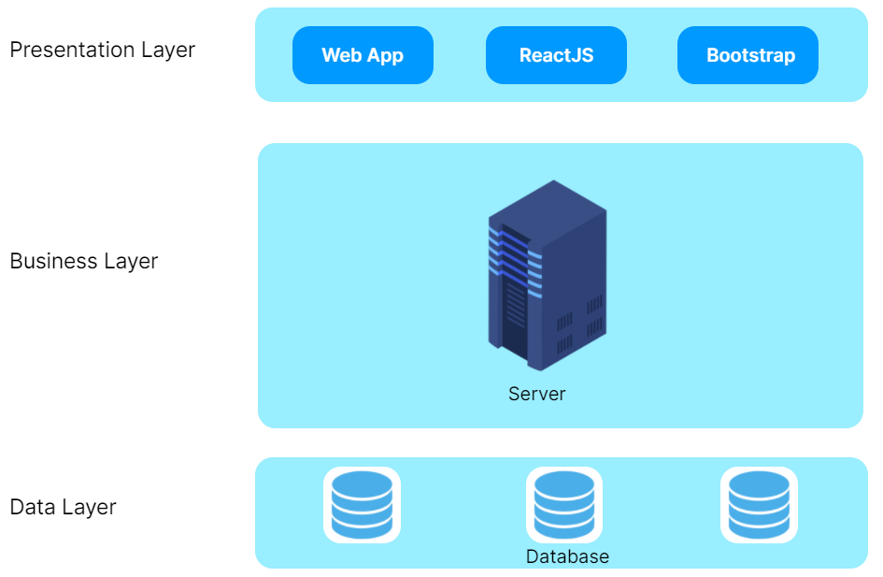

5. Database Diagram

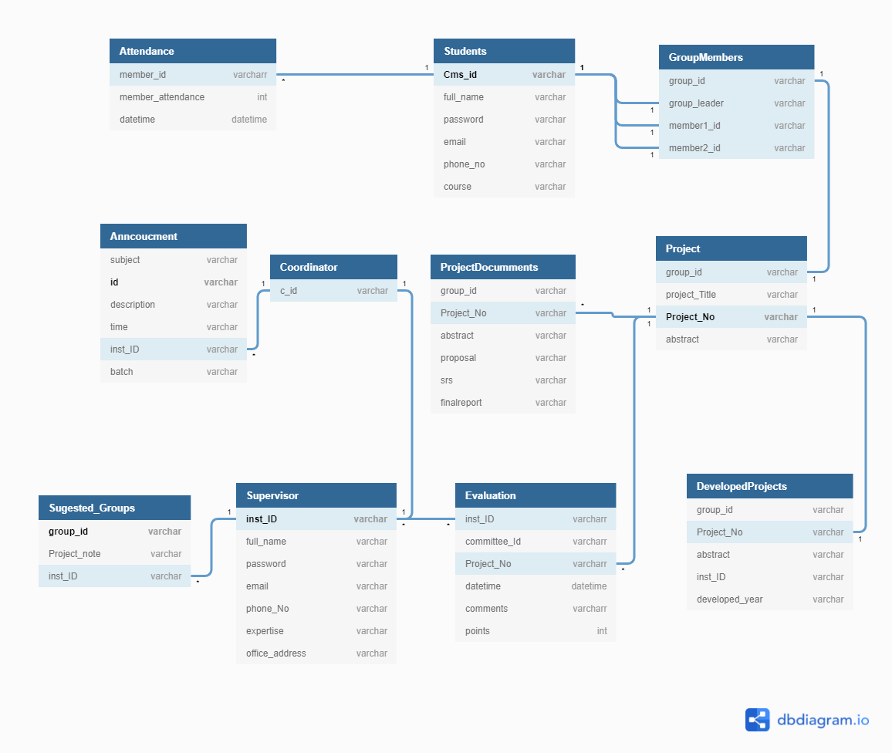

6. Class Diagram

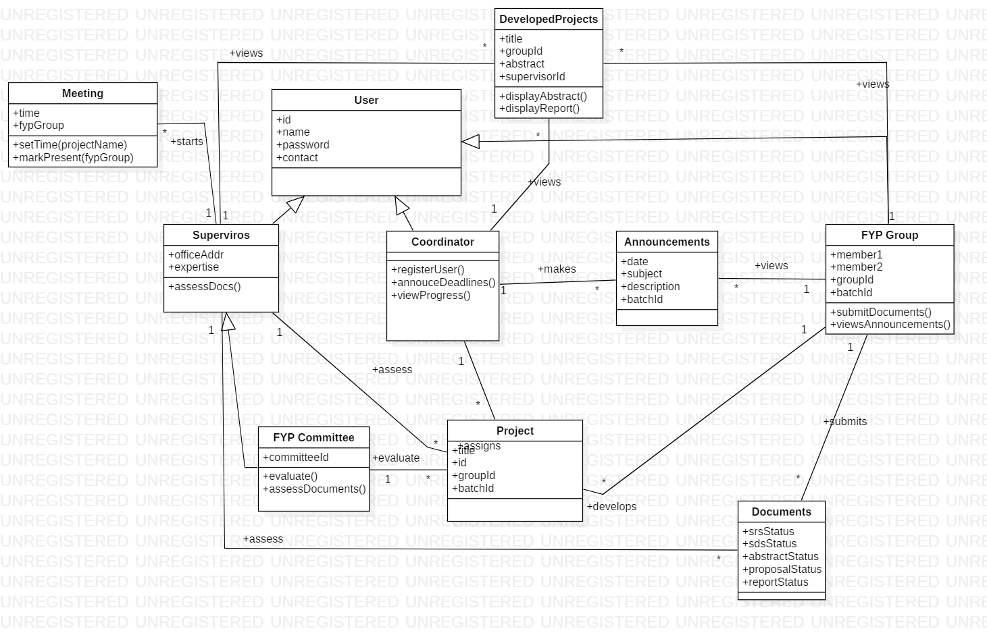

7. Interface Design

8. Test Cases