|  |  |  |  |  |  |  |  |  |
| --- | --- | --- | --- | --- | --- | --- | --- | --- |
| **Sukkur IBA University**  **Software Requirements Specification (SRS)**  **For**  **A Web-based Final Year Project (FYP) Management System**  **Version 1.4**   |  |  | | --- | --- | | **Project Code** | **F17133** | | **Supervisor** | **Sir Khalid Hussain** | | **Project Team** | **Suhail Ahmed**  **Tarique Hassan**  **Muhammad Ahsan** | | **Submission Date** |  | |

**Document History**

|  |  |  |  |
| --- | --- | --- | --- |
| **Version** | **Name of Person** | **Date** | **Description of change** |
| *1.0* | *Tarique Hassan*  *Suhail Ahmed* | 4/6/2021 | Initial Draft (SRS) |
| *1.1* | *Suhail Ahmed*  *Tarique Hassan*  *Muhammad Hassan* | 4/5/2021 | Revised Functional Requirements |
| 1.1 | Mr. Khalid Hussain Detho | 4/10/2021 | Reviewed Initial Draft |
| *1.2* | *Tarique Hassan*  *Suhail Ahmed* | *4/13/2021* | Added Use case 1, 2, 3 |
| *1.2* | *Suhail Ahmed*  *Muhammad Ahsan* | *4/15/2021* | *Added Use case 4, 5* |
| *1.3* | *Muhammad Ahsan*  *Tarique Hassan* | *4/17/2021* | *Added use case 6,7* |
| *1.4* | *Suhail Ahmed*  *Tarsique Hassan* | *4/18/2021* | *Added non-functional and external interface requirements* |

**Distribution List**

|  |  |  |
| --- | --- | --- |
| **Name** | **Role** | |
| Khalid Hussain Detho | | Supervisor |
| Tarique Hassan | | Project Member |
| Suhail Ahmed | | Project Member |
| Muhammad Ahsan | | Project Member |

***Document Sign-Off***

*[Following table will contain sign-off details of document. Once the document is prepared and revised, this should be signed-off by the sign-off authority.*

*Any subsequent changes in the document after the first sign-off should again get a formal sign-off by the authorities.]*

|  |  |  |  |
| --- | --- | --- | --- |
| **Version** | **Sign-off Authority** | **Project Role** | **Sign-off Date** |
|  |  |  |  |
|  |  |  |  |
|  |  |  |  |
|  |  |  |  |
|  |  |  |  |
|  |  |  |  |
|  |  |  |  |

**Table of Contents**

*1.* *Introduction 13*

1.1. Purpose of Document 13

1.2. Intended Audience 13

1.3. Document Convention 13

2.2. Project Scope 13

2.3. Not In Scope 13

*2.* *Overall System Description 14*

2.1. Project Background 14

2.4. Project Objectives 14

2.5. Stakeholders 14

2.6. Operating Environment 14

2.7. System Constraints 14

2.8. Assumptions & Dependencies 14

*3.* *External Interface Requirements 15*

3.1. Hardware Interfaces 15

3.2. Software Interfaces 15

3.3. Communications Interfaces 15

*4.* *Functional Requirements 16*

*4.1.* *Functional Hierarchy 16*

4.2. Use Cases 16

4.2.1. [Title of use case] 16

*5.* *Non-functional Requirements 17*

5.1. Performance Requirements 17

5.2. Safety Requirements 17

5.3. Security Requirements 17

5.4. User Documentation 17

*6.* *References 18*

*7.* *Appendices 19*

1. **Introduction**

In undergraduate program of computer science department, FYP (Final Year Project) is a project-based course which is an important part of degree for final year students. The objective of FYP is to examine student’s learning efforts, project management skill, teamwork, and performance throughout whole degree program.

In computer science department at Sukkur IBA University, the final year students are offered a project-based course for the last 2 semesters of the degree. In the first phase, students form a group of two, finalize their FYP idea and work together under a supervisor that comes in project allocation process. After that students and supervisors arrange meetings to work further on the project. In these meetings students submit reports (i.e. abstracts, proposals, SRS’s) to their supervisors and get feedback to complete milestones of the project.

This whole manual process is time-consuming and difficult to manage. There should be an easier way to carefully monitor project activities, project records and project progress status. This will assist both supervisors and students to achieve the project milestones on given deadlines. Also, will be helpful for students in getting immediate feedback from their supervisors when they are not available in the campus. A web-based approach is best for monitoring project activities and progress.

* 1. **Purpose of Document**

The purpose of this document is to provide Software Requirement Specification including functional, non-functional requirements, external interface requirement, scope of the project, and define the stakeholders. It also describes the constraints, operating system environment, and features of the system, and the list of all dependencies related to FYP Management System.

* 1. **Intended Audience**

The intended audience are FYP Committee including FYP Coordinator, Project supervisor, and Project Groups. This system is for the Computer Science department, Sukkur IBA University to automate the whole manual process.

* 1. **Document Convention**
* The font used in this document is Times New Roman
* Font size for normal text is 12
* For headings font size is 16
* For sub-headings font size is 14
* All text is of black color
  1. **Project Scope**

Our scope is to develop a web-based application. The fully working system will enable the department to manage whole FYP process including monitoring project progress, track meetings of students with supervisors by taking attendance, and reports submission (proposal, SRS, SDS, report, etc).

* 1. **Not in Scope**
* AI in system.

**Overall System Description**

* 1. **Project Background**

Currently, at Sukkur IBA University, Computer Science department is managing records related to FYP manually. FYP coordinator, supervisors, and students are facing difficulty in managing phases like, registration, assessing grades, allocation of projects and supervisors, and submission of reports.

Manual work for the FYP process has several disadvantages:

* Running the manual system reduces efficiency because it requires more human energy and consumes a lot of time.
* Supervisors and students (groups) face difficulties in discussing FYP related problems because there no system which maintains records of their meetings. That results in deadlines delays.
* No record of previously developed projects.
* Managing different phases of FYP process is difficult because there is no such system which provides a single platform to perform activities (i.e., submission, grading, announcements, deadlines).
* FYP work records are mishandled because manual record data is error prone.
* No status of project progress which makes it difficult for supervisor to monitor project deadlines.

The proposed system will provide a platform that maintains all FYP work records, meetings, project progress status, and easy to monitor for users. This way supervisors can review, give feedback and validate students’ work.

* 1. **Project Objectives**

The proposed system, as we will discuss in this section, will replace the manual system and solve these problems by providing a web-based platform to assist the users. Additionally, the system will combine whole FYP process in a single web-based platform which includes, managing user profiles, assessing students, keeping updated with project progress, and maintaining previous and current project records in a user-friendly way. This system can be used as a valuable source in computer science department at Sukkur IBA University so that FYP committees, supervisors, and students (groups) can monitor FYP related activities. The final output of the system will be a web-based final year project (FYP) management system.

* 1. **Stakeholders**

Stakeholders are important to better understand the constraints and risk of the project. The more stakeholders are involved, the more risks of the project will be reduced. Following are the stakeholders for our project:

* ICT department
* Development team of the project
* FYP Committee, FYP Coordinator, Project Supervisors, Project Group members

**Operating Environment**

* Web Application - It includes all operating system such as Windows, Linux, Mac and so on.
* web browser (supporting the technology used in development of the system)
* It uses mySql database for data storage.
* From hardware perspective, it runs on Desktop PC, Laptops and Mobile.
* Web-server – where the web app will be hosted*.*
  1. **System Constraints**
* **Softwareconstraints**
  + MySql Database would be used in the back end.
* **Hardware constraints**
  + This software would run on computer, laptop and mobile.
* **Cultural contraints (inclues langage etc.)**
  + Only English Language would be used*.*
* **Legal constraints**
  + Not applicable
* **Environmental constraints** 
  + Not applicable
* **User constraints**
  + User friendly and highly efficient and familiar like (LMS, CMS, ERP).
  1. **Assumptions & Dependencies**
* User must have internet connection.
* User must be student, instructor at computer science Sukkur IBA University.
* User must have used systems like LMS, CMS.

1. **External Interface Requirements**
   1. **Hardware Interfaces**

* The system shall display user interface according to device. For example, on desktop system shall show desktop view and on mobile, mobile view.
  1. **Software Interfaces**
* Since system is a web application, any operating system and web browser (supporting the technology used in development of the system) can be used.
  1. **Communications Interfaces**
* Users can communicate about schedule via email with the help of server.
* Students can submit document/reports over website with the help of server.

1. **Functional Requirements**
   1. **Functional Hierarchy**

* **Register Users**
  + The system shall allow coordinator to register students and instructors.
  + The system shall ask supervisors information including name, email, id, expertise of instructor.
* **Login**

The system shall ask id and password from users (coordinator, supervisor, and student) to login into the system.

* **View Information**
  + The system shall allow the coordinator to view information of students and instructors.
  + The system shall allow the coordinator to view supervisors and their groups.
  + The system shall allow the students to view information of instructors.
  + The system shall allow instructors to view information of FYP group members under supervision.
  + The system shall allow instructors to update their information.
* **Announce Dates**
  + The system shall provide G-mail option to coordinator to announce deadlines of project reports, presentations, prototypes, source codes.
  + The system shall allow students to view project deadlines notifications.
* **Assign Project**
  + The system shall allow the coordinator to assign projects FYP groups.
* **Allocate Supervisor**
  + System shall allow coordinator to assign supervisor to FYP groups.
* **Submit Project Reports** 
  + The system shall allow coordinator to create a slot for submission of abstract, proposal, SRS, SDS, final report, and source code.
  + The system shall allow student to submit project work.
  + The system shall allow supervisor of each group to view those reports and give feedback of approval or changes (if any) and assign grades.
  + The system shall allow students to view their grades as well.
* **Track Project Progress**
  + The system shall allow coordinator to view progress of all current projects. Progress includes title of project idea, names of group members, and corresponding supervisor, percentage of work done and work remaining.
  + The system shall allow supervisor to view progress of only those projects that are under supervision.
  + The system shall allow students (groups) to view their project progress.
* **Meetings**
  + The system shall allow supervisor to start meeting.
  + The system shall mark students present when the meeting starts.
  + The system shall allow supervisor to assign topic and task to students.
  + The system shall allow supervisor to view status of topics and tasks assigned in previous meeting.
  + The attendance will be week-wise.
  + The system shall automatically alert students in their profile in case absents exceed.
  + The system shall allow students to view absents.
* **Developed Projects Module**
  + The system shall allow coordinator, supervisors, and students to view previously developed FYP projects and related work.
* **Project Evaluation**
  + The system shall allow FYP committee to evaluate FYP projects and provide feedback.
  1. **Use Cases**

**Use case Diagram**

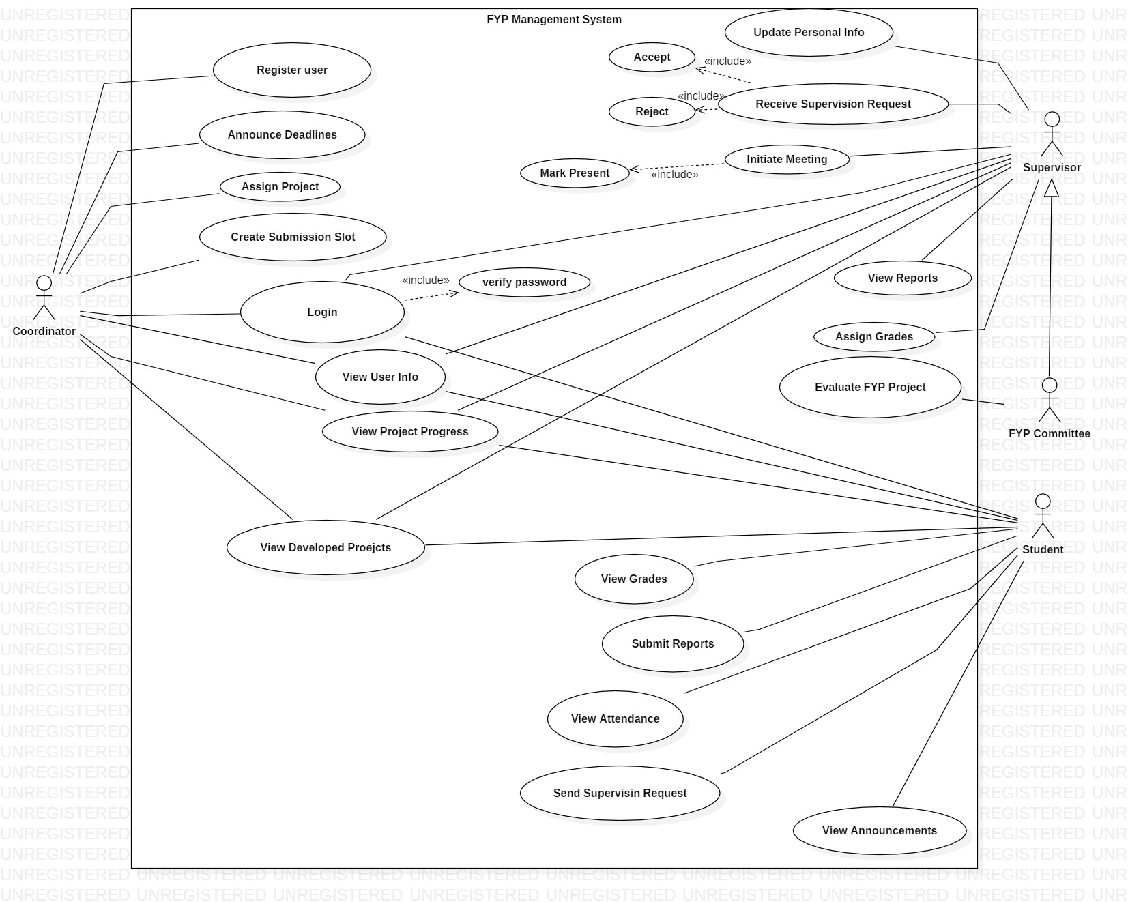

* + 1. **Login**

|  |  |  |  |  |
| --- | --- | --- | --- | --- |
| ***<Use case Id: Login>*** | | | | |
| ***Use case Id:*** | | UseCase01 | | |
| ***Actors:*** coordinator, supervisor, and student | | | | |
| ***Feature:*** It is driven from Manage Users | | | | |
| ***Pre-condition:*** | | User must have an account (id, password) | | |
| ***Scenarios*** | | | | |
| ***Step#*** | ***Action*** | | | ***Software Reaction*** |
| ***1.*** | User enters login credentials | | | Verify user Id and password from database |
| ***2.*** | User click on login button | | | Allow user for login |
| ***3.*** |  | | |  |
| ***Alternate Scenarios:*** | | | | |
| ***1a:*** User enter incorrect credentials.  ***1b:*** forget password | | | | |
| ***Post Conditions*** | | | | |
| ***Step#*** | ***Description*** | | | |
| ***1*** | After login, coordinator, supervisor, and student can perform their respective Actions. | | | |
|  |  | | | |
| ***Use Case Cross referenced*** | | | usecase02 | |

* + 1. **Register User**

|  |  |  |  |  |
| --- | --- | --- | --- | --- |
| ***<Use case Id: Register User>*** | | | | |
| ***Use case Id:*** | | UseCase02 | | |
| ***Actors:*** coordinator | | | | |
| ***Feature:*** It is driven from Manage Users | | | | |
| ***Pre-condition:*** | | User must have high privileges | | |
| ***Scenarios*** | | | | |
| ***Step#*** | ***Action*** | | | ***Software Reaction*** |
| ***1.*** | Coordinator fill instructor’s data | | | Store user information into database |
| ***2.*** | Coordinator register instructor | | | New user registered |
| ***3.*** | Coordinator fill FYP groups’ data | | | Store user information into database |
| ***Alternate Scenarios:*** | | | | |
| ***1:***  User already exists  **2:** Coordinator fills incorrect user’s data | | | | |
| ***Post Conditions*** | | | | |
| ***Step#*** | ***Description*** | | | |
| ***1*** | After registration, supervisor, and student can now login into their respective accounts | | | |
| ***Use Case Cross referenced*** | | | Usecase01 | |

* + 1. **View information**

|  |  |  |  |  |
| --- | --- | --- | --- | --- |
| ***<Use case Id: View Information>*** | | | | |
| ***Use case Id:*** | | UseCase03 | | |
| ***Actors:*** coordinator, supervisor, student | | | | |
| ***Feature:*** It is driven from User Info | | | | |
| ***Pre-condition:*** | | User must have account | | |
| ***Scenarios*** | | | | |
| ***Step#*** | ***Action*** | | | ***Software Reaction*** |
| ***1.*** | Coordinator views all FYP groups’ information | | | System shows all FYP groups’ information |
| ***2.*** | Supervisor views FYP groups’ information under supervision | | | System shows FYP groups’ information |
| ***3.*** | Students view supervisors’ information | | | System shows supervisors’ information |
| ***4.*** | Coordinator, supervisor, and FYP group views previously developed project | | | System shows previously developed projects |
| ***5.*** | Coordinator, supervisor, and FYP group views current project progress | | | System shows current projects progress |
| ***6.*** | Supervisor views submitted reports, documents, and source codes | | | System shows submitted reports, documents, and source codes |
| ***7.*** | Supervisor and FYP groups View Announcements | | | System displays announcements |
| ***8.*** | FYP groups View their grades | | | System shows grades for each submission |
| ***Alternate Scenarios:*** | | | | |
| ***1:***  System takes too much to respond. | | | | |
| ***Post Conditions*** | | | | |
| ***Step#*** | ***Description*** | | | |
| ***1*** | After clicking on view user button, information will be displayed for respective user | | | |
| ***2*** | After clicking on view files button, submitted reports, documents, and source codes | | | |
| ***Use Case Cross referenced*** | | | Usecase04, Usecase05, Usecase7 | |

* + 1. **Files submission**

|  |  |  |  |  |
| --- | --- | --- | --- | --- |
| ***<Use case Id: Files Submission>*** | | | | |
| ***Use case Id:*** | | UseCase04 | | |
| ***Actors:***  student | | | | |
| ***Feature:*** It is driven from report submission | | | | |
| ***Pre-condition:*** | | User must have account and register in FYP | | |
| ***Scenarios*** | | | | |
| ***Step#*** | ***Action*** | | | ***Software Reaction*** |
| ***1.*** | FYP groups upload reports and source Code | | | System shows message “files uploaded successfully” |
| ***2.*** | FYP groups Click submit button | | | System saves information into server and show submitted |
| ***Alternate Scenarios:*** | | | | |
| ***1:***  System takes too much to respond.  2: submit without uploading files. | | | | |
| ***Post Conditions*** | | | | |
| ***Step#*** | ***Description*** | | | |
| ***1*** | After clicking on submit button, FYP group can view their submissions | | | |
| ***2*** |  | | | |
| ***Use Case Cross referenced*** | | | Usecase03 | |

* + 1. **Evaluate Projects**

|  |  |  |  |  |
| --- | --- | --- | --- | --- |
| ***<Use case Id: Evaluate projects>*** | | | | |
| ***Use case Id:*** | | UseCase05 | | |
| ***Actors:***  FYP committee, Supervisor | | | | |
| ***Feature:*** It is driven from Project Evaluation | | | | |
| ***Pre-condition:*** | | FYP groups must have submitted reports | | |
| ***Scenarios*** | | | | |
| ***Step#*** | ***Action*** | | | ***Software Reaction*** |
| ***1.*** | FYP committee open Evaluation page | | | System displays evaluation rubric |
| ***2.*** | FYP committee fill evaluation rubric and submit | | | System shows grades assigned and save into database |
| ***Alternate Scenarios:*** | | | | |
| ***1:***  FYP groups have not submitted reports | | | | |
| ***Post Conditions*** | | | | |
| ***Step#*** | ***Description*** | | | |
| ***1*** | System saves grades into database | | | |
| ***2*** |  | | | |
| ***Use Case Cross referenced*** | | | Usecase03 | |

* + 1. **Start Meetings**

|  |  |  |  |  |
| --- | --- | --- | --- | --- |
| ***<Use case Id: Start Meetings>*** | | | | |
| ***Use case Id:*** | | UseCase06 | | |
| ***Actors:***  Supervisor | | | | |
| ***Feature:*** It is driven from Meeting and attendance | | | | |
| ***Pre-condition:*** | | FYP groups must be registered | | |
| ***Scenarios*** | | | | |
| ***Step#*** | ***Action*** | | | ***Software Reaction*** |
| ***1.*** | Supervisor starts meeting | | | System marks student present |
| ***2.*** | Supervisor assigns tasks to FYP groups | | | System stores tasks into student’s record |
|  | Supervisor view pending tasks of FYP groups | | | System shows status (complete or incomplete) of tasks |
| ***Alternate Scenarios:*** | | | | |
| ***1:***  meeting cannot start because students are absent (then system marks absent) | | | | |
| ***Post Conditions*** | | | | |
| ***Step#*** | ***Description*** | | | |
| ***1*** | System store tasks into records | | | |
| ***2*** |  | | | |
| ***Use Case Cross referenced*** | | | Usecase05 | |

* + 1. **Assign Project and supervisor**

|  |  |  |  |  |
| --- | --- | --- | --- | --- |
| ***<Use case Id: Assign Project and supervisor >*** | | | | |
| ***Use case Id:*** | | UseCase07 | | |
| ***Actors:***  Coordinator | | | | |
| ***Feature:*** It is driven from project and supervisor allocation | | | | |
| ***Pre-condition:*** | | FYP groups and supervisors must be registered and coordinator have privileges. | | |
| ***Scenarios*** | | | | |
| ***Step#*** | ***Action*** | | | ***Software Reaction*** |
| ***1.*** | Coordinator assigns project | | | System save information |
| ***2.*** | Coordinator assigns supervisor | | | System maps FYP group to supervisor |
|  |  | | |  |
| ***Alternate Scenarios:*** | | | | |
| ***1:***  supervisor can’t be assigned because FYP group is not assigned project. | | | | |
| ***Post Conditions*** | | | | |
| ***Step#*** | ***Description*** | | | |
| ***1*** | System updates supervisor and students database | | | |
| ***2*** |  | | | |
| ***Use Case Cross referenced*** | | | Usecase03 | |

1. **Non-functional Requirements**
   1. **Performance Requirements**

* Software would response to clicks within 2 seconds.
* The design will be responsive.
  1. **Safety Requirements**
* System shall ensure backup of data.
  1. **Security Requirements**
* System shall ensure integrity, confidentiality, authenticity, authorization, availability.
  1. **User Documentation**
* Not applicable

1. **References**

*[This section should provide a complete list of all documents referenced at specific point in time. Each document should be identified by title, report number (if applicable), date, and publishing organization. Specify the sources from which the references can be obtained. (This section is like the bibliography in a published book).]*

1. Leung, C.-H., et al., *The Development of a Final Year Project Management System for Information Technology Programmes.* 2015. **494**: p. 86-97.

2. Bakar, M.A., et al., *Final Year Supervision Management System as a Tool for Monitoring Computer Science Projects.* Procedia - Social and Behavioral Sciences, 2011. **18**: p. 273-281.

3. IONUT NEAGU, F.C. *Angular vs React vs Vue: Which Framework to Choose in 2020*. 2020 [cited 2020 november 20]; Available from: https://[www.codeinwp.com/blog/angular-vs-vue-vs-react/#license](http://www.codeinwp.com/blog/angular-vs-vue-vs-react/#license).

4. Feoktistov, I. *Angular vs. React vs. Vue.js – choosing a JavaScript framework for your project*. 2020 [cited 2020 november 20]; Available from: https://relevant.software/blog/angular-vs-react-vs-vue-js-choosing-a-javascript-framework-for-your-project/#Angular,_React,_Vue_js_%E2%80%93_then_and_now.

5. Gr¨unwaldt, J.-M., *A Comparison of Modern Backend Frameworks*

*Protections against Common Web Vulnerabilities.* 2019.

6. Nurture, L. *Django vs Laravel vs Node js*. 2019 [cited 2020 november 20]; Available from: https://[www.letsnurture.com/blog/django-vs-laravel-vs-node-js.html](http://www.letsnurture.com/blog/django-vs-laravel-vs-node-js.html).

7. Kaur, M. *QL vs NoSQL : MySQL vs MongoDB — The Difference*. 2018 [cited 2020 november 20]; Available from: https://medium.com/@mandeepkaur1/sql-vs-nosql-mysql-vs-mongodb-the-difference-6145e437cd40.

1. ***Appendices***

*[This section should include supporting detail that would be too distracting to include in the main body of the document.]*