Mental Health Evaluation During Internet Blackouts: Integrating Emotional, Behavioral, and Environmental Factors – A Case Study of Bangladesh Quota Movementy

|  |  |  |
| --- | --- | --- |
| Md Tariqul Islam  *Department of CSE*  *BRAC University*  Dhaka-1212, Bangladesh  md.tariqul.islam3@g.bracu.ac.bd | Tahidul Islam  *Department of CSE*  *University*  Dhaka-1207, Bangladesh  mail | Mohammad Ariful Islam Rafi  *Department of EEE*  *University of Liberal Arts Bangladesh*  Dhaka-1207, Bangladesh  ariful.islam1.eee@ulab.edu.bd |
| Tauhidur Rahman Sakib  *Department of CSE*  *BRAC University*  Dhaka-1212, Bangladesh  tauhidur.rahman.sakib@g.bracu.ac.bd |  |  |

*Abstract*— This study examines the mental health impacts of internet blackouts during political movements, specifically focusing on the Bangladesh Quota Movement of July 2024. The government-imposed internet shutdown aimed to control the spread of unrest, creating significant disruptions to communication, financial transactions, and access to essential services. This research explores the psychological effects of such disruptions, highlighting how the sudden disconnection from digital communication and social support networks exacerbates anxiety, stress, and feelings of isolation among the population. The study utilized a 20-question survey distributed among 192 participants to assess the emotional, behavioral, and environmental factors affecting mental well-being during the blackout. Key factors analyzed include internet usage disruptions for academic, social media, entertainment, work, and communication purposes, as well as the resulting stress levels, ranging from no stress to extreme stress. Findings indicate that the absence of internet access significantly disrupted daily routines and increased psychological distress, with the majority of respondents reporting moderate to extreme stress levels. The study highlights the critical need for mental health support during such crises, particularly in low- and middle-income countries where mental health care infrastructure is limited. It also highlights the broader implications of internet shutdowns on societal stability, suggesting that such measures can severely impact the mental health of individuals, disrupt community engagement, and elevate long-term emotional and behavioral challenges.

Keywords— Internet Blackout, Quota Movement, Emotional, Behavioral,

# Introduction

The current global political landscape is experiencing an unprecedented surge in civil unrest and protests, driven by widespread dissatisfaction with government policies and actions across various nations, from South America to Asia [1]. These persistent protests, often fueled by economic disparities, social injustices, and lack of political freedoms, have profound implications, leading to financial instability, strained diplomatic relations, and security challenges for affected countries [2]. One prominent example of such unrest is in Bangladesh, where the Quota Movement has significantly intensified national tensions. In response to growing civil unrest, the Bangladesh government imposed a state-sanctioned internet shutdown to control the spread of protests. Beginning on July 18, 2024, this “total shutdown” lasted five days [3], which led to cutting off the country’s population from the rest of the world [4] and Mobile internet services were also slowed down for 12 days [5]. During this period, Bangladeshi citizens faced severe restrictions on communication, financial transactions, and access to essential services, effectively isolating them from the outside world. This blackout, referred to by many as a “total shutdown” of the country, was one of the most extensive internet disruptions Bangladesh has experienced to date [6]. A similar occurrence happened in previous years when the government slowed down the internet. For instance, in 2018, when a Road Safety Protest occurred where the internet was slowed down several times from July 29 to August 10 [7], the same types of incidents happened from 2009 to 2024 when the government slowed or blocked the internet multiple times [8, 9, 10, 11]. Internet blackouts, such as the one in Bangladesh, have significant adverse effects on mental health. The sudden disconnection from digital communication and social support networks can exacerbate feelings of isolation, anxiety, and stress. The absence of reliable information sources during such blackouts creates uncertainty, leading to increased psychological distress among the population. This heightened state of anxiety often serves as a contributing factor to various psychological and physical health complications, including heart disease and diabetes, and can aggravate pre-existing mental health disorders [12, 13].

Globally, mental health disorders, particularly depression, are a leading cause of disability. Approximately 264 million people suffer from depression, which, in severe cases, can lead to suicide. For individuals aged 15 to 29, depression-induced suicide ranks as the second leading cause of death, with nearly 800,000 people dying by suicide annually due to depression [14]. Mental health disorders can also significantly impact daily life, affecting personal relationships, work productivity, and overall quality of life, which in severe cases can lead to suicide [15]. The inability to access mental health support during critical periods, such as internet blackouts, worsens these outcomes, as individuals are left without the necessary resources to manage their conditions. In regions like Bangladesh, where mental health care infrastructure is already underdeveloped, the impact of internet blackouts on mental health is particularly severe. With 6.4 million people (4.10% of the population) experiencing various depressive disorders, over 75% of individuals in low- and middle-income countries (LMICs) like Bangladesh do not receive proper mental health care [16]. The stigma surrounding mental health, combined with a lack of access to qualified specialists, prevents many from seeking necessary treatment, exacerbating the burden of mental health disorders in these communities. The situation is expected to worsen during internet blackouts as people fear losing jobs, businesses, and connections to their support networks. For many, the lack of access to information about their surroundings during these blackouts heightens fear and uncertainty, compounding their mental health challenges [17]. Despite the availability of treatment, a significant proportion of those suffering from depression remain undiagnosed and untreated, highlighting the critical need for early recognition and intervention to manage mental health disorders effectively.

The advancement of technology, particularly in data analytics and machine learning algorithms, has significantly improved the evaluation and detection of mental health risks and their after-effects. These innovations enable early identification of mental health disorders, paving the way for timely interventions. However, despite these advancements, there remains a considerable gap in research on the impact of internet blackouts on mental health, especially from the perspective of Bangladesh and globally. To date, no comprehensive studies have been conducted specifically evaluating mental health during internet blackouts despite numerous works on mental health in other contexts. Addressing the mental health impact of internet blackouts requires a multi-faceted approach that includes enhancing access to mental health care, reducing stigma, and ensuring continuous communication and information access during crises. Recognizing early signs of mental health disorders allows for timely interventions, which can save lives and improve overall well-being [18].

Thus, a study was conducted to evaluate mental health during the internet shutdown following the Quota Movement protests in Bangladesh. The study surveyed 192 individuals using a 20-question questionnaire to assess levels of depression, anxiety, stress, and overall mental well-being during the blackout. The findings highlight the impact of the internet blackout on mental health, revealing that every aspect of life was affected, particularly in sectors already vulnerable to resource constraints, such as academia. The academic sector, already struggling with resource shortages, was further destabilized, exacerbating stress and anxiety among students.

Section II will explain the methodology, which comprises theory, datasets and other criteria, and the results will be discussed in Section III. In section IV, we discussed the limitations of the study. In Section V, we will present our concluding remarks and discuss future goals. Each section is established to continuously build from the beginning concept to the final inferences and suggestions regarding the research findings.

# Theoretical Background

## Mental Health

A mental health illness is a condition that affects a person's wellbeing, emotions, thoughts, behavior, and communication with others [19]. According to the American Psychiatric Association (APA), mental health illness refers to emotional, behavioral, or a combination of both types of health conditions that are linked to family, social, or work-related problems [20]. It can be further explained that mental health illness is a condition that impacts a person's emotional and behavioral wellbeing, leading to physiological effects.

## Anxiety

According to the APA, anxiety involves feelings of nervousness, anxiousness, and excessive fear [20]. These feelings are accompanied by physiological symptoms, which persist and appear cyclically when anxiety is triggered [21]. Anxiety disorders are mainly classified into three types: Generalized Anxiety Disorder (GAD), panic disorder, and social anxiety disorder. GAD leads individuals to avoid or seek reassurance about unpredictable circumstances and be unnecessarily concerned about unfavorable outcomes. Panic disorders are characterized by sudden onset of psychological and physiological reactions, such as irregular pulse, sweating, shaking, and shortness of breath. Social anxiety disorder involves extreme fear or anxiety about other people’s reactions in social settings. Individuals with social anxiety tend to avoid attention or situations that may be difficult or embarrassing [22]. Anxiety disorders appear to be shared among students in their daily activities.

## Depression

Depressive disorder, also known as clinical depression, is a mood disorder that causes severe symptoms affecting a person’s feelings, thoughts, and daily activities. This disorder is typically characterized by sadness, loss of interest, guilt or low self-worth, disturbed sleep, low appetite, fatigue, and poor concentration [19]. There are two types of depressive disorders: persistent depressive disorder and psychotic depression. Persistent depressive disorder, also known as dysthymia, is a state where a person experiences a depressed mood for at least two years [19]. A person diagnosed with persistent depressive disorder may have major depressive episodes along with periods of less severe symptoms, and this cycle of symptoms lasts for two years, making this disorder more chronic. Psychotic depression differs from persistent depressive disorder in that a person experiences severe depression accompanied by psychosis, where symptoms include disturbing false fixed beliefs and hallucinations of seeing or hearing things that others cannot.

## Environmental

Surroundings and environmental stressors, particularly during movements or political events, significantly impact mental health. Exposure to such environments, including protests, increased crime rates, and unstable political conditions, can elevate stress, anxiety, and depression, especially among those directly involved or affected [23]. Events like the Black Lives Matter protests and the Hong Kong pro-democracy demonstrations highlight how external stressors such as crowding, noise, and police presence can worsen mental health conditions [24]. Fig. 1 illustrates the engagement levels across Facebook, YouTube, Twitter, and Instagram during the Bangladesh Quota Movement in July 2024, highlighting the effects of internet blackouts on mental health [25]. Facebook maintained high engagement but showed declines as the movement intensified, while YouTube and Twitter had erratic peaks, with Twitter spiking during blackout periods, reflecting increased user activity and discourse. Conversely, Instagram showed minimal engagement fluctuations. These patterns suggest that during crises like internet shutdowns, social media engagement is heavily disrupted, adding to environmental stressors that impact individuals’ mental health, such as routine disruptions, unsafe surroundings, and pollution, such as noise [26, 27] and air [28]. This aligns with broader findings that these stressors exacerbate the psychological impact of social and political upheaval [29].

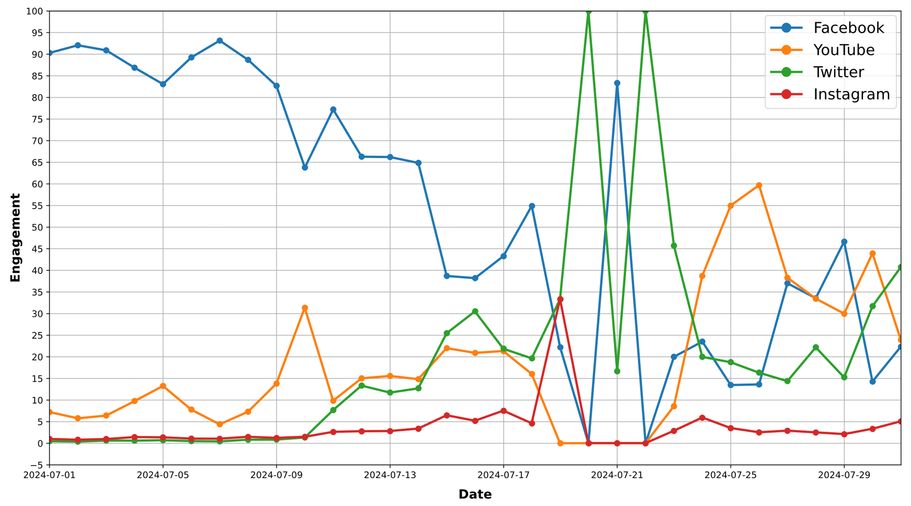

Fig. 1. Social Media Engagement During the Bangladesh Quota Movement and Internet Blackout (July 2024)

# Methodology

## Questionnaire design

A questionnaire was developed for the study, consisting of 20 questions in total. The survey was designed to be inclusive and was circulated among a diverse group of people using a Google form to ensure accessibility for a diverse range of participants. Participants' voluntary consent was collected before the survey was conducted. Two items were dedicated to collecting demographic information: gender and age. This demographic data helped contextualize the responses within specific groups, offering insights into how different age groups and genders experienced and responded to environmental stressors during movements. The survey was then structured around four categories: general, mental, emotional, and behavioral, comprised of five sub-questions each. Participants provided voluntary consent before the survey, emphasizing the ethical standards upheld during the study.

## Survey objective

The survey, with a primary object on the mental health impact of the internet blackout during the Bangladesh Quota Movement in July 2024, was designed to capture the invaluable experiences and perceptions of the participants. It aimed to understand how the lack of internet access affected their mental state, making their contributions crucial to the research. As a general guideline, participants were instructed to think about the questions to understand or visualize the scenario that occurred in the movement. The survey collected 192 responses, and the data was saved into an Excel file for in-depth analysis. The psychological and behavioral impact of the internet shutdown during a critical social movement enlightens about the potential mental health implications of such events.

## Factors of Mental Health

Fig. 2 shows the factors influencing mental health during internet blackouts, specifically highlighting Internet Usage, Stress Level, Surroundings, and Emotional Well-being. Internet usage disruptions, such as for academic, social media, communication, entertainment, and work purposes, are primary contributors to stress, as they interrupt daily routines and create emotional challenges. Stress levels are categorized into No Stress, Stress, and Extreme Stress, quantifying the immediate psychological impact of these disruptions on mental stability. Emotional Well-being is assessed by how significantly individuals feel affected, from ‘Not at all’ to ‘Significantly,’ reflecting emotional disturbances like anxiety, depression, or feelings of isolation. Surroundings measure the level of environmental awareness during the blackout, showing how internet disconnection affects interactions with one’s immediate physical and social environments. These factors reveal how the lack of internet access during critical moments like social motions can severely disrupt daily life, contribute to heightened stress, and impact long-term emotional and mental well-being, affecting social behaviors and coping mechanisms.

# Result and Discussion

## Impact on Daily Activities

Daily work is closely linked to mental health, as the nature and conditions of work significantly impact an individual’s psychological well-being. Work provides structure, purpose, and social interaction, essential for maintaining mental health.

Fig. 3 presents an overview of Internet usage across various age groups in Bangladesh, highlighting how individuals use the Internet for academic, social media, entertainment, communication, and work purposes. The highest internet usage is observed among younger age groups, particularly those aged 19 to 27, with the peak at 24 years, where 124 individuals are actively engaged online, mainly using the Internet for social media, entertainment, and academic purposes. A noticeable shift occurs as users age; internet usage for social media and entertainment decreases, while work-related and communication purposes become more prominent among those aged 30 and above. The age group of 23 to 25 shows the most diverse internet activity across all categories, with significant contributions from work and communication. The lowest number of users is at age 27; however, above this age, the graph indicates an increasing trend of using social media for work and communication. This pattern suggests that internet usage in Bangladesh reflects age-related shifts in priorities, with younger individuals focusing more on social, entertainment, and academic needs, while older users prioritize professional and communication purposes. Internet shutdowns can severely disrupt these patterns, affecting mental health by limiting access to social, academic, work-related, and communication activities, thereby increasing stress, isolation, and anxiety.

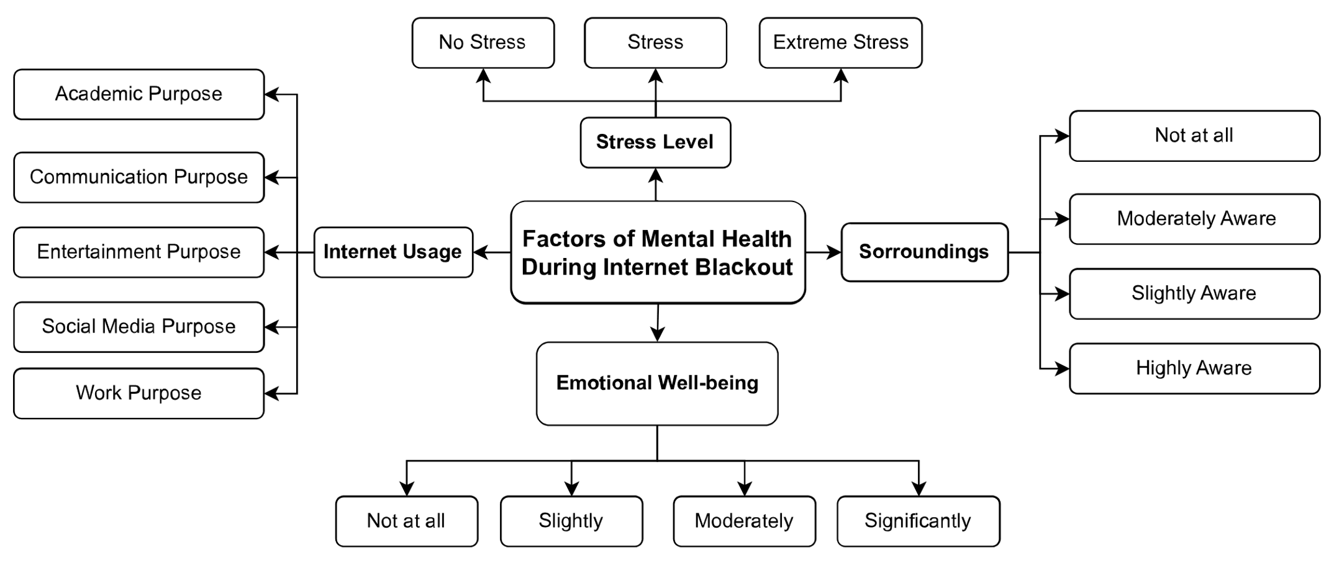

Fig. 2. Factors influencing mental health during internet blackout

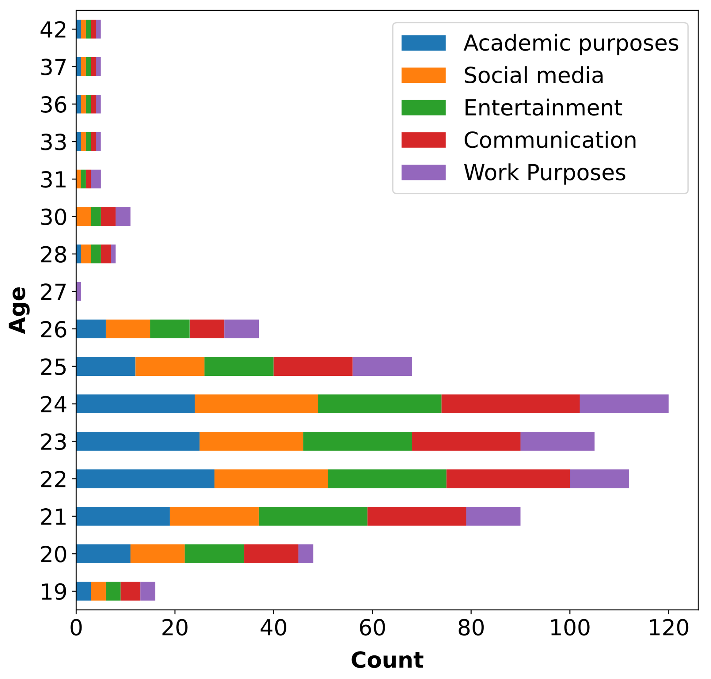

Fig. 3. Age-Wise Internet Usage For Daily Activities

## Stress Levels

Supportive measures and awareness of mental health impacts during digital disruptions like internet shutdowns are crucial. Fig. 4 illustrates the distribution of stress levels experienced by individuals during an internet blackout, categorizing the responses into three levels: ‘Extreme Stress,’ ‘Stress,’ and ‘No Stress.’ Most participants (53.7%) reported experiencing moderate stress levels during the blackout, indicating that over half of the respondents were significantly affected by the disruption. 26.3% felt no stress, showing resilience or indifference to the internet outage. However, 20% of participants experienced extreme stress, highlighting the severe psychological impact that such events can have on specific individuals. It highlights the varying degrees of psychological strain that internet blackouts impose, reflecting how such disruptions affect mental well-being. It can be implied that while some individuals may cope without significant stress, many are vulnerable to moderate to extreme psychological strain, which can manifest in increased anxiety, frustration, and feelings of isolation.

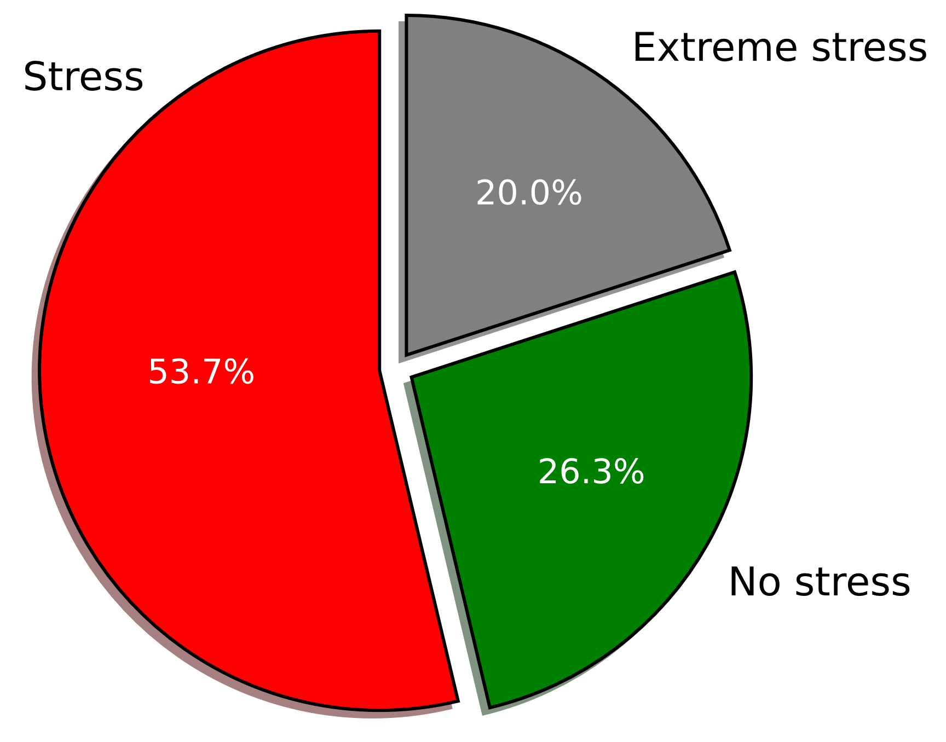

Fig. 4. Stress Level Distribution During the Blackout

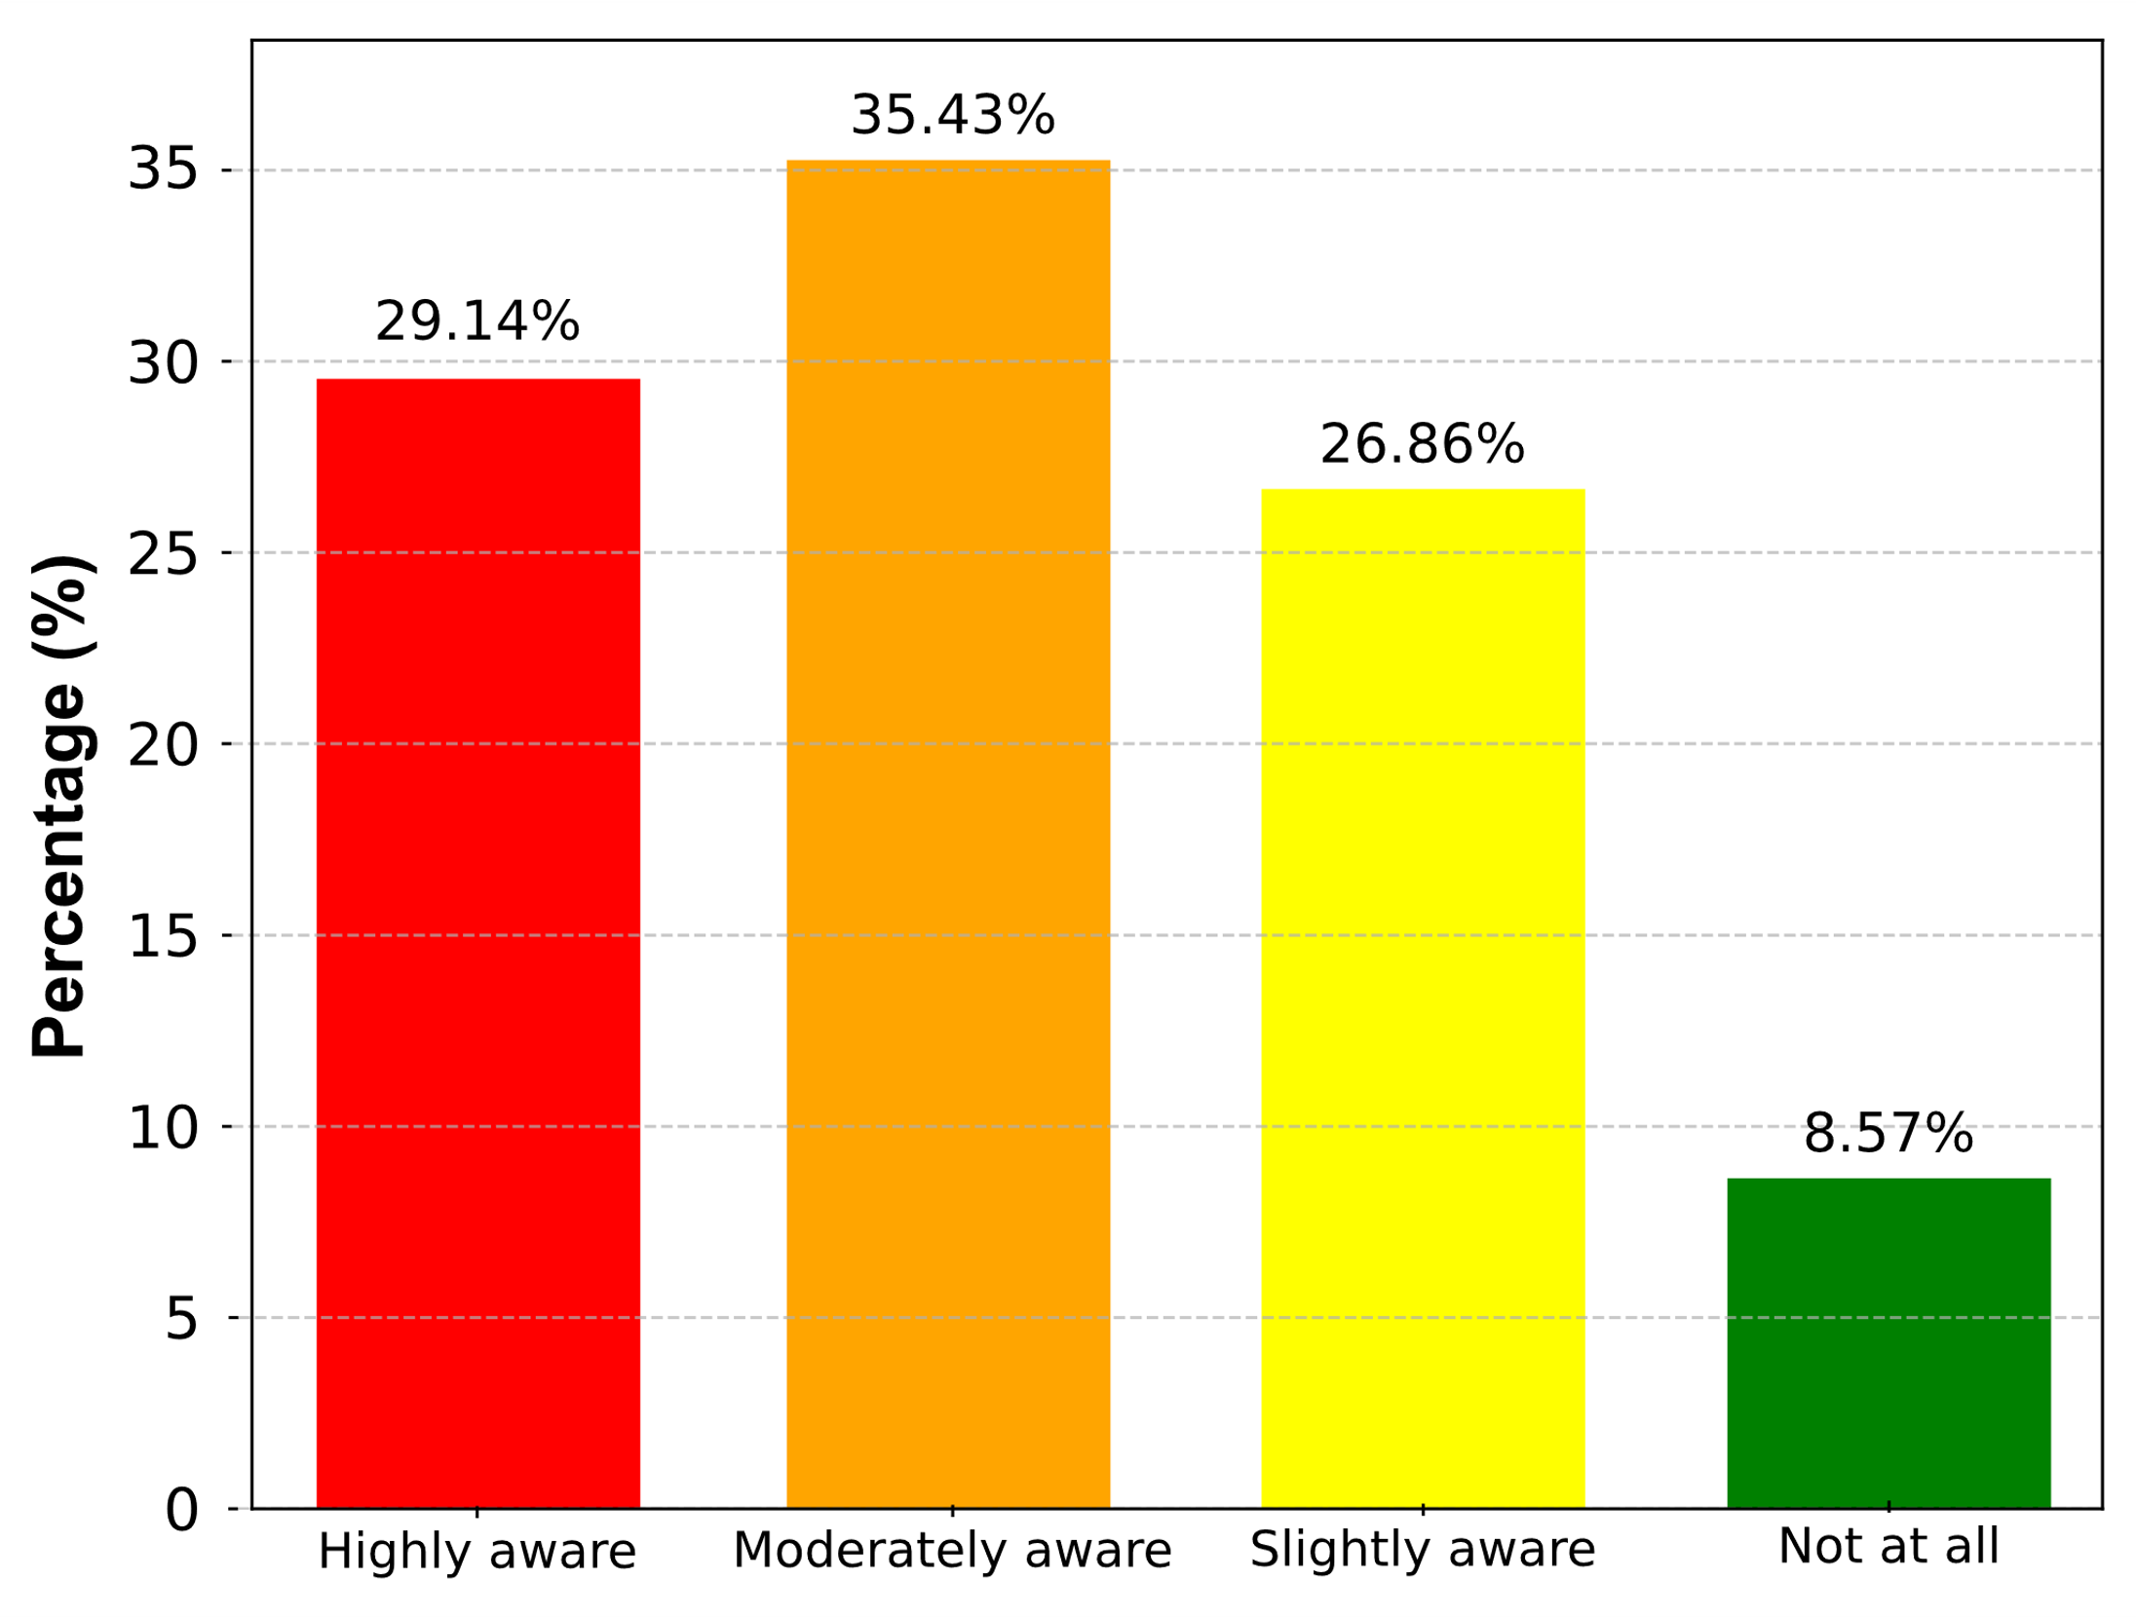

Fig. 6. Community Engagement and Awareness Levels During the Internet Blackouts

## Emotional Impact

Stress is a natural response to challenging situations, triggering emotional, physical, and mental reactions that can impact overall well-being. The emotional responses of respondents regarding the potential loss of a remote job or project due to an internet blackout are categorized into four distinct emotional states: ‘Worried but hopeful,’ ‘Frustrated,’ ‘No concerns,’ and ‘Felt secure,’ as shown in Fig. 5. Most respondents (35%) reported feeling worried but hopeful, indicating a blend of anxiety and optimism about potential solutions. 30% expressed frustration, feeling helpless or dissatisfied with the possibility of losing work due to internet outages. In contrast, 20% of participants expressed no concerns, suggesting confidence in their job security or contingency plans to manage potential disruptions. Finally, 10% indicated they felt secure, demonstrating minimal anxiety and high confidence in their ability to retain their job or project despite an internet blackout. Overall, 65% of respondents (combining those worried but hopeful and frustrated) demonstrated significant emotional concern about losing their jobs or projects, which also highlights the psychological impact internet blackouts may have on remote workers’ stability and confidence in their professional roles.



Fig. 4. Community Engagement and Awareness Levels During Internet Blackout

## Behavioral Impact

Behavioral aspects focus on how individuals act, respond, and adapt to different situations, reflecting changes in habits, routines, and coping mechanisms in response to external stressors. Fig. 6 showcases how respondents engaged with their local community during a period that disruptions like internet blackouts may have impacted. It reveals that 35.43% of respondents were moderately aware of their surroundings, indicating that they maintained a reasonable level of community involvement, possibly staying informed and connected despite any challenges. A significant 29.14% were highly aware, showing strong and proactive engagement with their community, suggesting that they actively sought ways to stay involved and aware during this time. Another 26.86% of respondents fell into the slightly aware category, indicating some level of engagement but less intensity, possibly due to personal circumstances or more limited opportunities to connect with others. The smallest group, 8.57%, reported being 'unaware' of their surroundings, reflecting minimal or no community engagement, possibly due to isolation, a lack of resources, or the impact of the lockdown or blackout. Overall, Fig. 6 suggests that despite potential challenges, most people remained engaged with their community to some extent, with most maintaining a moderate level of awareness,

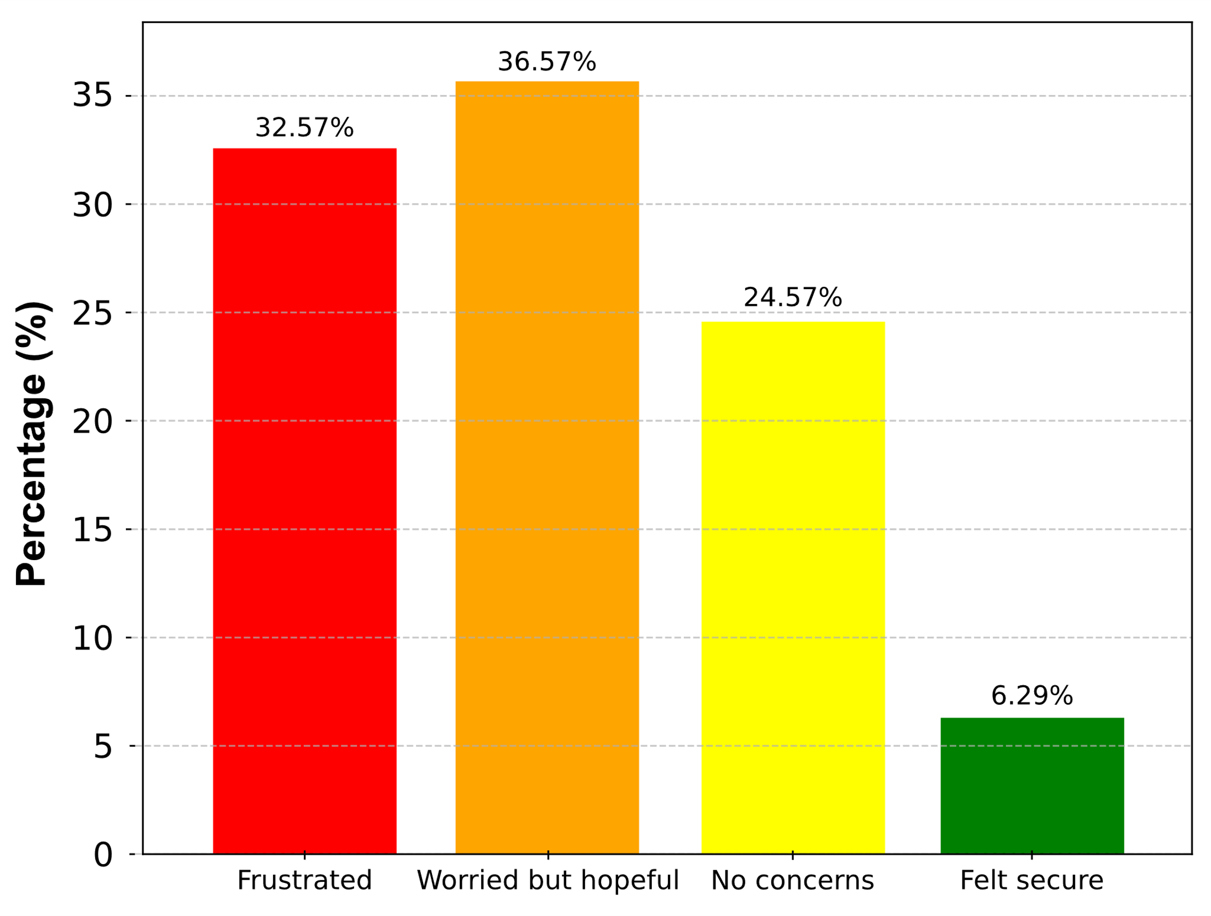

Fig. 5. Emotionally Concerns About Losing Remote Jobs or Projects Due to Internet Blackout

indicating resilience and adaptability in staying connected with their local environment.

# Conclusions

The findings of this study highlight the impact of internet blackouts on mental health, particularly during socio-political movements like the Bangladesh Quota Movement. The imposed internet shutdown not only disconnected individuals from vital communication and social networks but also intensified feelings of anxiety, stress, and isolation, which are known to exacerbate existing mental health disorders. The survey data revealed that the majority of participants experienced moderate to extreme stress levels, reflecting the immediate psychological impact of losing access to online resources, academic information, and social connections. Furthermore, disruptions in daily internet usage for essential activities such as education, work, and communication significantly affected emotional well-being, contributing to increased levels of depression and anxiety. The study also highlights the urgent need for accessible mental health resources during periods of digital disruption, particularly in regions with underdeveloped mental health care systems. It also calls for the development of policies to mitigate the negative impacts of internet shutdowns on mental health, including enhancing public awareness, reducing stigma, and ensuring continuous access to mental health support services. Addressing these challenges is crucial to safeguarding the well-being of affected populations and minimizing the long-term consequences of internet blackouts on mental health, social stability, and overall quality of life.

##### References

1. L. W. Ford and R. Hass, “Democracy in Asia,” Brookings, Jan. 22, 2021. [Online]. Available: <https://shorturl.at/JpJcB>
2. K. Deininger, “Causes and Consequences of Civil Strife: Micro-Level Evidence from Uganda,” Oxford Economic Papers, vol. 55, no. 4, pp. 579–606, Oct. 2003, doi: 10.1093/oep/55.4.579.
3. Cloudflare Radar [@CloudflareRadar], “The 5-day Shutdown was in Response to Student Protests.,” X/Twitter, Jul. 24, 2024. https://rb.gy/5vlaja (accessed Jul. 24, 2024).
4. T. Record, “Bangladesh is Сoming Back Online After Five Days of Near-Total Internet Blackout,” The Record, Jul. 24, 2024. Accessed: Jul. 24, 2024. [Online]. Available: <https://rb.gy/701ydp>
5. J. Tanner, “Mobile Internet Returns to Bangladesh, but Not Social Media,” Developing Telecoms, Jul. 31, 2024. <https://rb.gy/ngp0yp>
6. A. Jazeera, “Bangladesh Restores Mobile Internet After 11-Day Blackout to Quell Protests,” Al Jazeera, Jul. 28, 2024. [Online]. Available: <https://rb.gy/iva9r6>
7. G. S. Reporter, “Unrest in Bangladesh as Student Road Safety Protests Turn Violent,” The Guardian, Aug. 05, 2018. [Online]. Available: <https://rb.gy/ffpcss>
8. A. Jazeera, “Dhaka Bans Youtube Over Mutiny Tape,” Al Jazeera, Mar. 10, 2009. [Online]. Available: <https://shorturl.at/pgLmp>
9. Reuters, “Bangladesh Lifts Ban on YouTube, Blocked After Anti-Islam Film,” Reuters, Jun. 05, 2013. Accessed: Jun. 05, 2013. [Online]. Available: <https://shorturl.at/FEqu3>
10. M. Z. Islam, “Sudden Shutdown Follows Verdict,” The Daily Star, Nov. 20, 2015. [Online]. Available: <https://shorturl.at/bOvgJ>
11. Access Now, “Internet Throttling in Bangladesh: Government, Telcos Must #KeepItOn - Access Now,” Access Now, Nov. 01, 2023. <https://shorturl.at/vboH6>
12. M. A. Whooley and J. M. Wong, “Depression and Cardiovascular Disorders,” Annual Review of Clinical Psychology, vol. 9, no. 1, pp. 327–354, Mar. 2013, doi: 10.1146/annurev-clinpsy-050212-185526.
13. C. Otte et al., “Major depressive disorder,” Nature Reviews Disease Primers, vol. 2, no. 1, Sep. 2016, doi: 10.1038/nrdp.2016.65.
14. S. L. James et al., “Global, Regional, and National Incidence, Prevalence, and Years Lived With Disability for 354 Diseases and Injuries for 195 Countries and Territories, 1990–2017: A Systematic Analysis for the Global Burden of Disease Study 2017,” The Lancet, vol. 392, no. 10159, pp. 1789–1858, Nov. 2018, doi: 10.1016/s0140-6736(18)32279-7.
15. A.-S. Uban, B. Chulvi, and P. Rosso, “An Emotion and Cognitive-Based Analysis of Mental Health Disorders From Social Media Data,” Future Generation Computer Systems, vol. 124, pp. 480–494, Nov. 2021, doi: 10.1016/j.future.2021.05.032.
16. A. R. Arusha and R. K. Biswas, “Prevalence of Stress, Anxiety and Depression Due to Examination in Bangladeshi Youths: A Pilot Study,” Children and Youth Services Review, vol. 116, p. 105254, Sep. 2020, doi: 10.1016/j.childyouth.2020.105254.
17. P. S. Wang et al., “Use of Mental Health Services for Anxiety, Mood, and Substance Disorders in 17 Countries in the WHO World Mental Health Surveys,” The Lancet, vol. 370, no. 9590, pp. 841–850, Sep. 2007, doi: 10.1016/s0140-6736(07)61414-7.
18. T. Zhang, A. M. Schoene, S. Ji, and S. Ananiadou, “Natural Language Processing Applied to Mental Illness Detection: A Narrative Review,” Npj Digital Medicine, vol. 5, no. 1, Apr. 2022, doi: 10.1038/s41746-022-00589-7.
19. Healthdirect Australia, “Depression,” Symptoms, Types, Treatment, Healthdirect, April 2023. Accessed: April 2023. [Online]. Available: <https://www.healthdirect.gov.au/depression>
20. D. P. Shenoy, C. Lee, and S. L. Trieu, “The Mental Health Status of Single-Parent Community College Students in California,” Journal of American College Health, vol. 64, no. 2, pp. 152–156, Jul. 2015, doi: 10.1080/07448481.2015.1057147.
21. Substance Abuse and Mental Health Services Administration, Trauma-Informed Care in Behavioral Health Services. Substance Abuse and Mental Health Services Administration, 2014. [Online]. Available: https://shorturl.at/Mw5dq
22. A. R. Teo, “Phobias,” in Elsevier eBooks, 2014, pp. 890–891. doi: 10.1016/b978-0-12-385157-4.01081-2.
23. A. Heald et al., “Brexit, the Leave Campaign, and Mental Health of Ethnic Minority Communities,” The Lancet Psychiatry, vol. 5–5, Jan. 2018, [Online]. Available: http://www.thelancet.com/psychiatry
24. M. E. Khoury-Malhame, S. B. Malhab, R. Chaaya, M. Sfeir, and S. E. Khoury, “Coping During Socio-political Uncertainty,” Frontiers in Psychiatry, vol. 14, Jan. 2024, doi: 10.3389/fpsyt.2023.1267603.
25. StatCounter Global Stats, “Desktop Social Media Stats Bangladesh, Statcounter Global Stats,” StatCounter Global Stats, Available: https://gs.statcounter.com/social-media-stats/desktop/bangladesh
26. M. A. Islam Rafi, M. Rahman Sohan, A. Jawad, H. R. Sourid and M. M. Hossain, “Sound Pollution Monitoring System and Awareness Creation in Modern Cities: A Case Study,” 2023 International Conference on Advances in Electronics, Communication, Computing and Intelligent Information Systems (ICAECIS), Bangalore, India, 2023, pp. 637-642, doi: 10.1109/ICAECIS58353.2023.10170378.
27. M. A. I. Rafi, M. R. Sohan, M. S. Hasan, T. S. Rafa and A. Jawad, “Exploring Classification of Vehicles Using Horn Sound Analysis: A Deep Learning-Based Approach,” 2024 23rd International Symposium INFOTEH-JAHORINA (INFOTEH), East Sarajevo, Bosnia and Herzegovina, 2024, pp. 1-6, Available: <https://shorturl.at/VyVYD>, doi: 10.1109/INFOTEH60418.2024.10496018.
28. M. A. Islam Rafi, M. Rahman Sohan, M. Hossain Nadid, and A. Jawad, “Air Pollution Prediction and Classification with a Hybrid ANN-LSTM Model in Modern Cities: A Comparative Study,” 2024 3rd IEEE International Conference on Power Electronics, Intelligent Control and Energy Systems (ICPEICES), Delhi, India, 2024
29. N. Selvaraj, “Psychological Acute Stress Measurement Using a Wireless Adhesive Biosensor,” 2015 37th Annual International Conference of the IEEE Engineering in Medicine and Biology Society (EMBC), Milan, Italy, 2015, pp. 3137-3140, doi: 10.1109/EMBC.2015.7319057.