
MIDLANDS STATE UNIVERSITY
IP DISCLOSURE OF INTELLECTUAL PROPERTY | For Official Use  Received on:
To: Research and Innovation Division  Midlands State University  P. Bag 9055  Gweru | Representative’s File Reference :
Name of inventor(s): | Thamsanqa Zwana
Job Title (eg. acad., student): | Staff
Contact details (disclosing inventor/s): | 0785609582
Email address | zwanat@staff.msu.ac.zw
Faculty | N/A
Department | Research and Innovation Division
Date of disclosure: | 26 June 2025

- Title of Invention:

Canine Registry: Blockchain-Based Dog Registration and Identity System

- What is the field of technology of the invention?
This innovation lies at the intersection of blockchain technology, veterinary informatics, animal identity management, and decentralised regulatory compliance platforms. Specific domains include:
- Distributed ledger technologies (DLTs)
- IoT and RFID-based microchip integration
- Veterinary digital health record systems
- Animal welfare and biosecurity tracking
- What problems does the invention solve?

- Fragmented registries: Replaces inconsistent paper/municipal systems with a unified digital ledger. Manual or paper-based systems are prone to forgery and data loss.
- Ownership disputes: Immutable proof of ownership via NFT tokens. Lack of reliable, tamper-proof dog identity and ownership records
- Theft prevention: Tamper-proof microchip-to-blockchain linkage
- Breeder accountability: Verified lineage recording
- Health tracking: Timestamped veterinary records and the absence of an integrated dog registry in Zimbabwe linked to microchips. Ineffective tracking of health, sterilisation, and breeding lineage

- Provide full description of the invention
This blockchain-powered system assigns a unique digital identity to each dog in the form of a Non-Fungible Token (NFT). It links microchip data, lineage, ownership, and medical records into a decentralised and tamper-proof smart contract ecosystem. Verified actors (vets, breeders, regulators) interact via role-based permissions, ensuring integrity and real-time updates.

- Stage of development of the Invention
Prototype: Smart contracts deployed on Polygon Mumbai testnet (v1.0)
Pending Pilot: Hardware integration completed with 3 veterinary clinics in Gweru
Pending: National rollout infrastructure

- Type of IP Protection Envisaged:

    - Patent: System architecture (microchip-NFT-health lineage integration)
    - Copyright: Software codebase on smart contract code
    - Trademark: " Zimbabwe Canine Registry (ZCR)™ "

- Has the work been disclosed? No

If yes, when (date):
And how?
b) Is any public disclosure planned?

Demo planned at the World Congress on Veterinary and Animal Health (WCVAH)

- Nature of Public Disclosures: Display of the system in operation and presentations to potential institutional partners.

- Use of Existing Knowledge

Is the work:
i) based on, or derived from, existing knowledge or use

Yes

If yes, please describe in more detail:

Existing rudimentary methods of keeping and managing animal registration and health data using spreadsheets and local databases were the base or driving force for system development. Derived from:
  - Zimbabwe Kennel Union’s paper registries
  - South Africa’s PETnScan system
  - Ethereum’s ERC721 standard

ii) co-owned or individual

No
If yes, has a contract been entered into to record this co-ownership?

- Materials

- Materials received from third parties under materials transfer agreement:
N/A
- Source(s):
N/A
- Conditions of transfer including relevant agreements:
N/A
- Do the conditions of transfer permit commercial exploitation and use of the material? If so, do any royalties need to be paid?
N/A
- Source of Research Funding

- Funding sources:

Funder | Amount ($)

- Potential Commercial Partners/Licensees

- Companies that may be interested in the invention:
    - Pet insurance companies
    - Animal welfare organisations (e.g., SPCA)
    - Government veterinary departments (Department of Veterinary Services)
    - Blockchain startups focused on identity
    - Kennel clubs and dog show organisers

- Existing links with potential commercial partners:

N/A

- Technical, marketing and investment contacts with knowledge relevant to the potential application that could assist with the commercial evaluation of the invention:
- Blockchain developers and researchers
- University innovation hubs
- Animal health researchers and breeders
- Information on the commercial viability of the invention, e.g. selling price, potential markets, or a business plan:

Revenue Model:
Breeder registration fees ($5/dog)
Municipal API access licenses
Market: 50k+ pedigree dogs in Zimbabwe
- What are the practical applications of the invention?
  - Municipal dog licensing
  - Breed certification for exports
  - Lost pet recovery
  - Pandemic disease tracking
  - Registration of dogs with immutable identities
  - Breeder verification and regulation
  - Vaccination and sterilisation record tracking
  - Ownership transfer and anti-theft mechanism
  - Pedigree management and inbreeding prevention
  - Digitisation of kennel records and pet passports

- Are they any third parties who have a claim of ownership to the Invention? If so, stipulate the nature of commitments and provide associated agreements detailing such ownership claims if any

None. All code and concepts were developed independently.

- Are they any agreements that affect the Invention (eg material transfer agreements)?
No

- Did you use any University resources in the development of the Invention? If yes, stipulate nature of these contributions.

N/A

Name of Inventor: Thamsanqa Zwana Signature ………….……Date……………...

Research and Innovation Rep: …………………..Signature…………… … Date:……………

A/ Director (Research & Innovation) …………….Signature …….………….Date…………...

DETAILED DESCRIPTION

1.0 Core Innovation Overview
The Blockchain-Based Dog Registration and Identity System is a decentralised Canine Registry, a blockchain-powered platform that enables secure registration, identity verification, health tracking, and ownership management of domestic dogs. Each dog is uniquely registered on the blockchain as a Non-Fungible Token (NFT) using the ERC-721 standard, embedding its microchip data, lineage, health history, and ownership record in an immutable digital record.
It is the first of its kind in Zimbabwe, providing a trusted digital infrastructure for animal welfare, veterinary services, breeding regulation, and public health interventions.
The goal of this Dog Registry System is to build trust in the genetic lineage, health status, and ownership history of dogs, while promoting responsible breeding, veterinary oversight, and ethical sales practices.
Unlike countries such as the United States—where the American Kennel Club (AKC) has maintained a central registry for purebred dogs since 1884—Zimbabwe currently lacks a formal canine registry system. This absence has contributed to growing concerns, including an increase in dog attacks, misidentification of breeds, and a lack of accountability among breeders. Without a reliable record-keeping system, there is a high risk of inbreeding and crossbreeding, which poses a threat not only to animal welfare but also to public safety and breed integrity.
The Dog Registry System seeks to address this gap by providing a secure, transparent, and digital platform for registering dogs, verifying their lineage, tracking health and ownership, and supporting the work of ethical breeders, veterinarians, and pet owners across the country.

The decentralised digital identity system for canines that integrates:
  - Biometric-Anchor Blockchain Tokens
Each dog receives an ERC-721 NFT with:
    - On-chain storage of microchip UUID (ISO 11784/85 compliant)
    - Off-chain encrypted health data (IPFS + Filecoin)
    - Dynamic metadata updating via Chainlink oracles

1.2 Three-Tier Verification Architecture

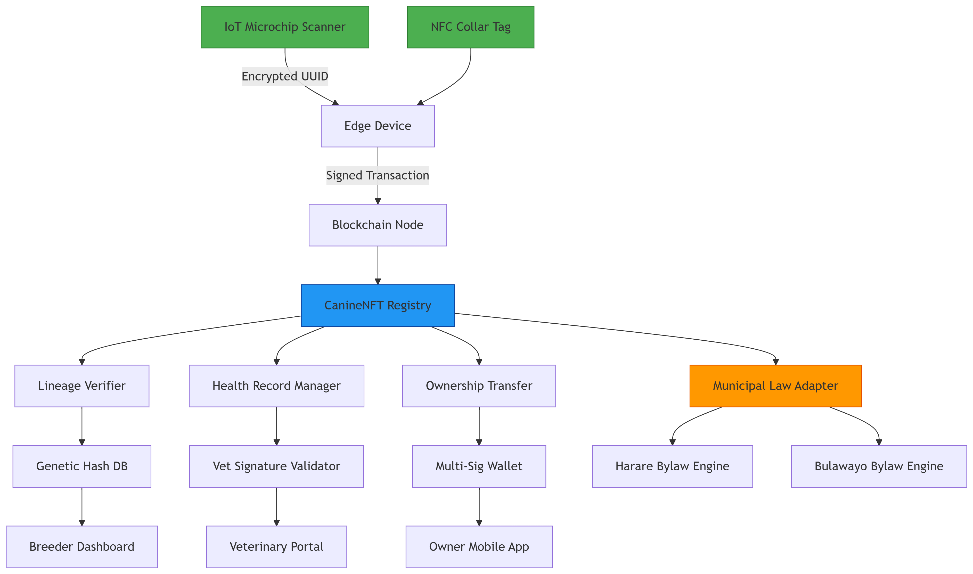
Figure 1: Visualisation of the blockchain canine registry system architecture

The blockchain-based canine registry system establishes secure hardware integration through IoT/NFC devices that communicate via encrypted channels, with edge devices performing initial data validation before processing. At its core, a modular smart contract architecture separates concerns into specialised components for lineage verification, health record management, and ownership transfers, utilising genetic hashing to prevent pedigree fraud. The system implements localised compliance through a plug-in architecture for municipal law engines that enable real-time bylaw enforcement at the protocol level. Decentralised verification mechanisms ensure trustless operation, employing veterinary ECDSA signatures for medical record authentication and multi-signature schemes for ownership transfers. This technical design effectively replaces traditional regulatory interfaces with automated law adapters, substitutes manual approvals with cryptographic proof systems, and transitions centralised validation processes to smart contract-executed operations, maintaining all critical regulatory functions while achieving full decentralisation. The architecture particularly excels in preventing data tampering through its hardware-to-blockchain cryptographic chain of custody and enables granular compliance adaptation via its modular law engine plugins.

1.3 Problem the Innovation Solves
Currently, dog registration and identity verification in many regions are:
- Paper-based, prone to forgery or loss
- Decentralised across various breeders, shelters, and veterinary offices
- Unreliable, with no unified health or pedigree verification system
- Unregulated, allowing unethical breeding and misrepresentation

This system solves these problems by creating a tamper-proof, transparent, and standardized digital identity for each dog from birth, maintained throughout its lifetime.
The application that we have developed uses smart contracts and blockchain technology to verify and store dog registry data on a blockchain contract. Establishment of provenance and authenticity is a major application of blockchain technology, yet to date, the technology is not widely used by pet animal enthusiasts. Blockchain technology is very suitable for authenticating and tracking the provenance of both purebred and rescue pet animals.
Benefits of using a decentralised application (DAPP) compared to traditional dog registries:
- Verify dog breed lineage easily
- Prevent fraud activities
- Improve transparency
- Real-time accounting
- Cost reduction for registrations
- Immutability
- Decentralised ledger accessible to the public
- Increased trust in record-keeping
- Programable system
The registry dapp tracks a puppy from broker to new owner in a single, immortal, blockchain smart contract that is accessible to all key actors in the process. For each litter the blockchain record has relevant identities, certifications and information (Figure 1). The broker or kennel club, certifies a veterinarian, and buyer/ owner are also recorded along with the certifications given by each entity.
This blockchain application introduces a heretofore unprecedented level of transparency to dog breeding and increases the confidence of dog owners in the veracity of breeding information while supporting responsible breeders, veterinarians, and brokers.

  - How It Works
1.4.1 Dog NFT Minting: When a dog is born, an authorized breeder registers it using a unique ISO microchip number. This mints a dog NFT with all associated data (breed, birth date, parents, health status, DNA hash, etc.).
    - Litter Pre-Registration: Breeders must pre-register litters, tying each puppy to certified parentage.
    - Health Record Management: Licensed veterinarians update vaccination status, sterilization records, and routine checkups via role-based access.
    - Ownership Transfer: Transfers of dog ownership are securely recorded on-chain, enabling traceable provenance.
    - Verification Access: Anyone (e.g., new buyers, regulators) can verify dog details by scanning the microchip or accessing the NFT’s metadata.

2.0 Novel Technical Components
  - Hybrid On-Chain/Off-Chain Data Structure
2.1.1 On-Chain (Immutable):
  - Microchip ID (SHA-256 hashed)
  - Ownership history (transfer events)
  - Breeder credentials (ZK-SNARK verified)
    - Off-Chain (Encrypted):
  - Full medical records (AES-256 encrypted)
  - DNA profiles (Stored on IPFS with CID on-chain)
  - High-resolution images
2.2 Municipal Law Adaptability Engine

pragma solidity ^0.8.0;

contract LawEngine {
mapping(uint256 => string) public municipalCodes; // TokenID -> Bylaw hash

function applyLocalLaw(
uint256 tokenId,
string memory bylaw,
bytes memory regulatorSig
) public {
require(_verifyRegulatorSignature(regulatorSig), "Unauthorized");
municipalCodes[tokenId] = bylaw;
emit LawUpdated(tokenId, bylaw);
}
}

- Key Differentiators
3.1 Low-Bandwidth Accessibility
  - USSD menu (*#134#<Microchip n#> for ownership checks)
  - SMS-based transfer confirmations
  - Light client syncing (<100MB storage)
  - Anti-Theft Features
  - Geofenced Ownership (GPS pings via IoT collar integration)
  - Stolen Dog Flagging (Blacklist registry with ZRP integration)
3.3 Breeding Integrity Tools
  - Genetic similarity scoring (Prevents inbreeding)
  - Litter prediction algorithms
  - Sire/Dame reputation system

4.0 Technical Specifications

Component | Implementation Detail
Blockchain | Polygon PoS (ERC-721M modified standard)
Consensus | Proof-of-Authority (Regulator nodes)
Data Storage | IPFS + Ceramic Network (StreamID)
Hardware Interface | Bluetooth/NFC microchip readers
Compliance | ISO 11784/85 + Zimbabwe Animals Act

4.1 Innovation Workflow

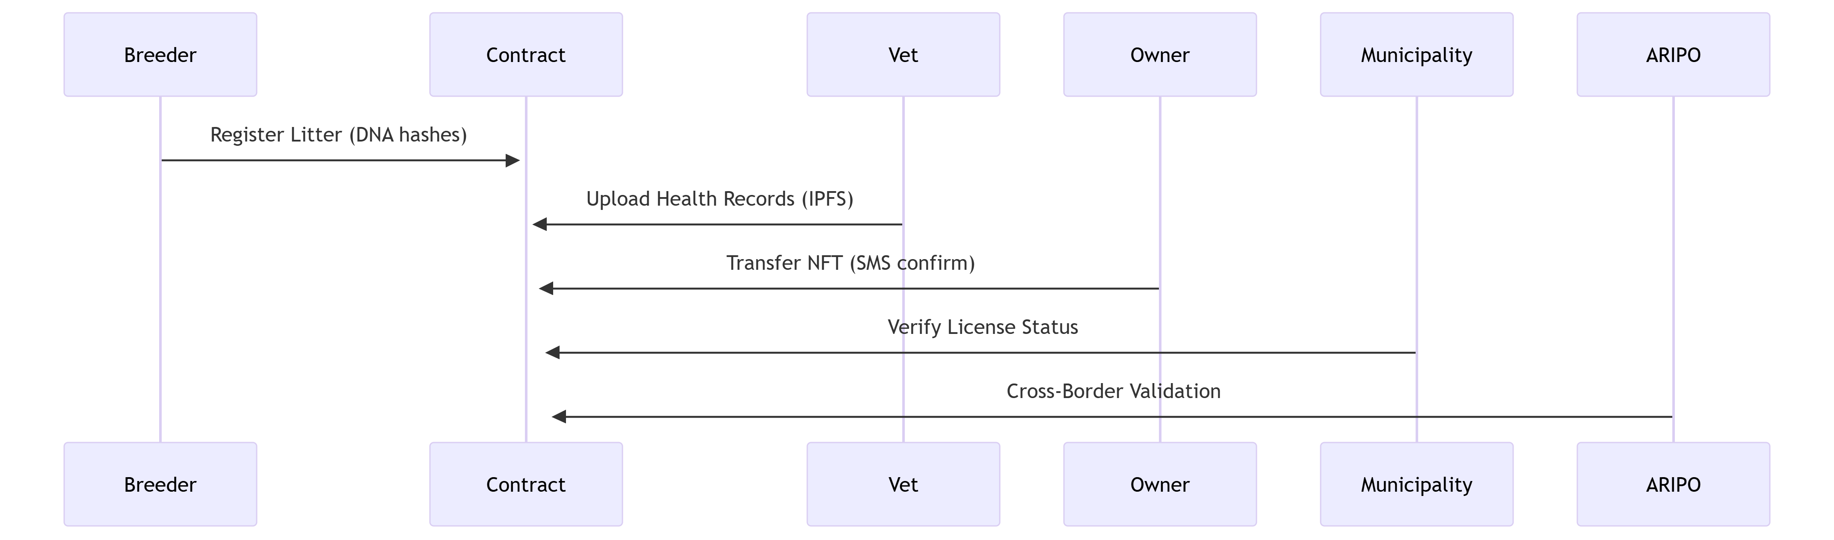
Figure 2: Innovation Workflow diagram
- Novelty Aspects
5.1 Dynamic NFT Attributes
  - Auto-updating vaccine expiry dates
  - Municipal license status changes
  - Breed certification milestones
  - Zero-Knowledge Proof System
  - Owners prove compliance without revealing private data
  - Vets verify credentials without seeing full history
5.3 Dispute Resolution DAO
  - Stake-based voting for ownership conflicts
  - Multi-sig release of disputed dogs

This system represents a significant advancement over existing paper-based registries by creating an immutable, interoperable identity layer for canines that respects both technological constraints in developing markets and international standards for animal identification. The integration of regulatory adapters specifically for Zimbabwean and VDS frameworks makes it uniquely positioned for Zimbabwean deployment.
Table 1: Components
Component | Description
Microchip Integration | Ties physical identity (ISO chip) to digital record
Immutable Health Records | Vets update vaccination & sterilization records
Lineage Tracking | Stores sire, dame, and litter data to prevent inbreeding
Ownership Ledger | Track chain of custody for each dog
Verification System | Enables buyers, shelters, and authorities to confirm authenticity

6.0 Innovation Highlights
- Decentralized Trust: Breeders and vets operate within smart-contract-defined roles, preventing tampering.
- Transparency: Buyers, shelters, and authorities can access verified dog data anytime.
- Animal Welfare Support: Enables ethical breeding, reduces disease spread, and promotes sterilization tracking.
- Regulatory Compliance: Aligns with animal protection, licensing, and biosecurity efforts.

7.0 Potential Applications
- Veterinary Networks: Standardized digital health passports.
- Government & Municipalities: Animal registration and control.
- Kennel Clubs & Breed Registries: Digital pedigree verification.
- Pet Insurance Companies: Trusted identity and medical history.
- Animal Welfare NGOs: Improved traceability of rescues and adoptions.
- Agricultural & Research Institutions: Controlled breeding for working or research dogs.

8.0 Unique Value Proposition
“Canine Registry transforms traditional dog registration into a smart, secure, and transparent digital experience — enabling traceability from birth to transfer, from kennel to vet, and from owner to owner.”

9.0 Scalability Potential
- Expandable to include cats, livestock, or exotic animals
- Interoperable with mobile apps, QR code tags, RFID readers
- Plug-and-play for shelters, vet clinics, and local governments

10.0 System Code

// SPDX-License-Identifier: GPL-3.0
pragma solidity ^0.8.0;

import "@openzeppelin/contracts/token/ERC721/ERC721.sol";
import "@openzeppelin/contracts/access/AccessControl.sol";
import "@openzeppelin/contracts/utils/Counters.sol";

contract CanineRegistry is ERC721, AccessControl {
using Counters for Counters.Counter;
Counters.Counter private _tokenIds;

bytes32 public constant BREEDER_ROLE = keccak256("BREEDER_ROLE");
bytes32 public constant VET_ROLE = keccak256("VET_ROLE");
bytes32 public constant REGULATOR_ROLE = keccak256("REGULATOR_ROLE");

struct MicrochipData {
string isoNumber;
string implantDate;
address implanter;
}

struct Lineage {
string dameId;
string sireId;
string litterId;
uint256 birthDate;
}

struct HealthRecord {
string vaccineHistory;
string sterilizationStatus;
string dnaHash;
uint256 lastCheckup;
}

struct Dog {
string name;
string breed;
MicrochipData microchip;
Lineage lineage;
HealthRecord health;
uint256 registrationDate;
address currentOwner;
address breeder;
}

mapping(uint256 => Dog) public dogs;
mapping(string => uint256) public microchipToTokenId;
mapping(string => bool) public registeredLitters;

event DogRegistered(
uint256 indexed tokenId,
address indexed owner,
string microchipNumber
);
event OwnershipTransferred(
uint256 indexed tokenId,
address indexed from,
address indexed to
);
event HealthUpdated(uint256 indexed tokenId, address indexed vet);
event BreederVerified(address indexed breeder, string kennelId);

constructor() ERC721("ZimbabweCanineRegistry", "ZCR") {
_setupRole(DEFAULT_ADMIN_ROLE, msg.sender);
}

function registerDog(
string memory name,
string memory breed,
string memory isoMicrochip,
string memory implantDate,
string memory dameId,
string memory sireId,
string memory litterId,
uint256 birthTimestamp,
string memory vaccineInfo,
string memory dnaHash,
string memory tokenURI
) public onlyRole(BREEDER_ROLE) returns (uint256) {
require(microchipToTokenId[isoMicrochip] == 0, "Microchip already registered");
require(bytes(litterId).length > 0, "Litter ID required");
require(registeredLitters[litterId], "Litter not pre-registered");

_tokenIds.increment();
uint256 newTokenId = _tokenIds.current();

_mint(msg.sender, newTokenId);
_setTokenURI(newTokenId, tokenURI);

dogs[newTokenId] = Dog({
name: name,
breed: breed,
microchip: MicrochipData(isoMicrochip, implantDate, msg.sender),
lineage: Lineage(dameId, sireId, litterId, birthTimestamp),
health: HealthRecord(vaccineInfo, "Not Sterilized", dnaHash, block.timestamp),
registrationDate: block.timestamp,
currentOwner: msg.sender,
breeder: msg.sender
});

microchipToTokenId[isoMicrochip] = newTokenId;
emit DogRegistered(newTokenId, msg.sender, isoMicrochip);
return newTokenId;
}

function transferOwnership(
uint256 tokenId,
address newOwner
) public {
require(_isApprovedOrOwner(msg.sender, tokenId), "Not owner nor approved");
dogs[tokenId].currentOwner = newOwner;
_transfer(ownerOf(tokenId), newOwner, tokenId);
emit OwnershipTransferred(tokenId, ownerOf(tokenId), newOwner);
}

function updateHealthRecord(
uint256 tokenId,
string memory vaccines,
string memory sterilizationStatus
) public onlyRole(VET_ROLE) {
dogs[tokenId].health.vaccineHistory = vaccines;
dogs[tokenId].health.sterilizationStatus = sterilizationStatus;
dogs[tokenId].health.lastCheckup = block.timestamp;
emit HealthUpdated(tokenId, msg.sender);
}

function registerLitter(
string memory litterId,
string memory dameMicrochip,
string memory sireMicrochip,
uint256 expectedBirthDate
) public onlyRole(BREEDER_ROLE) {
require(microchipToTokenId[dameMicrochip] != 0, "Dame not registered");
require(microchipToTokenId[sireMicrochip] != 0, "Sire not registered");
registeredLitters[litterId] = true;
}

function verifyBreeder(
address breederAddress,
string memory kennelId
) public onlyRole(REGULATOR_ROLE) {
grantRole(BREEDER_ROLE, breederAddress);
emit BreederVerified(breederAddress, kennelId);
}

function verifyVet(address vetAddress) public onlyRole(REGULATOR_ROLE) {
grantRole(VET_ROLE, vetAddress);
}

function getDogByMicrochip(string memory microchip) public view returns (Dog memory) {
return dogs[microchipToTokenId[microchip]];
}

function supportsInterface(bytes4 interfaceId)
public
view
override(ERC721, AccessControl)
returns (bool)
{
return super.supportsInterface(interfaceId);
}
}

Glossary of Terms

Access Control
A method of restricting system access to authorised users, ensuring that only breeders, veterinarians, or regulators can perform specific actions within the platform.

AES-256 Encryption
An advanced encryption standard used to secure data, offering 256-bit key length for high-level protection of sensitive off-chain health and DNA records.

Blockchain
A decentralised, distributed ledger technology that records transactions in a secure, immutable way across multiple nodes.

Canine Registry
A structured system for recording and verifying the identity, ownership, lineage, and health records of dogs.

Chainlink
A decentralised oracle network used to securely connect smart contracts with real-world data and off-chain systems.

DAO (Decentralized Autonomous Organization)
An organisation governed by smart contracts and community votes without centralised leadership; in this system, it handles dispute resolution.

Decentralised Application (DApp)
A software application that runs on a blockchain or peer-to-peer network instead of a centralised server.

ECDSA (Elliptic Curve Digital Signature Algorithm)
A cryptographic algorithm is used to authenticate data, ensuring that veterinarians' health record updates are genuine.

ERC-721
A token standard on the Ethereum blockchain for creating unique, non-fungible tokens (NFTs) that represent individual assets, such as dogs.

Filecoin
A decentralised storage network used to securely store off-chain data like medical records and images.

IPFS (InterPlanetary File System)
A decentralised protocol and network for storing and sharing data in a distributed file system used for off-chain data storage.

IoT (Internet of Things)
Networked physical devices (like microchip scanners or GPS collars) used to collect and transmit data about dogs in real-time.

ISO 11784/85
International standards for animal identification using RFID-compatible microchips.

Metadata
Data that provides information about other data; for example, a dog NFT's metadata includes breed, birthdate, microchip number, etc.

Microchip
A small RFID implant placed under a dog’s skin, containing a unique identifier used for digital identity mapping.

Multi-Signature (Multi-sig)
A security feature requiring multiple parties to approve an action (e.g., ownership transfer or dispute resolution).

NFT (Non-Fungible Token)
A unique digital token that represents ownership of a specific asset, in this case, an individual dog’s identity on the blockchain.

Polygon
A scalable, eco-friendly blockchain protocol used for deploying smart contracts in this system.

Proof-of-Authority (PoA)
A blockchain consensus algorithm where validators are pre-approved and trusted, suitable for regulatory systems.

QR Code
A machine-readable code used to quickly access a dog’s identity or vaccination status via a scan.

Smart Contract
A blockchain-based self-executing program that enforces rules and logic (e.g., verifying breeders or recording ownership).

Sterilization
The medical procedure (spaying or neutering) to prevent animals from reproducing, tracked in the digital registry.

TokenURI
A unique link associated with an NFT that stores its metadata.

USSD (Unstructured Supplementary Service Data)
A protocol used by GSM cellular networks to communicate with the service provider's computers; in this context, it allows access to the registry without the internet.

Veterinary Health Record
A digital record capturing vaccination, sterilisation, and medical history of each registered dog, updated by authorised vets.

ZK-SNARK (Zero-Knowledge Succinct Non-Interactive Argument of Knowledge)
A privacy-preserving cryptographic proof that allows someone to prove possession of information (e.g., breeder credentials) without revealing the information itself.

ZRP
Zimbabwe Republic Police – a proposed integration partner for stolen dog flagging and verification.

