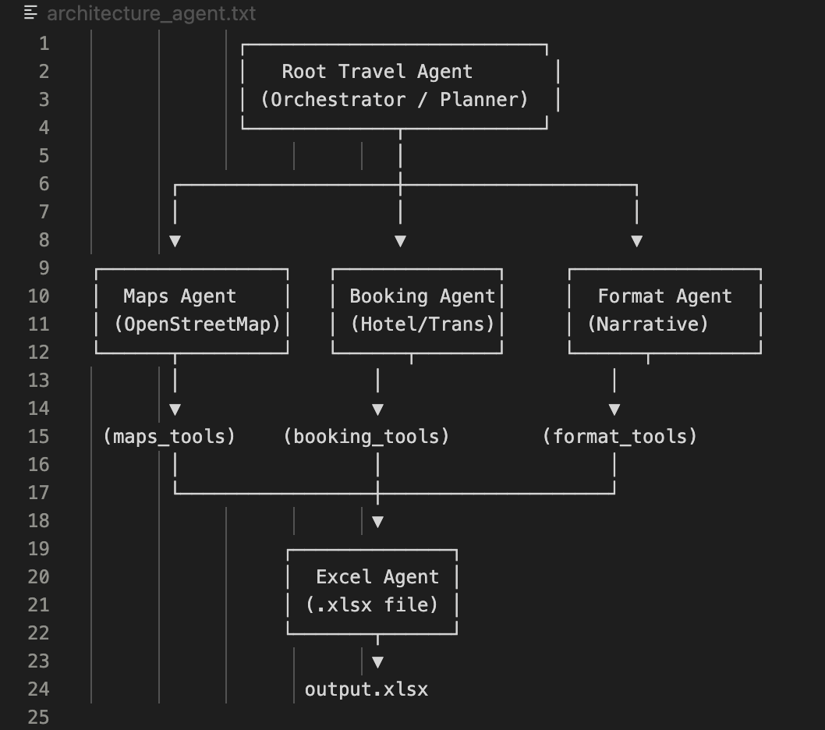

Library Requirements:
google-adk
google-genai
penpyxl requests
python-dotenv

Root Agent: travel_agent.py
import os
from dotenv import load_dotenv

from google.adk.agents import Agent
from google.adk.models.google_llm import Gemini
from google.adk.runners import InMemoryRunner
from google.adk.tools import google_search
from google.genai import types

# Load API key
load_dotenv()

# Setup environment
os.environ["GOOGLE_API_KEY"] = os.getenv("GOOGLE_API_KEY")

retry_config = types.HttpRetryOptions(
attempts=5, # Maximum retry attempts
exp_base=7, # Delay multiplier
initial_delay=1, # Initial delay before first retry (in seconds)
http_status_codes=[429, 500, 503, 504] # Retry on these HTTP errors
)

root_agent = Agent(
name="travel_itinerary_agent",
model=Gemini(
model="gemini-2.0-flash",
retry_options=retry_config
),
description="A simple agent that can answer general questions.",
instruction="You are NaviTrip, a friendly and organized travel-planner AI agent. "
"You create detailed, realistic travel itineraries using efficient routing, "
"estimating costs, and adapting to the user's preferences and constraints. "
"You always ask clarifying questions if needed, but if enough data is provided, "
"you generate a full itinerary without asking again. "
"Your responses should be in Indonesian language.",
tools=[google_search],
)

runner = InMemoryRunner(agent=root_agent)

# Add this handler for adk web
@root_agent.on_message
async def handle_message(message: str) -> str:
"""Handle incoming user messages"""
response = await runner.run(message)
return response

Subagent:
- Booking Agent
# booking_agent.py
from google.adk.agents.llm_agent import Agent
from tools.hotel_tool import search_hotels
from tools.transport_tool import search_transport

booking_agent = Agent(
model="gemini-2.5-flash-lite",
name="booking_agent",
description="Agent untuk mencari hotel, tiket transport, dan link pemesanan.",
instruction=(
"Kamu adalah BookingAgent. "
"Tugasmu mencari hotel dan transport yang relevan berdasarkan preferensi user, "
"memberikan rekomendasi harga, rating, lokasi, dan link pemesanan. "
"Gunakan tools yang tersedia. Semua output dalam bahasa Indonesia."
),
tools=[search_hotels, search_transport]
)

- Maps Agent
# maps_agent.py
from google.adk.agents.llm_agent import Agent
from tools.google_maps_tool import (
google_places_search,
google_distance_matrix,
google_geocode,
)

maps_agent = Agent(
model="gemini-2.5-flash-lite",
name="maps_agent",
description="Agent khusus untuk pencarian lokasi, jarak, estimasi waktu tempuh, dan routing.",
instruction=(
"Kamu adalah MapsAgent. "
"Gunakan tools yang tersedia untuk mencari lokasi wisata, hotel, restoran, "
"menghitung jarak dan waktu tempuh, serta membuat rute paling efisien. "
"Semua output dalam bahasa Indonesia."
),
tools=[google_places_search, google_distance_matrix, google_geocode]
)

- Excel Agent
# excel_agent.py
from google.adk.agents.llm_agent import Agent
from tools.excel_writer_tool import generate_excel

excel_agent = Agent(
model="gemini-2.5-flash-lite",
name="excel_agent",
description="Agent untuk membuat file itinerary dalam format Excel.",
instruction=(
"Kamu ExcelAgent. "
"Jika mendapat data itinerary, konversikan menjadi file .xlsx melalui tool."
),
tools=[generate_excel]
)

- Format Agent
# format_agent.py
from google.adk.agents.llm_agent import Agent

format_agent = Agent(
model="gemini-2.5-flash-lite",
name="format_agent",
description="Agent untuk merapikan dan menyusun itinerary menjadi format yang rapi.",
instruction=(
"Kamu FormatAgent. "
"Tugasmu menggabungkan data dari MapsAgent dan BookingAgent menjadi itinerary "
"yang runtut, jelas, dan mudah dibaca. Gunakan bahasa Indonesia yang natural."
)
)

Tools:
- Maps_tool
# tools/google_maps_tool.py
import os
import requests
from google.adk.tools import tool

GOOGLE_KEY = os.getenv("GOOGLE_API_KEY")

PLACES_FIND_URL = "https://maps.googleapis.com/maps/api/place/findplacefromtext/json"
PLACE_DETAILS_URL = "https://maps.googleapis.com/maps/api/place/details/json"
DIST_MATRIX_URL = "https://maps.googleapis.com/maps/api/distancematrix/json"

@tool
def places_search(query: str, country_bias: str = "") -> dict:
"""
Cari tempat berdasarkan teks, kembalikan structured dict:
{
"name": "...",
"address": "...",
"lat": ...,
"lng": ...,
"place_id": "...",
"types": [...]
}
"""
if not GOOGLE_KEY:
raise RuntimeError("GOOGLE_API_KEY not set in environment")

params = {
"input": query,
"inputtype": "textquery",
"fields": "place_id,formatted_address,name,geometry,types",
"key": GOOGLE_KEY,
}
if country_bias:
params["region"] = country_bias

r = requests.get(PLACES_FIND_URL, params=params, timeout=10)
r.raise_for_status()
data = r.json()

candidates = data.get("candidates", [])
if not candidates:
return {"error": "no results", "query": query, "raw": data}

c = candidates[0]
geometry = c.get("geometry", {}).get("location", {})
return {
"name": c.get("name"),
"address": c.get("formatted_address"),
"lat": geometry.get("lat"),
"lng": geometry.get("lng"),
"place_id": c.get("place_id"),
"types": c.get("types", []),
}

@tool
def distance_matrix(origins: list, destinations: list, mode: str = "driving") -> dict:
"""
origins/destinations : list of dicts with keys 'lat' and 'lng' or strings "lat,lng"
returns structured results for each pair
"""
if not GOOGLE_KEY:
raise RuntimeError("GOOGLE_API_KEY not set in environment")

def fmt(coord):
if isinstance(coord, str):
return coord
return f"{coord['lat']},{coord['lng']}"

origins_s = "|".join(fmt(o) for o in origins)
dest_s = "|".join(fmt(d) for d in destinations)

params = {
"origins": origins_s,
"destinations": dest_s,
"mode": mode,
"key": GOOGLE_KEY,
"units": "metric"
}
r = requests.get(DIST_MATRIX_URL, params=params, timeout=10)
r.raise_for_status()
data = r.json()

# Basic sanity check and simpler structure
out = []
rows = data.get("rows", [])
for i, row in enumerate(rows):
elements = row.get("elements", [])
row_out = []
for j, el in enumerate(elements):
status = el.get("status")
if status == "OK":
row_out.append({
"distance_text": el["distance"]["text"],
"distance_meters": el["distance"]["value"],
"duration_text": el["duration"]["text"],
"duration_seconds": el["duration"]["value"],
"status": "OK",
})
else:
row_out.append({"status": status})
out.append(row_out)

return {"raw": data, "matrix": out}

- Booking tool
# tools/booking_tool.py
import urllib.parse
from google.adk.tools import tool

@tool
def generate_hotel_booking_links(hotel_name: str, city: str) -> dict:
"""
Return template booking search URLs for common OTAs.
"""
q = urllib.parse.quote_plus(f"{hotel_name} {city}")
return {
"booking_com": f"https://www.booking.com/searchresults.html?ss={q}",
"agoda": f"https://www.agoda.com/search?searchTerm={q}",
"traveloka": f"https://www.traveloka.com/en-en/hotel/search?keyword={q}"
}

@tool
def generate_transport_links(origin: str, destination: str, date: str = "") -> dict:
"""
Simple transport links templates; extend with APIs if available
"""
orig = urllib.parse.quote_plus(origin)
dest = urllib.parse.quote_plus(destination)
base_flight = f"https://www.traveloka.com/en-id/flights?origin={orig}&destination={dest}"
return {
"traveloka_flight": base_flight,
"google_maps_directions": f"https://www.google.com/maps/dir/?api=1&origin={orig}&destination={dest}"
}

- Excel tool
# tools/excel_tool.py
import os
import tempfile
from datetime import datetime
from google.adk.tools import tool
from openpyxl import Workbook
from openpyxl.utils import get_column_letter

@tool
def generate_excel_itinerary(itinerary: list, filename_prefix: str = "itinerary") -> str:
"""
itinerary: list of dicts, each dict example:
{
"day": "Day 1",
"time": "08:00",
"activity": "Sarapan",
"location": "Kopi Kenangan",
"maps_url": "...",
"booking_url": "...",
"cost": "Rp 50.000",
"notes": "..."
}
Returns absolute path to generated xlsx file.
"""
wb = Workbook()
ws = wb.active
ws.title = "Itinerary"

headers = ["Day", "Time", "Activity", "Location", "Google Maps URL", "Booking Link", "Estimated Cost", "Notes"]
ws.append(headers)

for row in itinerary:
ws.append([
row.get("day", ""),
row.get("time", ""),
row.get("activity", ""),
row.get("location", ""),
row.get("maps_url", ""),
row.get("booking_url", ""),
row.get("cost", ""),
row.get("notes", "")
])

# autosize columns
for i, col in enumerate(ws.columns, 1):
max_length = 0
for cell in col:
try:
if cell.value:
max_length = max(max_length, len(str(cell.value)))
except:
pass
ws.column_dimensions[get_column_letter(i)].width = max_length + 3

t = datetime.now().strftime("%Y%m%d_%H%M%S")
fname = f"{filename_prefix}_{t}.xlsx"
tmp_dir = tempfile.gettempdir()
path = os.path.join(tmp_dir, fname)
wb.save(path)
return os.path.abspath(path)

- Excel writer tool
# excel_writer_tool.py
from google.adk.tools import tool
import openpyxl
from openpyxl.utils import get_column_letter

@tool
def generate_excel(itinerary: dict, filename: str = "itinerary.xlsx"):
"""
itinerary = {
"Hari 1": [
{"jam": "08:00", "aktivitas": "Sarapan", "lokasi": "Hotel", "maps_url": "..."},
...
]
}
"""
wb = openpyxl.Workbook()
ws = wb.active
ws.title = "Itinerary"

ws.append(["Hari", "Jam", "Aktivitas", "Lokasi", "Maps URL"])

for hari, kegiatan_list in itinerary.items():
for k in kegiatan_list:
ws.append([
hari,
k.get("jam"),
k.get("aktivitas"),
k.get("lokasi"),
k.get("maps_url")
])

wb.save(filename)
return {"file": filename, "status": "success"}

- Format tool
# tools/format_tool.py
from google.adk.tools import tool

@tool
def validate_itinerary(itinerary) -> dict:
"""
Validate and normalize itinerary structure.
Returns dict: { "ok": True/False, "errors": [], "itinerary": normalized_list }
"""
errors = []
normalized = []
if not isinstance(itinerary, list):
return {"ok": False, "errors": ["itinerary must be a list"], "itinerary": []}

for idx, row in enumerate(itinerary):
if not isinstance(row, dict):
errors.append(f"row {idx} is not a dict")
continue
# minimal normalization
normalized.append({
"day": row.get("day", ""),
"time": row.get("time", ""),
"activity": row.get("activity", ""),
"location": row.get("location", ""),
"maps_url": row.get("maps_url", ""),
"booking_url": row.get("booking_url", ""),
"cost": row.get("cost", ""),
"notes": row.get("notes", "")
})

return {"ok": len(errors) == 0, "errors": errors, "itinerary": normalized}

- Hotel tool
# hotel_tool.py
from google.adk.tools import tool

# Mock data (karena Traveloka/Agoda tidak punya public API)
HOTEL_DB = [
{
"name": "Hotel Harmoni Puncak",
"price": 550000,
"rating": 4.3,
"location": "Puncak, Bogor",
"booking_url": "https://www.booking.com/hotel-harmoni"
},
{
"name": "Green Forest Resort",
"price": 800000,
"rating": 4.7,
"location": "Cisarua, Puncak",
"booking_url": "https://www.agoda.com/green-forest"
}
]

@tool
def search_hotels(location: str, max_price: int = None):
filtered = []
for hotel in HOTEL_DB:
if location.lower() in hotel["location"].lower():
if max_price is None or hotel["price"] <= max_price:
filtered.append(hotel)
return filtered

- Transport tool
# transport_tool.py
from google.adk.tools import tool

TRANSPORT_DB = [
{
"type": "Kereta",
"route": "Jakarta → Bogor",
"price": 20000,
"booking_url": "https://tiket.com/kereta"
},
{
"type": "Travel",
"route": "Jakarta → Puncak",
"price": 150000,
"booking_url": "https://traveloka.com/travel"
}
]

@tool
def search_transport(origin: str, destination: str):
results = []
for t in TRANSPORT_DB:
if origin.lower() in t["route"].lower() and destination.lower() in t["route"].lower():
results.append(t)
return results

