Software Design
Specification

LDAP Project
Jonathan Smith

Table of Contents
Table of Contents ii
Revision History iii
1. Introduction 1
1.1 Purpose 1
1.2 System Overview 1
1.3 Design Map 1
1.4 Definitions and Acronyms 1
2. Design Considerations 1
2.1 Assumptions 2
2.2 Constraints 2
2.3 System Environment 2
3. Architecture 3
3.1 Overview 3
3.2 Subsystem, Component, or Projects. 3
3.3 Design / Architectural Patterns and Strategies 4

Revision History
Version | Name | Reason For Changes | Date
1.0 | Jonathan Smith | Initial Revision | 8/20/2016

Introduction

Purpose
The purpose or this document is to explain some of the design / architectural decisions about the overall project.

System Overview
The system allows custom authentication and authorization based upon an LDAP directory. In an organization, users and groups are stored in an LDPA directory. All the intranet applications are supposed to use this directory for authentication and authorization to implement SSO. The LDAP project is a common system for these applications to use for such authentication and authorization.

Design Map
The present document presents the design considerations expressed in the requirements document, as well as explaining the architecture and some of the design patterns used.

Definitions and Acronyms
Lightweight Directory Access Protocol (LDAP) is a client/server protocol used to access and manage directory information. It reads and edits directories over IP networks and runs directly over TCP/IP using simple string formats for data transfer.

Single sign-on (SSO) is a session and user authentication service that permits a user to use one set of login credentials (e.g., name and password) to access multiple applications.

Design Considerations
The design considerations are based on the requirements document and include:

- Create a web application that
  - Contains a log in page where users accessing intranet applications are redirected for authentication, it authenticates using a web service

- Create a web service that
  - Authenticate users against the LDAP directory, for the log in page
  - Keeps track of currently authenticated users, for later validations
  - Provides authorization data like user groups

- Create an http module that
  - Can be installed either on IIS for all applications or be enabled in a specific application
  - Provides custom authentication an authorization for the .NET applications using the web service
  - Authenticates every request to an application

- Create two single-page test applications
  - To test the system using the http module
  - Can display data like logged in user and user’s groups
  - A user if logged-in into one application, he should be able to use the other application without re-login

Assumptions
- The authentication method was not specified in the requirements, so it’s safe to assume that any method is a valid method. The method used in the LDAP project is the Forms authentication method.

Constraints
- For the testing of the project, an online free LDAP server was used. That implies that there were some limitations as to what the configuration of the server and users were.

System Environment
The system environment consisted in:

- Visual Studio Community 2015, for development
- Ldapadmin LDAP browser, to test the LDAP server
- An online Ldap test server. More info about the free test server on their site at: http://www.forumsys.com/en/tutorials/integration-how-to/ldap/online-ldap-test-server/

Architecture

Overview
The solution is composed of 7 different projects, 4 of which are testing projects

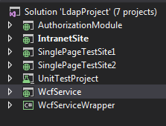
The projects are:
- A service project that communicates with the LDAP server
- A service wrapper that reference the service project and is consumed by the other applications
- An authorization module that defines an HTTP module
- Three testing sites
- An unit test project

Subsystem, Component, or Projects.
For the solution, only 3 main projects represent the core of the business logic. The web service that authenticates against the LDAP server, a service wrapper around the web service and the Http module to intercept all request and authenticate them as needed.

The following diagram shows the mapping between the different projects:
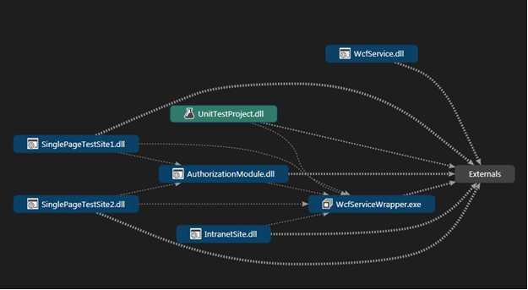

One of the design decisions for this project was to implement against interfaces and not base classes, to make the modules more granular. The following diagrams show the class diagram for several of the projects.
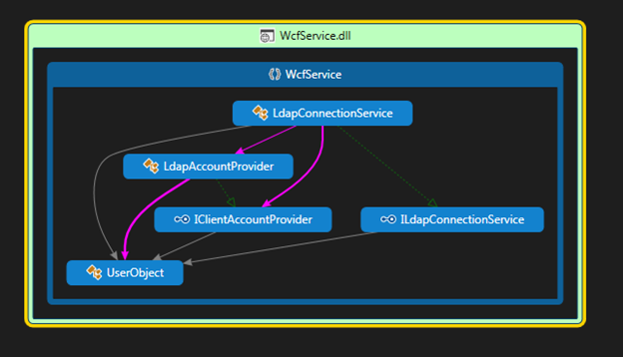

Design / Architectural Patterns and Strategies
Among some of the design / architectural patterns included in the solution are:

- The Façade pattern: to create a wrapper around the service and expose only the method important for this particular solution. It provides as well a separation between the service and the rest of the application, giving it a single entry point.

- The MVC pattern: this architectural pattern provides great separation of concerns for the application making it easier to manage its different components.

- The Repository pattern and The Unit of Work pattern: although this is a small project, this pattern helps avoid the coupling of the business logic and the model entities and the controllers.

The authentication method used for the project was the forms authentication, since is very easy to implement and works very well with the .NET framework.

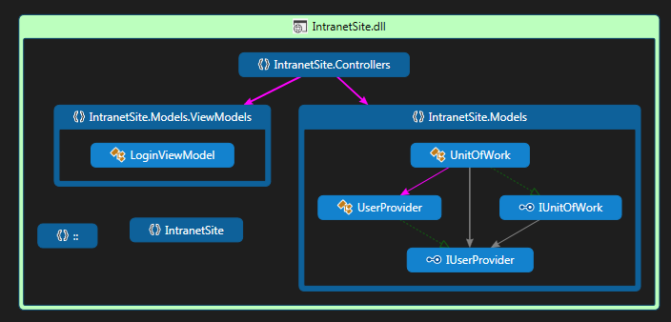

As a result of the design / architectural decisions made, the result is a code highly maintainable and with very defined separation of concerns.

