Software Design
Specification

Stock Exchange Project
Jonathan Smith

Table of Contents
Table of Contents ii
Revision History iii
1. Introduction 1
1.1 Purpose 1
1.2 System Overview 1
1.3 Design Map 1
1.4 Definitions and Acronyms 1
2. Design Considerations 1
2.1 Assumptions 2
2.2 Constraints 2
2.3 System Environment 2
3. Architecture 3
3.1 Overview 3
3.2 Subsystem, Component, or Projects. 3
3.3 Design / Architectural Patterns and Strategies 5

Revision History
Version | Name | Reason For Changes | Date
1.0 | Jonathan Smith | Initial Revision | 9/27/2016

Introduction

Purpose
The purpose or this document is to explain some of the design / architectural decisions about the overall project.

System Overview
The system is a stock exchange simulator for different users with customizable stock ticker. The system allows users to register and log into the system to manage stocks. The stock prices are retrieved from an ASMX service and refreshed every 10 seconds.

Design Map
The present document presents the design considerations expressed in the requirements document, as well as explaining the architecture and some of the design patterns used.

Definitions and Acronyms
Web Service (ASMX) is a software system designed to support interoperable machine-to-machine interaction over a network.

Design Considerations
The design considerations are based on the requirements document and include:

- Create a ASMX web service that
  - Exposes a method for returning stock prices for a list of stock codes. Each stock price is a random integer between 1 and 1000.
  - Is secured. Only authorized clients can call it. Any form of security is valid.

- Create a web application where
  - Users could register themselves.
  - Users should be able to login. Any authentication provider is valid, even custom.
  - Users can add or delete stock codes to their personalized list.
  - Users can see their stock codes along with their current prices. The prices are taken from the stock exchange service. The prices should auto refresh every 10 seconds.
  - The application have validation and constraints wherever necessary to create a stable application
  - The application connects to the service using the service exposed security mechanism.
  - The application have a database where user stock list is stored

Assumptions
- The web application needs to pass some sort of credentials/token to the service in order to use it.
- An error will be thrown if a user tries to consume the wen service without authenticating first.

Constraints
- The Web service must be ASMX, it cannot be WCF.

System Environment
The system environment consisted in:

- Visual Studio Community 2015, for development
- SQL Server 2012, for persistent storage

Architecture

Overview
The solution is composed of 3 different projects, 1 of which is a testing project

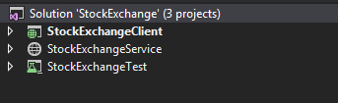

The projects are:
- A service project that provides the prices for the stock codes
- A web application that simulates a stock exchange and consumes the service
- An unit test project

Subsystem, Component, or Projects.
For the solution, only 2 main projects represent the core of the business logic. The web service that provides the stock prices, and the web application that simulates the stock exchange with the ticker.

The following diagram shows the mapping between the different projects:
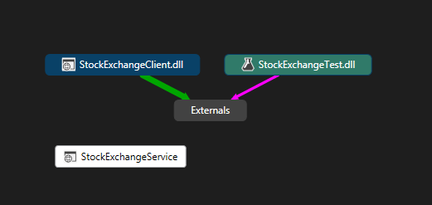

The following diagram shows the components and the dependencies between them:

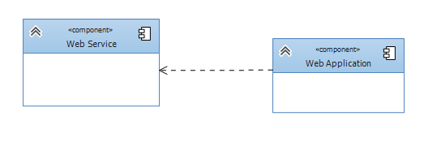

One of the design decisions for this project was to implement against interfaces and not base classes, to make the modules more granular. The following diagrams show the class diagram structure for project.

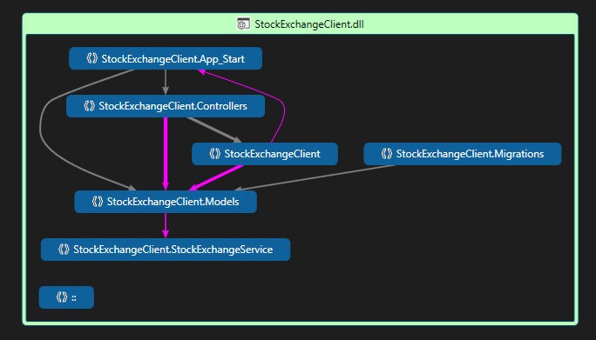
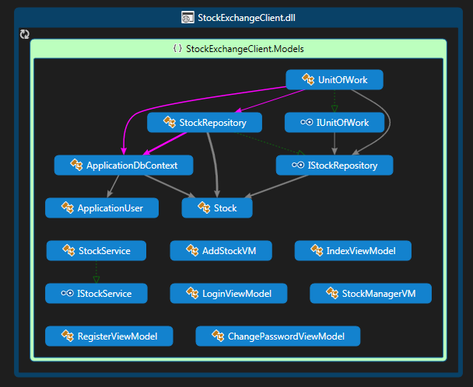

Design / Architectural Patterns and Strategies
Among some of the design / architectural patterns included in the solution are:

- The Proxy pattern: to create an interface between the real service and the service the application could use. The invocation to the real service happens in the proxy and the application then consumes the service through the proxy.

- The MVC pattern: this architectural pattern provides great separation of concerns for the application making it easier to manage its different components.

- The Repository pattern and The Unit of Work pattern: although this is a small project, this pattern helps avoid the coupling of the business logic and the model entities and the controllers.

- The Inversion of Control pattern and the Dependency Injection pattern: is a clean decoupled way of resolving dependencies and thus complying with the single responsibility principle.
The authentication method used for the web application was the forms authentication, since is very easy to implement and works very well with the .NET framework. The service, since is consumed through the client, utilizes authorization action filter to prevent unauthorized users to access the service. As an extra measure of authentication, with every request, the username is sent to the web service and then validated against the registered users in the database in order to allow only registered users to access the web service methods.

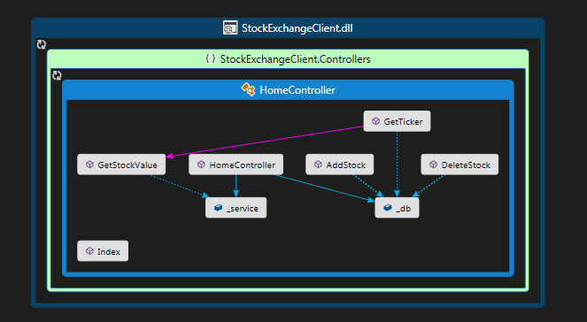

For the logging functionality, the ELMAH library was used. With this framework every error gets logged into the database and only the authenticated users can have access to the error logs available at elmah.axd

The logs can be exported and an RSS feed can be setup to receive emails with the errors, when those occur.

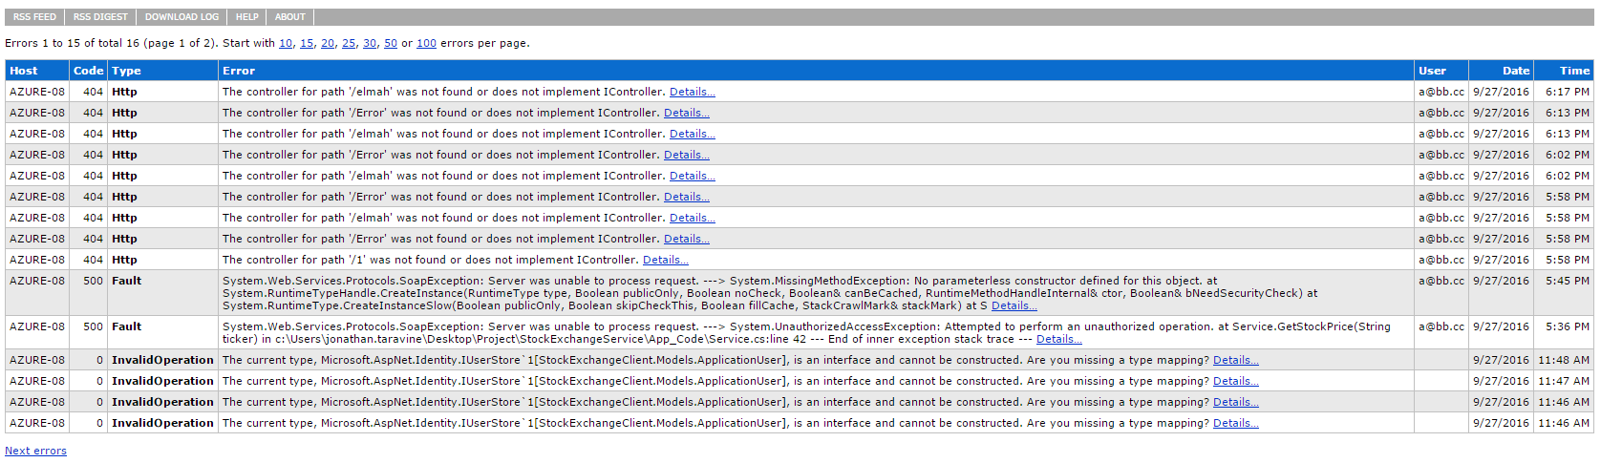

For the unit testing, the MOQ library was used to help mock request and controller states for the application. The dependency injection pattern helped test unique features in every scenario.

The following is a sequence diagram for the service process:

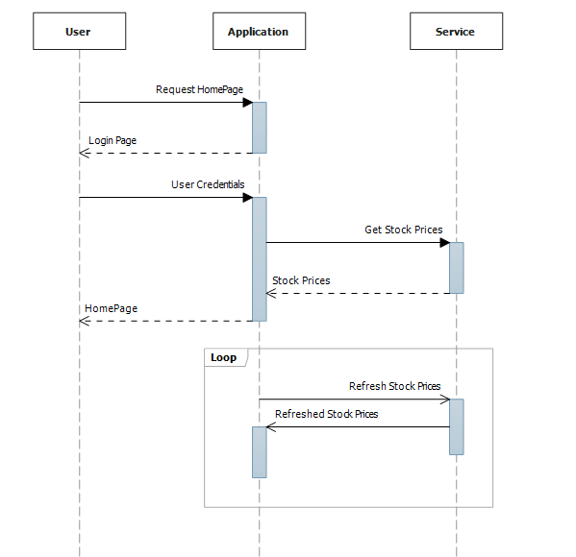

As a result of the design / architectural decisions made, the result is a code highly maintainable and with very defined separation of concerns.

