**Assignment #1. HTML Basics (Page Structure)**

Student: Baimyrza Tarlan

Group: IT-2404

**Objective:**

By the end of this assignment, students will be able to:

* Understand the structure and purpose of HTML.
* Use basic and intermediate HTML tags to create a simple webpage.
* Apply knowledge of text formatting, images, links, lists, tables, and forms.
* Publish their first webpage online.

**Rules for Submission:**

1. The assignment must be completed individually. If you have the same paperwork with other students, you will have 0 to this work.
2. The assignment must be submitted by the deadline which is specified in the lms.astanait.edu.kz. Works submitted after the deadline will not be accepted! To receive a grade, you must submit by deadline and defend your work at practice lesson time.
3. SUBMIT REPORT(DOC FILE) AND YOUR PROJECT FOLDER IN ZIP FORMAT. Ensure that the project runs without errors.

IN REPORT SHOULD BE:

* YOUR NAME, GROUP
* All parts with screens(write part, task and then add screen)
* Brief summary of your work process

**Setup Instructions:**

1. Install VS Code (or another code editor).

The link to download: <https://code.visualstudio.com/download>

1. Create a folder for the project (e.g. assignment1)

**Part 1. Introduction to HTML**

**Step 0. Create a new HTML file named index.html**

* Add the basic HTML boilerplate (<!DOCTYPE html>, <html>, <head>, <title>, <body>).
* Title your page as "My First Webpage".

Comment: I created a new HTML file named index.html. I added the basic HTML boilerplate including <!DOCTYPE html>, <html>, <head>, <title>, and <body>. The page title was set to **"My First Webpage"**.

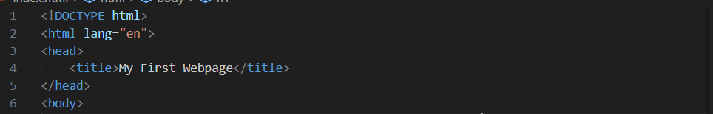

**Step 1. Structure text using HTML tags**

* Add headings <h1> to <h3> with your name, course, and "About Me".
* Add a short paragraph <p> describing yourself.

Comment: I used heading tags <h1> to <h3> to display my name, course, and section headings. I also wrote a short paragraph <p> about myself.

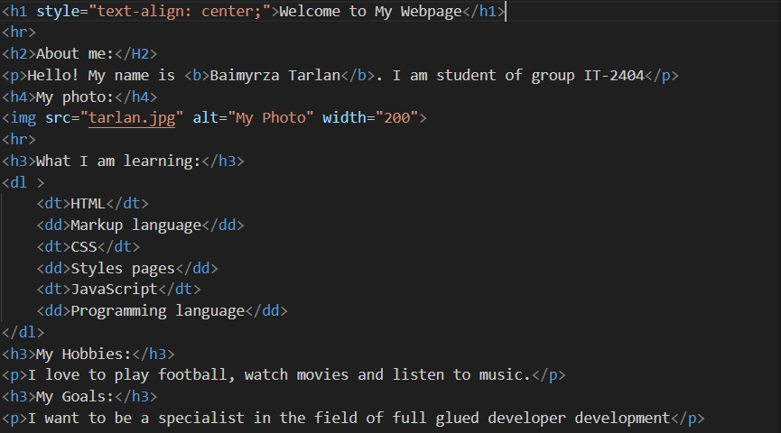

**Step 2. HTML Lists**

* Create an ordered list <ol> of your hobbies.
* Create an unordered list <ul> of your favorite websites.

Comment: I added all three types of lists:

* An **unordered list <ul>** for favorite music.

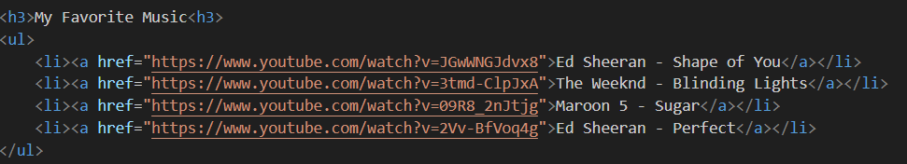

* An **ordered list <ol>** for favorite movies.

* A **description list <dl>** for learning skills

This showed how HTML supports all types of bullet lists ,numbered lists and description lists.

**Step 3. Images and Links**

* Insert your photo using the <img> tag.
* Add at least two clickable links with <a> (e.g., to your favorite websites).

Comment: I inserted my personal photo with the <img> tag. I also added multiple clickable links <a> that lead to my telegram, music videos and movies.



**Step 4. HTML Buttons**

* Add a simple button with text "Click Me". (No functionality required yet).

Comment: I included a button labeled **"Contact on WhatsApp"** which opens a WhatsApp chat when clicked.



**Part 2. Intermediate HTML**

**Step 5. Tables**

* Create a table with 3 columns: "Subject", "Day", "Time".
* Fill in a simple weekly schedule.

Comment: I created a table with 3 columns: **Day, Activity, Time**. This displayed my weekly schedule in a structured format.

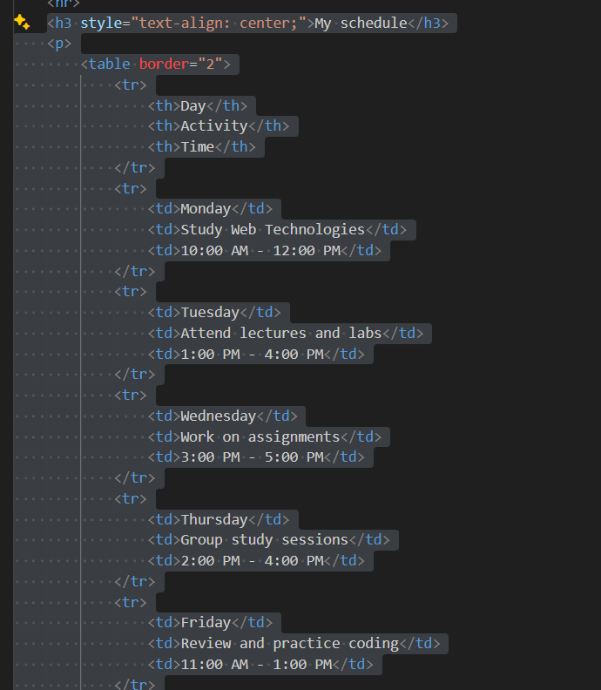

**Step 6. Using Tables for Layout (Optional Challenge)**

* Create a two-column layout using a table: left column (menu), right column (main content).

Comment: I experimented with a nested table to create a **menu vs. content layout**. The left column had “menu”, while the right column displayed food and drinks.

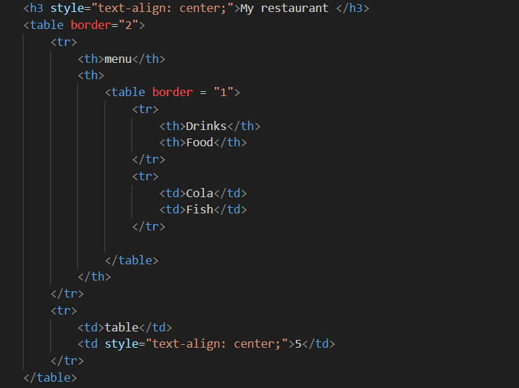

**Step 7. Typing Emojis**

Add at least 3 emojis inside a paragraph about your mood today.

Comment: I used HTML entity codes to show emojis representing my mood for different days of the week inside a table.

**Step8. HTML Forms**

* Create a form with the following fields:
  + Name (text input)
  + Email (email input)
  + Favorite Color (color input)
  + A Submit button

Comment: I built a contact form with the following inputs:

* Name (text input)
* Email (email input)
* Favorite Color (color input)
* A Submit button

**Step 9. Publish Your First Website**

* Use GitHub Pages or Netlify to publish your home.html.
* Submit the URL link along with your files.

**Evaluation Criteria (100 points total):**

1. **Functionality (15 points):**
   * Webpage includes correct HTML boilerplate and runs without errors.
   * Text is properly structured with headings, paragraphs, and lists.
   * Images, links, tables, buttons, and forms work as intended.
   * Published webpage link is functional.
2. **Code Quality (20 points):**
   * Correct use of HTML tags and attributes.
   * Code is well-indented, readable, and logically organized.
   * Includes comments where necessary to explain sections of the code.
3. **User Interface (15 points):**
   * Layout is clear and visually structured.
   * Content is easy to navigate (headings, sections, lists).
   * Images and links are displayed and aligned properly.
4. **Customization (10 points):**
   * Page includes personalized content (e.g., hobbies, schedule, emojis).
   * Creativity in design (unique choices of text, images, and structure).
5. **Defense during Practice Lesson (30 points):**
   * Student clearly explains their code and chosen structure.
   * Demonstrates understanding of HTML concepts used.
   * Answers instructor’s questions correctly with confidence.
6. **Report (10 points):**
   * Report is well-written, clear, and concise.
   * Includes objective, description of steps taken, screenshots of webpage, and final reflection.
   * Proper formatting (headings, bullet points, or numbered sections).

**Resources:**

1. **Abitova G.A. Web technologies Front-End Development. Part 1 (2022);**
2. [**https://www.youtube.com/playlist?list=PLPT6CF0r4E3rOUj9uAS-SPOsJKJ1O1uxn**](https://www.youtube.com/playlist?list=PLPT6CF0r4E3rOUj9uAS-SPOsJKJ1O1uxn)
3. [**https://www.w3schools.com/html/html_basic.asp**](https://www.w3schools.com/html/html_basic.asp)

***\*\*Questions will be based on the provided resources***

**Good luck!**

**Note:** Feel free to seek assistance from me or use online resources. You can contact me via Microsoft Teams (kuralay.makhmetova@astanait.edu.kz) or send a message on Telegram (@niholuv).

**Please remember:** contact hours are **from 9:00 AM to 9:00 PM**. Messages sent outside of this time may not receive an immediate response.