SPEC-CTRL-004 Control specification
Fragrance Presentation Function

Target project | Ambient Experience Controller (AEC) PoC Evaluation Board
Specification ID | SPEC-CTRL-004
Revision | Ver1.5
Issuing department | Electrical Design Department
Last Updated Date | 2024-11-25
Corresponding requirement ID(s) | REQ-007, REQ-009, REQ-016

Approved | Confirmation | Created
Name: | Name: | Name:
This document is a sample for case study purposes of a fictitious project (AEC PoC Evaluation Board).

1. Purpose and scope
This document defines the inputs and outputs of the fragrance presentation function handled by the AEC ECU, as well as the corresponding Control logic. Since inputs to the ECU are not limited to signals via the In-vehicle network but also include power supply (Hardware input) and status signals from the driver IC built into the SDU, the section titles of Chapters 2 and 3 are simply designated as "Input" and "Output," respectively.
The Scent Diffuser Unit (hereinafter, SDU) is a functional block integrated within the AEC PoC evaluation board and is not an independent ECU/CAN node (refer to REQ-007 through 009). Therefore, inputs and outputs to/from the SDU are not signals on the In-vehicle network, but are controlled via internal hardware interfaces within the AEC ECU (such as Motor driver, sensor status via Driver IC, etc.). Meanwhile, the authoritative source for the detailed definitions (types, value ranges, etc.) of signals exchanged with external ECUs such as the BCM is SPEC-COM-001 (common signal table, Excel: Tx/Rx sheet), and the relevant entries are referenced by signal ID.
For the display specifications on the GUI (display screen) side, refer to the separate document SPEC-GUI-003 (fragrance settings screen). Signals related to ambient lighting have also been integrated into SPEC-COM-001, so please refer to that document (the former SPEC-SIG-003 has been discontinued).
2. Input
Input to the AEC ECU. In addition to signals via the In-vehicle network (refer to SPEC-COM-001), this includes power supply (Hardware input) and status from the sensors and Driver IC of the SDU (scent diffuser mechanism built into the AEC).
Signal ID | Input Name | Type | Value Range | Input Source / Type | Note
SIG-RX-001 | BCM_IG_Status | enum(uint8) | 0/1/2 | BCM (Signal) | 0=OFF, 1=ACC, 2=ON. Details of the operation enable conditions are scheduled to be reflected in the revision of the decision table 4.3 in the next version.
- | Battery_Voltage (Drive power supply voltage) | Analog (in-ECU A/D conversion) | Equivalent to 0–20000 (mV) | Vehicle battery (Hardware input, direct connection via power harness) | Used for determination of 5.2 (Low-voltage operation). Threshold: 9.0V/10.5V. Hardware input whereby the ECU itself measures the Power supply line directly, not via CAN signal.
- | Cartridge_Level_Sensor (Cartridge Remaining Level) | uint8 | 0 to 100 | SDU built-in sensor (directly connected to AEC board) | Cartridge remaining level (%). Used in decision table rule 1 of 4.3 and section 5.4.
- | Diffuser_Fan_Status (Diffusion Fan Status) | bool | 0/1 | SDU built-in fan Driver IC (Status bit via Internal serial communication) | Operating status of the diffusion fan (0 = stopped, 1 = operating). The fan Driver IC is expected to perform rotation detection and return the result as a Status bit. Used in fault diagnosis (see SPEC-SIG-007) and Section 5.5.
3. Output
Output from the AEC ECU. This is a control command to the SDU (scent diffuser mechanism built into the AEC), transmitted via an internal hardware I/F (Motor driver, etc.). Since this is not a signal on the In-vehicle network, no signal ID is assigned.
Signal ID | Output Name | Type | Value Range | Note
- | Scent_Intensity_Level | uint8 | 0 to 3 (4 levels) | 0=OFF, 1=Low, 2=Medium, 3=High. 4 levels starting from 0. Control command to Motor driver in SDU
- | Scent_Cartridge_ID | uint8 | 1 to 4 | Specifies the type of fragrance cartridge to be used
- | Scent_Forced_Stop_Flag | bool | 0/1 | Forced stop command triggered by conditions such as 30 minutes of Continuous operation elapsed (1). Corresponds to REQ-016. While active, forces Scent_Intensity_Level to transition to 0.
4. Control logic (Fragrance Intensity Control Flow)
4.1 Overview
1. By manual instruction from Scene selection or GUI, set and output Scent_Intensity_Level (0 to 3).
2. Control the Diffusion amount according to the set intensity from the cartridge corresponding to Scent_Cartridge_ID.
3. When the operating time reaches 30 consecutive minutes, set Scent_Forced_Stop_Flag to 1 and forcibly transition Scent_Intensity_Level to 0.
4. After a 10-minute Cooldown following a Forced stop, reset Scent_Forced_Stop_Flag to 0 and enable acceptance of re-instructions from the Occupant.
4.2 Flowchart
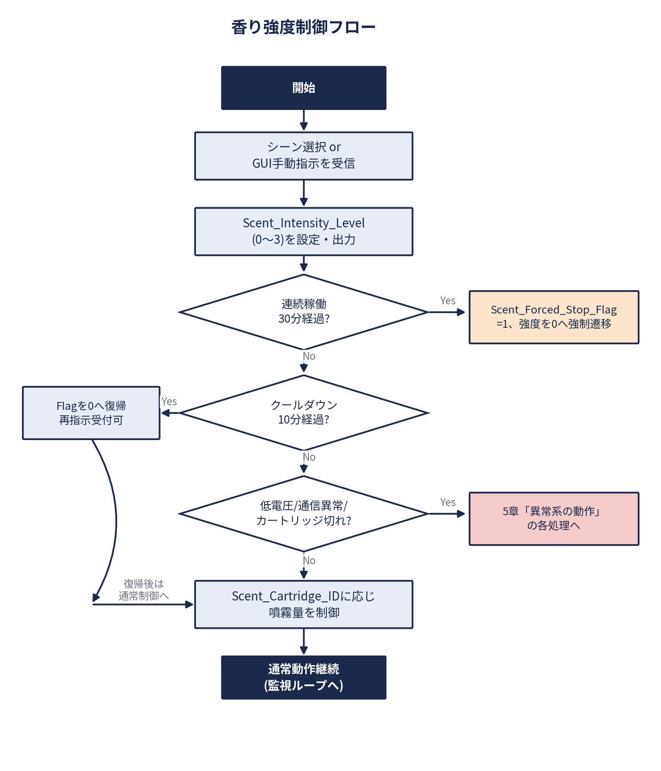
4.3 Decision table
Priority is higher when the number is smaller. When multiple conditions are satisfied simultaneously, the behavior is determined according to the rule with the highest Priority.
Priority | Condition | Operation | Scent_Intensity_Level | Scent_Forced_Stop_Flag
1 | Cartridge remaining amount = 0 (Cartridge_Level_Sensor = 0) | Output Shutdown / GUI Warning Request | 0 | 0 (cartridge empty state)
2 | Internal communication timeout (no response for 500 ms or more) | Output shutdown / GUI error notification | 0 | 0 (communication error state)
3 | Battery voltage < 9.0V | Forced stop | 0 | 1
4 | Continuous operation 30 minutes elapsed | Forced stop | 0 | 1
5 | Battery voltage < 10.5V (9.0V or above) | Output limited to 50% | Current value × 0.5 equivalent (rounded) | 0
6 | None of the above apply | Normal control (follows scene/manual command) | 0 to 3 (indicated value) | 0
4.4 State Transitions
4.4.1 State Transition Diagram
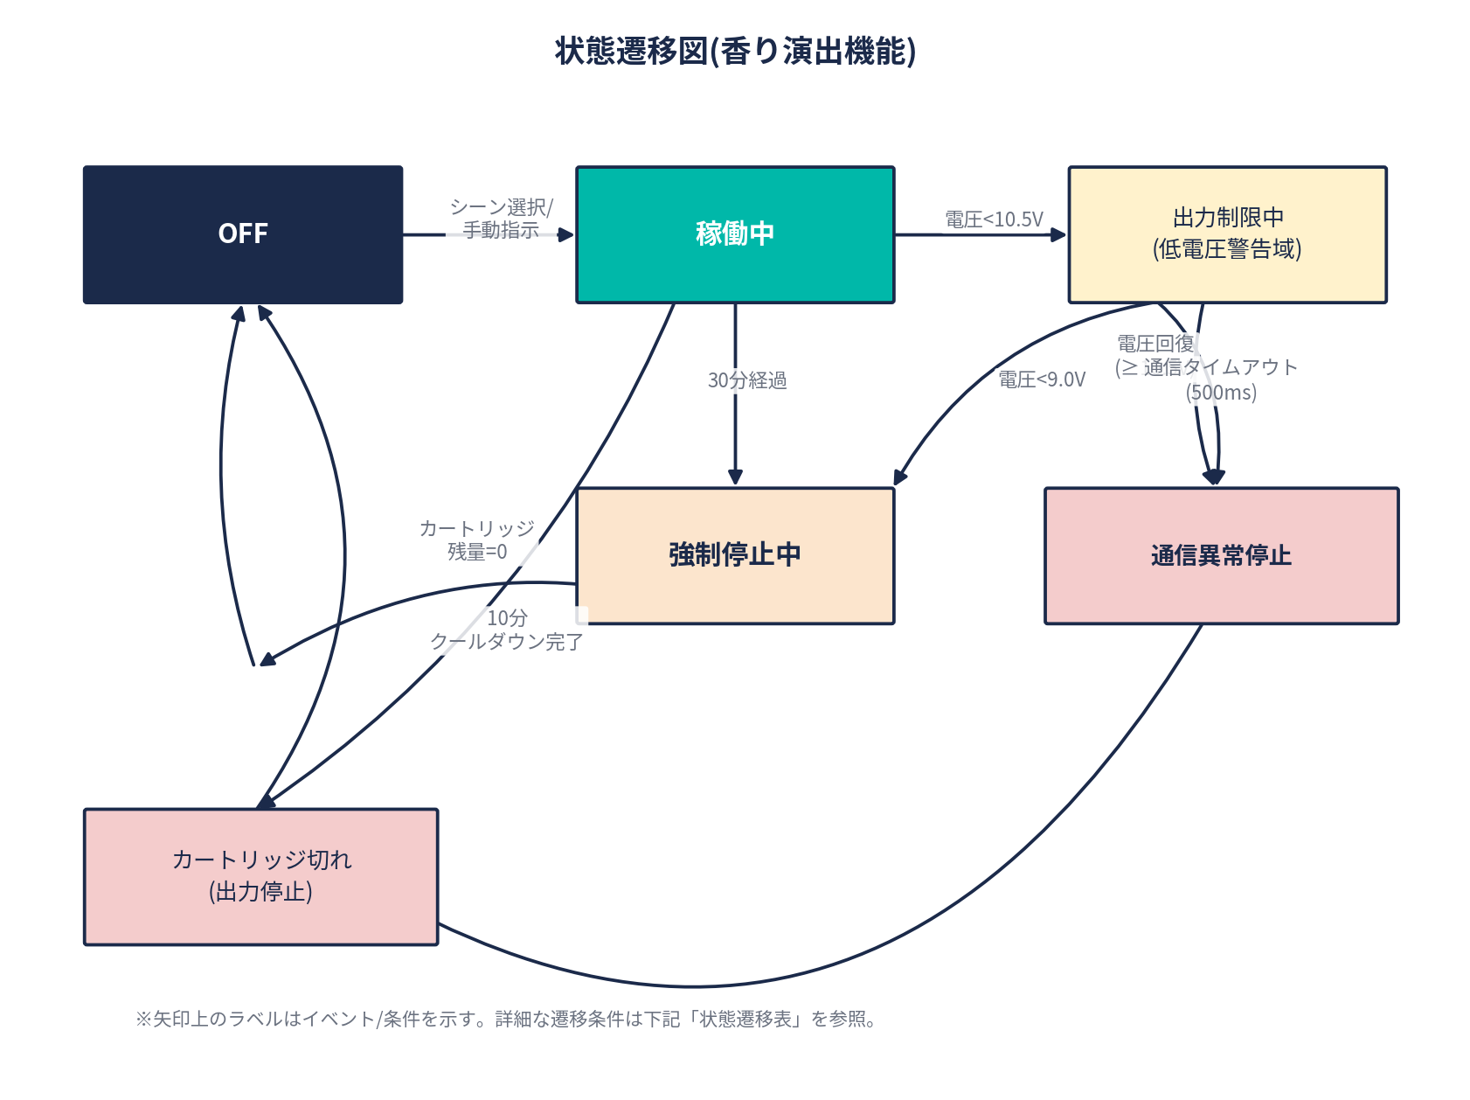
4.4.2 State Transition Table
No | Current Status | Event/Condition | Transition Destination State | Note
1 | OFF | Scene selection/manual instruction received | In Operation
2 | In Operation | Continuous operation 30 minutes elapsed | Forced stop in progress | Scent_Forced_Stop_Flag=1
3 | In Operation | Voltage < 10.5V (≥ 9.0V) | Output Limited
4 | Output Limited | Voltage recovery (≥10.5V) | In Operation
5 | Output Limiting in Progress | Voltage < 9.0V | Forced stop in progress
6 | Operating / Output Limited | Communication timeout (500ms) | Communication Error Stop
7 | In operation / Output limited / Forced stop in progress | Cartridge remaining level = 0 | Cartridge empty | Highest Priority (decision table rule 1)
8 | Forced stop in progress | 10-minute Cooldown elapsed (voltage and communication normal) | OFF | Ready to accept re-instruction
9 | Communication Error Stop | Communication restored | OFF | Ready to accept re-instruction
10 | Cartridge empty | Cartridge replacement detection | OFF
5. Abnormal-case behavior
5.1 Upon Reception of Abnormal Value
Condition: When a value outside the range of 0 to 3 (e.g., 4 or greater) is commanded to Scent_Intensity_Level from the GUI side or similar.
・Log as an invalid value
· Ignore the instruction and maintain the last normal value.
※It is assumed that the intensity notation (level notation) displayed on the GUI side matches the value range of this signal.
5.2 Low-voltage operation
Output is limited as follows, according to the threshold of Battery_Voltage (Drive power supply voltage; refer to Chapter 2).
・Voltage < 10.5V: Limit output to 50% of normal (output limiting active)
・Voltage < 9.0V: Set Scent_Forced_Stop_Flag to 1 and perform Forced stop
・Voltage ≥ 10.5V recovered: Automatically returns to normal operation
5.3 Communication error (timeout)
Condition: Any of the following conditions is met. (Or)
・In the internal communication between the control board inside the AEC ECU and the SDU (fragrance presentation function block), no response is received within 500ms after transmission
Operation:
· Fix Scent_Intensity_Level to 0
・Request abnormality notification to GUI
・Upon detection of Communication restored, transition to the OFF state and enable acceptance of re-instruction from the Occupant.
5.4 Fragrance Cartridge depletion / not installed
Condition: Any of the following conditions is met. (Or)
・Cartridge_Level_Sensor is 0%
・Cartridge not detected (sensor output abnormality, disconnection, etc.)
Operation:
· Immediately stop the output
・Request warning display on GUI
・Returns to the OFF state upon detection of cartridge replacement
※ This is treated as the highest priority among all abnormal conditions (decision table rule 1).
5.5 Fan abnormality (lock detected)
Condition: All of the following conditions are met. (And)
・Scent_Intensity_Level is set to 1 or greater
・Diffuser_Fan_Status does not transition to active (1) within the specified time (2 seconds)
Operation:
· Determine fan lock (seizure) and stop output
・Record the Diagnostic Trouble Code (DTC) in accordance with SPEC-SIG-007 (Diagnostic Log Specification).
6. Revision history
Revision | Date | Change Description | Approved | Confirmed | Created
Ver1.0 | 2024-07-20 | Initial release
Ver1.1 | 2024-08-25 | Added transition specification upon Scent_Forced_Stop_Flag activation (Section 4.1, Step 3)
Ver1.2 | 2024-08-25 | · Chapter structure reorganized and divided into "Input Signals" and "Output Signals"  ・Specify input signals from SDU/BCM/HVAC ECU
Ver1.3 | 2024-10-28 | ・Added cover page and approval section (Approved by / Reviewed by / Prepared by)  ・Add flowcharts/decision tables/state transitions (diagrams/tables) to Control logic  ・Redefine Chapter 5 as "Abnormal-case behavior" and add Low-voltage operation, communication errors, cartridge depletion, and fan failures  ・Added Approved by / Reviewed by / Prepared by columns to Revision history
Ver1.4 | 2024-11-15 | ・Resolve inconsistency with SPEC-COM-001 (common signal table)  ・Added BCM_IG_Status and BCM_Battery_Voltage in Chapter 2, and removed unused BCM_Occupancy_Flag and HVAC_Air_Circulation_Mode  · Added signal ID columns in Chapters 2 and 3 to clarify traceability
Ver1.5 | 2024-11-25 | ・Changed specification ID from SPEC-SIG-004 to SPEC-CTRL-004 (unified with the system-specific naming convention in common signal table SPEC-COM-001)  ・Changed the chapter titles of Chapters 2 and 3 from "Input Signals" and "Output Signals" to "Input" and "Output"  ・Redefine Drive power supply voltage as Hardware input (remove from common signal table)  ・Redefine the SDU (Scent Diffuser Unit) as an AEC built-in functional block, and classify it as outside the scope of the common signal table (SPEC-COM-001)  ・Revised the input source of Diffuser_Fan_Status to "Status bit via SDU built-in fan Driver IC"  ・Removed the expression "communication loss" from the cartridge non-detection conditions in 5.4 to align with the sensor-based method  ・Restructured Section 5 into bullet points with explicit Or/And notation for multiple conditions. Section 6 (this table) also restructured into bullet points.  · Section 4.2 flowchart image enlarged. Page breaks added at locations spanning across chapters.  - The cover layout has not been changed (user-edited layout is retained).
Scope of Application of This Document
This document solely defines signal values and vehicle-side Control logic; the on-screen display text and slider behavior presented to the Occupant shall conform to the specifications of SPEC-GUI-003 (fragrance settings screen). Regarding the correspondence between the two specifications, relevant departments shall be thoroughly notified and reviews shall be conducted upon each revision.

