

Fabrication notes

hw_DAA/BASIC-101010

September 24, 2024

1. PCB construction

- Number of layers: 16 layers.
- Number of flex layers: 6 (3 core structures joint with polyamide bondply).
- A strain relief shall be added over the flex and rigid intersection.
- Surface finish: Immersion silver.
- PCB Material requirement:
  - High TG material, greater than 180ºC.
  - RoHS compliant.
  - REACH compliant.
- Dielectric material: must comply with IPC-4101-126 standar.
- Soldermask: on both sides of the board, color green.
- All vias in pads shall be plugged with solder mask type V/VI.
- Layer stack shall comply with the IPC-6012C.
- Layout clearance shall comply with the IPC-2221B.
- PCB shall comply with the IPC 6011 Class 3/A.

2. Gerber description and stackup

The layer structure is defined below:

- Layer Top → *.cmp
- Layer 2 → *.l2
- Layer 3 → *.l3
- Layer 4 → *.l4
- Layer 5 → *.l5
- Layer 6 → *.l6
- Layer 7 → *.l7
- Layer 8 → *.l8
- Layer 9 → *.l9
- Layer 10 → *.l10
- Layer 11 → *.l11
- Layer 12 → *.l12
- Layer 13 → *.l13
- Layer 14 → *.l14
- Layer 15 → *.l15
- Bottom → *.sol
- Solder mask top → *.stc
- Solder mask bottom → *.sts
- Dimensions → *.dim
- Panel → *.gml
- Milling → *.gko
- Flex → *.flx
- Cream top → *.tcr
- Cream bottom → *.bcr
- Silkscreen top → *.tsilk
- Silkscreen bottom → *.bsilk
- Drills → *.drd

The PCB stackup is described in the next image:

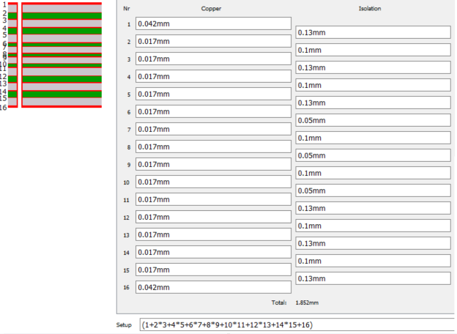

3. Drills
Number of drills: 3241
Drills used:
Code | Size | Used
T01 | 0.0059inch | 2874
T02 | 0.0079inch | 61
T03 | 0.0098inch | 17
T04 | 0.0197inch | 154
T05 | 0.0291inch | 32
T06 | 0.0315inch | 68
T07 | 0.0394inch | 4
T08 | 0.0591inch | 1
T09 | 0.0669inch | 4
T10 | 0.1181inch | 4
T11 | 0.1299inch | 4
T12 | 0.1575inch | 12
T13 | 0.2205inch | 6

5. Silkscreen
The PCB shall have silkscreen in the layers top and bottom.
The gerber data for silkscreen are the *.tsilk and *.bsilk.
Do not include manufacturing logos in the PCB.
The silkscreen color shall be white.
PCB manufacturers shall add a traceability number in the products. This number shall be the PCB batch and a week-year number.

6. Additional notes
The PCB manufacturing shall comply with the IPC-1602 standard to ensure a correct handling, protection and storage.
Two additional documents are added for the manufacturer:
- hw_DAA_Rigiflex_drawing.pdf: Describes placement and dimensions of the rigiflex segments.
- hw_DAA_Drill_and_Countersunk_drawing.pdf: Describes the placement and size of the countersunk drills.

