CHAPTER-3
DESIGN

3.1 Data Flow Diagram
- DFD (data flow diagram) is a graphical representation used to show the flow of data through the StudentHub system.
- DFD is useful for understanding the system because it represents the different processing activities and the exchange of information among these functions.
- It views the StudentHub system as a set of functions that transform input data into the required output.
- Each function is represented as a process that receives input information and produces corresponding output information.
- The StudentHub DFD represents student and administrator interaction with authentication, task management, notes and resources, habit tracking, study planning, timetable, performance reporting, finance and expense tracking, mood journal, goals and milestones, data export and privacy settings.
- The visual representation provides a clear communication tool between the user and the system designer.

- DFD has often been used due to the following reasons:
      - Logical representation of information flow in the StudentHub system.
      - Clear identification of system processes and the data required by each process.
      - Simplicity of notation for representing entities, processes, data flows and data stores.
      - Establishment of the information requirements for manual inputs and automated system processing.

[Table 1: Data Flow Diagram Symbols]

Symbols | Description
 | Entity: An external user or actor that interacts with the StudentHub system by providing or receiving data.
 | System: Represents the StudentHub application that processes student and administrator information.
 | Process: Represents the StudentHub application that processes student and administrator information.
 | Data Flow: Represents the movement of information from one part of the system to another.
 | Data Store: Represents stored student or system information used by the system processes.

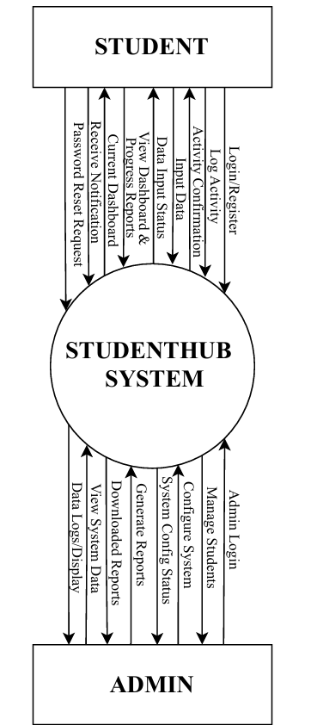
3.1 Context Level 0

[Figure 1: Context level 0]

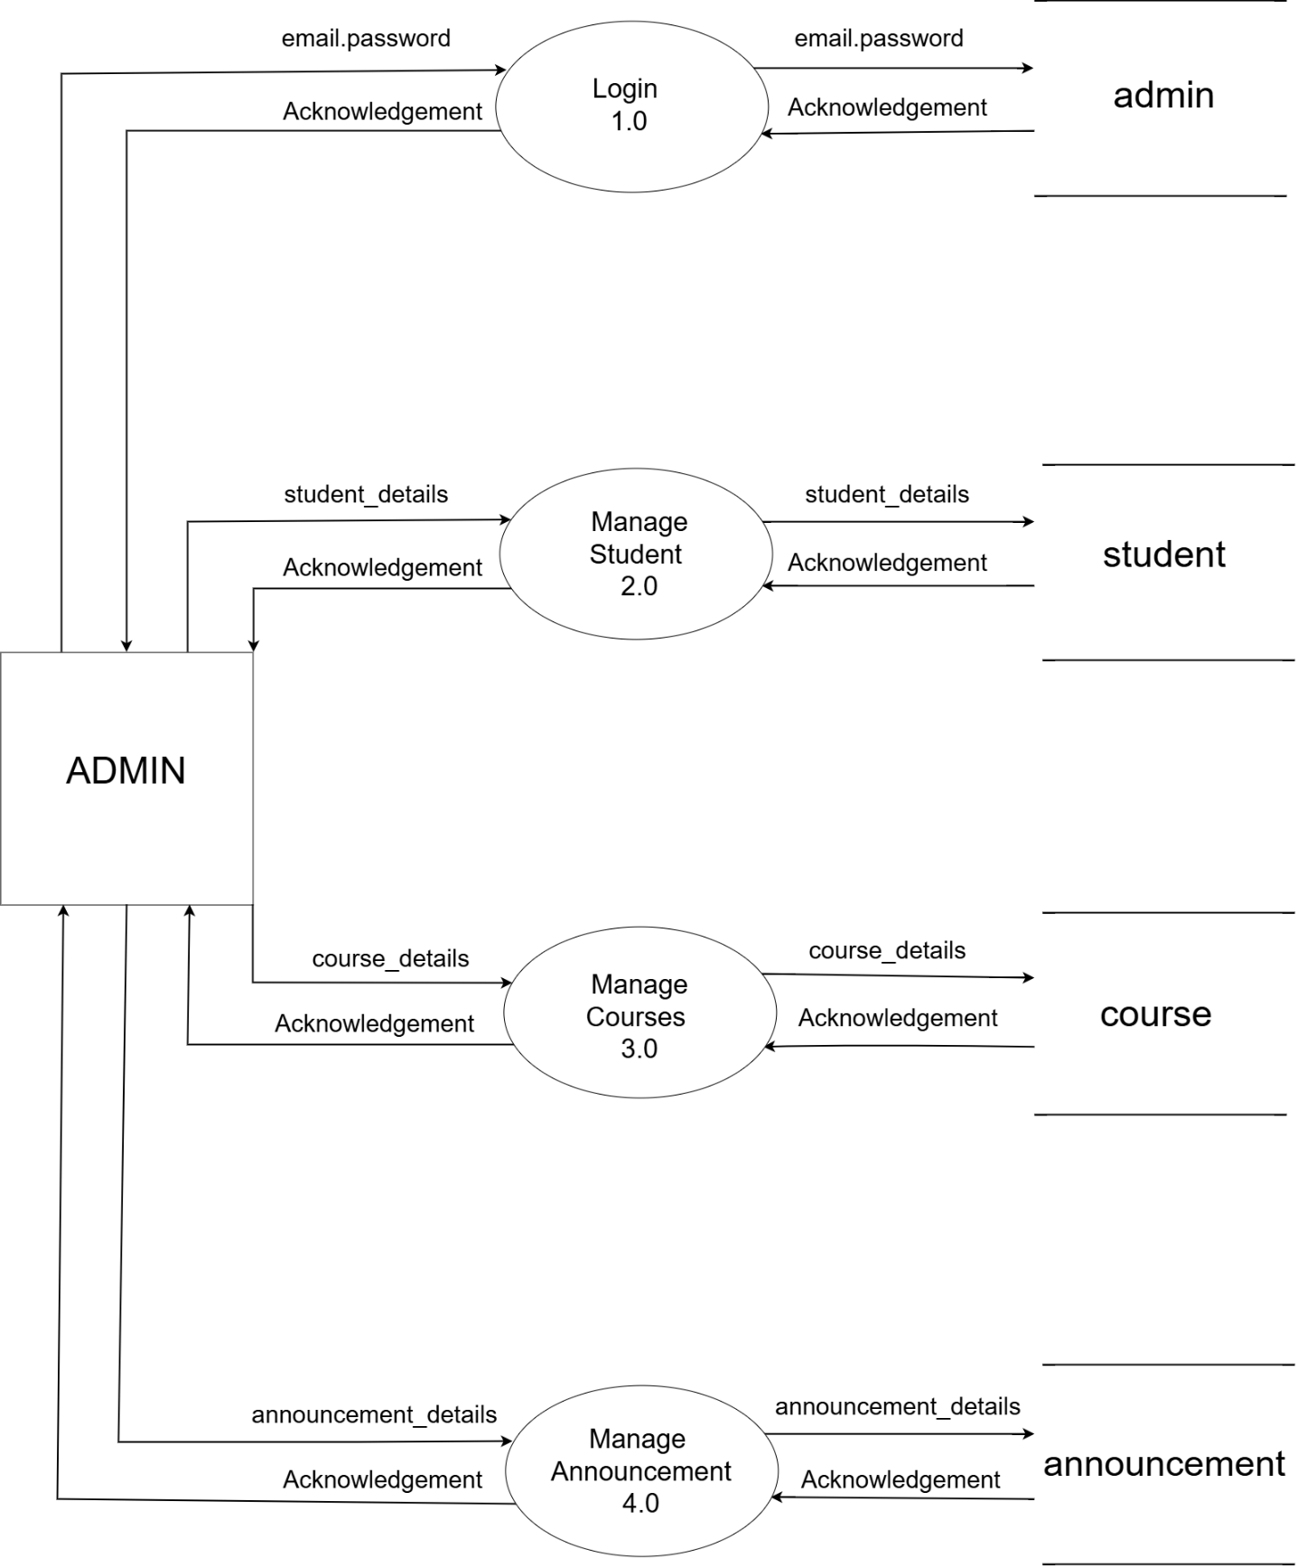
3.1.1 DFD Level 1: Admin

[Figure 2: DFD Level 1: Admin]

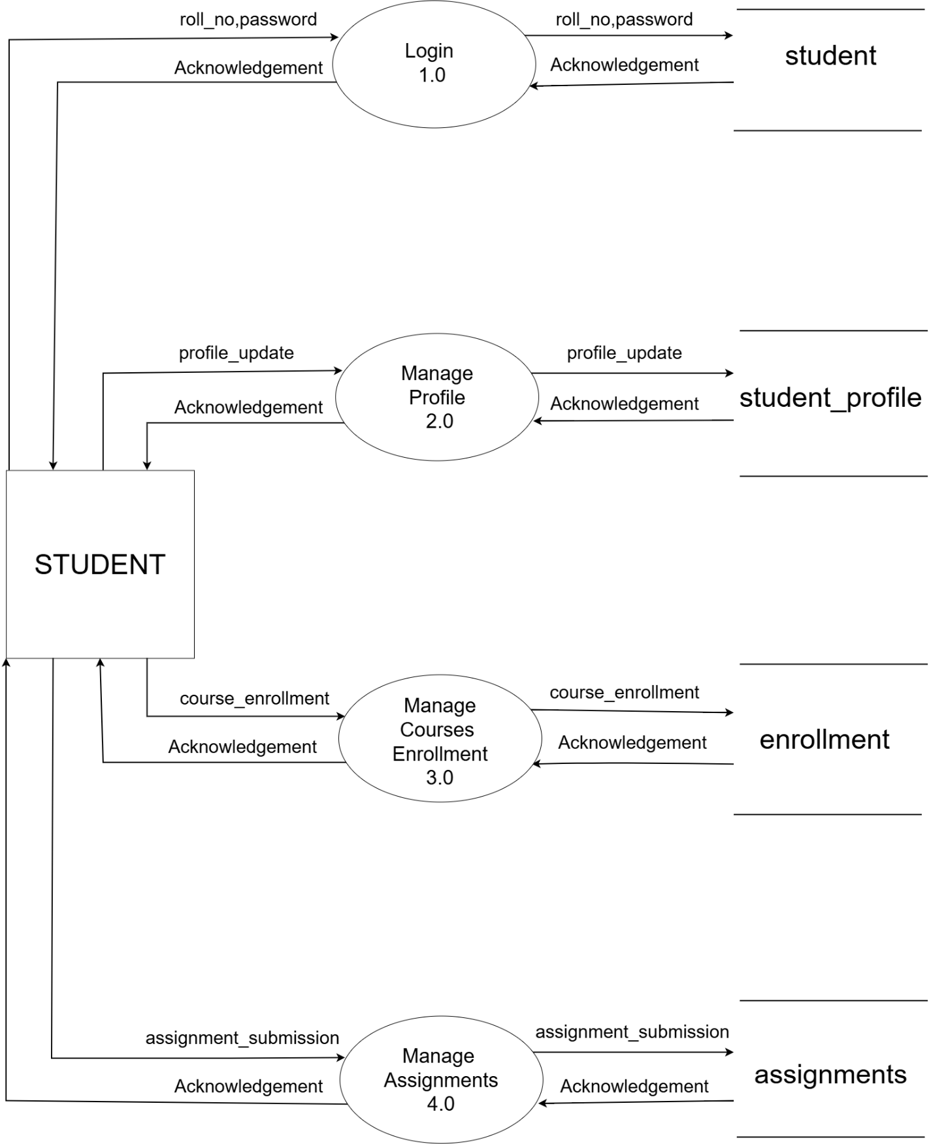
3.1.2 DFD Level 1: Student

[Figure 3: DFD Level 1: Student]

3.2 ER-Diagram
- An Entity Relationship (ER) Diagram represents the relationships among the major entities and data areas used in the StudentHub system. The conceptual design is based on the modules identified in the requirement analysis, including tasks, notes and resources, habits, study plans, timetable, performance reports, expenses, mood and journal entries, goals and milestones, and privacy-related information.
- The Student entity is the main entity that interacts with these modules, while the admin entity provides authorized administrative access to the required student-related information.

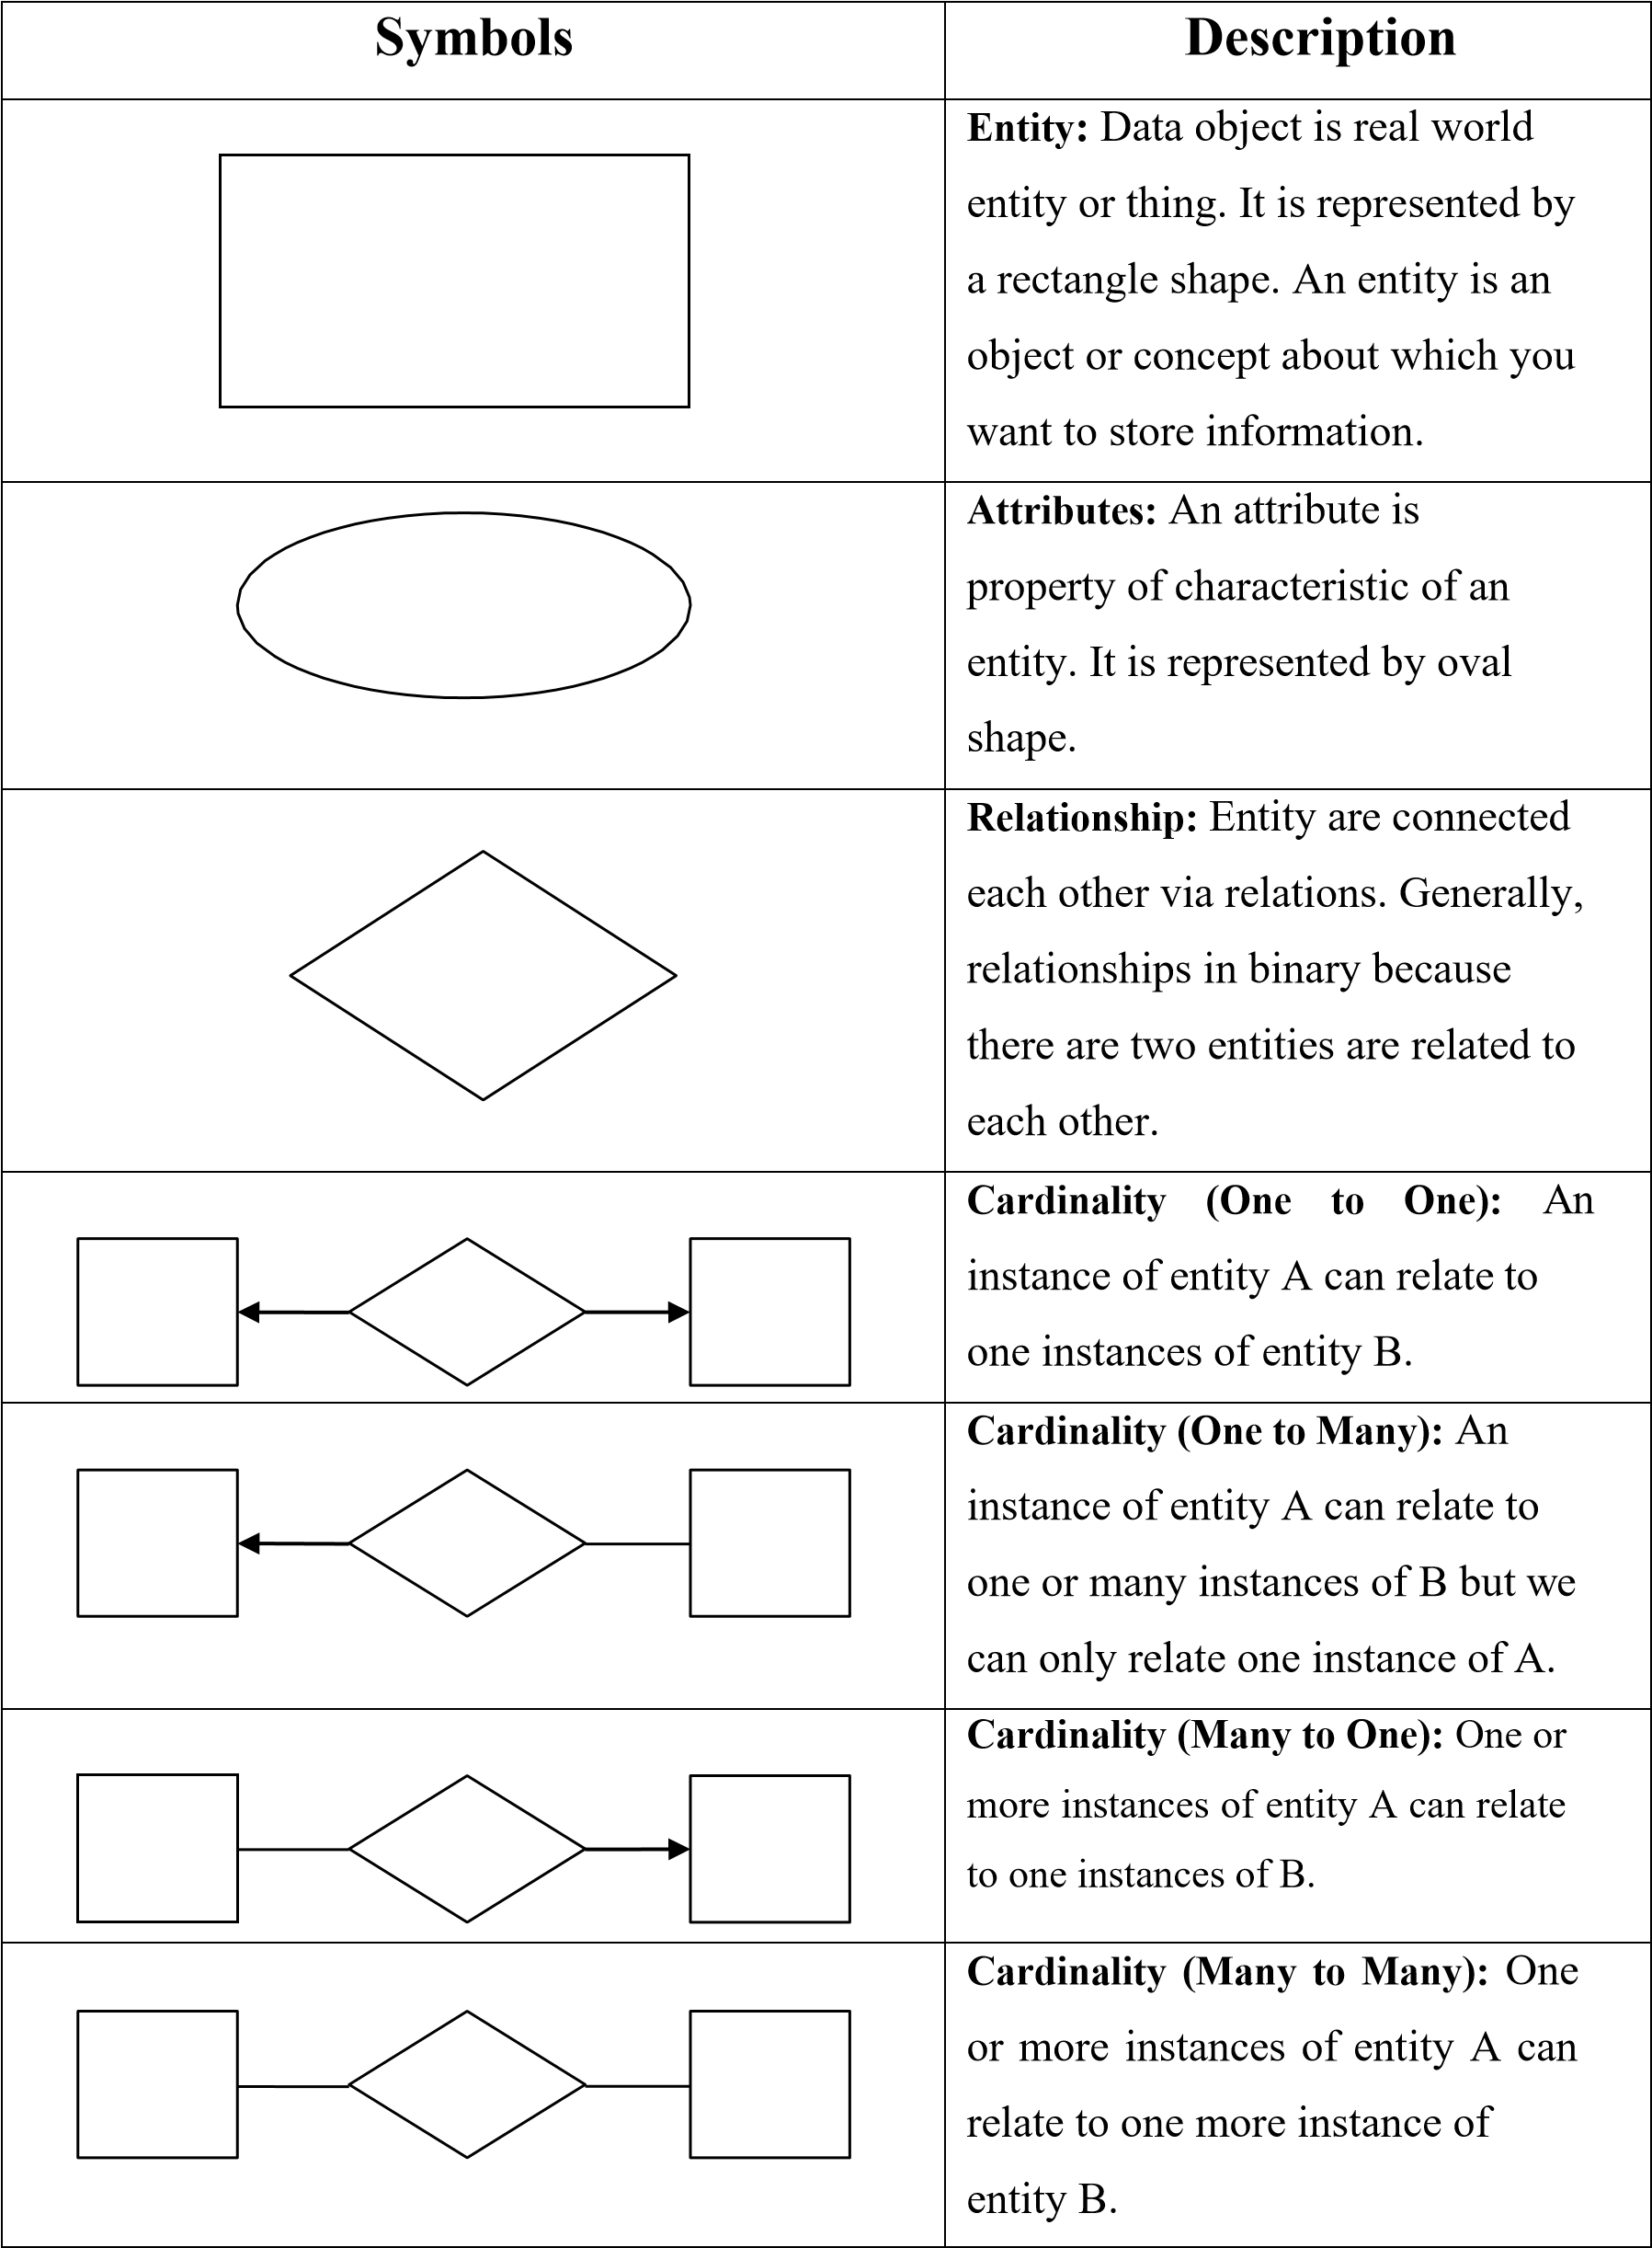
[Table 2: ER-Diagram Symbols]

ER-Diagram:
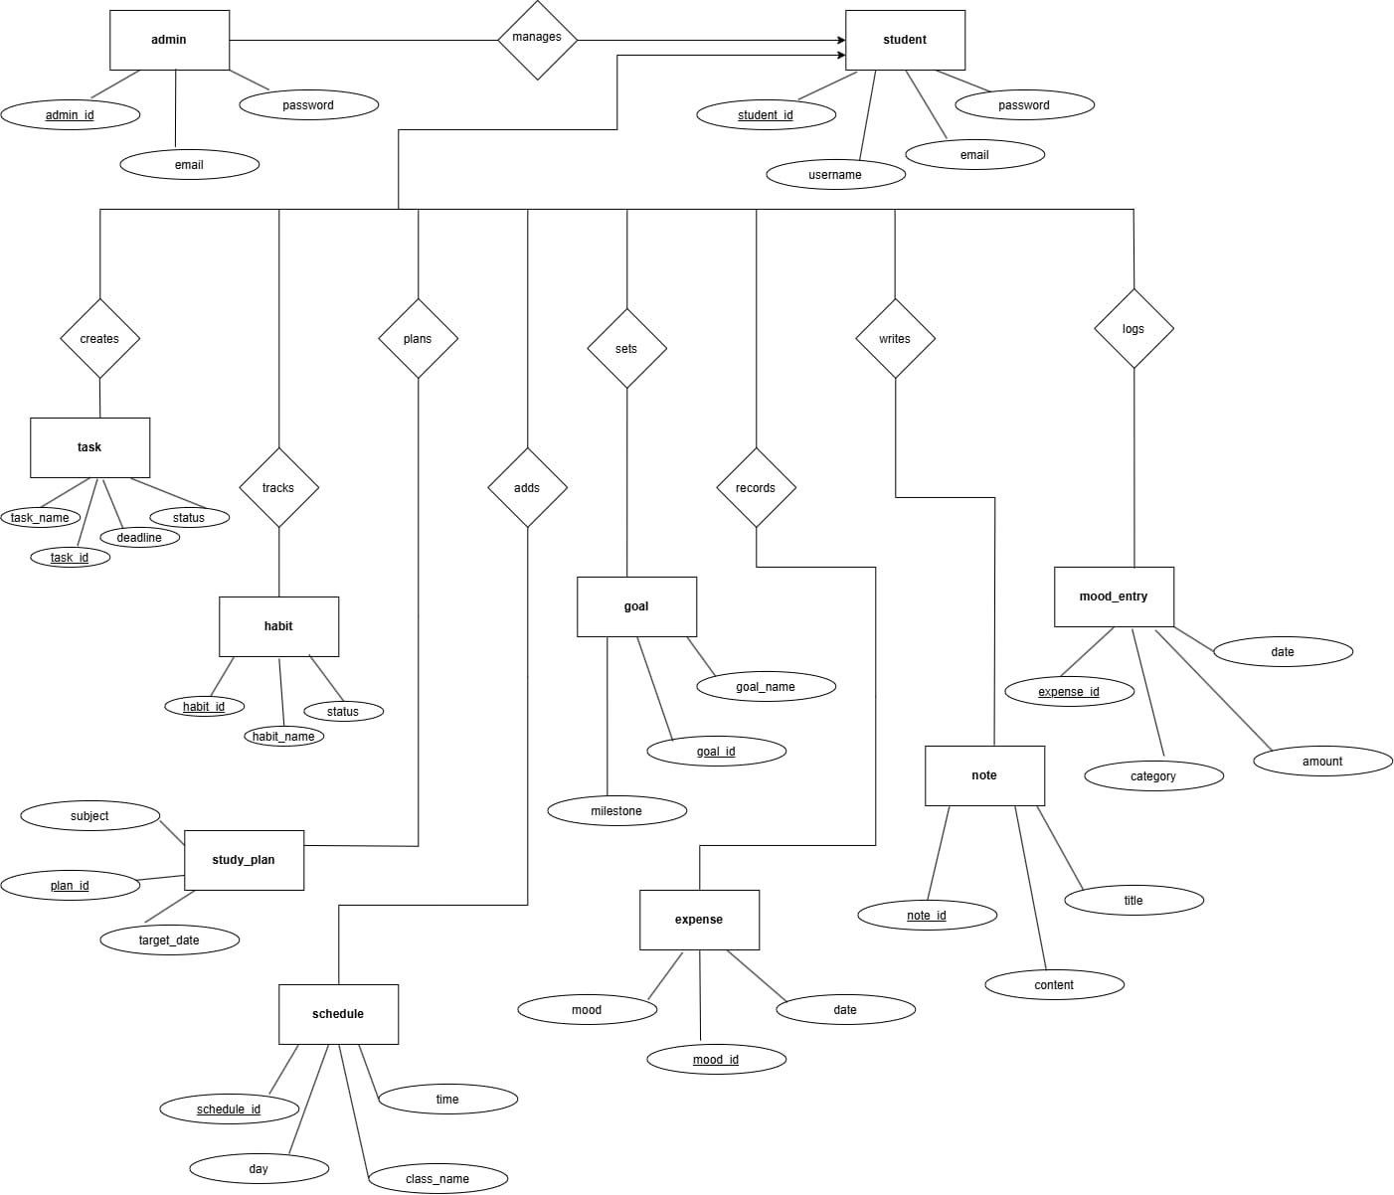

[Figure 4: ER Diagram]

