ADDITIONAL INFORMATION — EIC PATHFINDER OPEN 2026 PLATE I OF XX

SYMPHONY
a planisphere of the neuromimetic code substrate
· N E R V O U S S Y S T E M F O R S O F T W A R E ·
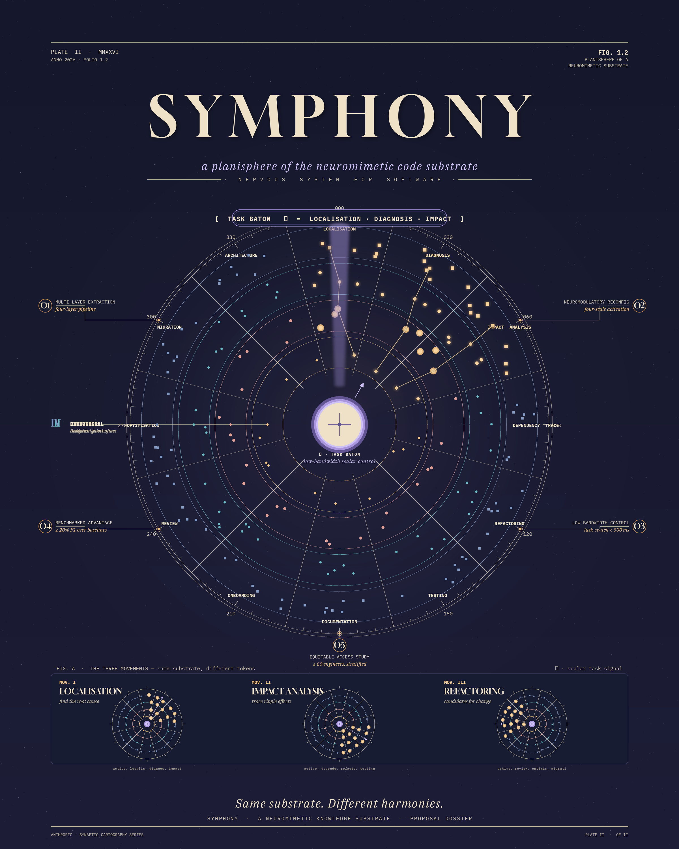

Additional Information Dossier
EIC Pathfinder Open 2026 · HORIZON-EIC-2026-PATHFINDEROPEN-01

Consortium · Real AI (NL) · Newcastle University (UK) · CREATE / PRISMA Lab (IT) · UP Robotics (HR)
live preview: tarrysingh.com/symphony

FOLIO II — TABLE OF CONTENTS PLATE II OF XX

Table of Contents
Executive summary · why this matters now 3
The long-term vision · a nervous system for software 5
The science-to-technology breakthrough 6
The four-layer substrate × four-scale neuromodulation 7
The statistical ceiling · what SWE-bench actually measures 8
The comprehension gap · software entropy and the EU response 9
Objectives O1–O5 and decision milestones 10
The Consortium 11
Newcastle · Sri Ramaswamy · the Blue Brain heritage 12
CREATE · Bruno Siciliano · the PRISMA Lab tradition 13
Real AI · Tarry Singh · Project HOMINIS and Leonardo 14
UP Robotics · the industrial coalface 15
Interdisciplinarity · the four-way combination 16
Innovation potential and the joint-venture pathway 17
Open science, EU AI Act and trustworthy AI alignment 18
The live demo page · tarrysingh.com/symphony 19
Closing — same substrate, different harmonies 20

FOLIO III — EXECUTIVE SUMMARY PLATE III OF XX

Executive summary
WHY THIS MATTERS NOW
SYMPHONY proposes a neuromimetic knowledge substrate for software systems: a representation in which modules, functions, tests, commit history and design decisions are encoded as nodes in a multi-scale network whose activation patterns are reconfigured, on demand, by task-specific neuromodulatory signals. In plain terms, a code representation that behaves less like a document and more like a nervous system foregrounding the structures the engineer needs.
We propose this now because two structural shifts make the existing approaches insufficient at exactly the moment Europe needs them most.

1. The statistical ceiling is now visible.
LLM coding agents reach SWE-bench headline scores above 80 per cent. Independent re-evaluation (ICSE 2025 Companion; ICLR 2026 SWE-Bench+) drops those scores to single digits or 30 per cent once solution leakage and weak test cases are removed. Industrial codebases run into the millions of tokens; production LLM context windows are in the low hundreds of thousands. Retrieval augmentation provides local relevance without system-level coherence. The dominant approach is not on a trajectory to close the gap by incremental scaling alone.

2. The comprehension gap is widening.
For seventy years humanity has built artefacts faster than it can document or understand them. The gap compounds every year: software entropy, ageing industrial plants, regulatory pressure rising (NIS2, the EU Cyber Resilience Act, the AI Act for high-risk systems). Europe operates on PLC code, robot programs and SCADA configurations that routinely outlive the engineers who wrote them. Telecommunications stacks, electricity-grid SCADA, public-administration legacy systems and rail signalling are dominated by software written across multiple decades and contractors, with the implicit knowledge that bound them together largely retired or redistributed.

Why SYMPHONY, why now.
SYMPHONY borrows the one principle that already solved this in biology. Living neural systems store no documentation; they encode knowledge in distributed, layered, context-dependent structures reconfigured by chemical messengers — neuromodulators — and low-bandwidth descending control signals. The four-scale neuromodulatory framework of Mei, Muller and Ramaswamy (Trends in Neurosciences, 2022) gives the mathematical template. The haptic shared control programme of Selvaggio, Pacchierotti, Giordano and Siciliano (RA-L 2018; T-RO 2022, and a decade of hardware-validated work) provides the bounded, auditable, low-bandwidth task-control surface. Real AI’s HOMINIS lineage — Europe’s first open-source human-centric LLM, trained on the Leonardo supercomputer under the Italian ISCRA programme — supplies the foundation-model engineering capacity. UP Robotics’ Croatian industrial coalface supplies the codebase against which the substrate is judged.
Same substrate. Different harmonies. The four-way combination has not been tried before — that is the bet.

FOLIO V — THE LONG-TERM VISION PLATE V OF XX

The long-term vision
A NERVOUS SYSTEM FOR SOFTWARE
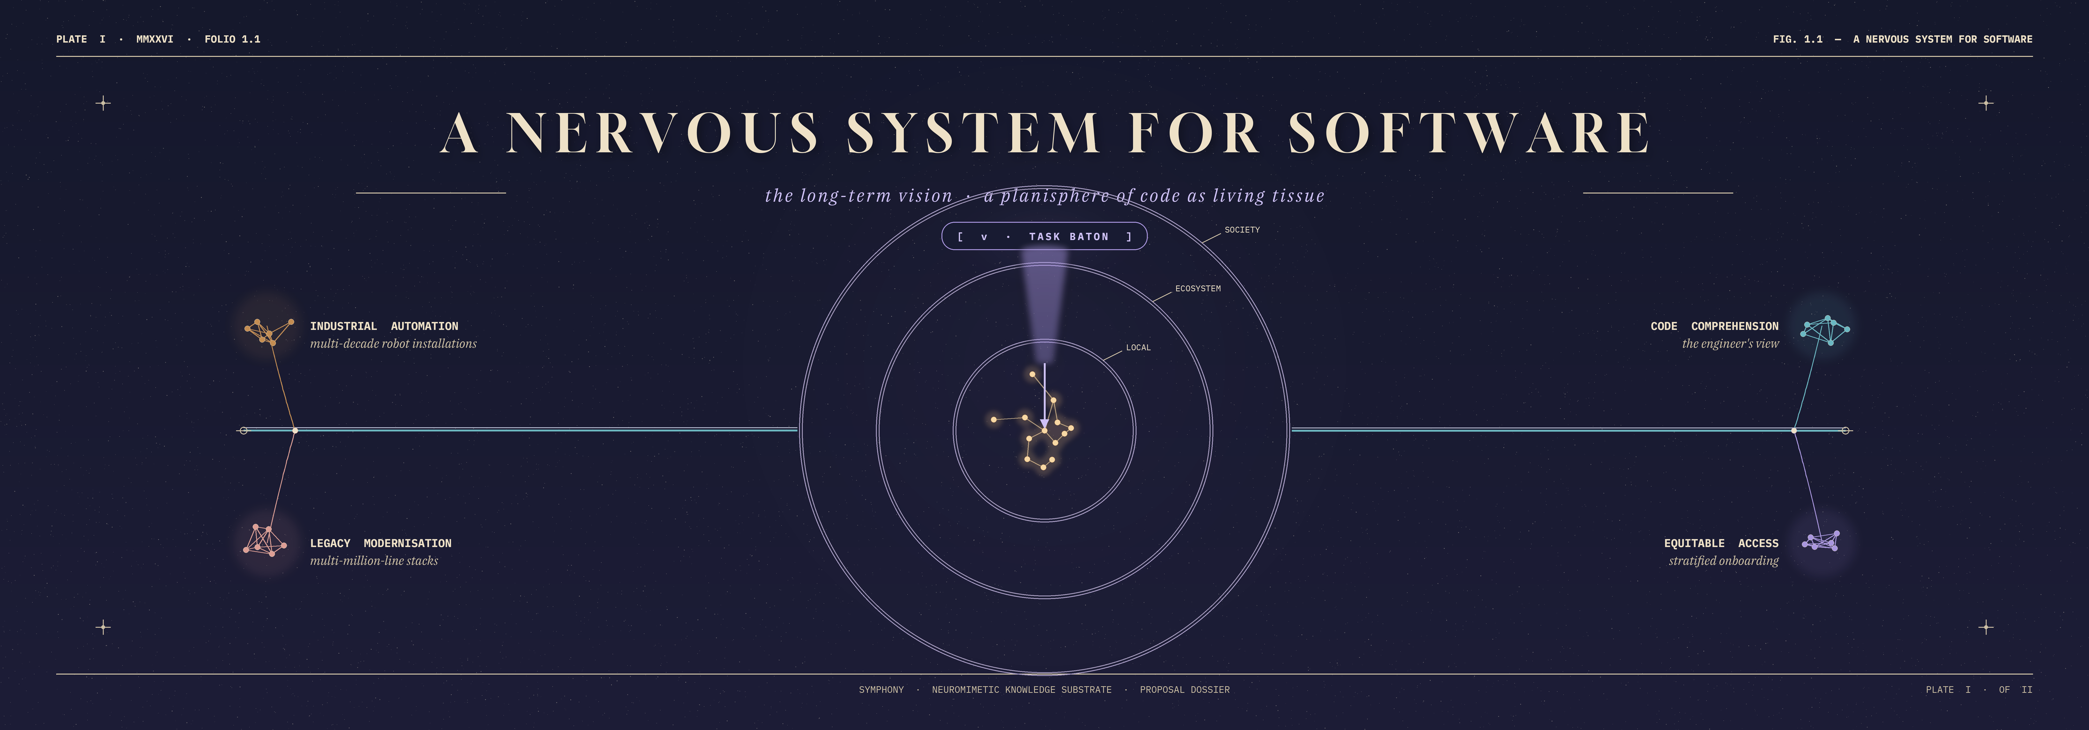
Plate I — the central neuromimetic substrate feeding four downstream domains across LOCAL, ECOSYSTEM and SOCIETY scales.
A decade after SYMPHONY we envision such substrates as the default interface through which humans and machines comprehend, evolve and safely extend artefacts whose behaviour has become collectively unreadable: multi-million-line software stacks, multi-decade industrial-robot installations, multi-scale models of neural circuits, and city-scale infrastructure control systems.
This is categorically distinct from today’s documentation generators, static analysers, knowledge graphs and large language models, which capture explicit structure or surface statistics but cannot recover when, why and under what context a piece of knowledge applies. SYMPHONY contributes the science that makes the first generation of truly comprehension-capable artificial systems possible.

FOLIO VI — SCIENCE → TECHNOLOGY BREAKTHROUGH PLATE VI OF XX

The science-to-technology breakthrough
FOUR LAYERS, FOUR SCALES, ONE SUBSTRATE
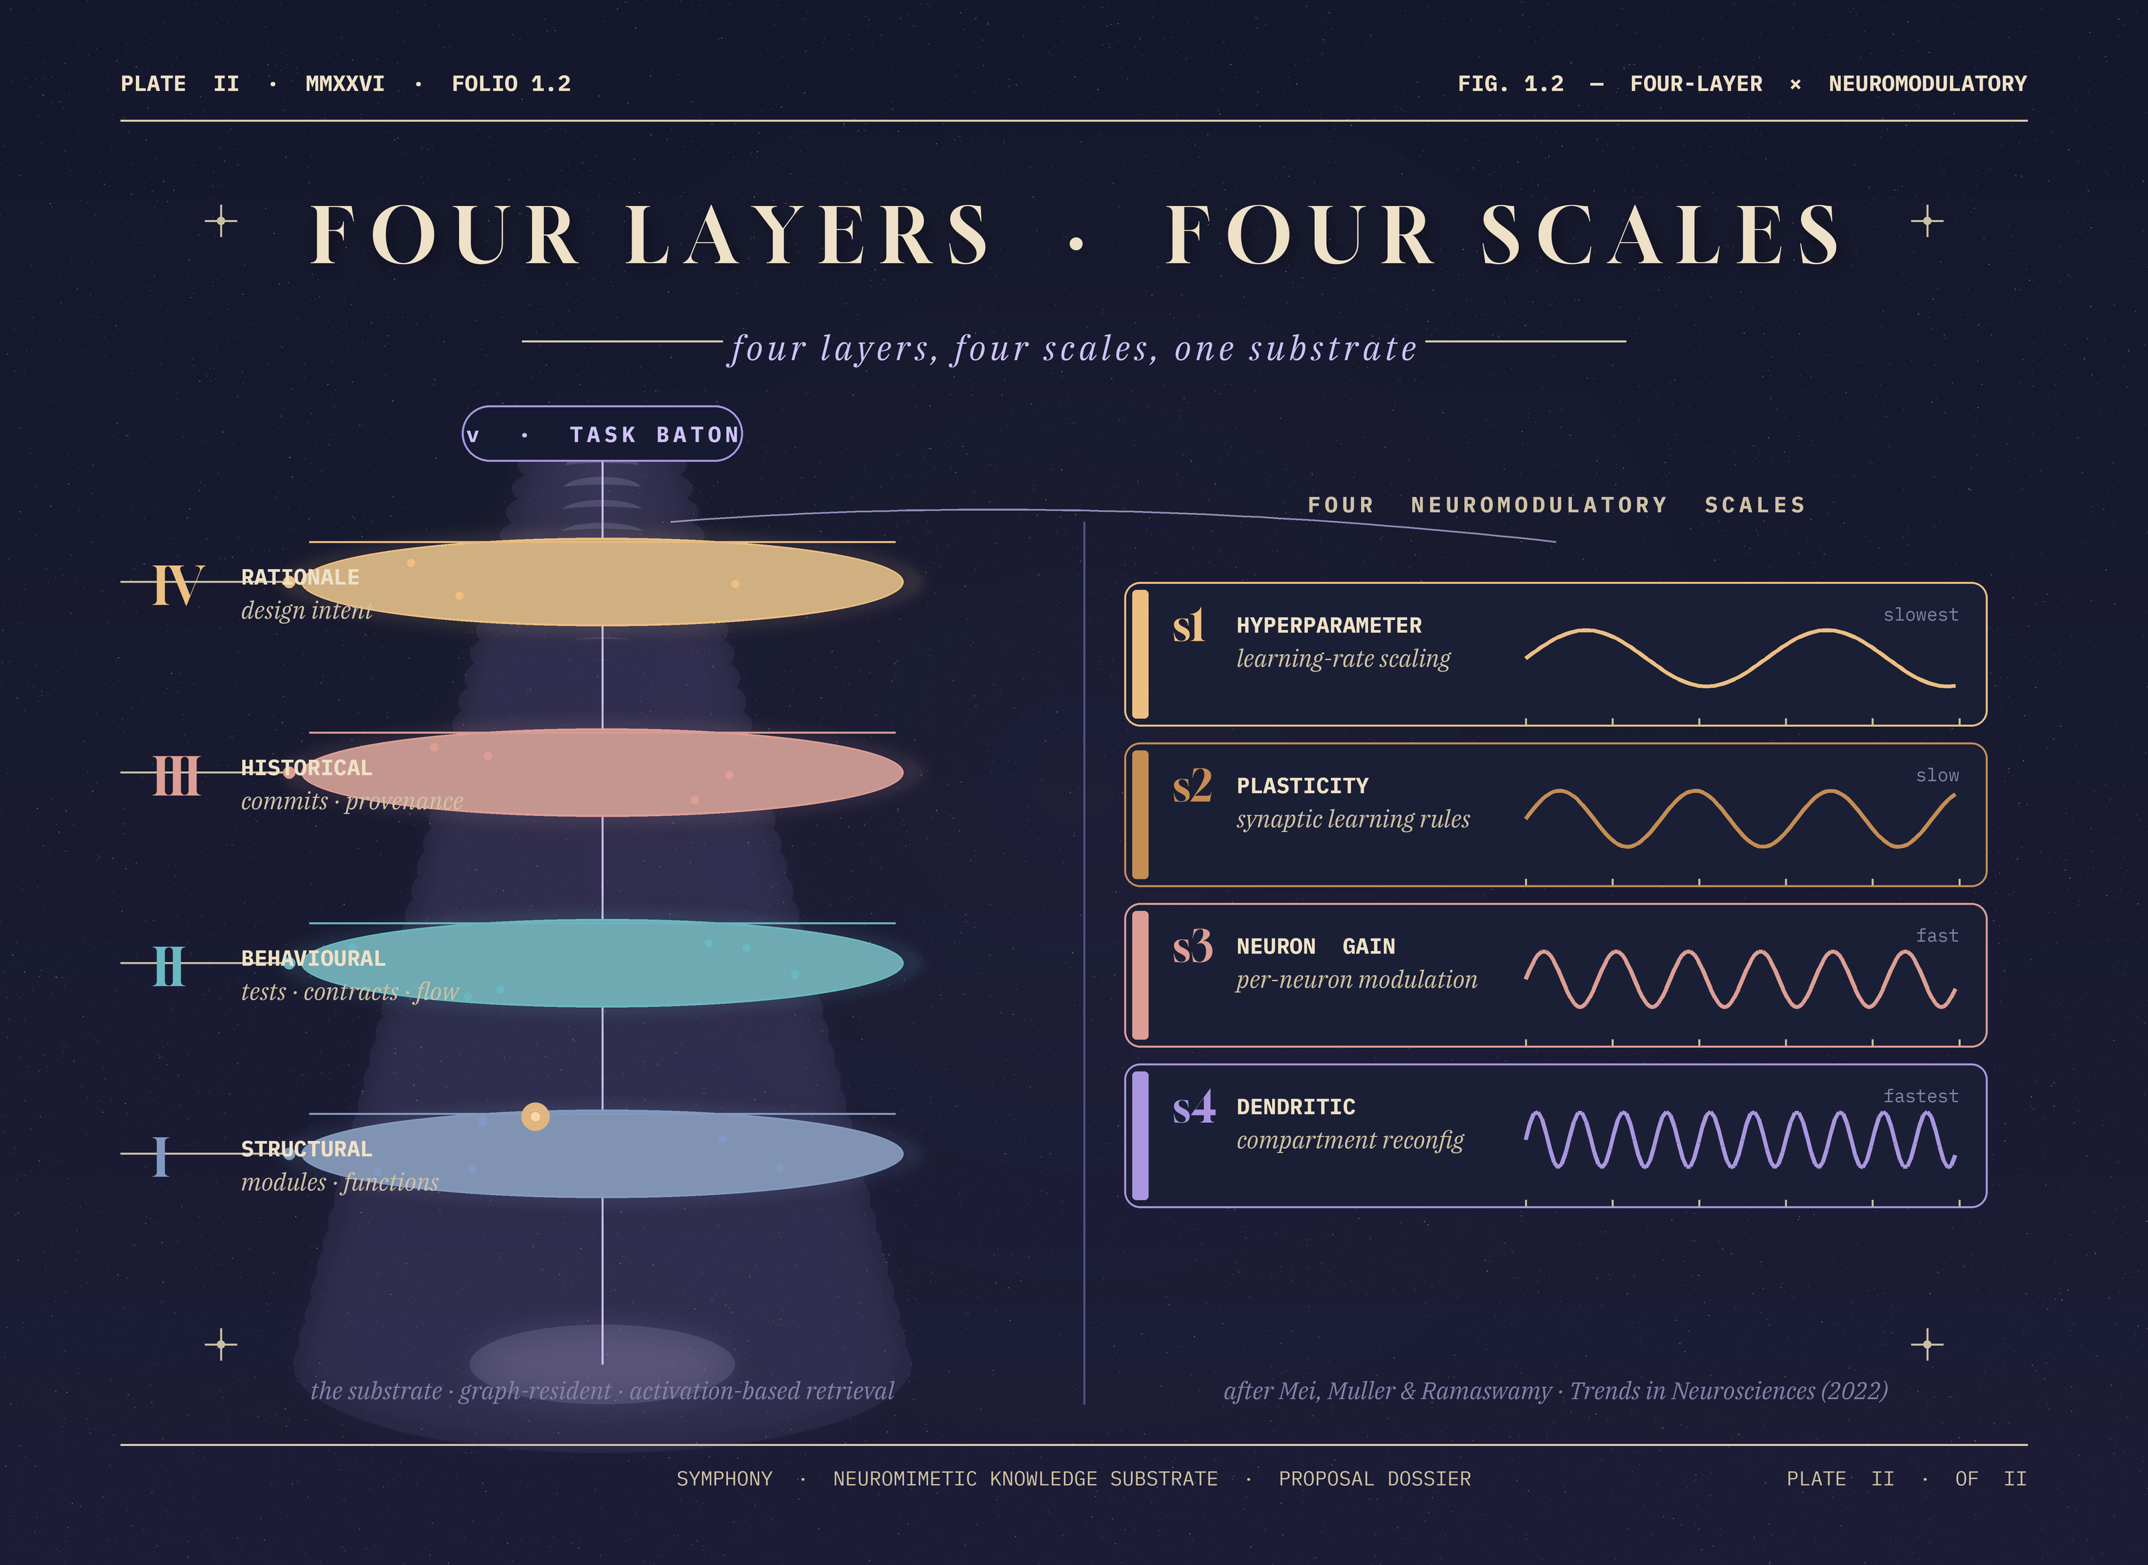
Plate II — the substrate is graph-resident across four layers; a low-bandwidth task baton modulates activation at four biologically-grounded scales.
Three specific advances distinguish SYMPHONY from all adjacent work.
(i) Multi-layer extraction into a single substrate. Existing architecture-recovery pipelines produce either a single view (static analysis output, dependency diagram, architecture knowledge graph) or a document corpus (READMEs, commit messages, issue trackers) treated separately. SYMPHONY unifies structural, behavioural, historical and rationale layers in a single graph-resident representation built for activation-based retrieval rather than query-based retrieval.
(ii) Context-dependent activation. No existing representation of a codebase alters its own salience profile in response to the engineer’s declared task. SYMPHONY’s substrate maintains a single state of the system but surfaces different subnetworks depending on an externally specified task token, using the neuromodulatory primitives of Mei, Muller and Ramaswamy (2022) as the mathematical template.
(iii) Low-bandwidth task control. Borrowing from haptic shared control, SYMPHONY’s task interface is intentionally narrow — a small set of scalar modulatory signals, not a prompt window — so that the system’s behaviour under different engineering tasks is composable, auditable, and bounded. This is the property that makes the substrate amenable to future industrial governance, in contrast to the unbounded prompt-response surface of current LLM agents.

FOLIO VII — THE STATISTICAL CEILING PLATE VII OF XX

The statistical ceiling
WHAT SWE-BENCH ACTUALLY MEASURES — AND WHAT IT DOESN’T
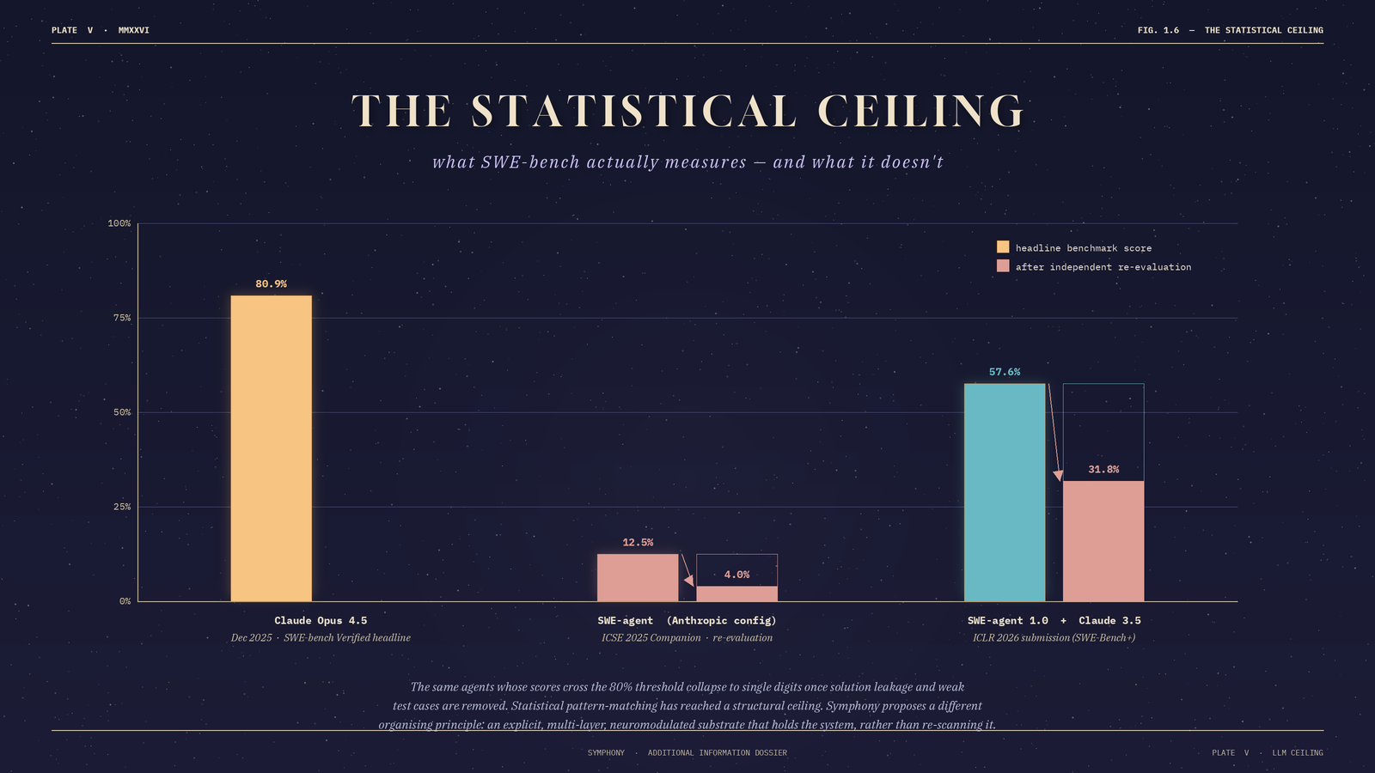
Plate V — independent re-evaluation collapses LLM-agent benchmark scores. Pattern-matching has reached a structural ceiling.
Current approaches to machine code understanding divide into two families, each with a structural ceiling. The first is statistical: large language model agents. These set the current public headline performance — Claude Opus 4.5 reached 80.9 per cent on SWE-bench Verified in December 2025, the first model to cross the 80 per cent threshold on that benchmark. The headline is misleading. Independent re-evaluation published at ICSE 2025 Companion showed that, once instances resolved through solution leakage or weak test cases are removed, the measured resolution rate of a leading SWE-agent configuration drops from 12.47 per cent to 3.97 per cent. A parallel ICLR 2026 submission (SWE-Bench+) replicated the effect, reporting that SWE-agent 1.0 with Claude 3.5 fell from 57.6 per cent to 31.8 per cent on SWE-bench Verified after filtering.
LLM agents are, at present, pattern-matchers with short memories; they do not build a durable, navigable representation of the system they are acting on.
The second family is structural: static analysis tools (SonarQube, PMD, IntelliJ inspections) and architecture knowledge graphs (ArchiMate-derived EAKGs, software knowledge graphs). These capture explicit structure but not the design rationale recognised since Avgeriou et al. (2007) as the hardest tier of software engineering knowledge to externalise.
SYMPHONY’s advance is not to improve either family but to combine their content under a different organising principle drawn from biology.
FOLIO VIII — THE COMPREHENSION GAP PLATE VIII OF XX

The comprehension gap
SOFTWARE WRITTEN FASTER THAN HUMANS CAN READ IT
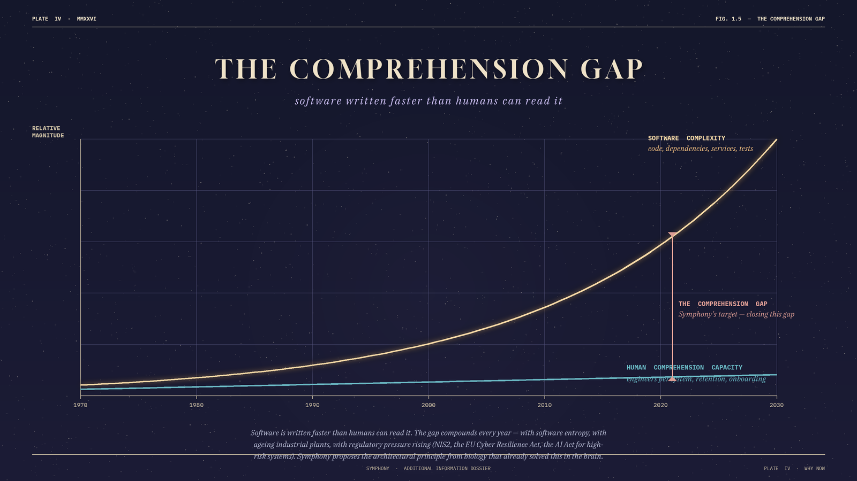
Plate IV — software complexity has grown exponentially; human comprehension capacity grows roughly linearly. The gap is the addressable market.

Four sectoral pathways
Industrial automation and manufacturing. The European industrial robotics installed base exceeded 100,000 new units in 2024 (IFR) on top of a stock measured in the millions, with median installation lifetimes well above a decade. UP Robotics confirms the pattern in its own Croatian and regional customer installations: PLC code, robot programs and SCADA configurations routinely outlive the engineers who wrote them.
Software-intensive critical infrastructure. Telecommunications stacks, electricity-grid SCADA, public-administration legacy systems and rail signalling are dominated by software written across multiple decades and contractors. NIS2, the EU Cyber Resilience Act and the AI Act make demonstrable understanding of legacy code a compliance prerequisite — a substrate whose read-outs are auditable to specific code elements is the kind of artefact compliance regimes can read.
Sovereign and human-centric AI tooling. Code-comprehension tooling is presently dominated by US-headquartered platforms (GitHub Copilot, Cursor, Claude Code, Replit Agent). The European Parliament’s June 2025 finding that Europe is "heavily dependent on foreign technologies" in this layer makes a credible European alternative a strategic priority. Real AI’s HOMINIS lineage places the consortium directly inside that policy moment.
Research-software sustainability. EU-funded research has produced two decades of computational artefacts whose long-tail maintenance is borne disproportionately by early-career researchers. SYMPHONY directly reduces the activation energy for cumulative scientific software.

FOLIO X — OBJECTIVES AND DECISION MILESTONES PLATE X OF XX

Five objectives · five decision milestones
EVERY OBJECTIVE CARRIES A NUMERICAL THRESHOLD AND A FALLBACK
SYMPHONY is organised around five decision-quality objectives delivered across a 36-month action structured in two reporting periods (RP1: M1–M12; RP2: M13–M36). Each objective has a single numerical success threshold, a verification method, a responsible partner, and a decision milestone. Failure of any objective at its decision milestone triggers a pre-specified alternative direction rather than abandonment of the project.
ID | Objective | Success threshold | Milestone | Responsible
O1 | Multi-layer extraction pipeline  structural · behavioural · historical · rationale | Coverage ≥ 90% functions and ≥ 80% inter-module dependencies on the two demonstrator codebases (an OSS shortlist of Linux-kernel / PostgreSQL / Kubernetes, plus a UP Robotics industrial codebase). | M12 | Real AI (lead) · UP Robotics
O2 | Neuromodulatory reconfiguration mechanism  four-scale activation framework | F1 ≥ 0.6 vs expert ground-truth across ≥ 3 task classes, p < 0.01, paired test, ≥ 30 instances. | M18 | Newcastle / Ramaswamy (lead) · Real AI
O3 | Low-bandwidth task control  haptic-shared-control derivation | Task-switch latency < 500 ms · state-preservation cosine similarity ≥ 0.95 over ≥ 100 trials. | M24 | CREATE / Siciliano (lead) · Newcastle
O4 | Benchmarked advantage  vs LLM, EAKG and LLM+RAG baselines | ≥ 20% F1 lift on task-relevant-subgraph recovery and ≥ 15% in expert-rated actionability on a pre-registered 200-instance benchmark. | M30 | Real AI (lead) · external 3-person advisory panel
O5 | Equitable-access user study  ≥ 60 engineers, stratified | Significant (p < 0.05) reduction in time-to-first-correct-change for under-represented strata, with no stratum disadvantaged. 30-day retention follow-up. | M33 | Newcastle (lead, ethics) · Real AI (platform)
Failure of any objective at its decision milestone triggers a documented alternative direction. A negative scientific result is still a publishable scientific finding.

FOLIO XI — THE CONSORTIUM PLATE XI OF XX

The Consortium
FOUR DISCIPLINES THAT ALMOST NEVER SHARE A PROJECT
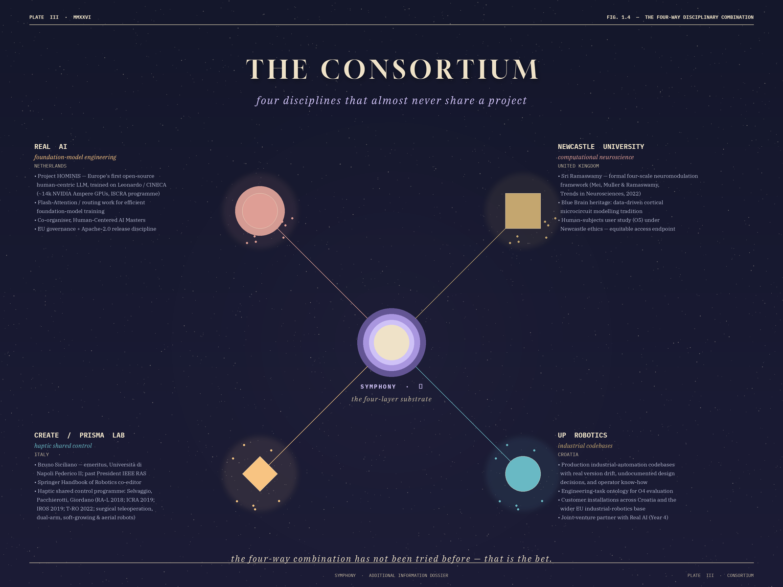
Plate III — Real AI (NL) · Newcastle (UK) · CREATE / PRISMA (IT) · UP Robotics (HR). Four traditionally distant disciplines integrated around a single four-layer substrate.
SYMPHONY’s breakthrough requires the genuine integration of four disciplines: computational neuroscience of cortical neuromodulation; robot manipulation with haptic shared control; software engineering and architecture recovery; and foundation-model engineering with a sovereign / human-centric AI orientation. The first two are biological and biomechanical; the second two are symbolic and computational. The shortest path between any pair runs through at least two intermediate fields. This is a deliberately uncomfortable combination, and it is the only combination that supplies what the proof of principle demands.

FOLIO XII — NEWCASTLE · SRI RAMASWAMY PLATE XII OF XX

Newcastle University · Sri Ramaswamy
THE BLUE BRAIN HERITAGE, FORMALISED

What Newcastle contributes
The formal four-scale framework for context-dependent reconfiguration of a fixed network. This is the mathematical template SYMPHONY transposes from cortical biology to the symbolic substrate.

Why this team
Dr. Sri Ramaswamy leads computational neuroscience at Newcastle University. His doctoral and post-doctoral training was at EPFL in the Blue Brain Project under Henry Markram — the international flagship effort to build a data-driven, biophysically detailed digital reconstruction of the neocortical microcircuit. The Blue Brain heritage is the tradition of data-driven cortical microcircuit modelling: the disciplined practice of building a network model from anatomical and physiological evidence rather than from convenient abstractions. That tradition is precisely the engineering discipline a neuromimetic substrate for code requires.
The canonical reference for SYMPHONY’s O2 is Mei, Muller and Ramaswamy (Trends in Neurosciences, 2022), which formalises a four-scale framework for integrating neuromodulation into deep networks: (1) hyperparameter modulation, (2) plasticity scaling, (3) neuron-level gain modulation, and (4) dendritic computation reconfiguration. The paper demonstrates in simulation that artificial neuromodulation at these four scales yields higher task rewards, faster learning, and reduced catastrophic forgetting — the three behavioural properties SYMPHONY requires from its substrate.
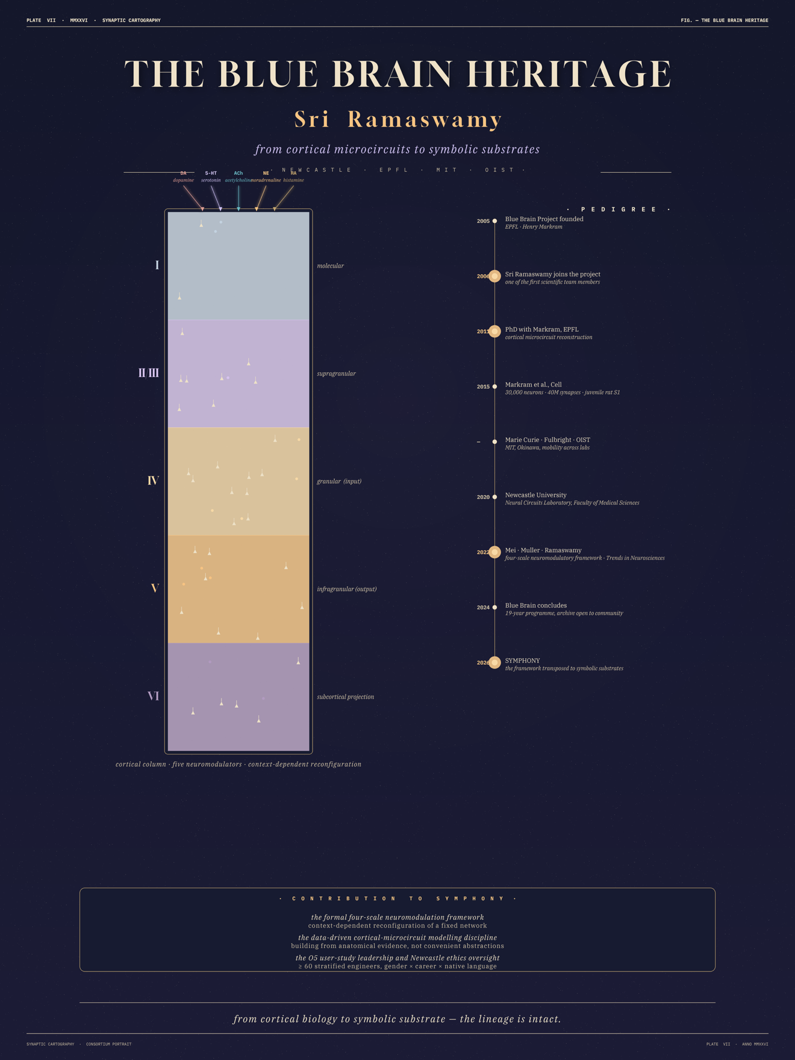

What absence would cost
Without Newcastle, SYMPHONY has no principled mathematical model for how a substrate’s activation regime should change in response to a task signal. The alternative — hand-engineered routing heuristics — is exactly the kind of incremental engineering Pathfinder Open is not designed to fund.

What Newcastle also delivers
The O5 equitable-access user study, run under Newcastle’s Faculty of Science, Agriculture & Engineering Ethics Committee, with pre-registered stratification across gender, career stage and native-language proficiency. The non-inferiority margin guards against deskilling. The study is the consortium’s primary human-subjects evidence.

FOLIO XIII — CREATE · BRUNO SICILIANO PLATE XIII OF XX

CREATE · PRISMA Lab · Bruno Siciliano
THE HAPTIC SHARED CONTROL FORMALISM, TRANSPOSED

What CREATE contributes
The published, hardware-validated control formalism through which a low-bandwidth descending signal reshapes a high-DOF autonomous controller’s operating regime without rewriting it. SYMPHONY’s low-bandwidth task-control surface (§1.2(iii); objective O3) is the transposition of this formalism from continuous motor control to discrete symbolic substrate dynamics.

Why this team
Professor Bruno Siciliano (Università di Napoli Federico II) is one of the founding figures of modern robotics. Past President of the IEEE Robotics and Automation Society; co-editor of the Springer Handbook of Robotics; author of the standard textbook Robotics: Modelling, Planning and Control. He directs the PRISMA Lab (Projects of Industrial and Service Robotics, Mechatronics and Automation) and is the head of CREATE.
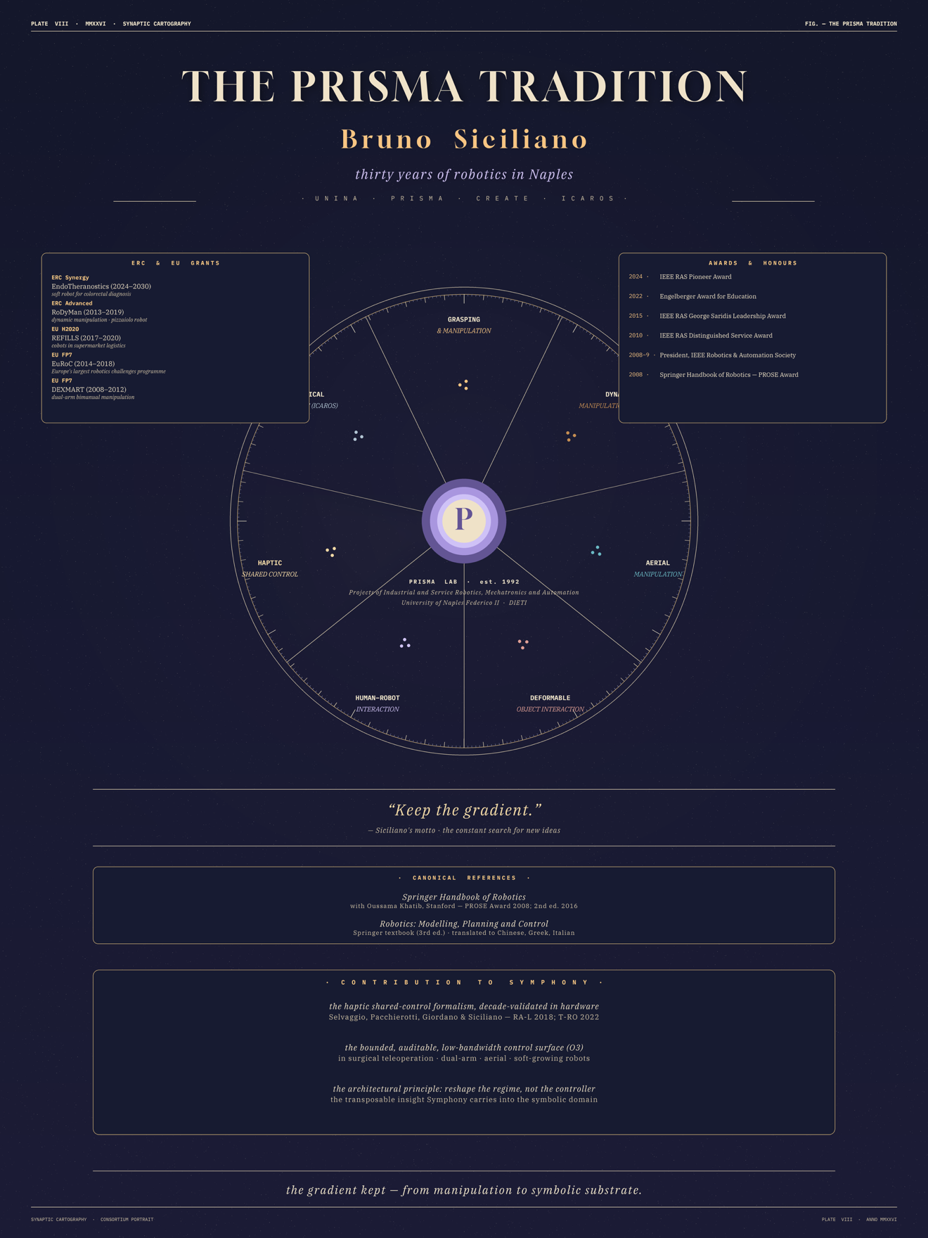
The Siciliano-school haptic shared control programme has produced a decade of hardware-validated work: Selvaggio, Pacchierotti, Giordano and Siciliano (IEEE RA-L 2018; ICRA 2019; IROS 2019; RA-L 2020; IEEE T-RO 2022); Caccavale and Finzi (TopiCS 2021; Autonomous Robots 2019); and subsequent platforms across surgical teleoperation, dual-arm manipulation, assistive teleoperation, and nonprehensile manipulation. The architectural property in common: qualitatively distinct, context-appropriate behaviours from a single underlying autonomous controller, achieved by reshaping the controller’s operating regime via a low-bandwidth descending signal — not by rewriting the controller.

What absence would cost
Without CREATE, SYMPHONY’s task-control interface defaults to a prompt window — the very surface whose unboundedness blocks industrial governance and which the project explicitly rejects. Haptic shared control is not a metaphor; it is a published, hardware-validated control formalism that delivers the bounded, auditable, narrow control surface SYMPHONY needs.

CREATE × Real AI
CREATE is also the founding co-organiser of Europe’s first Human-Centered AI Masters programme, in partnership with Real AI. The collaboration predates SYMPHONY and is a continuation of an existing scientific relationship.

FOLIO XIV — REAL AI · TARRY SINGH · HOMINIS PLATE XIV OF XX

Real AI · Tarry Singh · Project HOMINIS
EUROPE’S FIRST OPEN-SOURCE HUMAN-CENTRIC LLM, ON LEONARDO

What Real AI contributes
Two complementary contributions that together make SYMPHONY deployable rather than purely demonstrative. The first is foundation-model engineering at scale. The second is human-centric, sovereign-AI systems integration — the discipline of making a system’s narrow control surface auditable in a way European governance frameworks can read.

Project HOMINIS
Through Project HOMINIS, Real AI has been awarded compute on the Leonardo supercomputer at CINECA Bologna — approximately 14,000 NVIDIA Ampere GPUs — under the Italian ISCRA programme. With this allocation, Real AI has built and trained large transformer architectures with documented work on energy-efficient methods (Flash Attention, routing) that are directly applicable to SYMPHONY’s training regime and to the DNSH compute commitments in §1.3.
HOMINIS positioned Real AI as Europe’s first open-source human-centric LLM effort. The project has delivered on EU-funded engagements in healthcare, ethics, and energy, and maintains partnerships through CREATE (Europe’s first Human-Centered AI Masters) and the NVIDIA developer ecosystem.
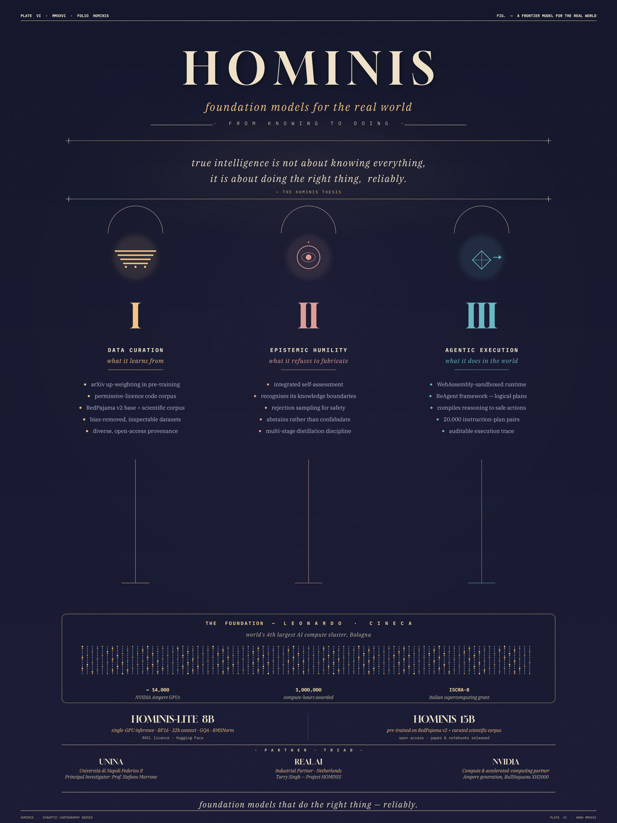

Why this matters for SYMPHONY
The June 2025 European Parliament finding that Europe is "heavily dependent on foreign technologies" in the developer-AI tooling layer makes a credible European alternative a strategic priority. The dominant code-comprehension tooling (GitHub Copilot, Cursor, Claude Code, Replit Agent) is US-headquartered, trained on extraterritorial pipelines, and operated under non-European governance. Real AI’s HOMINIS lineage places SYMPHONY directly inside this policy moment: a substrate released under Apache-2.0 with an EU-jurisdiction governance trail, designed to be a building block of the European AI Stack rather than a competitor to a US platform.

The joint-venture pathway
The consortium has agreed in principle on a Real AI × UP Robotics joint venture as the primary exploitation vehicle for the SYMPHONY substrate, with a non-binding term sheet drafted by M30 gated on O4 results. Real AI brings the engineering capacity and the European-jurisdiction governance posture; UP Robotics brings the industrial customer base and the Croatian-headquartered legal entity that anchors the venture inside the EU single market.

FOLIO XV — UP ROBOTICS PLATE XV OF XX

UP Robotics · the industrial coalface
PRODUCTION CODEBASES, NOT BENCHMARKS

What UP Robotics contributes
The ground-truth view of what a real industrial codebase looks like — not an OSS toy, but a production industrial-automation system with the version drift, undocumented design decisions, and operator know-how that constitute the actual problem domain. UP Robotics is the consortium’s only industrial partner; without its contribution, SYMPHONY would be evaluated only on community-developed open-source code, and any positive result would be open to the objection that it has not been tested where the impact lies.

What UP Robotics delivers
For O1 (the four-layer extraction pipeline) and O4 (the benchmarked advantage), UP Robotics supplies (a) a non-sensitive production industrial-automation codebase under a controlled-disclosure data-sharing agreement, (b) the engineering-task ontology against which the substrate’s task-relevance is judged, and (c) the industrial maintenance logs that constitute half of the O4 benchmark’s 200 task instances (the other half drawn from OSS issue trackers).

Customer base and JV anchor
UP Robotics is a Croatian industrial-automation SME with installations across Croatia and the wider EU industrial-robotics base. Its position as a joint-venture partner with Real AI is the Croatian-headquartered EU legal entity that anchors the post-project exploitation vehicle inside the single market — a structural property valuable for the EIC Transition application planned for Year 4.

Why this matters for impact
The European industrial robotics installed base exceeded 100,000 new units in 2024 (IFR) on top of a stock measured in the millions, with median installation lifetimes well above a decade. The single largest hidden cost in industrial-automation operations is time-to-diagnose on legacy systems. UP Robotics’ role makes the four sectoral impact pathways in §2.1 evidence-based rather than speculative.

FOLIO XVI — INTERDISCIPLINARITY PLATE XVI OF XX

Interdisciplinarity · the four-way combination
EACH PAIR HAS BEEN TRIED — THE FOUR-WAY HAS NOT
Each pair of these disciplines has been combined before. Neuroscience + AI in the NeuroAI community. Robotics + neuroscience in the embodied-AI literature. Software engineering + foundation models in the LLM-agent line. The four-way combination, with the symbolic / structural domain of source code as the target, has not.
SYMPHONY’s specific scientific bet is that the architectural principles by which biology produces task-appropriate behaviour from a fixed substrate — demonstrated in cortex by neuromodulation and in motor control by low-bandwidth descending modulation of substrate dynamics — transpose to a non-embodied, non-rhythmic, symbolic domain when implemented inside a foundation-model-scale engineering platform anchored to a real industrial codebase. None of the four disciplines, alone or in any pair, can run that test.

Shared language and working methodology
The consortium is committed to a single working representation — the four-layer graph substrate of §1.3 (O1) — as the boundary object across all four disciplines. Newcastle and CREATE specify the neuromodulatory and shared-control primitives in graph-operation terms; Real AI implements them as substrate-level operations on the graph; UP Robotics supplies the industrial graph and the engineering-task ontology that drives the evaluation. A monthly cross-disciplinary technical review and a quarterly all-partners scientific review are budgeted in WP1.

New collaborations seeded
Code, evaluation harnesses and the four-layer graph schema are published at each decision milestone with explicit invitations to the NeuroAI, robotics and HRI, software-architecture and foundation-model communities to fork, replicate and extend. Symphony is designed to seed a community of practice around auditable code comprehension that outlives the project itself.

FOLIO XVII — INNOVATION POTENTIAL PLATE XVII OF XX

Innovation potential and the joint-venture pathway
A CATEGORY THAT DOES NOT EXIST TODAY

The category SYMPHONY seeds
The auditable code-comprehension substrate — a class of artefact that is structurally distinct from both the dominant LLM-agent platforms (GitHub Copilot, Cursor, Claude Code, Replit Agent) and the legacy static-analysis / architecture-recovery tooling (SonarQube, PMD, ArchiMate-derived knowledge graphs). The disruptive surface is the combination of three properties delivered together: persistent task-adaptive memory of an industrial codebase; a narrow, auditable control surface that procurement and compliance functions can read; and an open, EU-jurisdiction governance trail.

Exploitation route
A Real AI × UP Robotics joint venture is the primary exploitation vehicle, with a non-binding term sheet drafted by M30 gated on O4 results. Real AI brings the foundation-model engineering capacity, the HOMINIS / Leonardo / ISCRA delivery track record, and the European-jurisdiction governance posture. UP Robotics brings the industrial customer base, the procurement and integration discipline of an automation SME, and the Croatian-headquartered legal entity that anchors the venture inside the EU single market.

IP strategy
Four IP categories with deliberately differentiated protection. (i) The four-layer graph schema and the neuromodulated activation mechanism: open under Apache-2.0 and CC-BY 4.0, with a single defensive patent application by Real AI at M24 covering the system architecture, filed under the EPO unitary patent route. (ii) The training methodology and energy-efficient pipeline: retained as trade secret by the JV, with a defensive publication option held in reserve. (iii) UP Robotics’ industrial codebase derivatives and engineering-task ontology: under data-sharing agreement with anonymised public release. (iv) The substrate-redistribution policy and governance documentation: published under CC-BY 4.0 to seed industry standardisation.

Follow-on funding pathway
EIC Transition application in Year 4; EuroHPC follow-on access through Real AI’s existing ISCRA relationship; downstream EIC Accelerator funding for the EU-headquartered industrial offering.

FOLIO XVIII — ETHICS, OPEN SCIENCE, EU AI ACT PLATE XVIII OF XX

Open science, EU AI Act, trustworthy-AI alignment
BUILT FOR AN EU GOVERNANCE READING FROM DAY ONE

Open science
All peer-reviewed outputs published in open-access venues (Zenodo / OpenAIRE), preprints where appropriate. FAIR data management plan governs all research data. Pre-registration of O4 and O5 protocols before data collection. Code, prompts, baselines, seeds and analysis scripts released alongside each manuscript. The four-layer extraction pipeline, the neuromodulatory reconfiguration module, the low-bandwidth control library and the benchmarking harness are released under permissive licences (Apache-2.0 / MIT).

Trustworthy AI
SYMPHONY applies the European Commission’s Ethics Guidelines for Trustworthy AI across all seven requirements. Transparency and interpretability: the substrate is graph-resident and activation-based; every retrieval is traceable to specific nodes, edges and modulatory scalars. Human agency and oversight: the low-bandwidth task-control interface preserves the engineer’s authorship and accountability. Reliability and robustness: O4 is pre-registered against three named baselines, adjudicated by a three-person external advisory panel. Privacy and data governance: full GDPR / UK GDPR compliance. Diversity, non-discrimination and fairness: O5 stratification with non-inferiority margins. Societal and environmental well-being: per-paper tCO₂e reporting (Green Algorithms methodology), absolute compute-budget cap, downstream JV inherits the same reporting discipline. Accountability: a consortium Ethics Manager (M1) and external advisory panel (M6).

EU AI Act alignment
SYMPHONY’s outputs constitute fundamental research at TRL 1 to 4 and do not deploy an AI system within the scope of Regulation (EU) 2024/1689. The project nonetheless tracks the AI Act’s high-risk classification (Annex III) and engages CEN-CENELEC JTC 21 through Newcastle’s existing committee participation, targeting a contributed working note on auditable code-AI by M30.

Negative-impact mitigations
- IP exfiltration: substrate is bound to its training codebase; substrate-redistribution policy ships with the O4 release at M30.
- Deskilling of junior engineers: O5 secondary endpoint detects retention loss; scaffolded-disclosure deployment patterns mitigate if flagged.
- Energy footprint: per-paper tCO₂e reporting binding through the consortium agreement.

FOLIO XIX — THE LIVE DEMO PAGE PLATE XIX OF XX

Live preview · tarrysingh.com/symphony
THE DOSSIER IN ITS NATIVE MEDIUM
This Word dossier compresses the SYMPHONY argument into print form. The same content lives as an interactive web microsite, designed in the same Synaptic Cartography visual language, at the URL below. Reviewers are warmly invited to spend five minutes there.
tarrysingh.com/symphony

What you will find there
- An interactive planispheric chart of the substrate. Clicking any of the twelve engineering-task sectors swings the task baton to that sector and animates the activation fan across all four code layers in real time.
- A side-by-side reading of the four code-substrate layers — Structural, Behavioural, Historical, Rationale — with a clickable comparison of the four neuromodulatory scales (hyperparameter, plasticity, neuron-level, dendritic).
- A live print-friendly view that exports each of the SYMPHONY plates as a 3-page PDF brief, suitable for forwarding by email.
- A consortium spread showing Real AI, Newcastle, CREATE / PRISMA Lab and UP Robotics, each with primary-source citations and direct links to the relevant publications.
- A pre-registration index linking to the Open Science Framework entries that will be lodged at each decision milestone.

Provenance
The microsite is built in Next.js 14 (TypeScript, Tailwind), hosted on Vercel in the Frankfurt region (fra1), with Vercel Analytics for privacy-respecting measurement. No third-party trackers, no cookie banner, no newsletter signup. The full source code is open on the consortium’s GitHub organisation at the same URL. Here we occasionally release codebase for the community.
Reviewers and VCs can request a secure login to get a much deeper understanding of Project Symphony and its ambition.
If the URL is unreachable at the moment of review, the dossier you are reading is self-contained. The interactive plates extend rather than replace it.

FOLIO XX — CLOSING PLATE XX OF XX

In closing
SYMPHONY proposes that the architectural principle by which biology produces task-appropriate behaviour from a fixed substrate — demonstrated in cortex by neuromodulation, in motor control by low-bandwidth descending modulation, validated in hardware across a decade of Siciliano-school shared-control work — transposes to the symbolic, structural domain of source code, when implemented inside a foundation-model-scale engineering platform anchored to a real industrial codebase.
We do not claim that this is easy. We claim it is decisive. Without SYMPHONY’s proof of principle, the vision of comprehension-capable artificial systems remains an analogy. With it, Europe gains the building block on which a sovereign, auditable, human-centric code-comprehension stack can be assembled — exactly when the political and regulatory frame demands one.
Four disciplines that almost never share a project. A four-way combination that has not been tried before. A bet, with five pre-registered decision milestones to settle it. A consortium pairing the Blue Brain heritage at Newcastle, the haptic shared control formalism at CREATE / PRISMA Lab, the HOMINIS / Leonardo foundation-model engineering at Real AI, and the Croatian industrial coalface at UP Robotics. An open-source, Apache-2.0, EU-jurisdiction governance trail, by design.
Same substrate. Different harmonies.

SYMPHONY · Additional Information Dossier · Anno MMXXVI
Real AI · Newcastle · CREATE / PRISMA Lab · UP Robotics
tarrysingh.com/symphony

