**How to create a Service for Windows using Visual Studio**

File->new-> Windows service

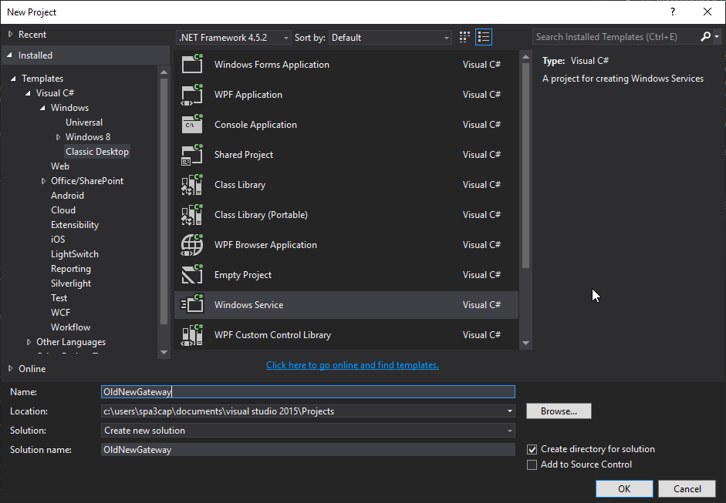

Rename service from solution explorer:

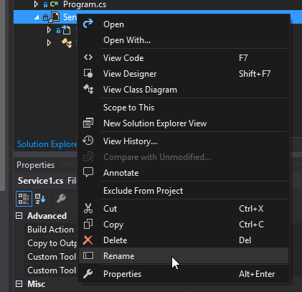 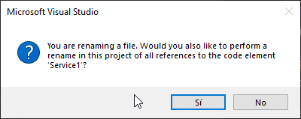

Change the name in the properties of the designer

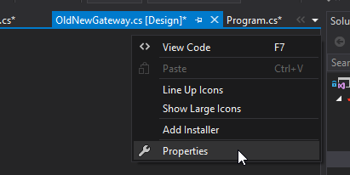

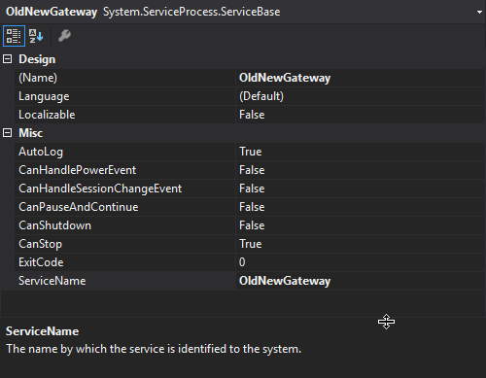

Add EventLog to the designer

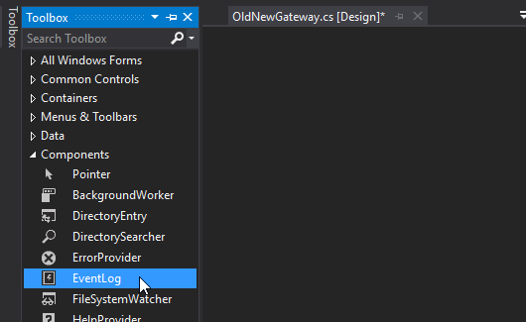

Right click in OldNewGateway.cs -> view code

Add this code:

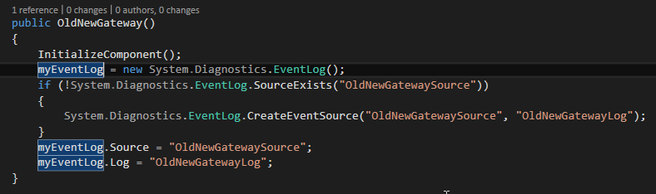

Rename the name in the design (eventLog1 -> myEventLog)

Add an event when the service starts

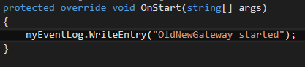

Add a timer to use as a poll mechanism





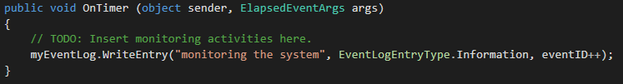

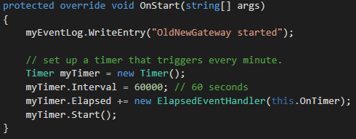

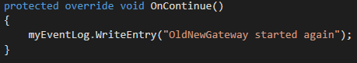

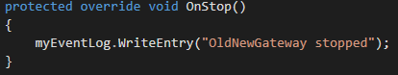

Implement service pending status



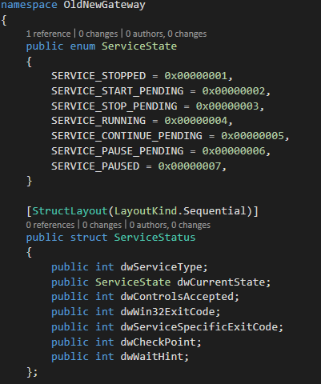

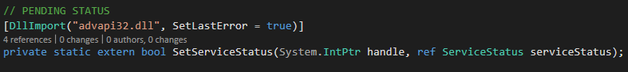

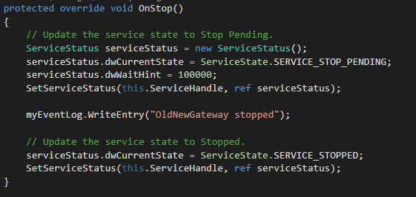

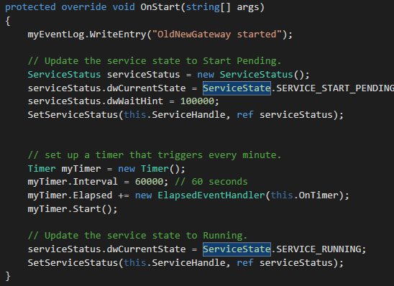

Add installers to the service

In the design right click add installer

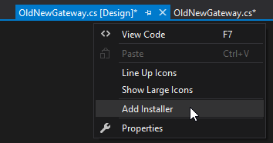

In the serviceInstaller1 change the description and the display name

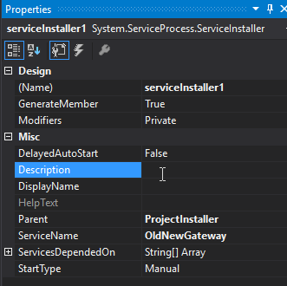

In the serviceProcessInstaller1 change the account to LocalSystem

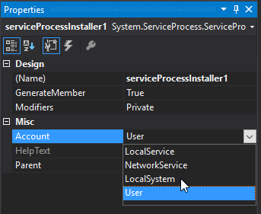

Build the service:

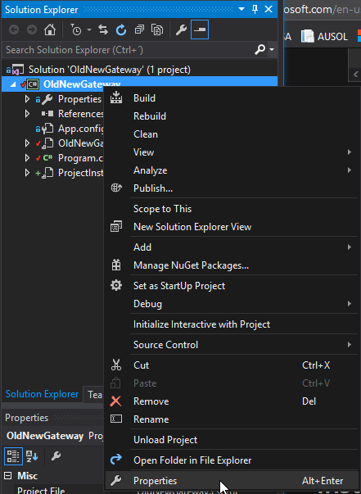

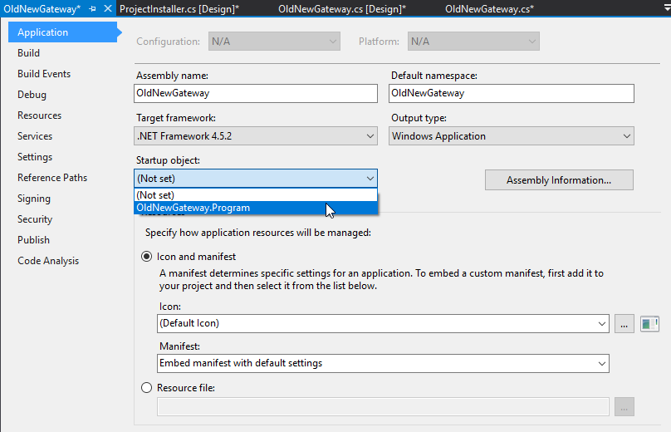

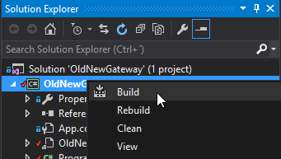

To install the service open the Developer command Prompt for Visual Studio with administrative credentials

Go to the project folder bin\debug

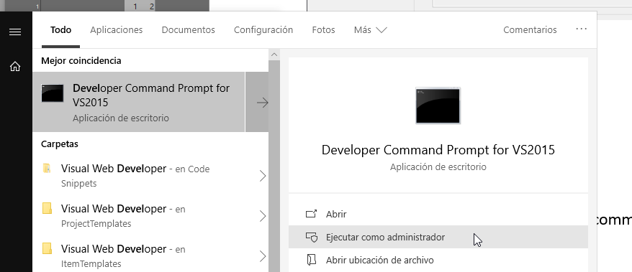

In the console:

installutil OldNewGateway.exe

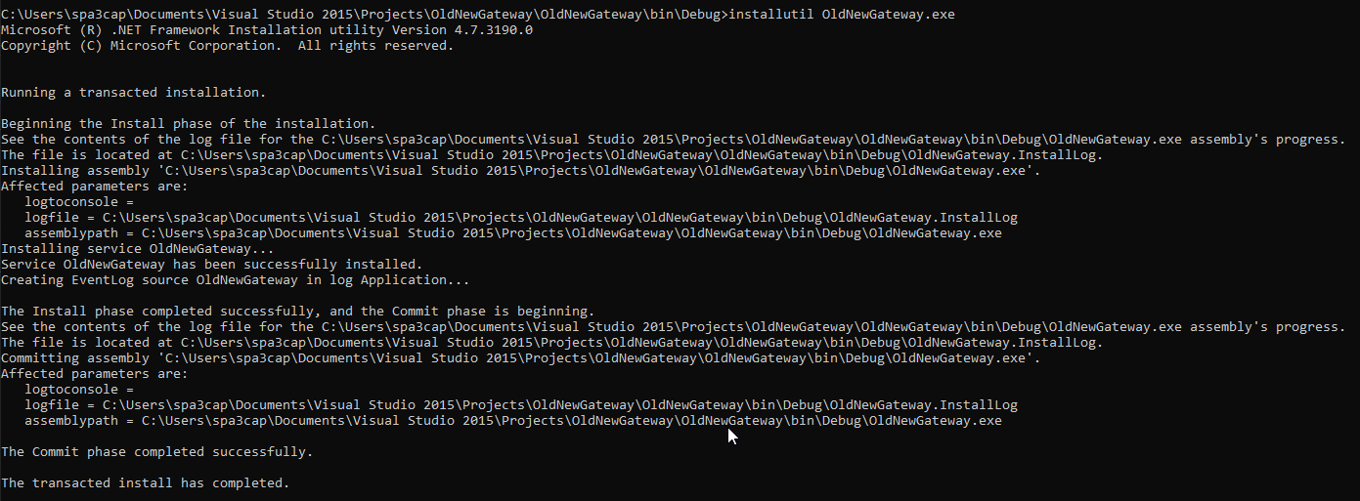

Or whith PowerShell:

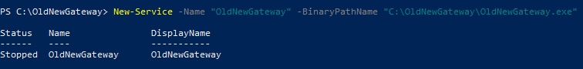

Or



sc create “OldNewGateway” binpath=”C:\OldNewGateway\OldNewGateway.exe”

To run the service from the console:

From the command line, use the commands **net start <service name>** and **net stop <service name>** to start and stop your service.



Or from windows:

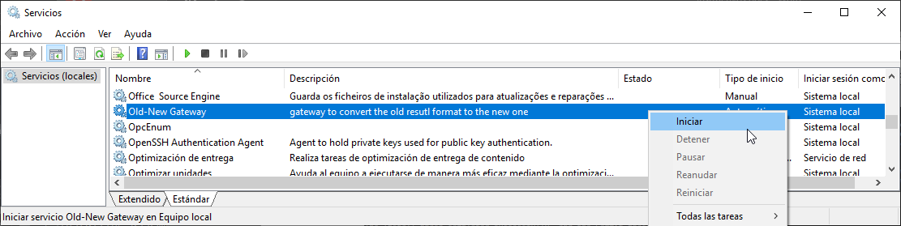

To view the events:

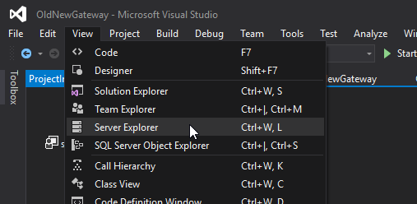

Or

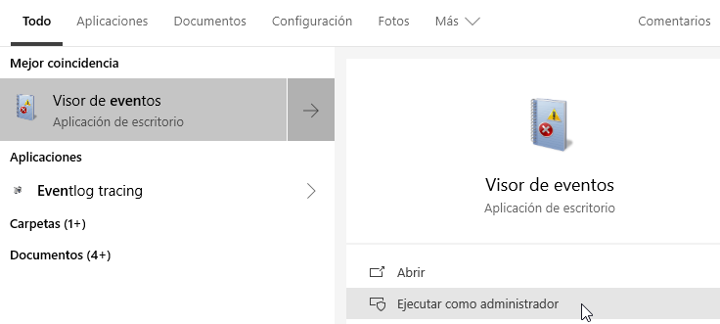

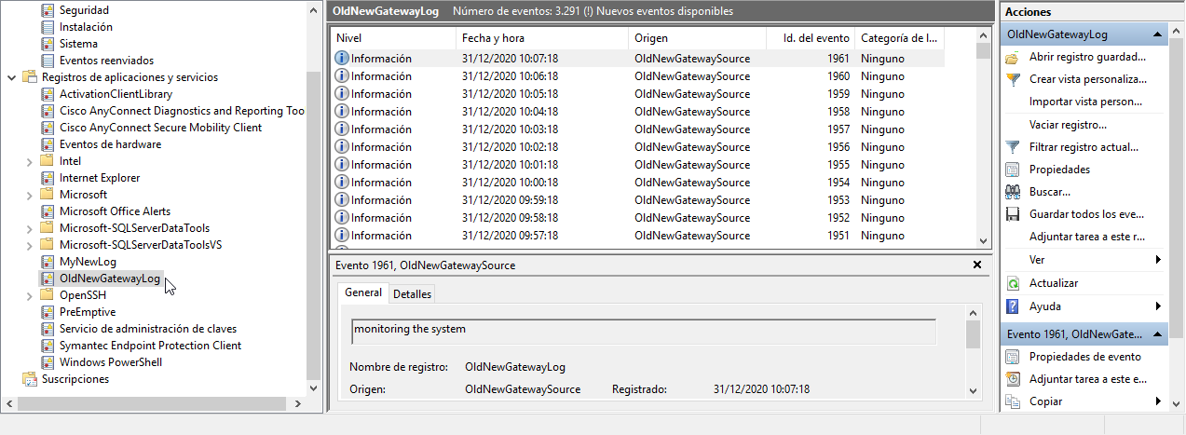

To uninstall the service in the command line:

installutil.exe /u OldNewGateway.exe

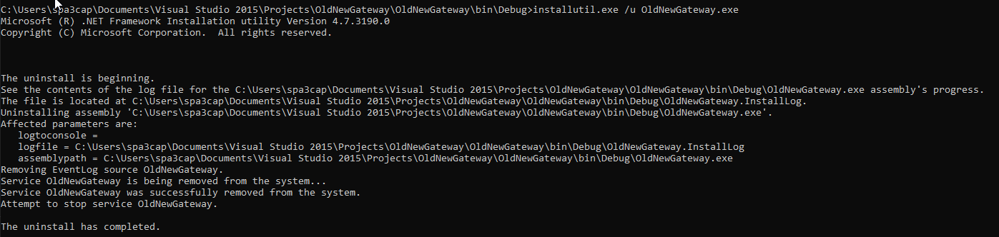

Or PowerShell:

Stop the service and then:



**How to automate Excel from Visual C#.NET**

