Voting C
Accuracy: 0.8129116002520713
Precision: 0.7068859300752838
Recall: 0.5877824821099569
F1-Score: 0.6133
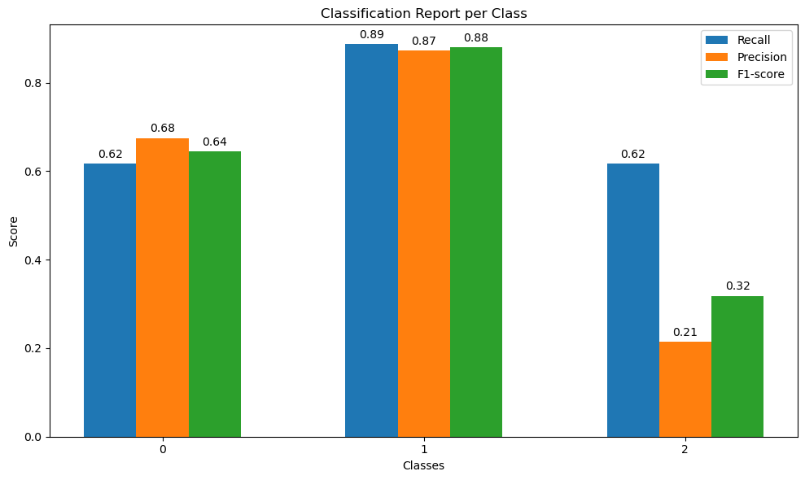

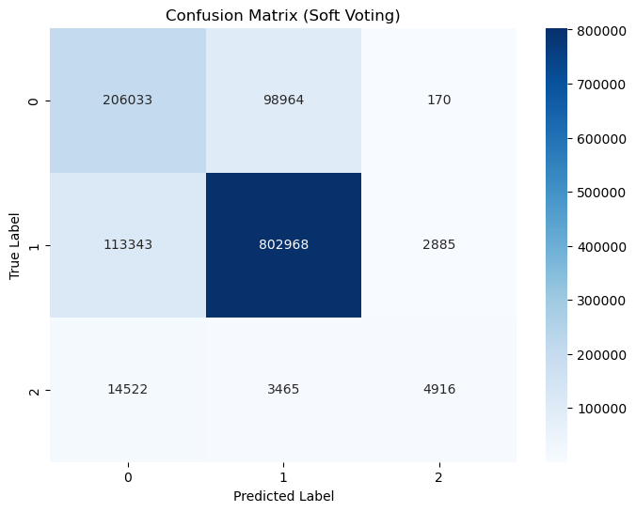

Voting D
Accuracy: 0.8182
Precision: 0.8130
Recall: 0.6672
F1-Score: 0.6237
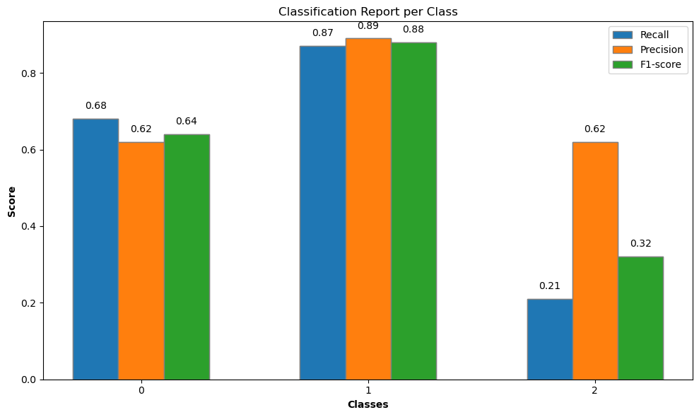
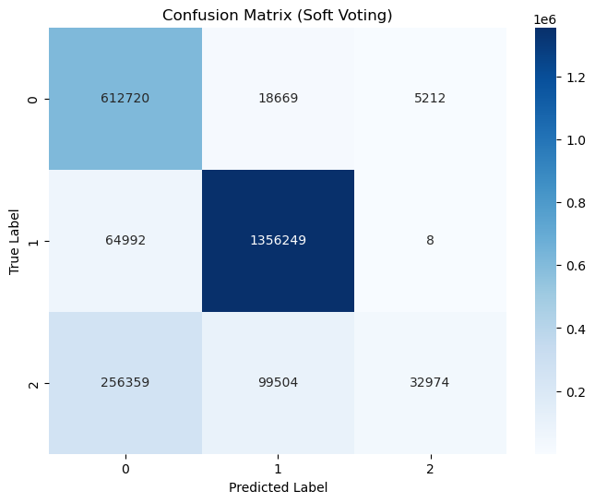

RFC without aggregation C
Accuracy: 0.9887
Precision: 0.74
Recall: 0.87
F1: 0.7933
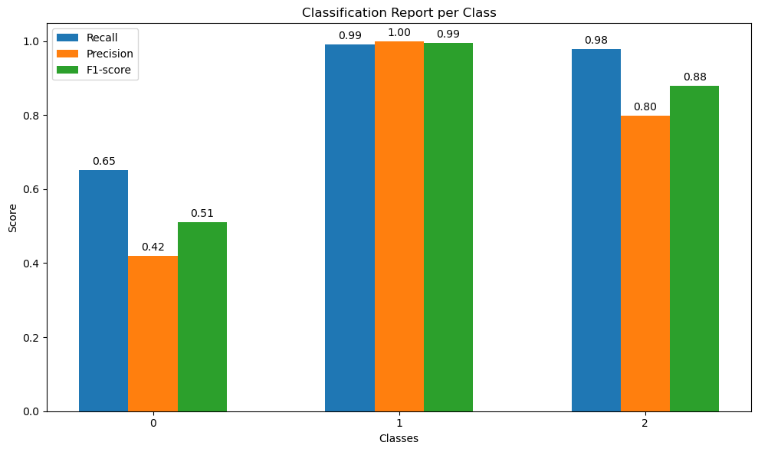
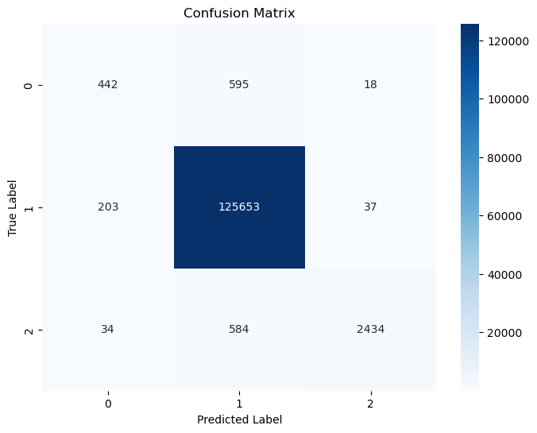

RFC without aggregation D
Accuracy: 0.9886846153846154
Precision: 0.8731881003360513
Recall: 0.7381869315920103
F1: 0.5500
