EXPERIMENT 2

**AIM:** To design and simulate Half Subtractor and full Subtractor using VHDL in Modelism.

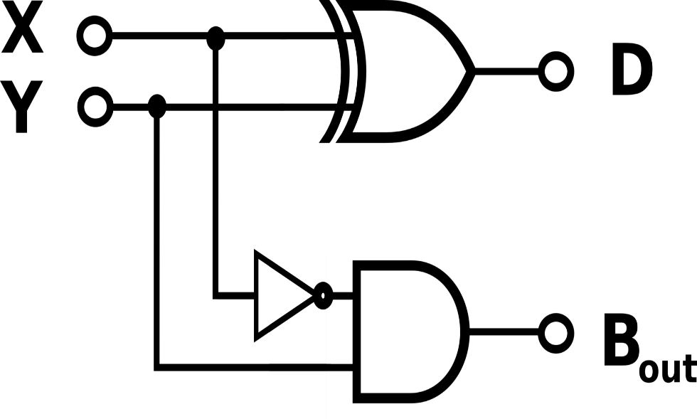**THEORY:** The **half subtractor** is a combinational circuit which is used to perform subtraction of two bits. It has two inputs, the minuend X {\displaystyle X} and subtrahend Y {\displaystyle Y} and two outputs the difference D {\displaystyle D} and borrow out B out {\displaystyle B_{\text{out}}} . his is an important distinction to make since subtraction itself is not commutative.

|  |  |  |  |
| --- | --- | --- | --- |
| **Inputs** | | **Outputs** | |
| **X** | **Y** | **D** | **BOUT** |
| **0** | **0** | **0** | **0** |
| **0** | **1** | **1** | **1** |
| **1** | **0** | **1** | **0** |
| **1** | **1** | **0** | **0** |

|  |  |  |  |  |
| --- | --- | --- | --- | --- |
| **X** | **Y** | **BIN** | **D** | **BOUT** |
| 0 | 0 | 0 | 0 | 0 |
| 0 | 0 | 1 | 1 | 1 |
| 0 | 1 | 0 | 1 | 1 |
| 0 | 1 | 1 | 0 | 1 |
| 1 | 0 | 0 | 1 | 0 |
| 1 | 0 | 1 | 0 | 0 |
| 1 | 1 | 0 | 0 | 0 |
| 1 | 1 | 1 | 1 | 1 |

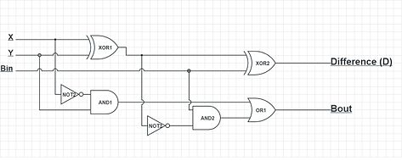The **full subtractor** is a combinational circuit which is used to perform subtraction of three input bits: the minuend XX {\displaystyle X} , subtrahend Y Y {\displaystyle Y} , and borrow in BINB in {\displaystyle B_{\text{in}}} . The full subtractor generates two output bits: the difference D {\displaystyle D} and borrow out BOUT B out {\displaystyle B_{\text{out}}} .BIN B in {\displaystyle B_{\text{in}}} is set when the previous digit is borrowed from X {\displaystyle X} X.

**VHDL CODE: FOR FULL SUBTRACTOR**

LIBRARY ieee;

USE ieee.std_logic_1164.all;

USE ieee.std_logic_arith.all;

ENTITY FULL_SUBTRACTOR IS

port(A,B,BORROW_IN: in std_logic ; DIFF,BORROW: out std_logic);

END ENTITY FULL_SUBTRACTOR;

--

ARCHITECTURE FULL_SUBTRACTOR_DATAFLOW OF FULL_SUBTRACTOR IS

SIGNAL ABAR: std_logic;

BEGIN

DIFF<= A XOR B XOR BORROW_IN;

ABAR<= not A;

BORROW<= (ABAR AND BORROW_IN)OR(ABAR AND B)OR(B AND BORROW_IN);

END ARCHITECTURE FULL_SUBTRACTOR_DATAFLOW;

ARCHITECTURE FULL_SUBTRACTOR_BEHAV OF FULL_SUBTRACTOR IS

SIGNAL S:std_logic_vector(2 downto 0);

BEGIN

S(2)<=A;S(1)<=B;S(0)<=BORROW_IN;

PROCESS(S)

BEGIN

if (S = "001" or S = "010" or S = "111") then

DIFF<='1'; BORROW<='1';

else if (S = "011") then

DIFF<='0'; BORROW<='1';

else if (S = "100") then

DIFF<='1'; BORROW<='0';

else

DIFF<='0'; BORROW<='0';

end if;

end if;

end if;

END PROCESS;

END ARCHITECTURE FULL_SUBTRACTOR_BEHAV;

ARCHITECTURE FULL_SUBTRACTOR_STRUCTURAL OF FULL_SUBTRACTOR IS

component AND_GATE

port(A,B:in std_logic;Z: out std_logic);

end component;

component XOR_GATE

port(A,B:in std_logic;Z: out std_logic);

end component;

component OR_GATE

port(A,B:in std_logic;Z: out std_logic);

end component;

component NOT_GATE

port(A:in std_logic;Z: out std_logic);

end component;

SIGNAL var: std_logic_vector(4 downto 0);

BEGIN

X1: XOR_GATE port map (A,B,var(0));

X2: XOR_GATE port map (BORROW_IN,var(0),DIFF);

N1: NOT_GATE port map (var(0),var(1));

A1: AND_GATE port map (var(1),BORROW_IN,var(2));

N2: NOT_GATE port map (A,var(3));

A2: AND_GATE port map (B,var(3),var(4));

O1: OR_GATE port map (var(2),var(4),BORROW);

END ARCHITECTURE FULL_SUBTRACTOR_STRUCTURAL;

**FOR HALF SUBTRACTOR**

LIBRARY ieee;

USE ieee.std_logic_1164.all;

USE ieee.std_logic_arith.all;

ENTITY HALF_SUBTRACTOR IS

port(A,B:in std_logic; DIFF,BORROW:out std_logic);

END ENTITY HALF_SUBTRACTOR;

--

ARCHITECTURE HALF_SUBTRACTOR_BEHAV OF HALF_SUBTRACTOR IS

SIGNAL s:std_logic_vector(1 downto 0);

BEGIN

s(1)<=A;

s(0)<=B;

PROCESS(s)

BEGIN

if (S = "00" or S = "11") then

DIFF<='0'; BORROW<='0';

else if (S = "01") then

DIFF<='1'; BORROW<='1';

else

DIFF<='1'; BORROW<='0';

end if;

end if;

END PROCESS;

END ARCHITECTURE HALF_SUBTRACTOR_BEHAV;

ARCHITECTURE HALF_SUBTRACTOR_DATAFLOW OF HALF_SUBTRACTOR IS

BEGIN

DIFF<=A XOR B;

BORROW<=( NOT A) AND B;

END ARCHITECTURE HALF_SUBTRACTOR_DATAFLOW;

ARCHITECTURE HALF_SUBTRACTOR_STRUCTURAL OF HALF_SUBTRACTOR IS

component AND_GATE

port(A,B:in std_logic;Z: out std_logic);

end component;

component XOR_GATE

port(A,B:in std_logic;Z: out std_logic);

end component;

component NOT_GATE

port(A:in std_logic;Z: out std_logic);

end component;

SIGNAL ANOT:std_logic;

BEGIN

A1: AND_GATE port map(A,B,DIFF);

N1: NOT_GATE port map(A,ANOT);

X1: XOR_GATE port map(ANOT,B,BORROW);

END ARCHITECTURE HALF_SUBTRACTOR_STRUCTURAL;

**OUTPUT:**

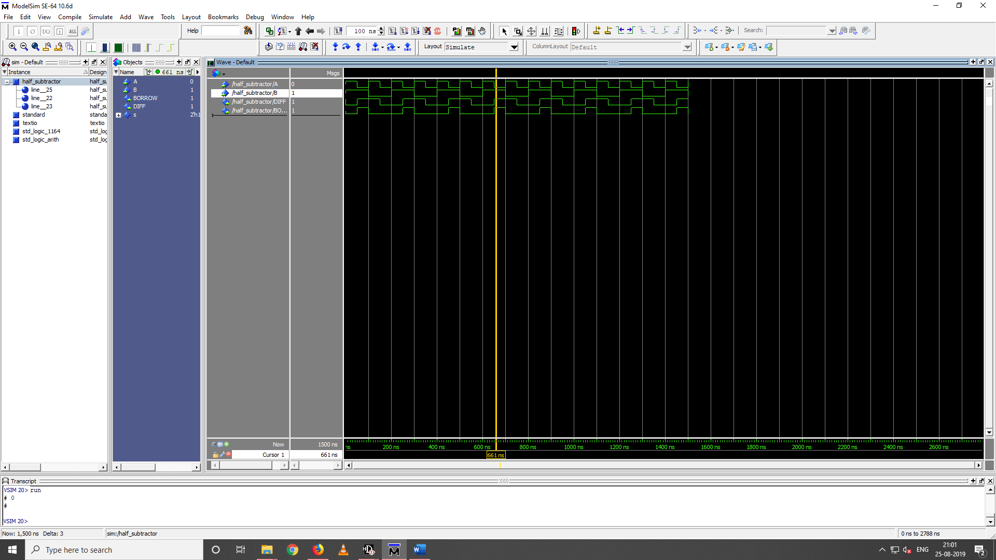

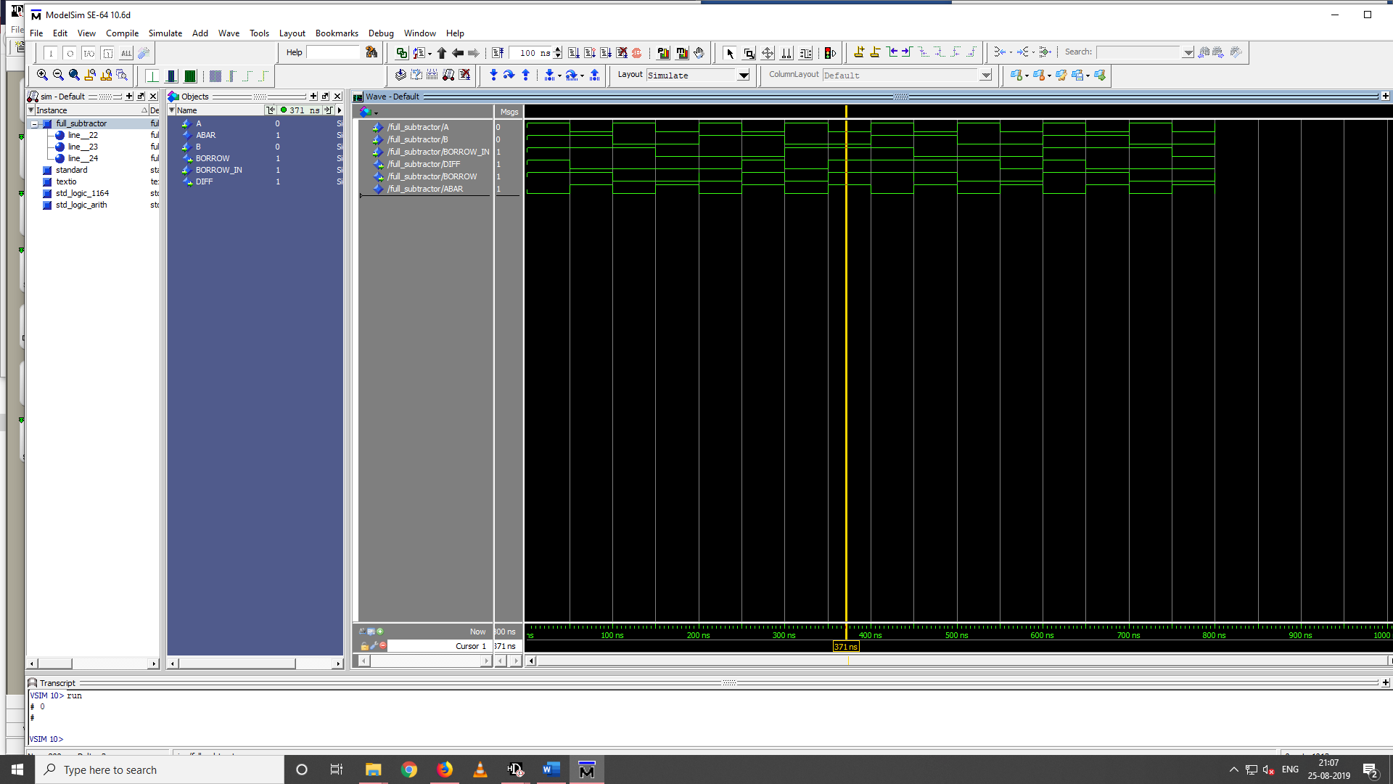**HALF SUBTRACTOR**

**FULL SUBTRACTOR**

**RESULT: Half-subtractor and Full-subtractor are simulated using model sim and HDL**

**Designer.**