EXPERIMENT 4

**AIM:** To design and simulate MUX and DEMUX using VHDL in ModelSim.

**Theory:** In electronics, a **multiplexer** (or **mux**) is a device that selects between several analog or digital input signals and forwards it to a single output line. A multiplexer of n 2 n {\displaystyle 2^{n}} inputs has 2n n {\displaystyle n} select lines, which are used to select which input line to send to the output. Multiplexers are mainly used to increase the amount of data that can be sent over the network within a certain amount of time and bandwidth. A multiplexer is also called a **data selector**. Multiplexers can also be used to implement Boolean functions of multiple variables.

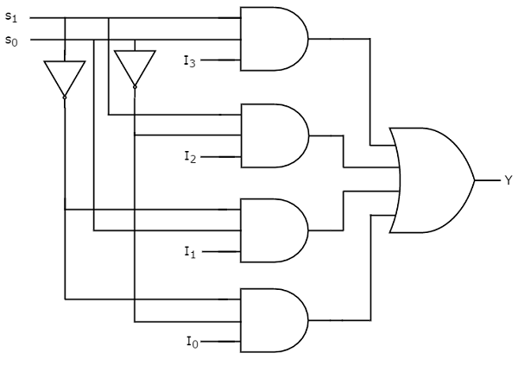

|  |  |  |
| --- | --- | --- |
| **INPUT** | | **OUTPUT** |
| **S1** | **S0** | **Y** |
| **0** | **0** | **D0** |
| **0** | **1** | **D1** |
| **1** | **0** | **D2** |
| **1** | **1** | **D3** |

The process of getting information from one input and transmitting the same over one of many outputs is called demultiplexing. A demultiplexer is a combinational logic circuit that receives the information on a single input and transmits the same information over one of 2n possible output lines.

The bit combinations of the select lines control the selection of specific output line to be connected to the input at given instant.

|  |  |  |  |  |  |  |
| --- | --- | --- | --- | --- | --- | --- |
| **DATA** | **SELECT LINES** | | **OUTPUTS** | | | |
| **D** | **S1** | **S0** | **D0** | **D1** | **D2** | **D3** |
| **D** | **0** | **0** | **0** | **0** | **0** | **D** |
| **D** | **0** | **1** | **0** | **0** | **D** | **0** |
| **D** | **1** | **0** | **0** | **D** | **0** | **0** |
| **D** | **1** | **1** | **D** | **0** | **0** | **0** |

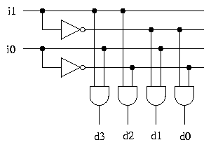

**VHDL CODE: 4-to-1 Multiplexer**

LIBRARY ieee;

USE ieee.std_logic_1164.all;

USE ieee.std_logic_arith.all;

ENTITY MULTIPLEXER_4_1 IS

port(A,B,C,D,S0,S1: in STD_LOGIC;Z: out STD_LOGIC);

END ENTITY MULTIPLEXER_4_1;

--

ARCHITECTURE MULTIPLEXER_4_1_DATAFLOW OF MULTIPLEXER_4_1 IS

BEGIN

Z<=(((NOT S1)AND(NOT S0)AND A) OR ((NOT S1)AND S0 AND B) OR(S1 AND (NOT S0)AND C) OR(S1 AND S0 AND D));

END ARCHITECTURE MULTIPLEXER_4_1_DATAFLOW;

ARCHITECTURE MULTIPLEXER_4_1_BEHAV OF MULTIPLEXER_4_1 IS

BEGIN

PROCESS (A,B,C,D,S0,S1) IS

BEGIN

if (S0 ='0' and S1 = '0') then

Z <= A;

elsif (S0 ='1' and S1 = '0') then

Z <= B;

elsif (S0 ='0' and S1 = '1') then

Z <= C;

else

Z <= D;

end if;

END PROCESS;

END ARCHITECTURE MULTIPLEXER_4_1_BEHAV;

ARCHITECTURE MULTIPLEXER_4_1_STRUCTURAL OF MULTIPLEXER_4_1 IS

component AND_GATE

port(A,B:in std_logic;Z: out std_logic);

end component;

component OR_GATE

port(A,B:in std_logic;Z: out std_logic);

end component;

component NOT_GATE

port(A:in std_logic;Z: out std_logic);

end component;

SIGNAL var,var1: std_logic_vector(4 downto 0);

SIGNAL S0BAR,S1BAR: std_logic;

BEGIN

N1: NOT_GATE port map (S1,S1BAR);

N2: NOT_GATE port map (S0,S0BAR);

A1: AND_GATE port map (S1BAR,S0BAR,var(0));

A2: AND_GATE port map (var(0),A,var1(0));

A3: AND_GATE port map (S1BAR,S0,var(1));

A4: AND_GATE port map (var(1),B,var1(1));

A5: AND_GATE port map (S1,S0BAR,var(2));

A6: AND_GATE port map (var(2),C,var1(2));

A7: AND_GATE port map (S1,S0,var(3));

A8: AND_GATE port map (var(3),D,var1(3));

O1: OR_GATE port map (var1(0),var1(1),var(4));

O2: OR_GATE port map (var1(2),var1(3),var1(4));

O3: OR_GATE port map (var(4),var1(4),Z);

END ARCHITECTURE MULTIPLEXER_4_1_STRUCTURAL;

**DEMUX CODE:**

LIBRARY ieee;

USE ieee.std_logic_1164.all;

USE ieee.std_logic_arith.all;

ENTITY DEMUX_1_4 IS

port ( A,S1,S0: in std_logic;Z:out std_logic_vector(3 downto 0) );

END ENTITY DEMUX_1_4;

--

ARCHITECTURE DEMUX_1_4_STRUCTURAL OF DEMUX_1_4 IS

component AND_GATE

port(A,B:in std_logic;Z: out std_logic);

end component;

component NOT_GATE

port(A:in std_logic;Z: out std_logic);

end component;

SIGNAL var: std_logic_vector(3 downto 0);

SIGNAL S0BAR,S1BAR: std_logic;

BEGIN

N1: NOT_GATE port map (S1,S1BAR);

N2: NOT_GATE port map (S0,S0BAR);

A1: AND_GATE port map (S1BAR,S0BAR,var(0));

A2: AND_GATE port map (var(0),A,Z(0));

A3: AND_GATE port map (S1BAR,S0,var(1));

A4: AND_GATE port map (var(1),A,z(1));

A5: AND_GATE port map (S1,S0BAR,var(2));

A6: AND_GATE port map (var(2),A,Z(2));

A7: AND_GATE port map (S1,S0,var(3));

A8: AND_GATE port map (var(3),A,Z(3));

END ARCHITECTURE DEMUX_1_4_STRUCTURAL;

ARCHITECTURE DEMUX_1_4_DATAFLOW OF DEMUX_1_4 IS

BEGIN

Z(0)<=(NOT S0)AND (NOT S1) AND A;

Z(1)<=(NOT S0)AND S1 AND A;

Z(2)<= S0 AND (NOT S1) AND A;

Z(3)<= S0 AND S1 AND A;

END ARCHITECTURE DEMUX_1_4_DATAFLOW;

ARCHITECTURE DEMUX_1_4_BEHAV OF DEMUX_1_4 IS

BEGIN

process (F,S0,S1) is

begin

if (S0 ='0' and S1 = '0') then

Z(0) <= A;

elsif (S0 ='1' and S1 = '0') then

Z(1) <= A;

elsif (S0 ='0' and S1 = '1') then

Z(2) <= A;

else

Z(3) <= A;

end if;

end process;

END ARCHITECTURE DEMUX_1_4_BEHAV;

**OUTPUTS:**

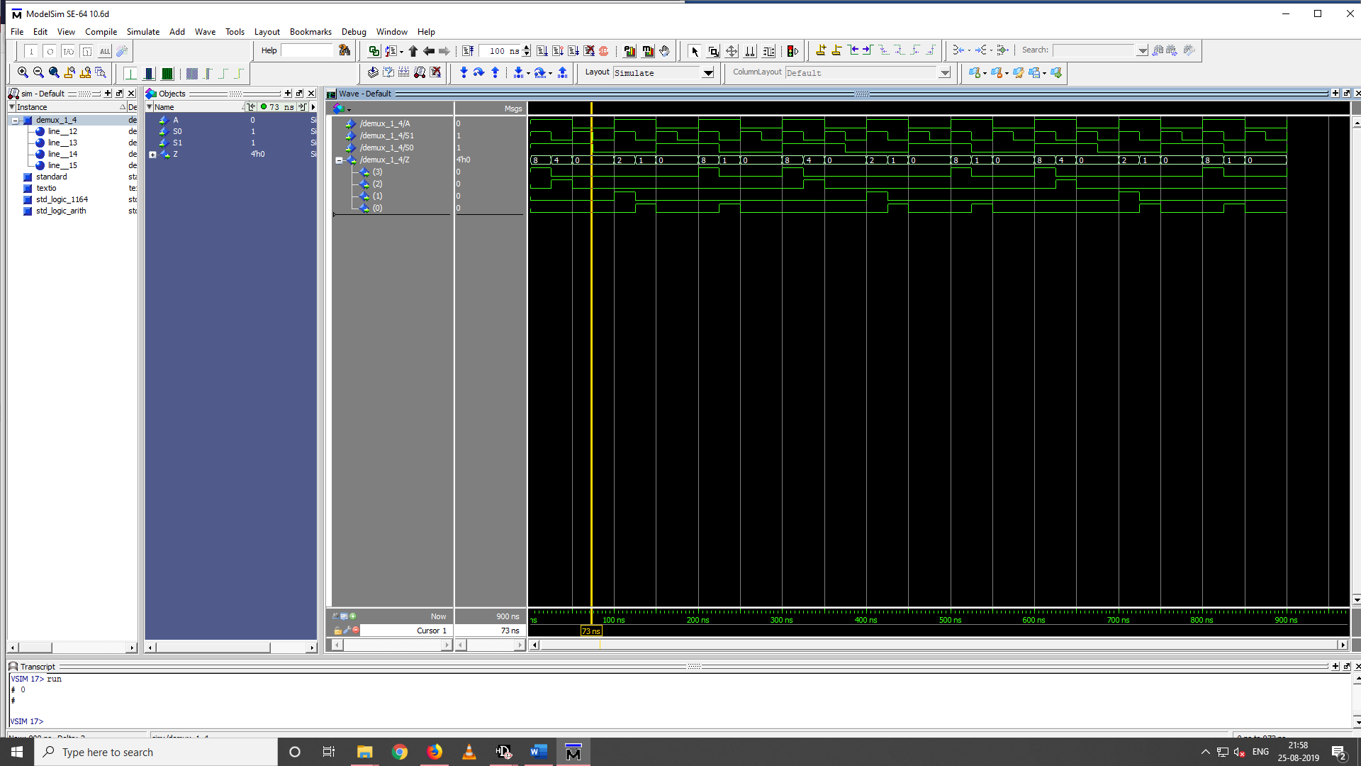

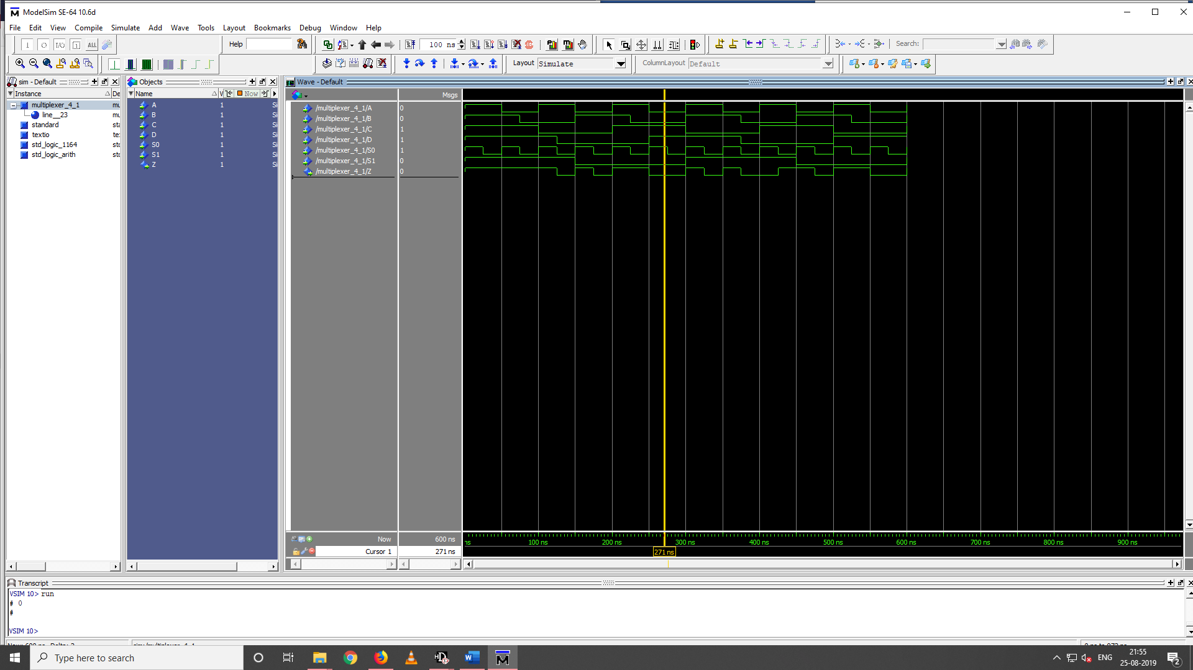**DEMUX**

**MUX**

**RESULT:** **MUX and DEMUX had been successfully simulated using VHDL in**

**ModelSim.**