**EXPERIMENT 5**

**AIM: To design and simulate priority Encoder and Decoder using VHDL and ModelSim.**

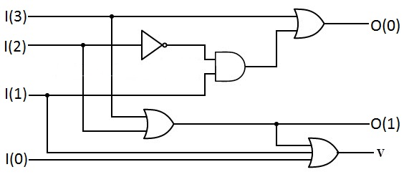**Theory:** A **priority encoder** is a circuit or algorithm that compresses multiple binary inputs into a smaller number of outputs. The output of a priority encoder is the binary representation of the original number starting from zero of the most significant input bit. They are often used to control interrupt requests by acting on the highest priority encoder.

**PRIORITY ENCODER**

|  |  |  |  |  |  |  |
| --- | --- | --- | --- | --- | --- | --- |
| **I(3)** | **I(2)** | **I(1)** | **I(0)** | **O(1)** | **O(0)** | **V** |
| **0** | **0** | **0** | **0** | **X** | **X** | **0** |
| **0** | **0** | **0** | **1** | **0** | **0** | **1** |
| **0** | **0** | **1** | **X** | **0** | **1** | **1** |
| **0** | **1** | **X** | **X** | **1** | **0** | **1** |
| **1** | **X** | **X** | **X** | **1** | **1** | **1** |

**TRUTH TABLE**

**DECODER:** In digital electronics, a **decoder** is a combinational logic circuit that converts binary information from the n coded inputs to a maximum of 2n unique outputs.

There are several types of binary decoders, but in all cases a decoder is an electronic circuit with multiple input and multiple output signals, which converts every unique combination of input states to a specific combination of output states. In addition to integer data inputs, some decoders also have one or more "enable" inputs. When the enable input is negated (disabled), all decoder outputs are forced to their inactive states.

|  |  |  |  |  |  |
| --- | --- | --- | --- | --- | --- |
| **A0** | **A1** | **D0** | **D1** | **D2** | **D3** |
| **0** | **0** | **1** | **0** | **0** | **0** |
| **0** | **1** | **0** | **1** | **0** | **0** |
| **1** | **0** | **0** | **0** | **1** | **0** |
| **1** | **1** | **0** | **0** | **0** | **1** |

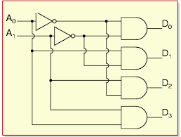

**TRUTH TABLE DECODER 2_4**

**VHDL CODE FOR PRIORITY ENCODER**

LIBRARY ieee;

USE ieee.std_logic_1164.all;

USE ieee.std_logic_arith.all;

ENTITY PENCODER_4_2 IS

port(D:in std_logic_vector(3 downto 0);x,y,P:out std_logic);

END ENTITY PENCODER_4_2;

--

ARCHITECTURE PENCODER_4_2_STRUCTURAL OF PENCODER_4_2 IS

component AND_GATE

port(A,B:in std_logic;Z: out std_logic);

end component;

component OR_GATE

port(A,B:in std_logic;Z: out std_logic);

end component;

component NOT_GATE

port(A:in std_logic;Z: out std_logic);

end component;

SIGNAL DBAR:std_logic;

SIGNAL VAR:std_logic_vector(1 downto 0);

BEGIN

N1: NOT_GATE port map (D(2),DBAR);

A1: AND_GATE port map (D(1),DBAR,VAR(0));

O1: OR_GATE port map (VAR(0),D(3),Y);

O2: OR_GATE port map (D(2),D(3),X);

O3: OR_GATE port map (X,D(1),VAR(1));

O4: OR_GATE port map (VAR(1),D(0),P);

END ARCHITECTURE PENCODER_4_2_STRUCTURAL;

ARCHITECTURE PENCODER_4_2_DATAFLOW OF PENCODER_4_2 IS

BEGIN

x<= D(2) or D(3);

y<= D(3) or (D(1) and (not D(2)));

P<= D(0) or D(1) or D(2) or D(3);

END ARCHITECTURE PENCODER_4_2_DATAFLOW;

**VHDL CODE FOR DECODER**

LIBRARY ieee;

USE ieee.std_logic_1164.all;

USE ieee.std_logic_arith.all;

ENTITY DECODER_2_4 IS

port(A,B:in std_logic;D: out std_logic_vector(3 downto 0));

END ENTITY DECODER_2_4;

--

ARCHITECTURE DECODER_2_4_DATAFLOW OF DECODER_2_4 IS

BEGIN

D(0)<= (not A) nand (not B) ;

D(1)<= (not A) nand B ;

D(2)<= A nand (not B) ;

D(3)<= A nand B ;

END ARCHITECTURE DECODER_2_4_DATAFLOW;

ARCHITECTURE DECODER_2_4_STRUCTURAL OF DECODER_2_4 IS

component NAND_GATE

port(A,B:in std_logic;Z: out std_logic);

end component;

component NOT_GATE

port(A:in std_logic;Z: out std_logic);

end component;

SIGNAL ABAR,BBAR:std_logic;

BEGIN

N1: NOT_GATE port map(A,ABAR);

N2: NOT_GATE port map(B,BBAR);

NA1: NAND_GATE port map(ABAR,BBAR,D(0));

NA2: NAND_GATE port map(ABAR,B,D(1));

NA3: NAND_GATE port map(A,BBAR,D(2));

NA4: NAND_GATE port map(A,B,D(3));

END ARCHITECTURE DECODER_2_4_STRUCTURAL;

ARCHITECTURE DECODER_2_4_BEHAV OF DECODER_2_4 IS

BEGIN

process (A,B) is

begin

if (A ='0' and B = '0') then

D <= "1110";

elsif (A ='1' and B = '0') then

D <= "1011";

elsif (A ='0' and B = '1') then

D <= "1101";

else

D <= "0111";

end if;

end process;

END ARCHITECTURE DECODER_2_4_BEHAV;

**RESULTS:**

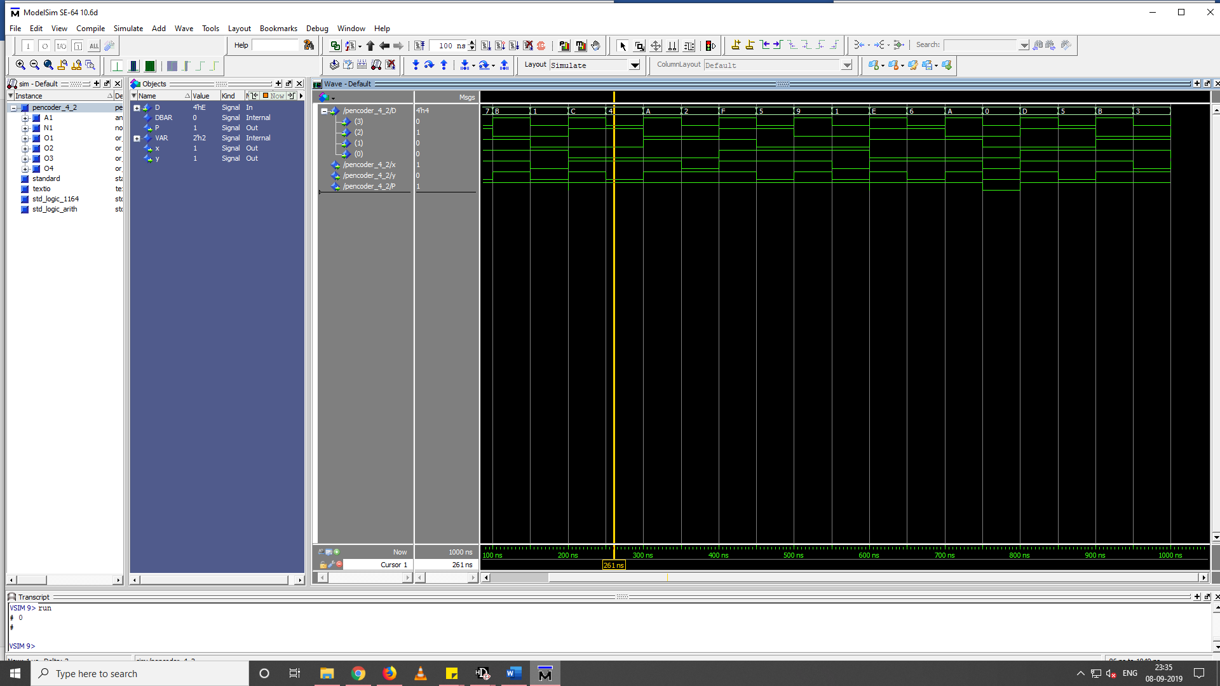

**PRIORITY ENCODER 4_2**

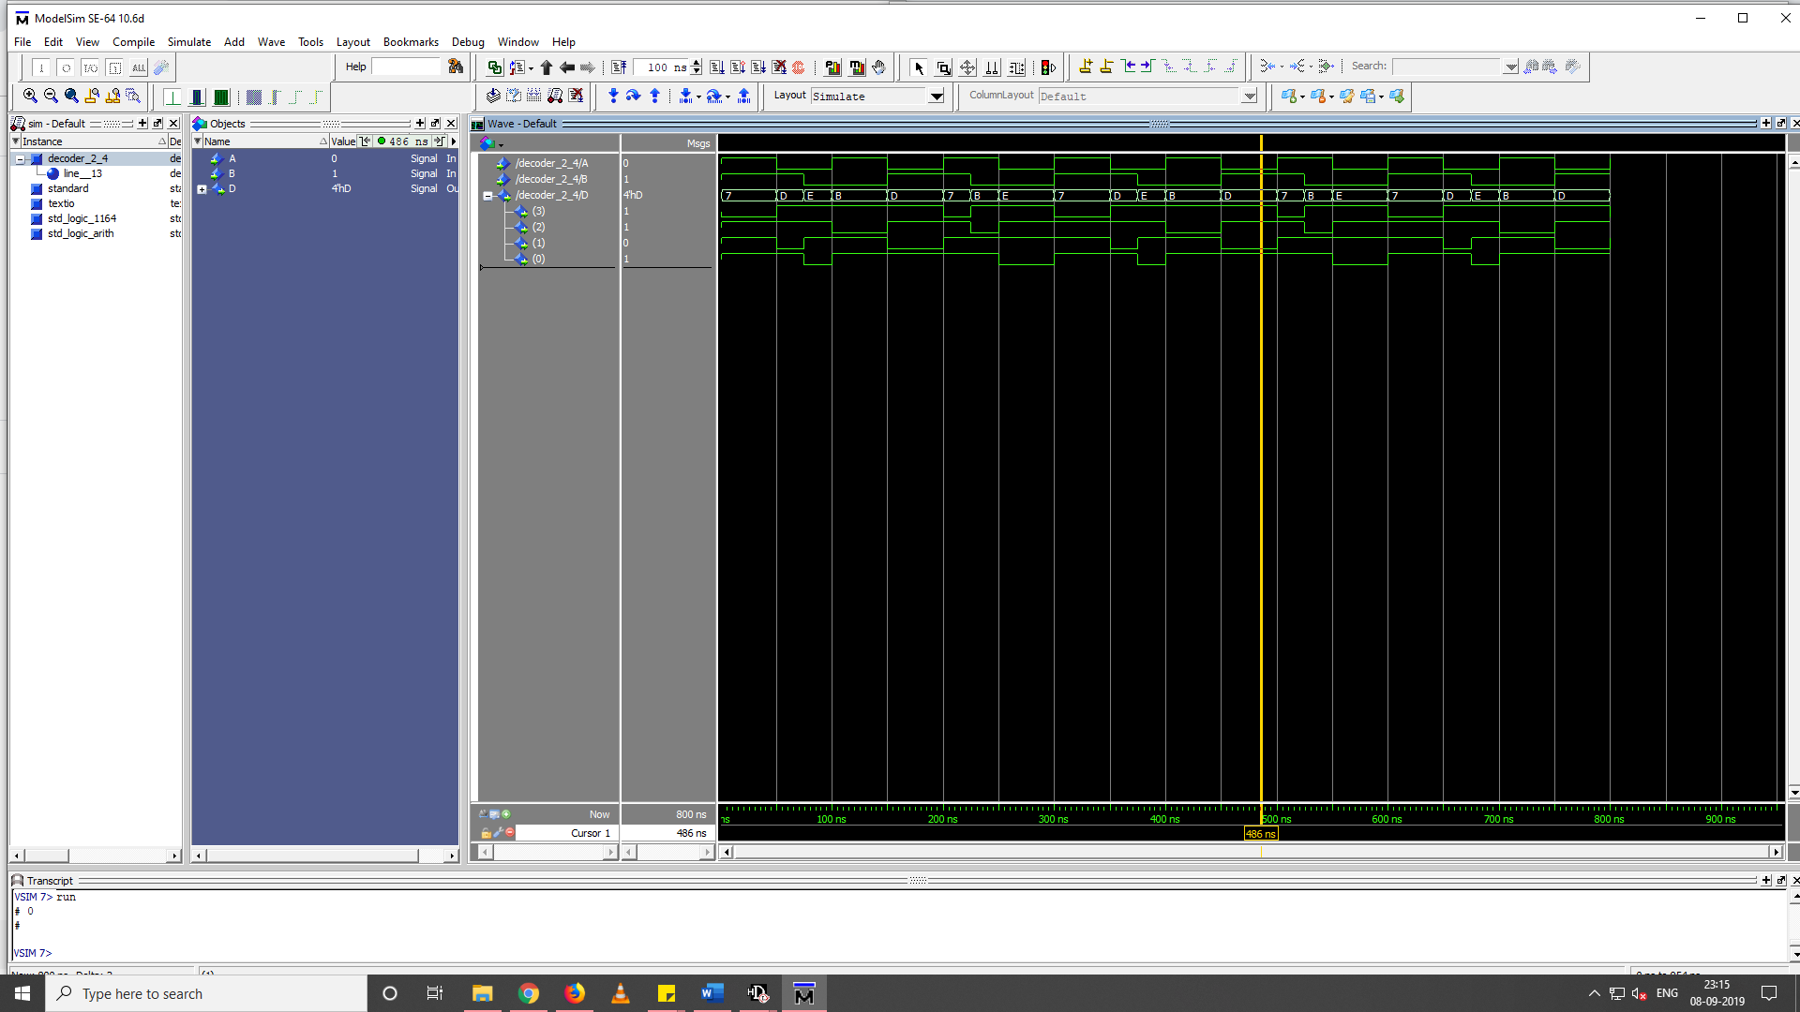

**DECODER 4_2**