**EXPERIMENT – 6**

**AIM -** WRITE VHDL CODE FOR FLIP-FLOP AND SIMULATE IT USING MODELSIM.

**THEORY** - A flip flop is an electronic circuit with two stable states that can be used to store binary data. The stored data can be changed by applying varying inputs. Flip-flops and latches are fundamental building blocks of digital electronics systems used in computers, communications, and many other types of systems. Flip-flops and latches are used as data storage elements. It is the basic storage element in sequential logic. But first, let’s clarify the difference between a latch and a flip-flop.

There are 4 types of flip-flop:

1. SR FLIP-FLOP
2. JK FLIP-FLOP
3. T FLIP-FLOP
4. D FLIP-FLOP

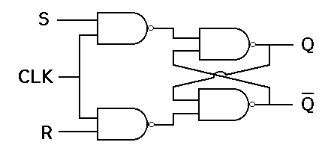

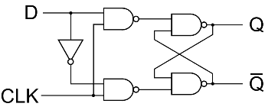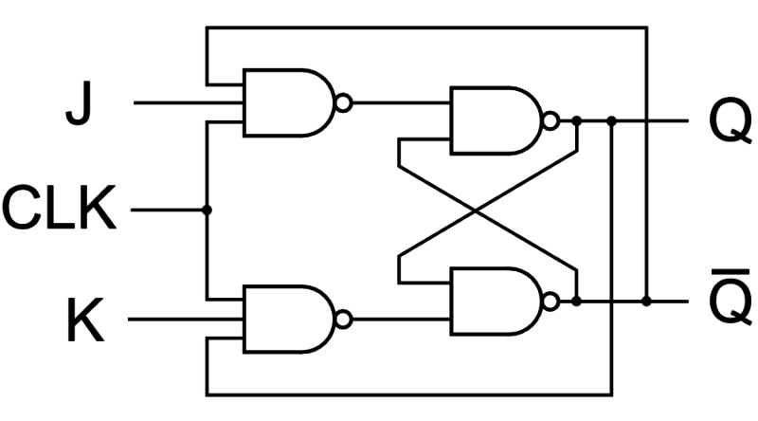

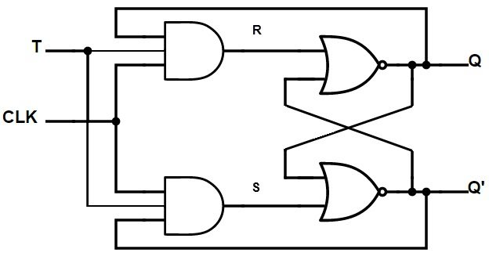

**VHDL CODE :**

**D FLIPFLOP**

LIBRARY ieee;

USE ieee.std_logic_1164.all;

USE ieee.std_logic_arith.all;

ENTITY D_FLIPFLOP IS

PORT( D,CLOCK: in std_logic; Q: out std_logic);

END ENTITY D_FLIPFLOP;

--

ARCHITECTURE D_FLIPFLOP_BEHAV OF D_FLIPFLOP IS

BEGIN

process(CLOCK)

begin

if(rising_edge(CLOCK)) then

Q <= D;

end if;

end process;

END ARCHITECTURE D_FLIPFLOP_BEHAV;

**JK FLIPFLOP**

LIBRARY ieee;

USE ieee.std_logic_1164.all;

USE ieee.std_logic_arith.all;

ENTITY JK_FLIPFLOP IS

port( J,K,CLOCK: in std_logic; Q,QBAR: out std_logic);

END ENTITY JK_FLIPFLOP;

--

ARCHITECTURE JK_FLIPFLOP_BEHAV OF JK_FLIPFLOP IS

BEGIN

process(CLOCK)

begin

if (rising_edge(CLOCK)) then

if(J/=K) then

Q <= J;

QBAR <= not J;

elsif(J='1' and K='1') then

Q <= not J;

QBAR <= J;

end if;

end if;

end process;

END ARCHITECTURE JK_FLIPFLOP_BEHAV;

**SR FLIPFLOP**

LIBRARY ieee;

USE ieee.std_logic_1164.all;

USE ieee.std_logic_arith.all;

ENTITY SR_FLIPFLOP IS

port(S,R,CLOCK: in std_logic; Q,QBAR: out std_logic);

END ENTITY SR_FLIPFLOP;

ARCHITECTURE SR_FLIPFLOP_BEHAV OF SR_FLIPFLOP IS

BEGIN

process(CLOCK)

begin

if(rising_edge(CLOCK)) then

if(S/=R) then

Q<=S;

QBAR<=R;

elsif (S='1' and R='1') then

Q<='Z';

QBAR<='Z';

end if;

end if;

end process;

END ARCHITECTURE SR_FLIPFLOP_BEHAV;

**T FLIPFLOP**

LIBRARY ieee;

USE ieee.std_logic_1164.all;

USE ieee.std_logic_arith.all;

ENTITY T_FLIPFLOP IS

port( T,CLOCK: in std_logic; Q: out std_logic);

END ENTITY T_FLIPFLOP;

ARCHITECTURE T_FLIPFLOP_BEHAV OF T_FLIPFLOP IS

BEGIN

process(CLOCK)

begin

if(rising_edge(CLOCK)) then

Q<=not T;

end if;

end process;

END ARCHITECTURE T_FLIPFLOP_BEHAV;

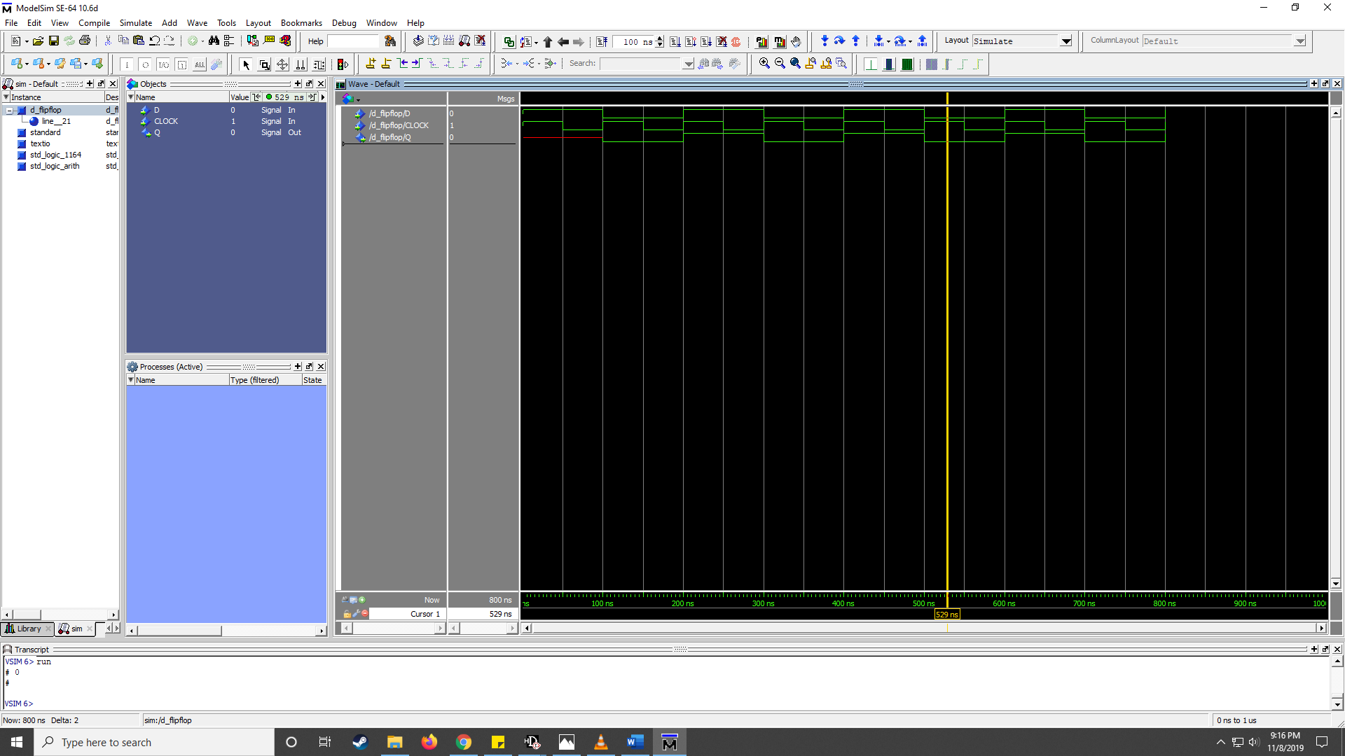**RESULT:**

