**EXPERIMENT -8**

**AIM:** WRITE VHDL CODE FOR ALU AND SHIFT REGISTER AND SIMULATE IT USING

MODELSIM.

**THEORY**: An **arithmetic logic unit (ALU)** is a digital circuit used to perform arithmetic and logic operations. It represents the fundamental building block of the central processing unit (CPU) of a computer. Modern CPUs contain very powerful and complex ALUs. In addition to ALUs, modern CPUs contain a control unit (CU).

Most of the operations of a CPU are performed by one or more ALUs, which load data from input registers.

In digital circuits, a **shift register** is a cascade of flip flops, sharing the same clock, in which the output of each flip-flop is connected to the "data" input of the next flip-flop in the chain, resulting in a circuit that shifts by one position the "bit array" stored in it, "shifting in" the data present at its input and 'shifting out' the last bit in the array, at each transition of the clock input.

More generally, a shift register may be multidimensional, such that its "data in" and stage outputs are themselves bit arrays; this is implemented simply by running several shift registers of the same bit-length in parallel.

**SIPO SHIFT REGISTER –** For Serial in – parallel out shift registers, all data bits appear on the parallel outputs following the data bits enters sequentially through each flipflop. The following circuit is a four-bit Serial in – parallel out shift register constructed by D flip-flops.

**PIPO SHIFT REGISTER –** For parallel in – parallel out shift registers, all data bits appear on the parallel outputs immediately following the simultaneous entry of the data bits. The following circuit is a four-bit parallel in – parallel out shift register constructed by D flip-flops.

**VHDL CODE:**

**ALU CODE**

LIBRARY ieee;

USE ieee.std_logic_1164.all;

USE ieee.std_logic_arith.all;

USE ieee.std_logic_unsigned.all;

USE ieee.numeric_std.all;

ENTITY ALU IS

Port (

A, B : in STD_LOGIC_VECTOR(7 downto 0); -- 2 inputs 8-bit

ALU_Sel : in STD_LOGIC_VECTOR(3 downto 0); -- 1 input 4-bit for selecting function

ALU_Out : out STD_LOGIC_VECTOR(7 downto 0); -- 1 output 8-bit

Carryout : out std_logic -- Carryout flag

);

END ENTITY ALU;

--

ARCHITECTURE ALU_BEHAV OF ALU IS

signal ALU_Result : std_logic_vector (7 downto 0);

signal tmp: std_logic_vector (8 downto 0);

BEGIN

process(A,B,ALU_Sel)

begin

case(ALU_Sel) is

when "0000" => -- Addition

ALU_Result <= A + B ;

when "0001" => -- Subtraction

ALU_Result <= A - B ;

when "0010" => -- Multiplication

ALU_Result <= std_logic_vector(to_unsigned ( (to_integer(unsigned(A) ) * ( to_integer(unsigned(B))),8))) ;

when "0011" => -- Division

ALU_Result <= std_logic_vector(to_unsigned(to_integer(unsigned(A)) / to_integer(unsigned(B)),8)) ;

when "0100" => -- Logical shift left

ALU_Result <= std_logic_vector(A sll 1);

when "0101" => -- Logical shift right

ALU_Result <= std_logic_vector(A srl 1);

when "0110" => -- Rotate left

ALU_Result <= std_logic_vector(A rol 1);

when "0111" => -- Rotate right

ALU_Result <= std_logic_vector(A ror 1);

when "1000" => -- Logical and

ALU_Result <= A and B;

when "1001" => -- Logical or

ALU_Result <= A or B;

when "1010" => -- Logical xor

ALU_Result <= A xor B;

when "1011" => -- Logical nor

ALU_Result <= A nor B;

when "1100" => -- Logical nand

ALU_Result <= A nand B;

when "1101" => -- Logical xnor

ALU_Result <= A xnor B;

when "1110" => -- Greater comparison

if(A>B) then

ALU_Result <= x"01" ;

else

ALU_Result <= x"00" ;

end if;

when "1111" => -- Equal comparison

if(A=B) then

ALU_Result <= x"01" ;

else

ALU_Result <= x"00" ;

end if;

when others => ALU_Result <= A + B ;

end case;

end process;

ALU_Out <= ALU_Result; -- ALU out

tmp <= ('0' & A) + ('0' & B);

Carryout <= tmp(8); -- Carryout flag

END ARCHITECTURE ALU_BEHAV;

**SHIFT REGISTER SIPO**

LIBRARY ieee;

USE ieee.std_logic_1164.all;

USE ieee.std_logic_arith.all;

ENTITY SHIFTREG_SIPO IS

port(CLOCK,Input_Data: in std_logic; Q: out std_logic_vector(3 downto 0) );

END ENTITY SHIFTREG_SIPO;

--

ARCHITECTURE SHIFTREG_SIPO_BEHAV OF SHIFTREG_SIPO IS

signal qout : std_logic_vector ( 3 downto 0);

BEGIN

process (CLOCK)

begin

if (rising_edge(CLOCK)) then

qout (3 downto 1) <= qout(2 downto 0);

qout(0) <= Input_Data;

end if;

end process;

Q<= qout;

END ARCHITECTURE SHIFTREG_SIPO_BEHAV;

**SHIFT REGISTER PIPO**

LIBRARY ieee;

USE ieee.std_logic_1164.all;

USE ieee.std_logic_arith.all;

ENTITY SHIFTREG_PIPO IS

port(CLOCK : in std_logic;D: in std_logic_vector(3 downto 0);

Q: out std_logic_vector(3 downto 0));

END ENTITY SHIFTREG_PIPO;

--

ARCHITECTURE SHIFTREG_PIPO_BEHAV OF SHIFTREG_PIPO IS

BEGIN

process (CLOCK)

begin

if (rising_edge(CLOCK)) then

Q <= D;

end if;

end process;

END ARCHITECTURE SHIFTREG_PIPO_BEHAV;

**RESULT:**

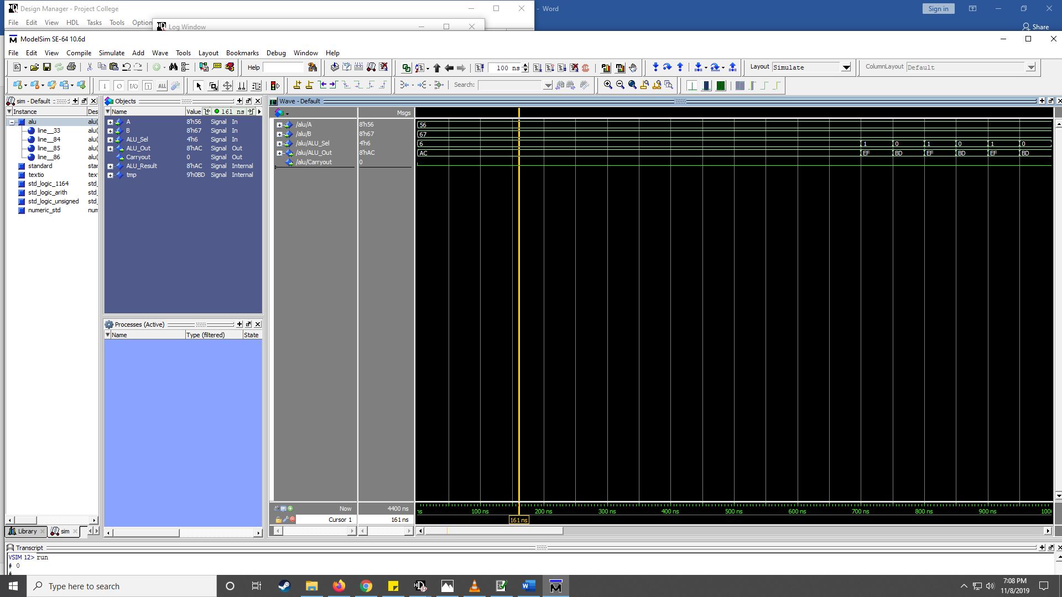

**ARITHMETIC LOGIC UNIT (ALU)**

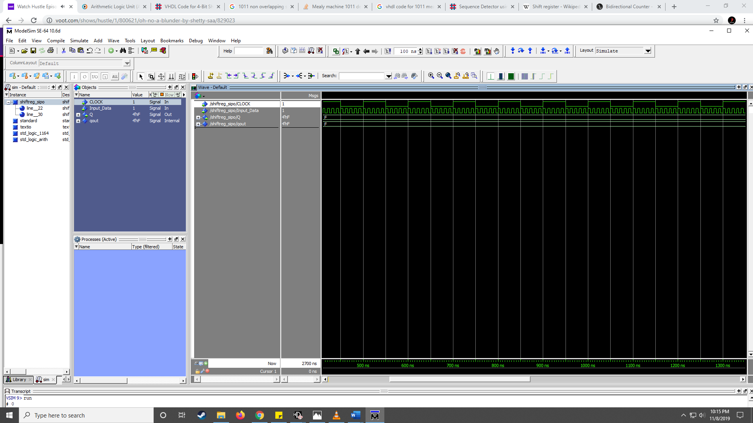

**SHIFT REGISTER SIPO**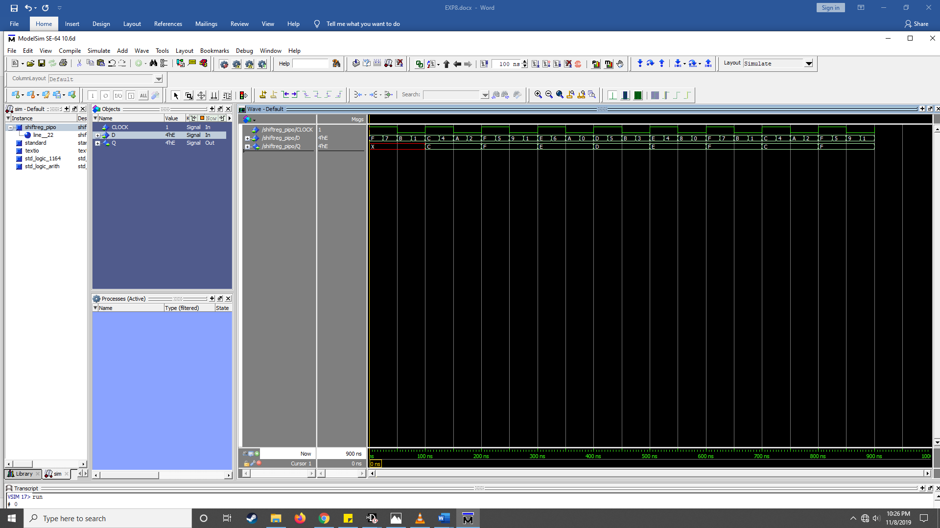

**SHIFT REGISTER PIPO**