**EXPERIMENT 1**

**AIM**: To simulate basic Logic gates using Model Sim Software.

**Theory**:To simulate basic gates first we need to know about the software and logic gate boolean tables so that we can check if there are any errors with our simulations or not.

There are basicly 7 logic gates :

1. AND
2. OR
3. NAND
4. NOR
5. NOT
6. XOR
7. XNOR

|  |  |  |  |  |
| --- | --- | --- | --- | --- |
| **S.**  **NO.** | **TYPE** | **SYMBOL** | **BOOLEAN ALGEBRA** | **TRUTH TABLE** |
| **1.** | AND | AND symbol | A.B | |  |  |  | | --- | --- | --- | | A | B | Q | | 0 | 0 | 0 | | 0 | 1 | 0 | | 1 | 0 | 0 | | 1 | 1 | 1 | |
| **2.** | OR | OR symbol | A+B | |  |  |  | | --- | --- | --- | | A | B | Q | | 0 | 0 | 0 | | 0 | 1 | 1 | | 1 | 0 | 1 | | 1 | 1 | 1 | |
| **3.** | NOT | NOT symbol |  | |  |  | | --- | --- | | A | Q | | 0 | 1 | | 1 | 0 | |
| **4.** | NOR | NOR symbol |  | |  |  |  | | --- | --- | --- | | A | B | Q | | 0 | 0 | 1 | | 0 | 1 | 0 | | 1 | 0 | 0 | | 1 | 1 | 0 | |
| **5.** | NAND | NAND symbol |  | |  |  |  | | --- | --- | --- | | A | B | Q | | 0 | 0 | 1 | | 0 | 1 | 1 | | 1 | 0 | 1 | | 1 | 1 | 0 | |
| **6.** | XOR | XOR symbol |  | |  |  |  | | --- | --- | --- | | A | B | Q | | 0 | 0 | 0 | | 0 | 1 | 1 | | 1 | 0 | 1 | | 1 | 1 | 0 | |
| **7.** | XNOR | XNOR symbol |  | |  |  |  | | --- | --- | --- | | A | B | Q | | 0 | 0 | 1 | | 0 | 1 | 0 | | 1 | 0 | 0 | | 1 | 1 | 1 | |

So above is the table for all the logic gates.

All the gates simulated below are made using universal logic gate NAND.

**VHDL CODE:**

**//CODE FOR AND GATE**

ENTITY AND_GATE IS

port (A,B:in std_logic; Q:out std_logic);

END ENTITY AND_GATE;

--

ARCHITECTURE AND_GATE_DATAFLOW OF AND_GATE IS

SIGNAL temp1:std_logic;

BEGIN

temp1<= A nand B;

Q<=not temp1;

END ARCHITECTURE AND_GATE_DATAFLOW;

**//CODE FOR OR GATE**

ENTITY OR_GATE IS

port (A,B:in std_logic; Q:out std_logic);

END ENTITY OR_GATE;

--

ARCHITECTURE OR_GATE_DATAFLOW OF OR_GATE IS

SIGNAL Temp1,Temp2:std_logic;

BEGIN

Temp1<=A nand A;

Temp2<=B nand B;

Q<=Temp1 nand Temp2;

END ARCHITECTURE OR_GATE_DATAFLOW;

**//CODE FOR NOT GATE**

ENTITY NOT_GATE IS

port(A:in std_logic;Q:out Std_logic);

END ENTITY NOT_GATE;

--

ARCHITECTURE NOT_GATE_DATAFLOW OF NOT_GATE IS

BEGIN

Q<=A nand A;

END ARCHITECTURE NOT_GATE_DATAFLOW;

**//CODE FOR NAND GATE**

ENTITY NAND_GATE IS

port (A,B:in std_logic; Q:out std_logic);

END ENTITY NAND_GATE;

--

ARCHITECTURE NAND_GATE_DATAFLOW OF NAND_GATE IS

BEGIN

Q<= A nand B;

END ARCHITECTURE NAND_GATE_DATAFLOW;

**//CODE FOR NOR GATE**

ENTITY NOR_GATE IS

port (A,B:in std_logic; Q:out std_logic);

END ENTITY NOR_GATE;

--

ARCHITECTURE NOR_GATE_DATAFLOW OF NOR_GATE IS

SIGNAL Temp1,Temp2,Temp3,Temp4:std_logic;

BEGIN

Temp1<=A nand A;

Temp2<=B nand B;

Temp3<=Temp1 nand Temp2;

Q<= Temp3 nand Temp3;

END ARCHITECTURE NOR_GATE_DATAFLOW;

**//CODE FOR XOR GATE**

ENTITY XOR_GATE IS

port(A,B:in std_logic;Q:out std_logic);

END ENTITY XOR_GATE;

--

ARCHITECTURE XOR_GATE_DATAFLOW OF XOR_GATE IS

SIGNAL Temp1,Temp2,Temp3:std_logic;

BEGIN

Temp1<=A nand B;

Temp2<=A nand Temp1;

Temp3<=B nand Temp2;

Q<=Temp2 nand Temp3;

END ARCHITECTURE XOR_GATE_DATAFLOW;

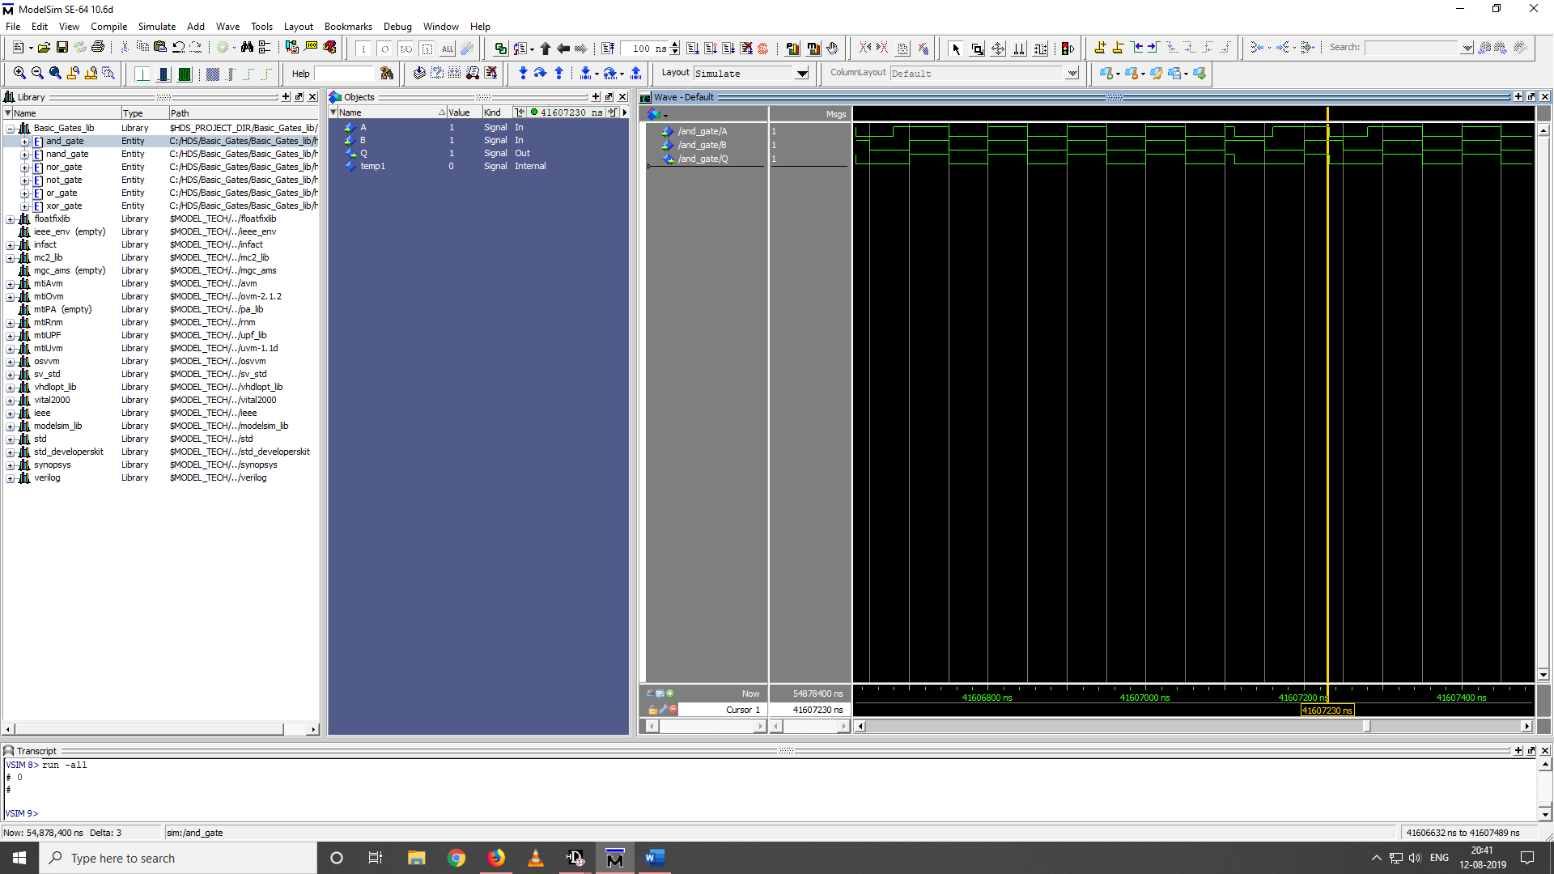**OUTPUTS:**

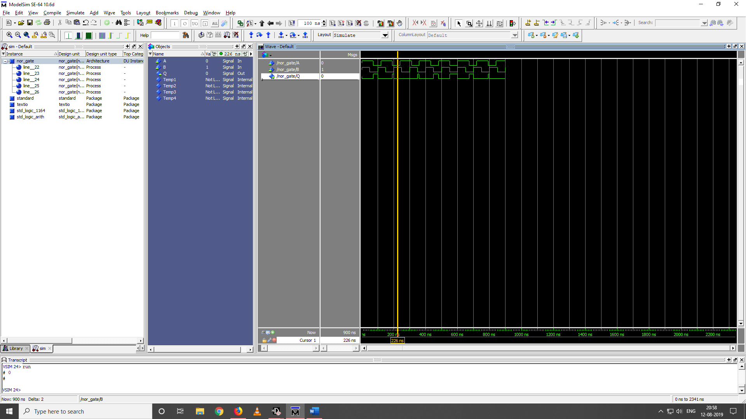**AND GATE**

**NOR GATE**

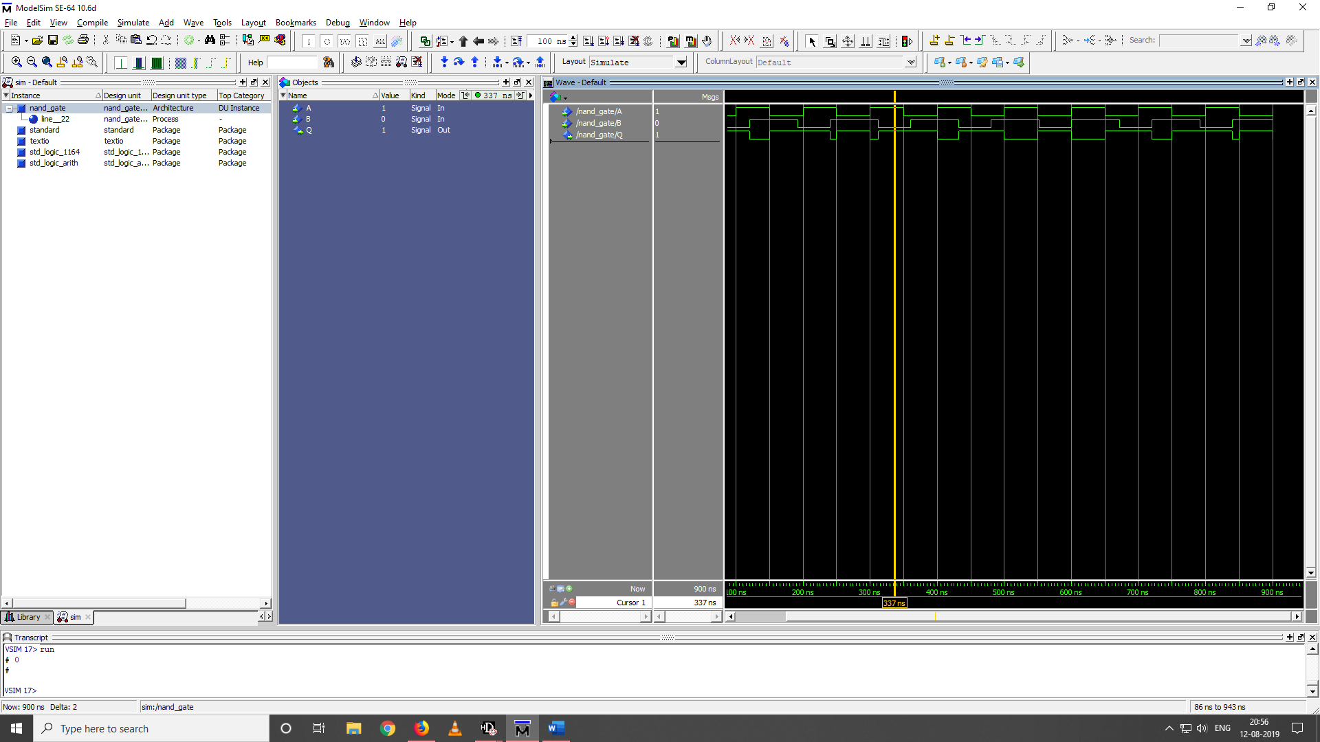

**NAND GATE**

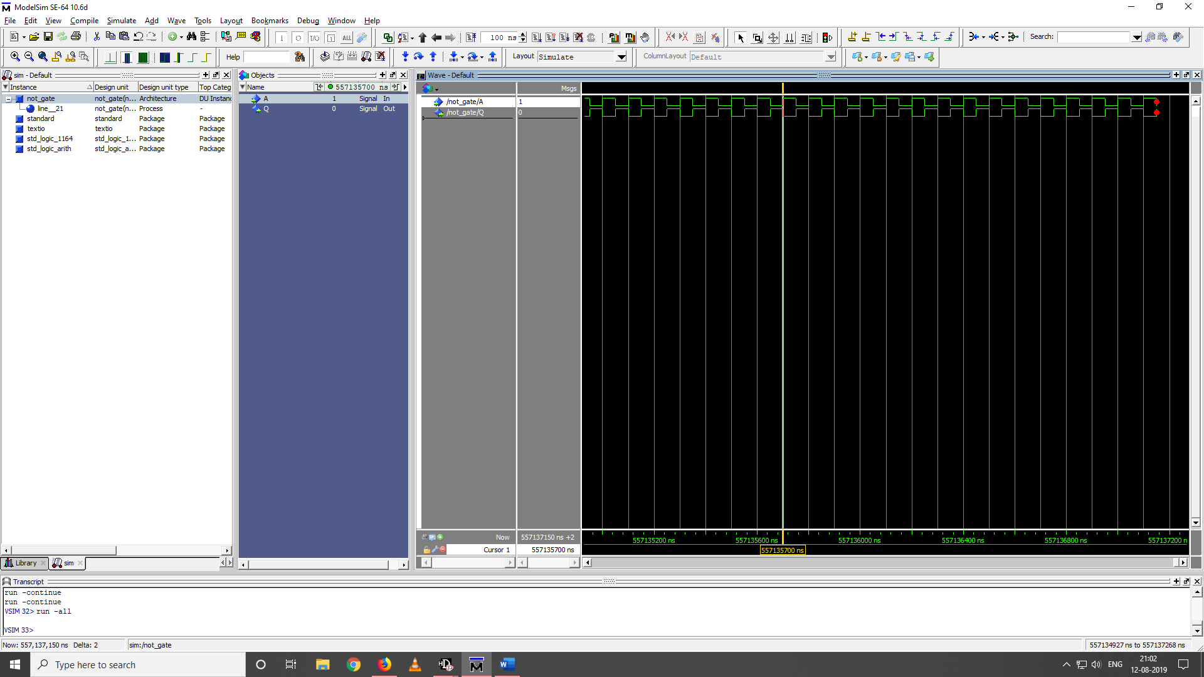

**NOT GATE**

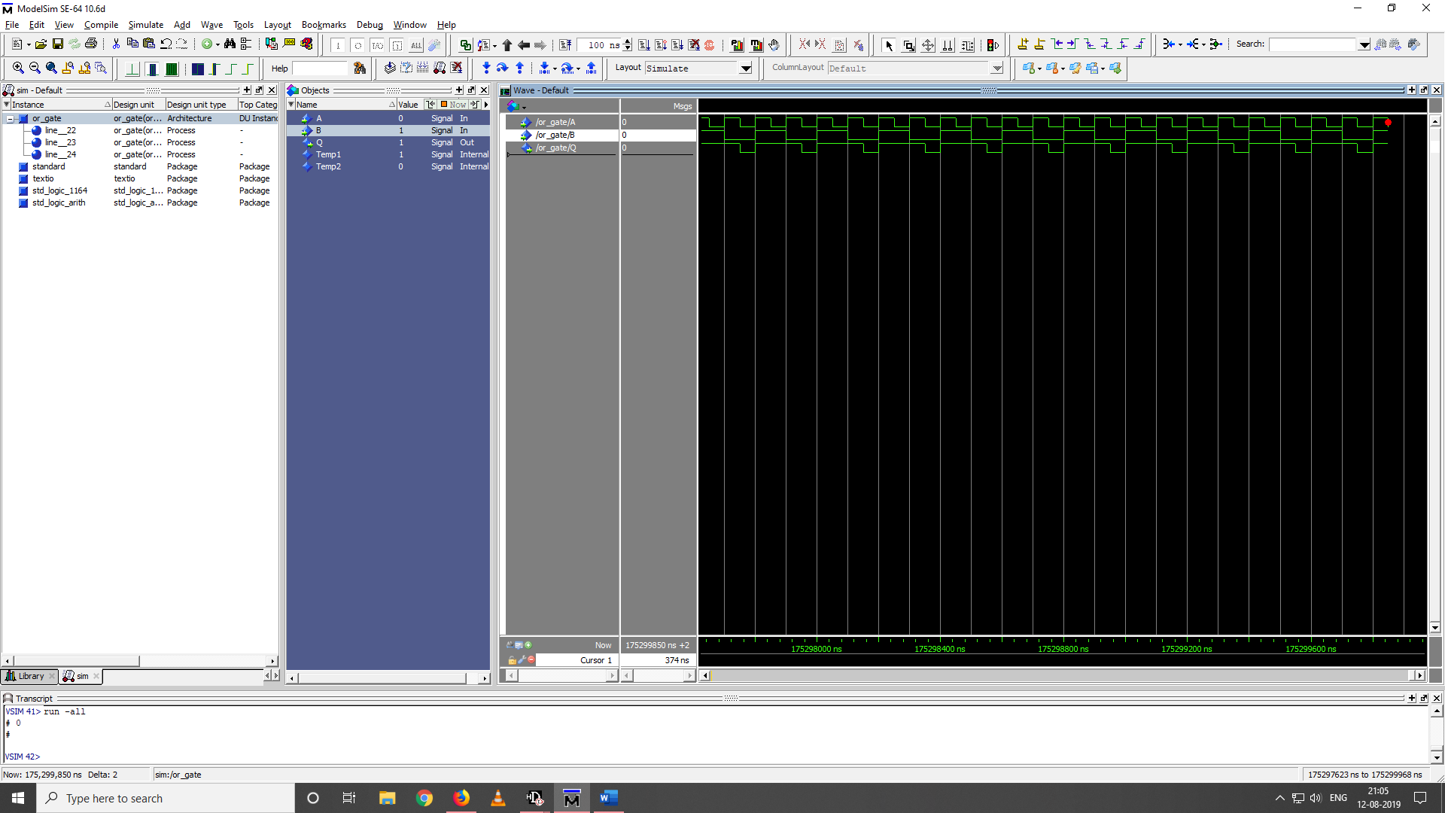

**OR GATE**

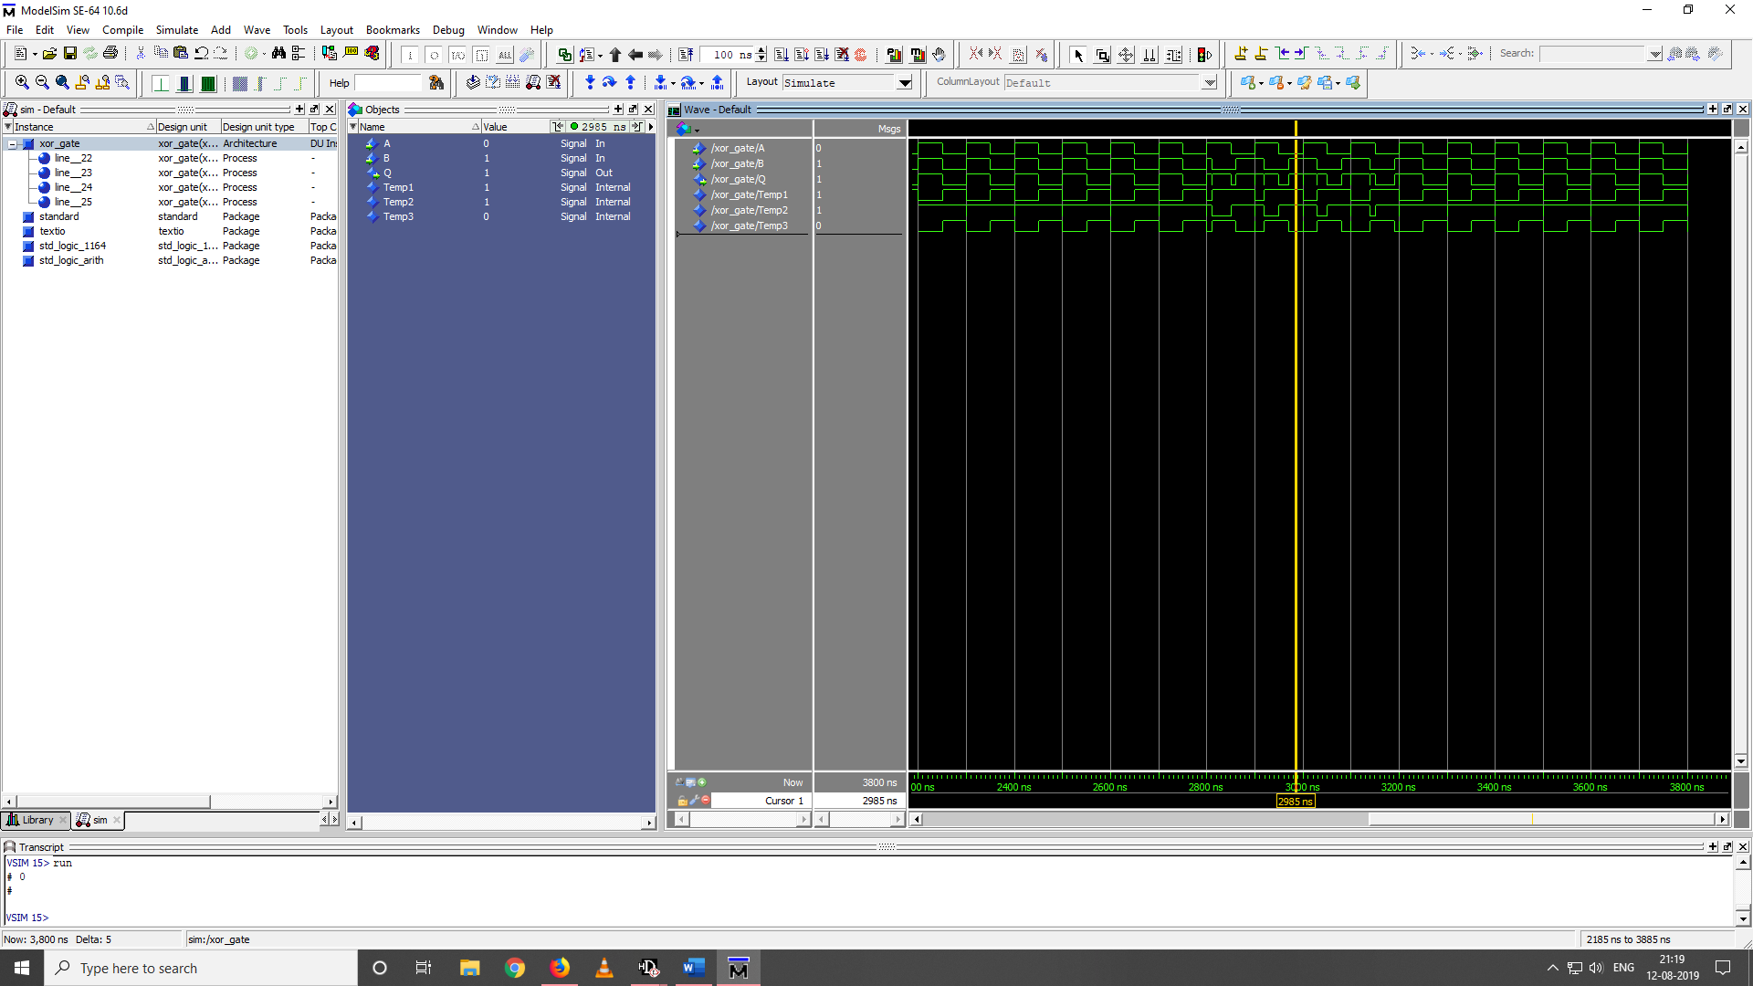**XOR GATE**

**Result: All the logic gates are simulated using MODELSIM Software.**