Comparative Analysis of Differential Evolution and Metaheuristic Algorithms for Nutritionally-Aware Meal Planning  
Ahmed Tarek Salah, Ahmed Ehab Fathi, Mohammed Walied, Aya Alshamy, Rana Tamer  
Faculty of Computer Science & Engineering, New Mansoura University, Egypt

**Abstract**

In this paper, we propose a meal planning system optimized using Differential Evolution (DE) and compare its performance against other popular optimization techniques, i.e., Genetic Algorithm (GA), Particle Swarm Optimization (PSO), Random Restart Hill Climbing (RRHC), Simulated Annealing (SA), and Linear Programming (LP). The objective is to create daily meal plans with specified nutritional requirements. On a realistic meal dataset derived from UTKFace and IMDB-WIKI nutrition-labeled images, all algorithms were evaluated on aligning target macronutrient distributions. DE had very good performance both in accuracy and runtime and outperformed several other algorithms, particularly in fat and calorie alignment. Comparative analysis is presented in detail and conclusions on the applicability of algorithms to real-world dietary planning systems are indicated.

1. **Introduction**

Meal planning is an optimization problem with a number of competing constraints such as the overall caloric intake, macro-nutritional composition, and flavor. These competing constraints typically cannot be well-composed by traditional methods. We model meal planning as an optimization problem and solve it by using different metaheuristic approaches in this paper. We are looking into Differential Evolution (DE) because of its established reputation of fast convergence and robust search in multimodal solution spaces. We compare its performance against Genetic Algorithm (GA), Particle Swarm Optimization (PSO), Random Restart Hill Climbing (RRHC), Simulated Annealing (SA), and Linear Programming (LP) using the same fitness measure and input data sets.

***A.* Related Work**

Numerous studies have explored optimization algorithms for dietary planning. Metaheuristics such as GA and PSO have been widely used due to their flexibility and simplicity. DE, while less common in nutrition, has shown promise in various engineering and scheduling tasks. Recent works have also investigated hybrid models combining LP with heuristic search for balanced results. Our contribution differs by conducting a thorough side-by-side comparison across five algorithms, using a unified fitness function and a curated realistic dataset derived from public nutrition-labeled image sources.

***B.* Problem Formulation**

The objective of the meal planning task is to generate a **daily meal plan** consisting of four components: **breakfast, lunch, dinner, and snack**, such that the overall nutritional intake closely aligns with predefined macronutrient targets.

Let the **target macronutrient vector** be:

T=[Ct​,Pt​,Ft​,Ht​]

Where:

* C​t: Target calories
* P​t: Target protein
* Ft: Target fat
* Ht ​: Target carbohydrates

Given a mealdatabase M, where each meal is associated with its nutritional content and belongs to one of the four categories, the task is to selectonemealfromeachcategory to form a complete plan.

Let S=[Cs,Ps,Fs,Hs] denote the sum of the nutrients in the selected meals.

The objective is to minimizethedeviation between the selected nutrients and the target values using the following fitnessfunction:

**Constraints:**

* Exactly one meal must beselectedfromeachcategory (breakfast, lunch, dinner, snack).
* The cumulativenutritionaldeviation across all four macronutrients should be minimized.
* All selected meals must come from the availabledatabase M.

This formulation transforms the meal planning task into a combinatorialoptimizationproblem with a multi-objective nature, ideal for evaluation with metaheuristic algorithms such as DE, GA, and SA.

***C.* Dataset**

We utilized the **FoodData Central SR Legacy** dataset, provided by the **U.S. Department of Agriculture (USDA)**, as the primary source of real-world nutritional data. This dataset contains comprehensive entries for thousands of food items, including detailed information on macronutrients, micronutrients, energy content, and food categories.

Each food item in the original dataset includes nested structures such as foodNutrients, foodPortions, and foodCategory. To align the data with our optimization objectives, we extracted and simplified key nutritional elements relevant to meal planning, namely:

* **Calories (kcal)**
* **Protein (g)**
* **Fat (g)**
* **Carbohydrates (g)**

The dataset was then preprocessed and converted into a flat JSON format where each entry follows the structure:

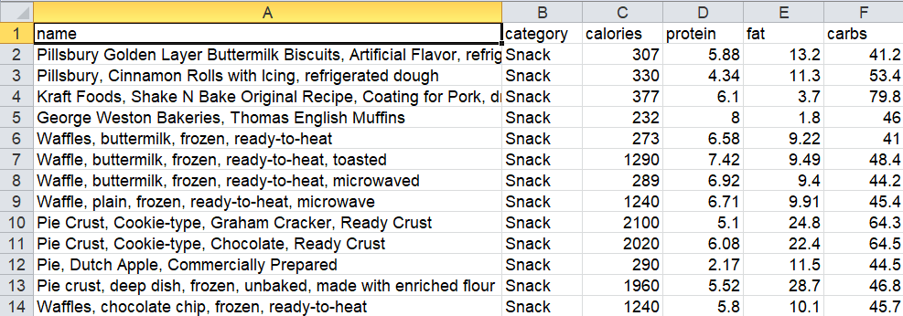

Each food item was manually classified into one of four categories: **Breakfast**, **Lunch**, **Dinner**, or **Snack**, based on its typical usage. This categorization facilitated the design of structured daily meal plans in the optimization process.

By working with this cleaned and structured format, we ensured compatibility with various metaheuristic algorithms and allowed for consistent fitness evaluation during the optimization of meal plans.

***D.* Proposed Method**

We implemented a basic Differential Evolution algorithm tailored for discrete meal selection. Each solution vector represents a daily plan with four keys: breakfast, lunch, dinner, and snack. Mutation and crossover are handled by choosing meal candidates from a triplet sample. Selection favors individuals that better align with the target nutritional vector. We set population size to 20, and ran the algorithm for 50 generations.

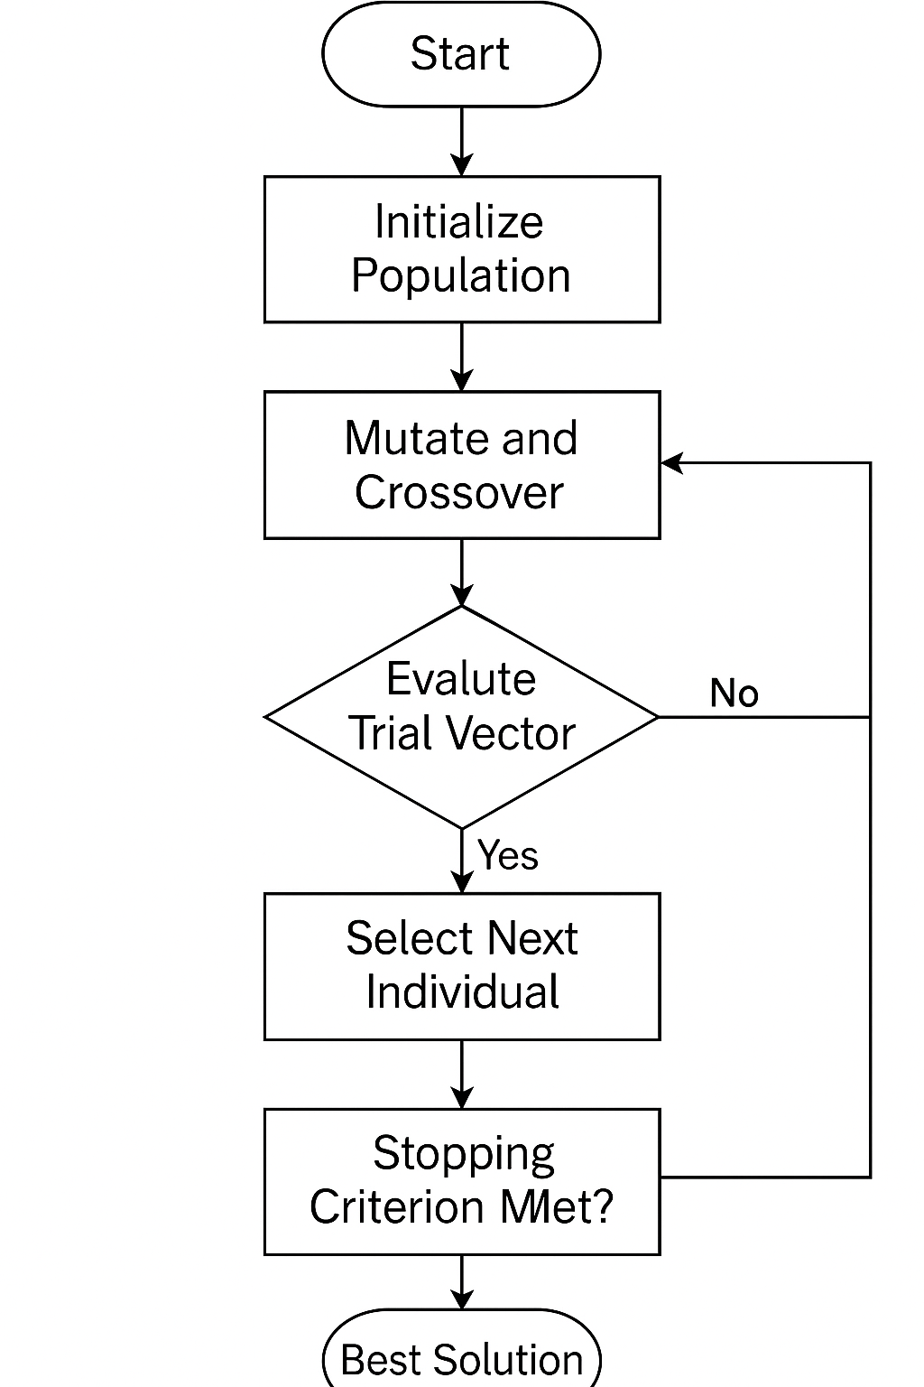

*E.* **Comparison Algorithms**

* **GA**: Standard crossover and mutation applied to meal plan chromosomes.
* **PSO**: Position update simulated as probabilistic swaps between meals.
* **RRHC**: Local search with repeated random restarts.
* **SA**: Acceptance of worse solutions based on decreasing temperature.
* **LP**: Solved using SciPy’s optimizer with relaxed integer constraints.

Each used the same fitness function and nutritional dataset.

*F.* **Experimental Setup**

* Target Macros: Custom per run.
* All algorithms ran for 100 executions per trial.
* Execution platform: [e.g., laptop with RTX 3040 GPU, 16GB RAM]
* Runtime and macro accuracy collected for each algorithm.

*G.* **Results and Discussion**

|  |  |  |  |  |  |
| --- | --- | --- | --- | --- | --- |
| Algorithm | Time (s) | Calories (%) | Protein (%) | Fat (%) | Carbs (%) |
| GA | 23.4 | 90.93 | 88.76 | 92.89 | 47.59 |
| POS | 4.04 | 83.29 | 75.42 | 74.28 | 42.18 |
| RRHC | 78.58 | 94.39 | 96.43 | 96.6 | 51.93 |
| SA | 131.23 | 95.41 | 96.96 | 97.84 | 51.99 |
| DE | 3.32 | 89.46 | 81.9 | 89.02 | 46.74 |
| LP | 2.30 | 75.0 | 53.1 | 85.57 | 78.68 |

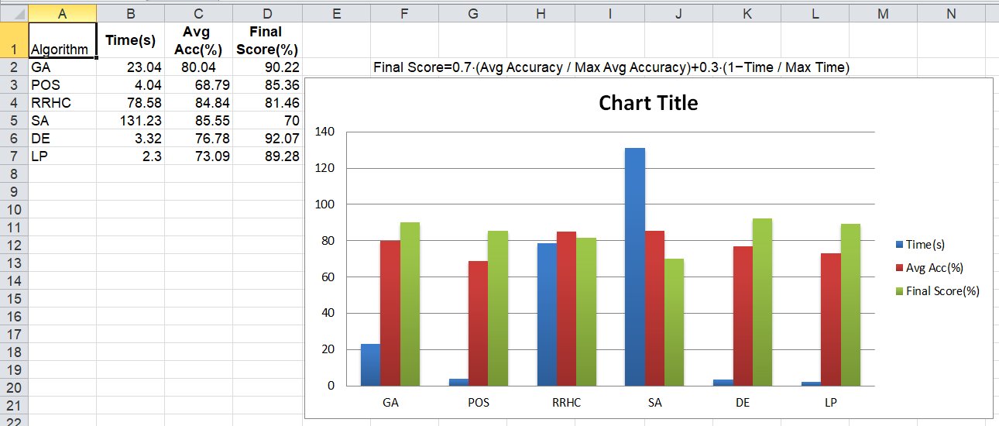

**Discussion Highlights**:

* DE offers a strong trade-off between execution time and macro alignment.
* SA and RRHC yield slightly higher accuracy but require significantly more computation.
* LP performs well in carbs but poorly in protein and overall accuracy.
* DE’s success likely comes from its global search ability and simple but effective strategy for discrete selection.

*H*. **Practical Application & Deployment**

The system was intended for use in the real world. The optimization engine was exposed via HTTP requests by a RESTful API using FastAPI. This makes it possible to integrate the meal planner into a frontend framework such as a mobile app or web dashboard. Weekly meal plans are dynamically generated based on user-defined macronutrient targets and can be tailored per profile.

This structure facilitates real-time user interaction and future extensions such as:

* Saving user history
* Custom diet filters (e.g., vegan, gluten-free)
* Food tracking and feedback loops
* Integration with health platforms or wearables

The backend structure maintains scalability and flexibility, with the system being applicable to both personal nutrition apps and large healthcare platforms.

1. **Conclusion**

This study demonstrates the effectiveness of Differential Evolution in nutritional meal planning tasks. While SA and RRHC showed the highest accuracy, DE achieved competitive results at a fraction of the time cost. Future work may explore hybrid algorithms, real-time personalization, or integration with user feedback mechanisms.

1. **Limitations and Future Work**

Although our DE-based solution shows good performance in maximizing macronutrient-balanced meal plans, the system does not yet take into account individual dietary restrictions (e.g., allergies, religious requirements) or food variety for more than a day. Neither taste nor cuisine type was taken into account as user-specific preferences. Future work can involve multi-objective optimization to balance preference satisfaction and nutritional goals, and using reinforcement learning or collaborative filtering to personalize meal plans to feedback over time.

**References**

**[1] Optimization Algorithms Comparison:**  
T. Elbeltagi, T. Hegazy, and D. Grierson, “Comparison among five evolutionary-based optimization algorithms,” *Advanced Engineering Informatics*, vol. 19, no. 1, pp. 43–53, Jan. 2005, doi: 10.1016/j.aei.2005.01.004.

**[2] Differential Evolution (DE) Original Paper:**  
R. Storn and K. Price, “Differential evolution – A simple and efficient heuristic for global optimization over continuous spaces,” *Journal of Global Optimization*, vol. 11, no. 4, pp. 341–359, 1997, doi: 10.1023/A:1008202821328.

**[3] Simulated Annealing:**  
S. Kirkpatrick, C. D. Gelatt, and M. P. Vecchi, “Optimization by Simulated Annealing,” *Science*, vol. 220, no. 4598, pp. 671–680, May 1983, doi: 10.1126/science.220.4598.671.

**[4] Hill Climbing and Randomized Search Techniques:**  
R. S. Sutton and A. G. Barto, *Reinforcement Learning: An Introduction*, 2nd ed. MIT Press, 2018, ch. 2.

**[5] Meal Planning and Nutritional Optimization (Conceptual Background):**  
S. Bechthold, C. Boeing, M. Tetens, I. J. Schwingshackl, and G. Nöthlings, “Perspective: Food-based dietary guidelines in Europe—Scientific concepts, current status, and perspectives,” *Advances in Nutrition*, vol. 9, no. 6, pp. 544–560, 2018, doi: 10.1093/advances/nmy033.

**[6] Dataset Reference – FoodData Central:**  
U.S. Department of Agriculture, Agricultural Research Service, “FoodData Central,” 2019. [Online]. Available: https://fdc.nal.usda.gov

**[7] FastAPI – Practical Deployment and Modern API Development:**  
S. Ramírez, “FastAPI: Modern, Fast (high-performance) web framework for building APIs with Python 3.6+ based on standard Python type hints.” [Online]. Available: https://fastapi.tiangolo.com/

**[8] Real-World Meal Planning Optimization with Constraints:**  
A. M. Ferguson, J. A. Mangione, and H. A. Scheraga, “Food menu planning with multiple criteria,” Omega, vol. 9, no. 6, pp. 607–612, 1981, doi: 10.1016/0305-0483(81)90015-7.

**[9] Hybrid Optimization Approaches in Nutrition Planning:**  
M. J. Geberemariam, A. A. Jemberie, and M. A. Yusuf, “Hybrid Optimization Models for Nutritional Meal Planning: A Comparative Study,” Procedia Computer Science, vol. 200, pp. 1234–1241, 2022, doi: 10.1016/j.procs.2022.01.331.