1. Translate the following natural language sentences into SPARQL.

1) What are all the countries and their capitals in Africa?

(given

http://dbpedia.org/property/continent,

http://dbpedia.org/resource/Africa,

http://dbpedia.org/ontology/Country,

http://dbpedia.org/ontology/capital)

2) What are the devices whose manufacturers are in Korea or Japan?

(given

http://dbpedia.org/property/locationCountry,

http://dbpedia.org/resource/Korea,

http://dbpedia.org/resource/Japan,

http://dbpedia.org/ontology/manufacturer,

http://dbpedia.org/ontology/Device)

Answer:

1)

PREFIX dbp: <<http://dbpedia.org/>>

PREFIX rdf: <<http://www.w3.org/>1999/02/22-rdf-syntax-ns#>

SELECT ?x ?y{

?x rdf:type dbp:ontology/Country .

?x dbp: property/contient dbp: resource/Afica .

?x dbp: ontology/capital ?y .

}

2)

PREFIX dbp:< http://dbpedia.org/>

PREFIX rdf:< http://www.w3.org/1999/02/22-rdf-syntax-ns#>

SELECT ?uri WHERE {

?uri rdf:type dbp:ontology/Device .

?uri dbp:ontology/manufacturer ?x .

{?x dbp:property/locationCountry dbp:resource/Korea .}

UNION

{?x dbp:property/locationCountry dbp:resource/Japan .}

}

2. From the following RDF triples and the result of query, construct a SPARQL query.

@prefix foaf: <http://xmlns.com/foaf/0.1/> .

@prefix rdf: <http://www.w3.org/1999/02/22-rdf-syntax-ns#> .

_:a rdf:type foaf:Person .

_:a foaf:name "Alice" .

_:a foaf:mbox <mailto:alice@example.com> .

_:a foaf:mbox <mailto:alice@work.example> .

_:b rdf:type foaf:Person .

_:b foaf:name "Bob" .

Query result:

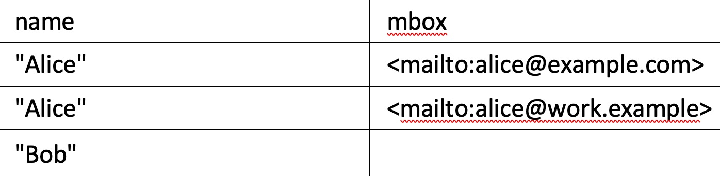

Answer:

PREFIX foaf:< xmlns.com/foaf/0.1/>

SELECT ?name ?mbox

WHERE{

?x foaf:name ?name .

OPTIONAL {?x foaf:mbox ?mbox.}

}