1. Given the dataset and query results as follows, please write the corresponding SPARQL Query.

Dataset:

dbpedia:Mount_Etna rdf:type umbel-sc:Volcano ;

rdfs:label "Etna” ;

p:location dbpedia:Italy .

dbpedia:Mount_Xiqiao rdf:type umbel-sc:Volcano ;

rdfs:label "Mount_Xiqiao" ;

p:location dbpedia:China .

dbpedia:Beerenberg rdf:type umbel-sc:Volcano .

rdfs:label "Beerenberg"@en ;

p:location dbpedia:Norway .

SPARQL Results:

dbpedia:Mount_Etna rdfs:label "Etna” ;

rdf:type myTypes:VolcanosOutsideChina .

dbpedia:Beerenberg rdfs:label "Beerenberg"@en ;

rdf:type myTypes:VolcanosOutsideChina .

Answer:

CONSTRUCT {

?v rdfs:label ?name ;

rdf:type myTypes:VolcanosOutsideChina .

} WHERE {

?v rdf:type umbel-sc:Volcano ;

rdfs:label ?name .

OPTIONAL { ?v p:location ?l .

FILTER ( ?l = dbpedia:China ) }

FILTER ( ! BOUND(?l) )

}

1. Given the dataset and natural language query as follows, please write the corresponding Cypher Query.

Dataset:

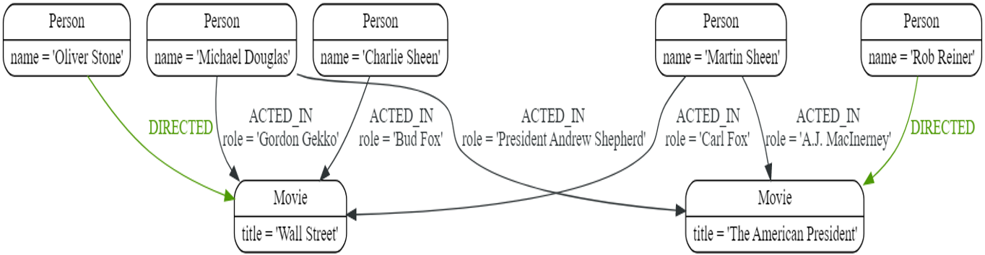

Natural language query:

Return the movie name containing the role “Bud Fox”.

Answer:

MATCH (actor)-[:ACTED_IN {role:'Bud Fox'}]->(movie:Movie)

RETURN movie.title