**Exercise 1:**

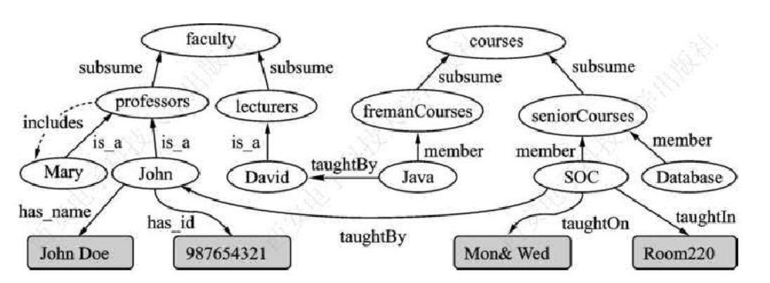Write RDF in Turtle for the part circled by the red line. All resources are defined in the namespace <http://www.semanticweb.org/ontology-9/>, and the prefix of its QName is “sw”.

**Exercise 2:**

Represent the following sentence graphically by means of the blank node:” Wikipedia said that Tolkien wrote Lord of the Rings”.

**Exercise 3:**

What can be inferred from the following triples using RDFS semantics?

1) ex:Postgraduate_student rdfs:subClassOf ex:Student

2) ex:Professor rdfs:subClassOf ex:Academic_staff

3) ex:Supervise rdfs:domain ex:Professor

4) ex:Supervise rdfs:range ex:Postgraduate_student

5) ex:John ex:Supervise ex:Mary