1) sw:John sw:is_a sw:professors .

sw:John sw:has_name “John Doe” .

sw:John sw:has_id “987654321” .

2) 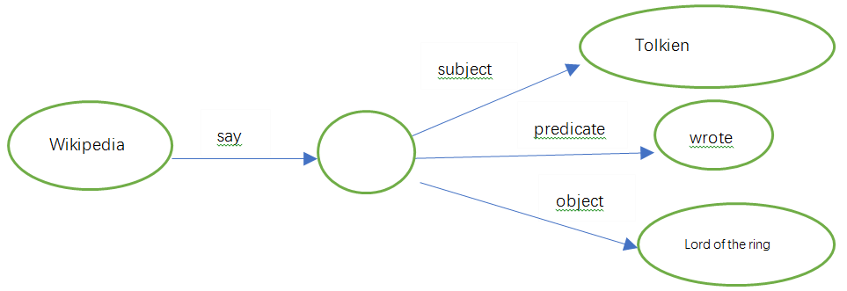

3) ex:John rdf:type ex:Professor

ex:Mary rdf:type ex:Postgraduate_student

ex:John rdf:type ex:Academic_staff

ex:Mary rdf:type ex:Student