1. Write the inferred axioms using description logic after conducting classification in forward reasoning on the following axioms.

Endocarditis $⊑$ Heart_Disease

Miocardial_Infarction $⊑$ Heart_Disease

Heart_Disease $⊑$ Disease

Enterococcal_Endocarditis $⊑$ Endocarditis

2） Given the following KG, please answer the question “Is Albert Einstein a mortal?” using query rewriting on the query *Mortal(Albert Einstein)* (this query is used for checking whether Albert Einstein is a mortal) .

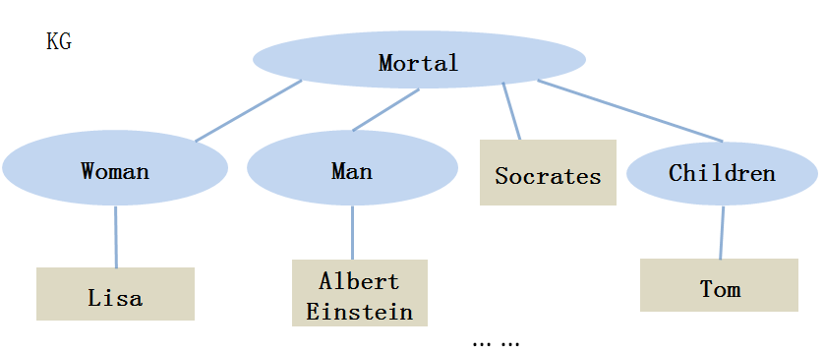

3) The following ontology is inconsistent. Please remove one axiom in it to make it consistent and explain why it should be removed in natural langauge.

$1 ∃{Enroll}_{in}.University⊑UniversityStudent$,

$2 UniversityStudent⊑¬Employee$,

$3 {Enroll}_{in}\left(John, SoutheastUniversity\right)$,

$4 Employee\left(John\right)$,

$5 Marriedto\left(John,Lisa\right)$,

6 University $\left(SoutheastUniversity\right)$

4）Give a model of the following ontology and verify it is a model:

$PhD_{student}⊔Undergraduatge_{student}⊑Student$,

$PhD_{student}\left(John\right)$,

$Undergraduatge_{student}(Jack)$,

$Sister\left(Lisa,Jack\right)$,

$$Employee\left(Lisa\right)$$