1. Write the inferred axioms using description logic after conducting classification in forward reasoning on the following axioms.

Endocarditis $⊑$ Heart_Disease

Miocardial_Infarction $⊑$ Heart_Disease

Heart_Disease $⊑$ Disease

Enterococcal_Endocarditis $⊑$ Endocarditis

答案：

Endocarditis $⊑$ Disease

Miocardial_Infarction $⊑$ Disease

Enterococcal_Endocarditis $⊑$ Heart_Disease

Enterococcal_Endocarditis $⊑$ Disease

2） Given the following KG, please answer the question “Is Albert Einstein a mortal?” using query rewriting on the query *Mortal(Albert Einstein)* (this query is used for checking whether Albert Einstein is a mortal) .

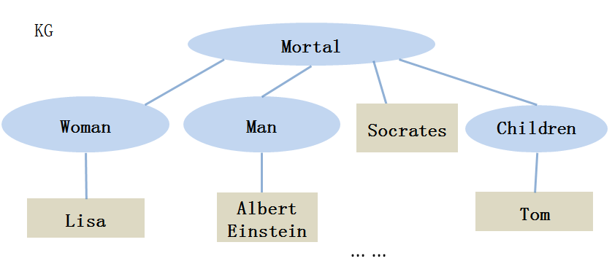

答案： Yes, and the rewritten query is Woman(x) ⋁ Man(x) ⋁ Children(x) ⋁ Mortal (x)

3) The following ontology is inconsistent. Please remove one axiom in it to make it consistent and explain why it should be removed in natural langauge.

$1 ∃{Enroll}_{in}.University⊑UniversityStudent$,

$2 UniversityStudent⊑¬Employee$,

$3 {Enroll}_{in}\left(John, SoutheastUniversity\right)$,

$4 Employee\left(John\right)$,

$5 Marriedto\left(John,Lisa\right)$,

6 University $\left(SoutheastUniversity\right)$

答案：we can remove either 1,2,3,4,6 to make the ontology consistent.

This is because 1,3,6 can infer that $∃{Enroll}_{in}.University(John)$ so $UniversityStudent(John)$, but this is in conflict with 2 and 4.

4）Give a model of the following ontology and verify it is a model:

$PhD_{student}⊔Undergraduatge_{student}⊑Student$,

$PhD_{student}\left(John\right)$,

$Undergraduatge_{student}(Jack)$,

$Sister\left(Lisa,Jack\right)$,

$$Employee\left(Lisa\right)$$

答案：

An interpretation I: $∆=\{jo,l,ja\}$

I(John)= $jo$, I(Lisa)=l, I(Jack)= $ja$

I($PhD_{student}$)={$jo$}, I(Employee)={l},

I($Undergraduatge_{student})$ ={$ja$}, I(Student)={$ja$, $jo$}

I($Sister$)={($l,ja$)}

Verify: it is necessary to verify the given interpretation I is a model of the ontology by verify it satisfies every axiom and assertion of the ontology.