1. What are the weakness of TransE compared with TransH and TransR, use an example to explain this (do not use the example in the slides).

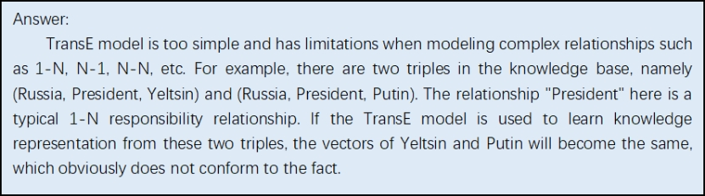

1. Explain why TransE cannot handle N-to-1 relations.

**Let’s consider one example (Xuanwu Lake, located_in, Nanjing), (Sipai Lou, located_in, Nanjing), if TransE is used to handle located_in relation, then Xuanwu Lake and Sipai Lou will become the same. More formally, for any (a_1, r, b),…, (a_n, r, b), by applying TransE, we will have a_1=a_2=…=a_n.**