1) Please use direct mapping to map the following three relational tables to RDF triples,

Given:

@base <http://foo.example/DB/> .

@prefix rdf: <http://www.w3.org/1999/02/22-rdf-syntax-ns#>.

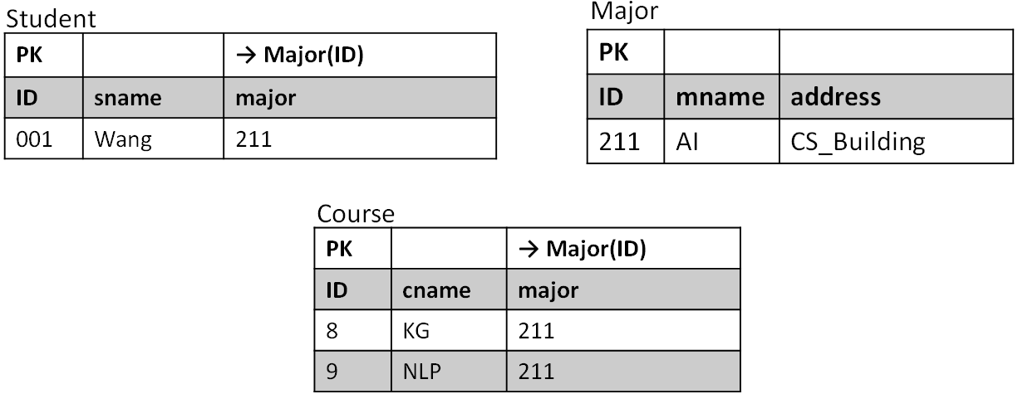

2) Given a relational database and RDF triples, please write corresponding R2RML triples maps which can map the given RDB to RDF.

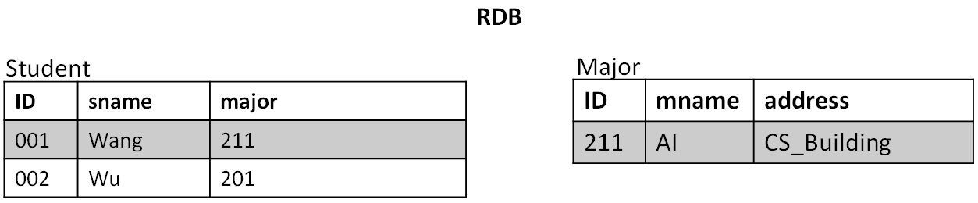

**RDF Triples**

<http://data.example.com/student/001> rdf:type ex:Student ;

ex:id "001" ;

ex:name "Wang" ;

ex:major <http://data.example.com/major/211> .

<http://data.example.com/student/002> rdf:type ex:Student ;

ex:id "002" ;

ex:name "Wu" .

<http://data.example.com/major/211> rdf:type ex:Major ;

ex:name "AI" .