1) Please use direct mapping to map the following three relational tables to RDF triples,

Given:

@base <http://foo.example/DB/> .

@prefix rdf: <http://www.w3.org/1999/02/22-rdf-syntax-ns#>.

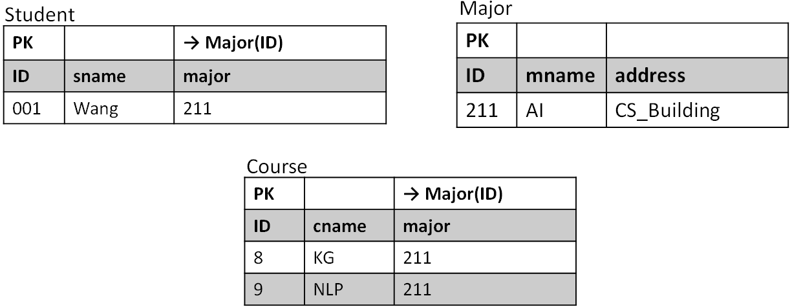

**Answer:**

<Student/ID=001> rdf:type <Student> ;

<Student#ID> "001" ;

<Student#sname> "Wang" ;

<Student#major> "211" ;

<Student#ref-major> <Major/ID=211> .

<Major/ID=101> rdf:type <Major> .

<Major#ID> "211" .

<Major#mname> "AI" .

<Major#address> "CS_Building" .

<Course/ID=8> rdf:type <Course> ;

<Course#ID> "8" ;

<Course#cname> "KG" ;

<Course#major> "211" ;

<Course#ref-major> <Major/ID=211> .

<Course/ID=9> rdf:type <Course> ;

<Course#ID> "9" ;

<Course#cname> "NLP" ;

<Course#major> "211" ;

<Course#ref-major> <Major/ID=211> .

2) Given a relational database and RDF triples, please write corresponding R2RML triples maps which can map the given RDB to RDF.

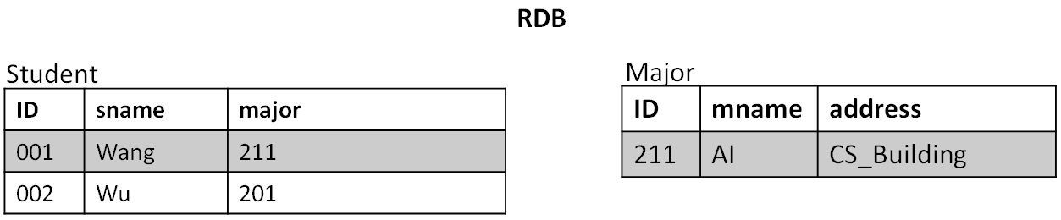

**RDF Triples**

<http://data.example.com/student/001> rdf:type ex:Student ;

ex:id "001" ;

ex:name "Wang" ;

ex:major <http://data.example.com/major/211> .

<http://data.example.com/student/002> rdf:type ex:Student ;

ex:id "002" ;

ex:name "Wu" .

<http://data.example.com/major/211> rdf:type ex:Major ;

ex:name "AI" .

**Answer:**

<#TriplesMap1>

rr:logicalTable [ rr:tableName "Student" ];

rr:subjectMap [

rr:template "http://data.example.com/student/{ID}";

rr:class ex:Student;

];

rr:predicateObjectMap [

rr:predicate ex:id;

rr:objectMap [ rr:column “ID" ];

];

rr:predicateObjectMap [

rr:predicate ex:name;

rr:objectMap [ rr:column “sname" ];

];

rr:predicateObjectMap [

rr:predicate ex:major;

rr:objectMap [

rr:parentTriplesMap <#TriplesMap2>;

rr:joinCondition [

rr:child "Major";

rr:parent "ID";

];

];

].

<#TriplesMap2>

rr:logicalTable [ rr:tableName "Major" ];

rr:subjectMap [

rr:template "http://data.example.com/major/{ID}";

rr:class ex:Major;

];

rr:predicateObjectMap [

rr:predicate ex:name;

rr:objectMap [ rr:column "mname" ];

].