习题1. Given a table as follows:

|  |  |  |  |
| --- | --- | --- | --- |
| Song Name | Artist | Album | Release Date |
| Towards My Original Aspiration | Chen Linong | heliocentric theory | 2021/12/31 |
| At Least I Had You | Gentle Bones, JJ Lin | Single | 2021/11/19 |
| Past | Jackson Wang, JJ Lin | Single | 2020/12/17 |
| Mutual Understanding | Karen Mok | We Meet in the Middle of the Field | 2018/5/31 |
| True to Myself | Han Hong | Single | 2018/5/25 |
| Under the Same Sky | Han Hong, JJ Lin | Single | 2018/4/23 |
| My Pride | Jimmy Lin | My Pride | 2018/4/9 |
| Behind me | A-Mei | The Story Thief | 2017/12/12 |
| Mini Lightning | Li Yitong | Single | 2017/10/29 |
| Born to Be Myself | You wo Girls | Single | 2017/6/24 |

|  |  |  |
| --- | --- | --- |
| Han Hong (Master’s Supervisor at Liaoning University of Traditional Chinese Medicine) | | |
| Subject | Predicate | Object |
| Han Hong | Chinese Name | Han Hong |
| Han Hong | Nationality | China |
| Han Hong | Ethnicity | Han |
| Han Hong | Date of Birth | 1959/5/1 |
| Han Hong | Alma Mater | Liaoning University of Traditional Chinese Medicine |
| Han Hong | Profession | Teacher |
| Han Hong | Retirement Date | 2018/5/25 |
| Han Hong | Writes | True to Myself |

The infoboxes of the three candidate entities of mention are as follows:

|  |  |  |
| --- | --- | --- |
| Han Hong  (Chinese Mainland Pop Singer) | | |
| Subject | Predicate | Object |
| Han Hong | Has Partner | Karen Mok |
| Han Hong | Gender | Female |
| Han Hong | Ethnicity | Tibetan |
| Han Hong | Nationality | [China](https://baike.baidu.com/item/%E4%B8%AD%E5%9B%BD/22516505?fromModule=lemma_inlink) |
| Han Hong | Alias | Yangjin Zhuoma |
| Han Hong | Has friend | Jimmy Lin, JJ Lin |

|  |  |  |
| --- | --- | --- |
| Han Hong (Member of the 13th Committee of the Political Consultative Conference in Sichuan Province) | | |
| Subject | Predicate | Object |
| Han Hong | Has friend | Chen Linong |
| Han Hong | Nationality | China |
| Han Hong | Ethnicity | Han |

Exercise: (Note: If a comma or a pause mark is encountered in a cell, it should be treated as containing multiple entities)

1. contSim(Han Hong, Han Hong (Chinese Mainland Pop Singer) )
2. contSim(Han Hong, Han Hong (Master’s Supervisor at Liaoning University of Traditional Chinese Medicine) )
3. contSim(Han Hong, Han Hong (Member of the 13th Committee of the Political Consultative Conference in Sichuan Province) )

答案：

1）

memContext(Han Hong) = {True to Myself, Single, 2018/5/25, Chen Linong, Gentle Bones, JJ Lin, Jackson Wang, Karen Mok, Jimmy Lin, A-Mei, Li Yitong, You wo Girls}

entContext(Han Hong (Chinese Mainland Pop Singer)) = {Karen Mok, *Female, Tibetan,* *China, Yangjin Zhuoma,* Jimmy Lin, JJ Lin}

A1 = menContext(Han Hong) ∩ entContext(Han Hong (Chinese Mainland Pop Singer)) = {Karen Mok, Jimmy Lin, JJ Lin}

A2 = menContext(Han Hong) ∪ entContext(Han Hong (Chinese Mainland Pop Singer)) = {True to Myself, Single, 2018/5/25, Chen Linong, Gentle Bones, JJ Lin, Jackson Wang, Karen Mok, Jimmy Lin, A-Mei, Li Yitong, You wo Girls, *Female, Tibetan, China, Yangjin Zhuoma*}

contSim(Han Hong, Han Hong (Chinese Mainland Pop Singer)) = |A1| / |A2| = 3 / 16

2）

memContext(Han Hong) = {True to Myself, Single, 2018/5/25, Chen Linong, Gentle Bones, JJ Lin, Jackson Wang, Karen Mok, Jimmy Lin, A-Mei, Li Yitong, You wo Girls}

entContext(Han Hong (Master’s Supervisor at Liaoning University of Traditional Chinese Medicine)) = {*China, Han, 1959/5/1, Liaoning College of Traditional Chinese Medicine, Teacher*, 2018/5/25, True to Myself}

A1 = menContext(Han Hong) ∩ entContext(Han Hong (Master’s Supervisor at Liaoning University of Traditional Chinese Medicine)) = {2018/5/25, True to Myself}

A2 = menContext(Han Hong) ∪ entContext(Han Hong (Master’s Supervisor at Liaoning University of Traditional Chinese Medicine)) = {True to Myself, Single, 2018/5/25, Chen Linong, Gentle Bones, JJ Lin, Jackson Wang, Karen Mok, Jimmy Lin, A-Mei, Li Yitong, You wo Girls, China, Han, 1959/5/1, Liaoning College of Traditional Chinese Medicine, Teacher}

contSim(Han Hong, Han Hong (Master’s Supervisor at Liaoning University of Traditional Chinese Medicine)) = |A1| / |A2| = 2 / 17

3）

memContext(Han Hong) = {True to Myself, Single, 2018/5/25, Chen Linong, Gentle Bones, JJ Lin, Jackson Wang, Karen Mok, Jimmy Lin, A-Mei, Li Yitong, You wo Girls}

entContext(Han Hong (Member of the 13th Committee of the Political Consultative Conference in Sichuan Province)) = {Chen Linong, *China, Han*}

A1 = menContext(Han Hong) ∩ entContext(Han Hong (Member of the 13th Committee of the Political Consultative Conference in Sichuan Province)) = {Chen Linong}

A2 = menContext(Han Hong) ∪ entContext(Han Hong (Member of the 13th Committee of the Political Consultative Conference in Sichuan Province)) = {True to Myself, Single, 2018/5/25, Chen Linong, Gentle Bones, JJ Lin, Jackson Wang, Karen Mok, Jimmy Lin, A-Mei, Li Yitong, You wo Girls, *China, Han*}

contSim(Han Hong, Han Hong (Member of the 13th Committee of the Political Consultative Conference in Sichuan Province)) = |A1| / |A2| = 1 / 14

习题2. In the Wikipedia article page of “Tim Berners-Lee”, the categories are as follows. Please extract facts from them in turtle using YAGO category maps and the following prefixes without domain and range checking, and clarify the subsequent validation steps on the extracted fact.

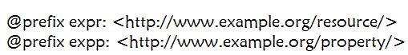

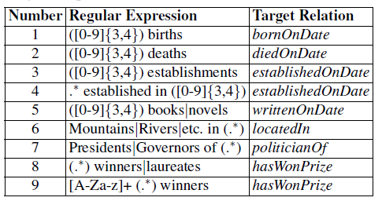

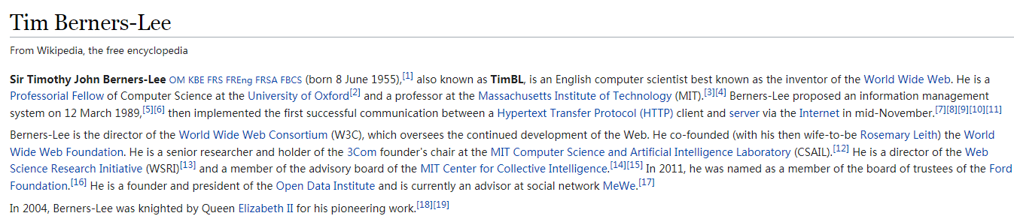

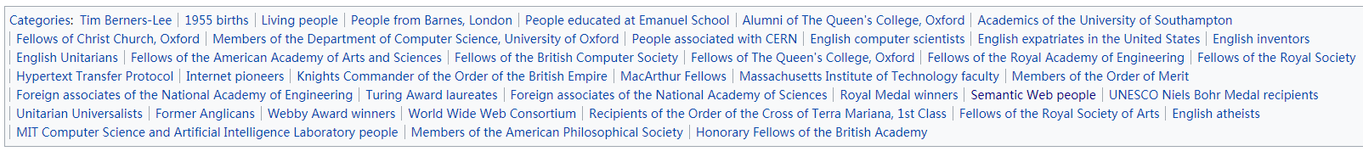

答案：

expr:Tim_Berners-Lee expp:bornOnDate “1955” ;

expp:hasWonPrize expr:Turing_Award ;

expp:hasWonPrize expr:Royal_Medal ;

expp:hasWonPrize expr:Medal;

expp:hasWonPrize expr:Webby_Award ;

expp:hasWonPrize expr:Award .

后续验证步骤：1) 检查expr:Tim_Berners-Lee是否在expp:bornOnDate的定义域中，“1955”是否在expp:bornOnDate的值域中；

2) 检查expr:Tim_Berners-Lee是否在expp:hasWonPrize的定义域中，expr:Turing_Award，expr:Royal_Medal，expr:Medal，expr:Webby_Award，expr:Award是否在expp:hasWonPrize的值域中。

习题3. Please tell the differences between the rdf:type relation and the general is-a relation.

答案：rdf:type is used to link from an instance to a class, and it is the connection between the instance level and schema level of a knowledge graph.

General is-a relations consists of type information (i.e., rdf:type relations) and rdfs:subClassOf relations, and they often used for forming a taxonomy.