**You can answer in Chinese or English.**

**Syntactic Parsing**

### Explanation of Syntactic Parsing, Comparison of Top-Down/Bottom-Up Parsing, CKY Algorithm, Probabilistic CKY Algorithm, Lexicalization of PCFGs, and Explanation of the Technical Development Trajectory and Motivation.

1. **Given grammar rules:**

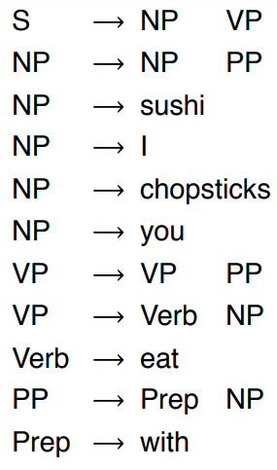

**1、Please use the CKY algorithm to write out the complete parsing process for the sentence "I eat sushi with chopsticks with you".**

**2、Please draw the final parse tree.**

1. **In statistical syntactic analysis, what is a Probabilistic Context-Free Grammar (PCFG)? How does it address the limitations of traditional syntax analysis?**

**Semantic Parsing**

**(一) Based on the definition of Semantic Role Labeling (SRL), answer the following questions:**

1. **Please explain the main tasks of Semantic Role Labeling and the classification standards for roles.**
2. **Explain how prior knowledge (such as selectional restrictions) is used in Semantic Role Labeling to resolve ambiguity, and provide an example.**

**（二）How do the PropBank and FrameNet datasets differ in their annotation methods? Please explain with reference to their specific annotation methods (such as role definitions and classifications).**

**Text Classification**

**（一）Given the following confusion matrix:**

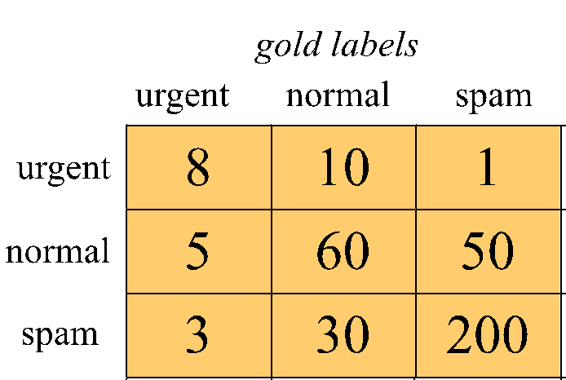

1、Calulate macro-precision，micro-precision.

2、Calulate macro-recall，micro-recall.

3、Calulate macro-F1，micro-F1.

**(二) Assumptions and Characteristics of the Naive Bayes Classifier**

1. In text classification, what are the key assumptions used by the Naive Bayes classifier? Explain the "conditional independence assumption" and the "bag of words assumption."
2. If certain words (e.g., "fantastic") never appear in a specific class in the training set, how should this be handled? Briefly explain the method for addressing the zero-probability problem.

**(三) Bias and Fairness in Text Classification**

1. In sentiment analysis or toxicity classification tasks, models may exhibit bias toward certain groups, such as classifying language associated with specific identities (e.g., "female" or "African American") as negative sentiment. What factors might cause this bias?
2. Provide two strategies to mitigate model bias, and briefly explain the principles behind their implementation.