Translator

Objective: Objective of this application is to Convert Voice to text and translate it to another language in offline system.

Installation Python and Setup Process:
Install Python on Windows 10
Since Windows doesn’t come with Python preinstalled, it needs to be installed explicitly. Here we will define step by step tutorial on How to install Python on Windows. Follow the steps below :

Steps to Download Python on Windows 10
Step 1: First and foremost step is to open a browser and type https://www.python.org/downloads/windows/

Step 2: Underneath the Python Releases for Windows find the Latest Python 3 Release – Python 3.11.2 (the latest stable release as of now is Python 3.11.2).

Step 3: On this page move to Files and click on Windows x86-64 executable installer for 64-bit or Windows x86 executable installer for 32-bit.

Steps to Install Python on Windows 10
Here we are providing the installation process of Python 3.11.2 on Windows

Run the Python Installer for how to install Python on the Windows downloads folder
Make sure to mark Add Python 3.11 to PATH otherwise you will have to do it explicitly. It will start installing Python on Windows.

After installation is complete click on Close. Bingo..!! Python is installed. Now go to Windows and type IDLE.

How to Install Python on Linux
Most Linux OSs have Python pre-installed. To check if your device is pre-installed with Python or not, just go to the terminal using Ctrl+Alt+T, On every Linux system including the following OS: Ubuntu, Linux Mint, Debian, openSUSE, CentOS, Fedora
You will find Python already installed. You can check it using the following command from the terminal
$ python --version
$ python3 --version

$ sudo add-apt-repository ppa:deadsnakes/ppa
$ sudo apt-get update
$ sudo apt-get install python3.11.2

Download Python Latest Version from python.org

The first and foremost step is to open a browser and open https://www.python.org/downloads/source/

Underneath the Stable Releases find Download Gzipped source tarball (the latest stable release as of now is Python 3.11.2).

Install Necessary Library

Create Virtual Environment Steps are as follows
Installing virtualenv:

Installing virtualenv
$ pip install virtualenv

Test your installation:
$ virtualenv --version

Create a new Virtual Environment
You can create a virtualenv using the following command:using the following command:
$ virtualenv my_env

$ virtualenv -p /usr/bin/python3 virtualenv_name

Activating a Virtual Environment in Python
Activating a Virtual Environment in Python Now after creating a virtual environment, you need to activate it. Remember to activate the relevant virtual environment every time you work on the project. This can be done using the following command:
Activate a Virtual Environment on Windows
To activate virtual environment using windows command prompt change directory to your virtual env, Then use the below command
$ cd <envname>
$ Scripts\activate

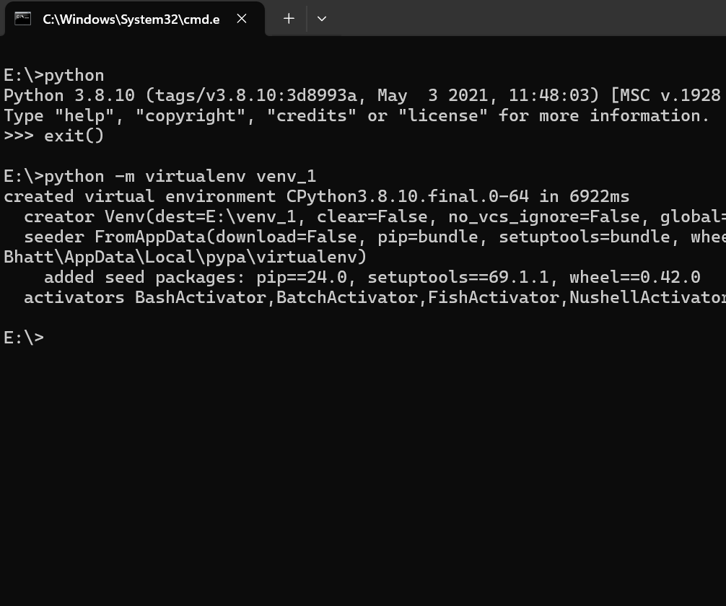

Activate a virtual environment on Linux
$ source virtualenv_name/bin/activate

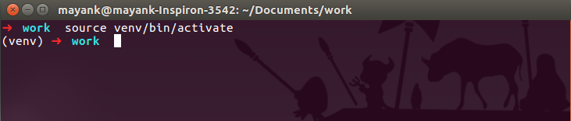

Installing Dependencies in Virtual Environment Python
PyTorch is one of the most popular deep learning libraries offering two core functionalities that facilitate the building and training of neural network-based models.

The following are the primary features of the library -

Its core data structure is called Tensor, and it can be easily migrated to GPUs for efficient and faster computing, and
An automatic differentiation engine called autograd is supported in the library that allows for the training of deep neural networks by automatically calculating gradients with ease.
In this article, we will be taking our first step towards learning to build deep neural networks in PyTorch - that is, installing and getting PyTorch running on our system.

Installation Commands
"pip3 install torch torchvision torchaudio"

Installing Dependencies in Virtual Environment Python

PyTorch is one of the most popular deep learning libraries offering two core functionalities that facilitate the building and training of neural network-based models.

The following are the primary features of the library -

Its core data structure is called Tensor, and it can be easily migrated to GPUs for efficient and faster computing, and
An automatic differentiation engine called autograd is supported in the library that allows for the training of deep neural networks by automatically calculating gradients with ease.
In this article, we will be taking our first step towards learning to build deep neural networks in PyTorch - that is, installing and getting PyTorch running on our system.
To install PyTorch with CPU support only, run:
pip3 install torch torchvision torchaudio --index-url https://download.pytorch.org/whl/cpu

To install PyTorch with GPU support run:
pip3 install torch torchvision torchaudio

Verify the installation
You can run the following command to verify that PyTorch has been installed:
python
import torch
print(torch.__version__)
The command above will start the Python interpreter, import the PyTorch library and print the version of PyTorch that is currently installed.

Install pyaudio
In ubuntu
sudo apt-get install libasound-dev portaudio19-dev libportaudio2 libportaudiocpp0
sudo apt-get install ffmpeg libav-tools
sudo pip install pyaudio

In Windows
pip install pyaudio

Download the other Dependencies
django-rest-framework
django-cors-headers
pyaudio
sacremoses
sentencepiece
setuptools
SpeechRecognition
torch
torchvision
torchaudio
Transformers
Vosk

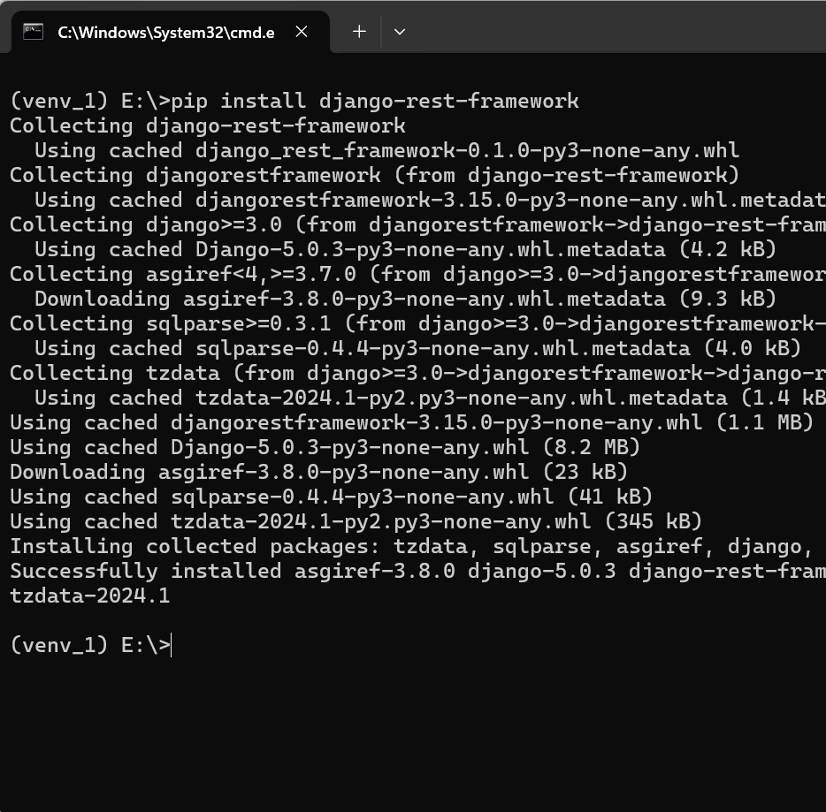

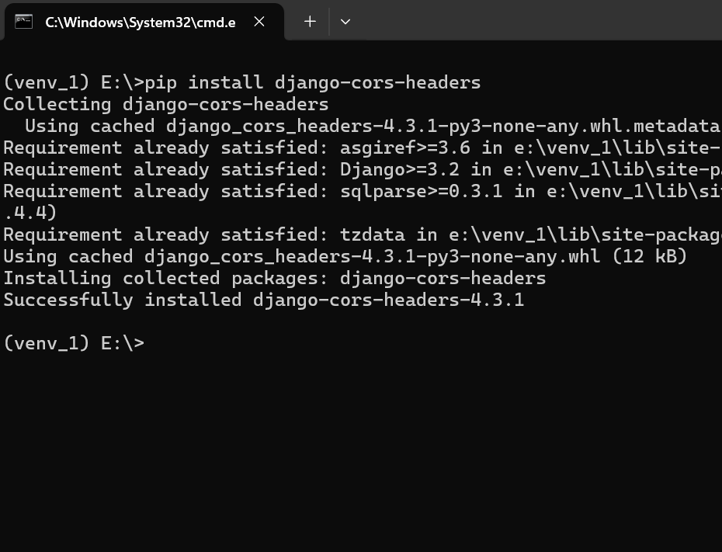
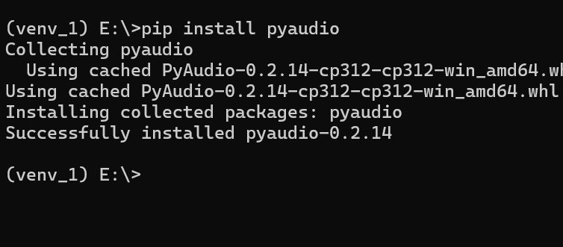
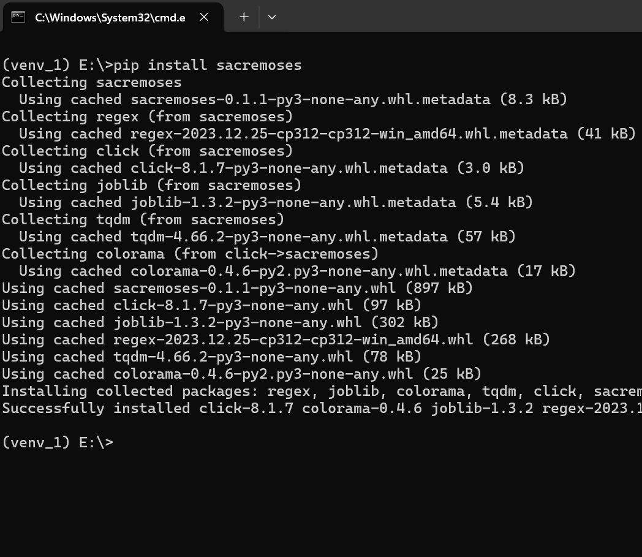

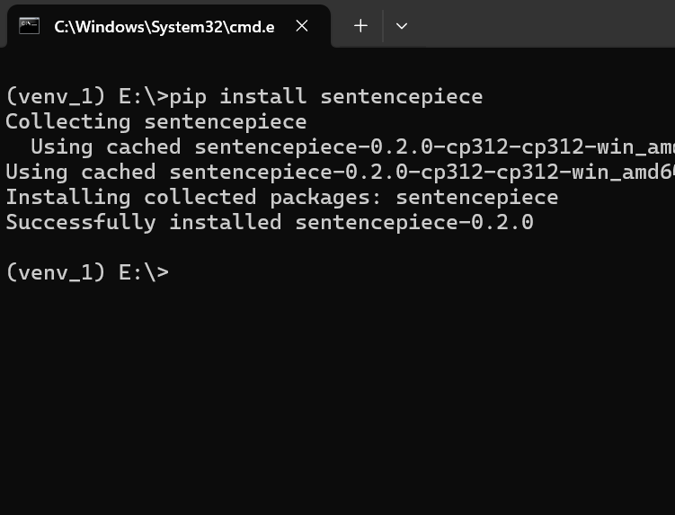

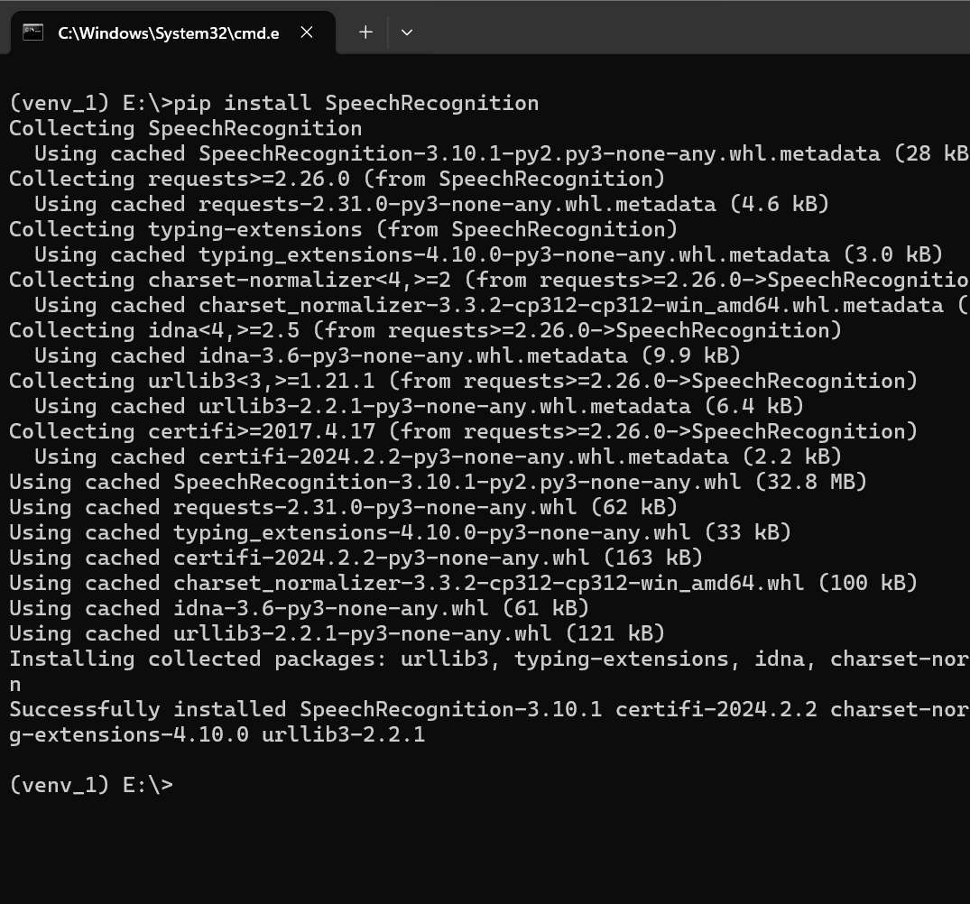

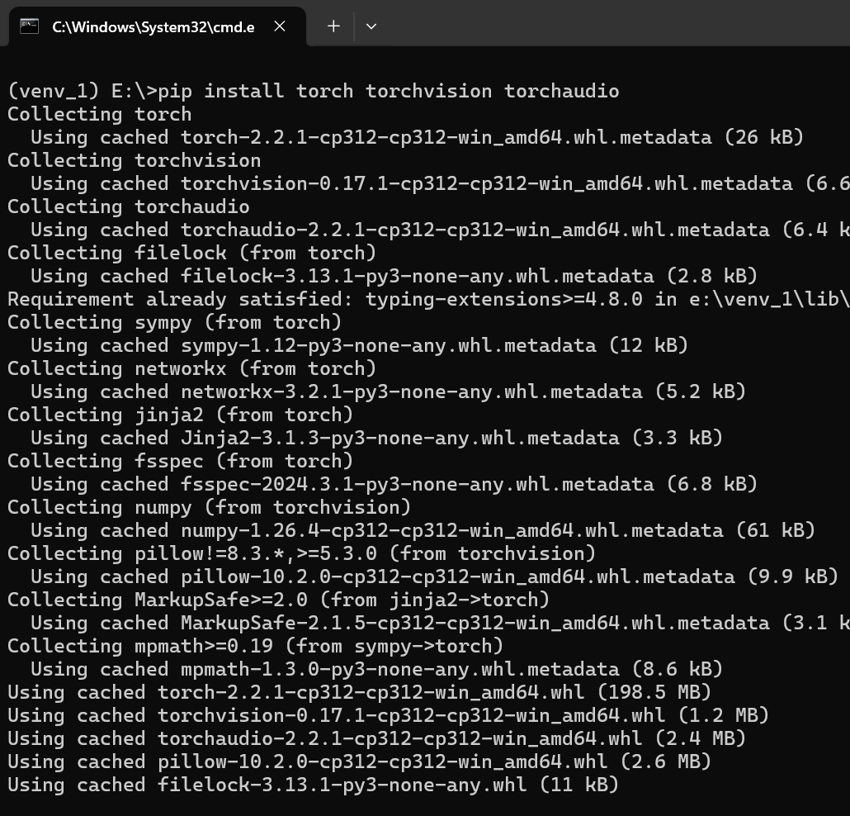

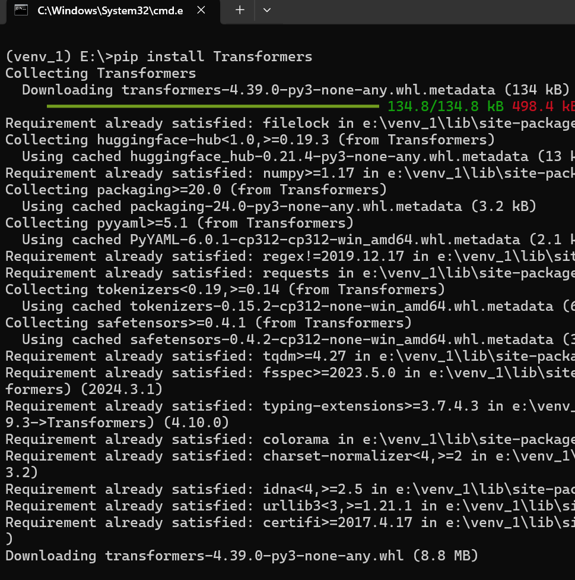

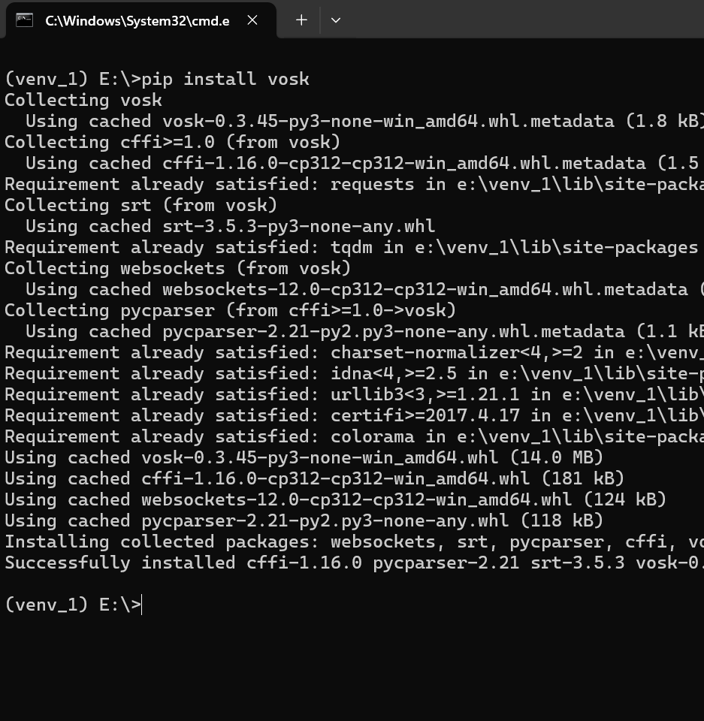

Setup Vosk
Goto https://alphacephei.com/vosk/models
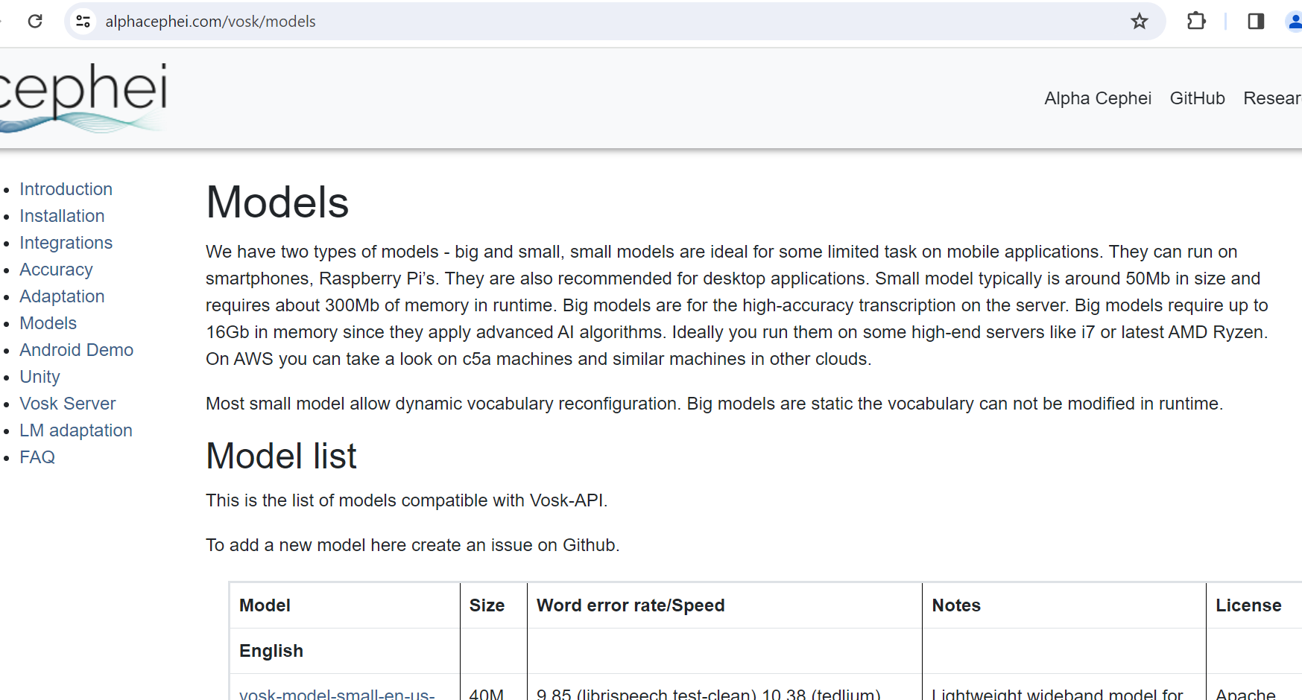

Download Necessary Models

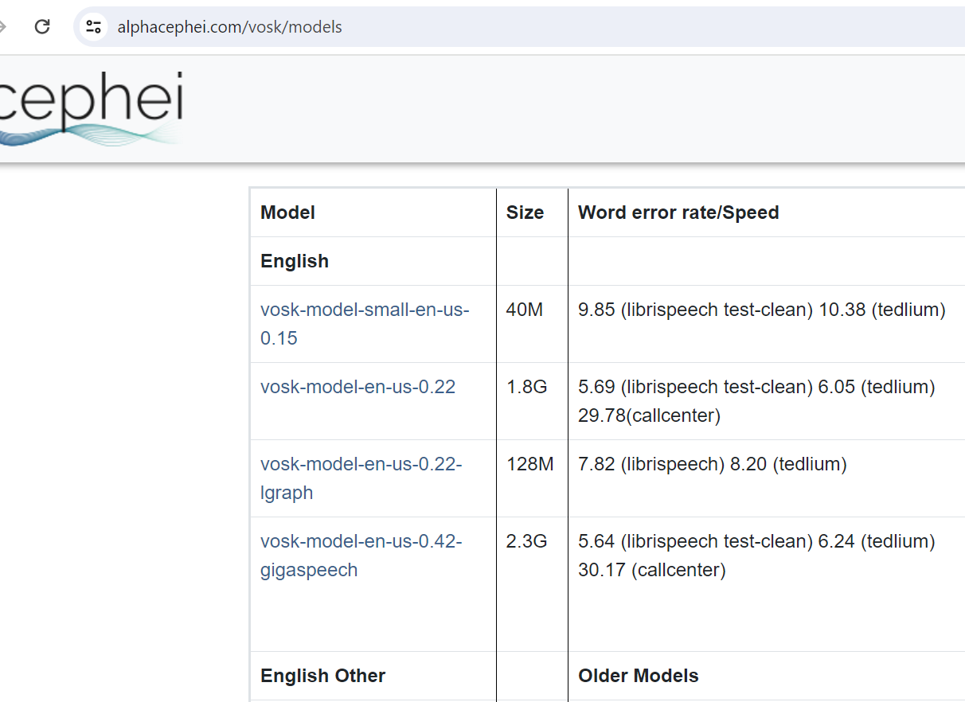

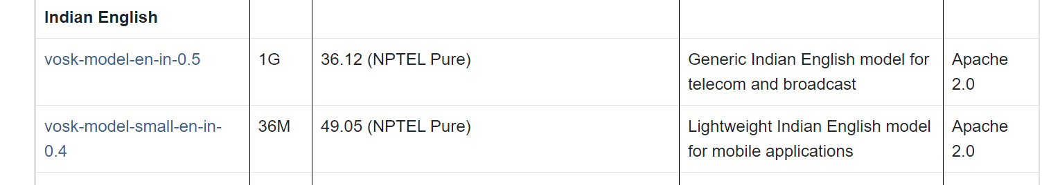

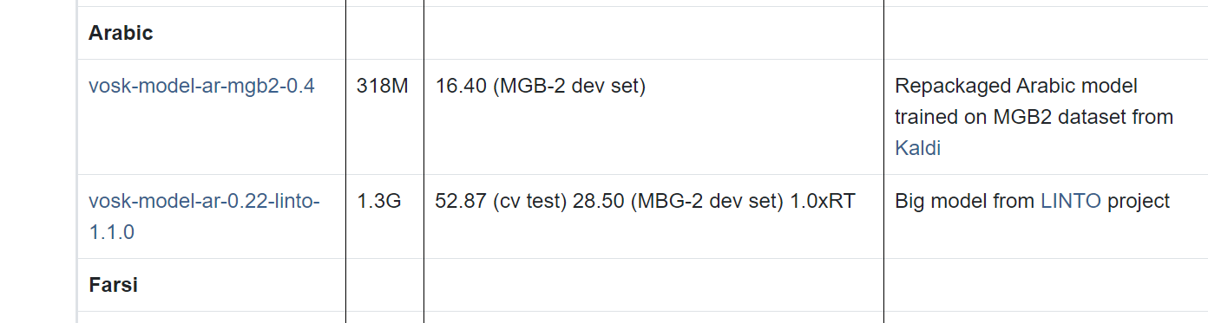

Extract it inside the project
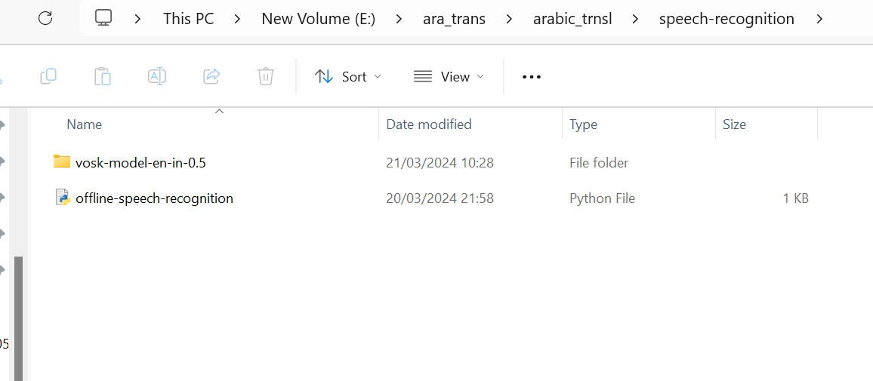

Download Github code from https://github.com/Sunilbhatt1996/Arabic-Translation/tree/main

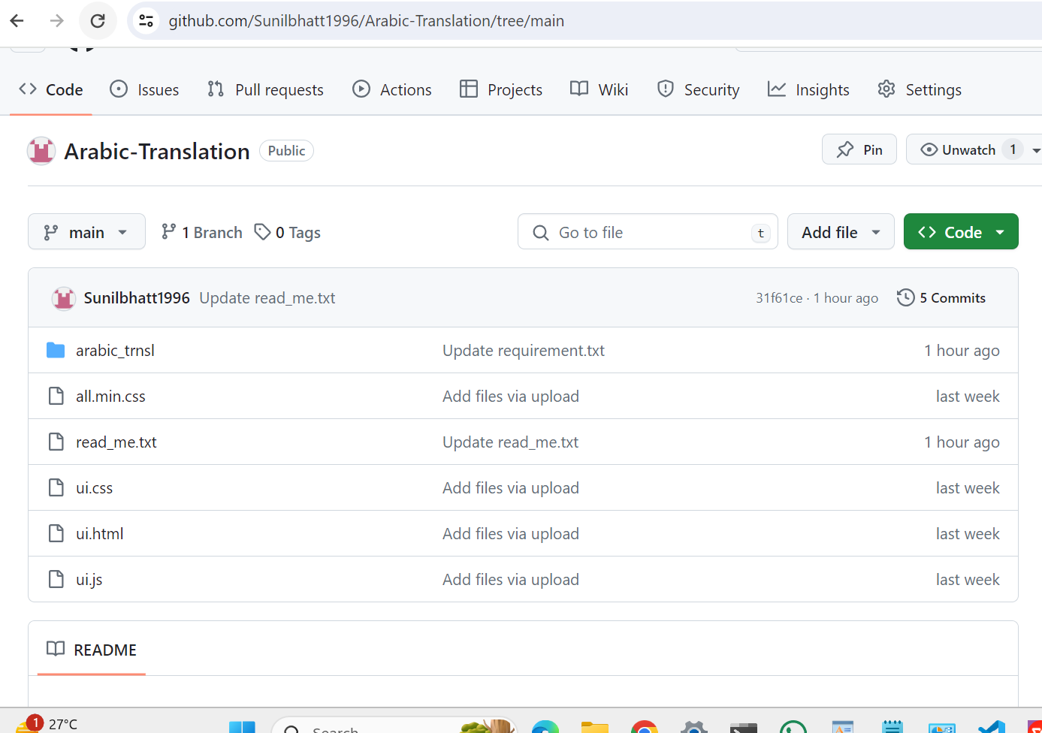

Application of work

Activate the python environment.
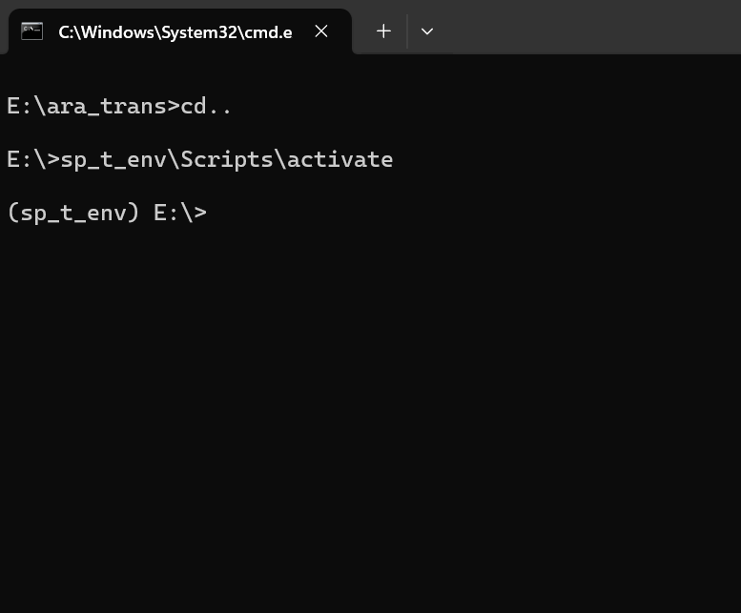

Convert Voice to text Sample
Run the following command
cd arabic_trans
python speech-recognition\offline-speech-recognition.py

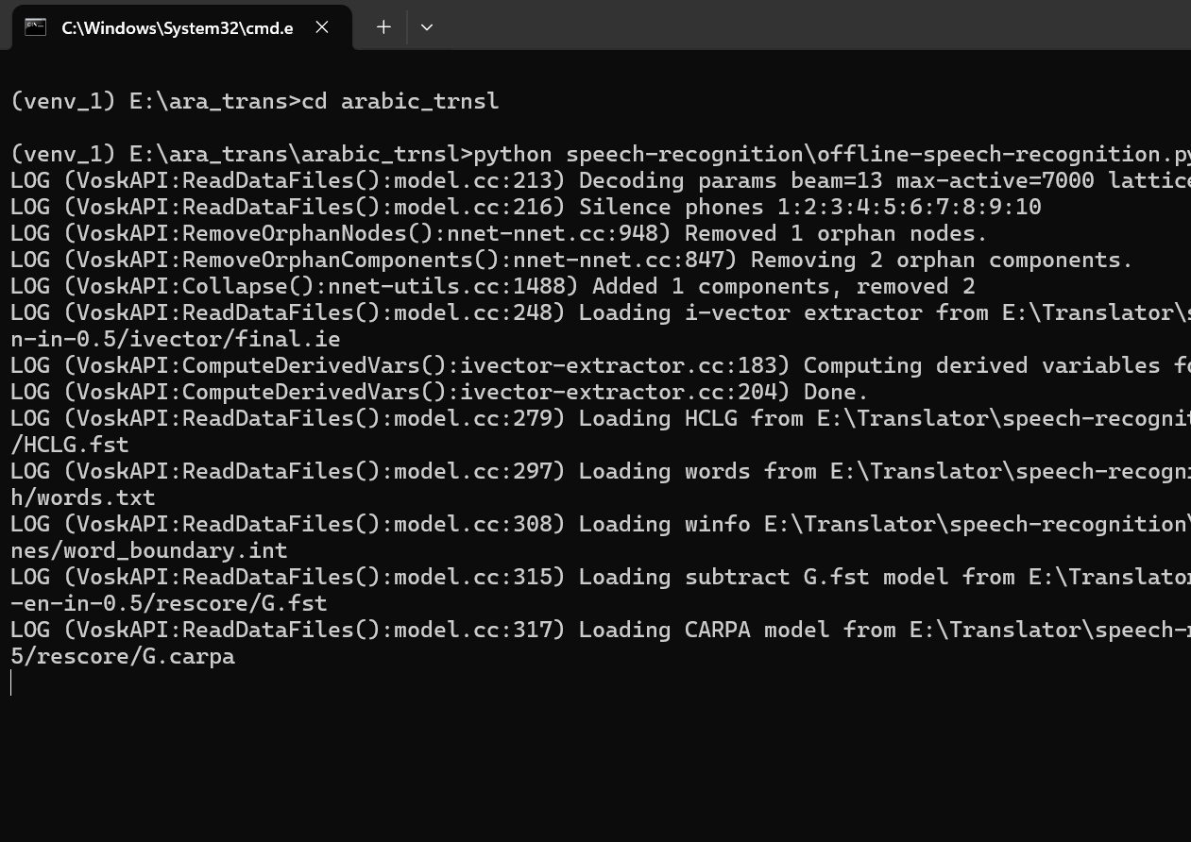

After Running the code try to speek it will convert it into text
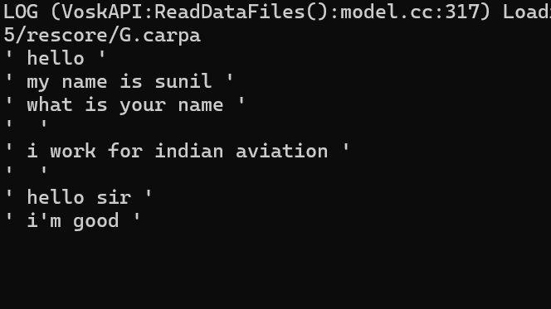

For Converting English to Arabic Translator
- Open arabic_trans folder
- Search Manage.py file.
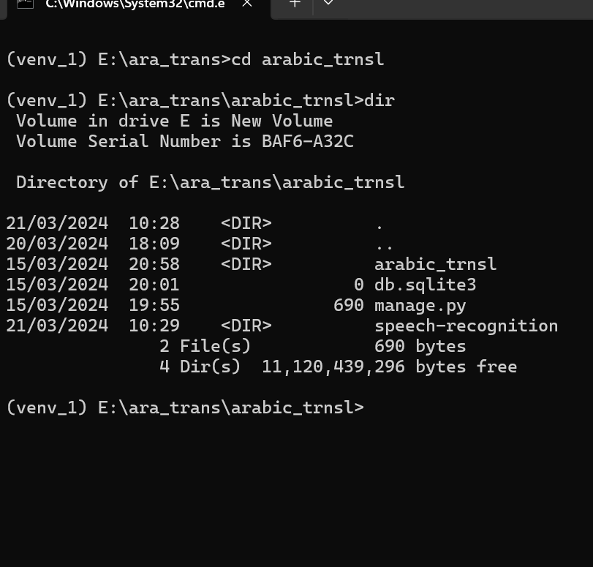

- Run python manage.py runserver command
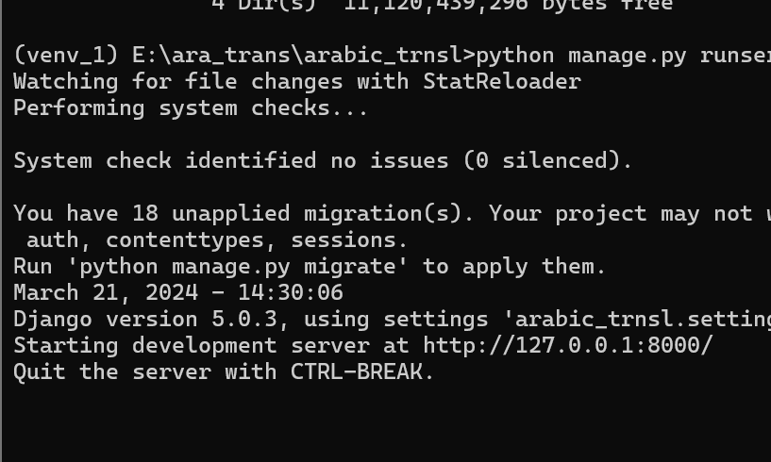

- Go back to folder and search UI.html file 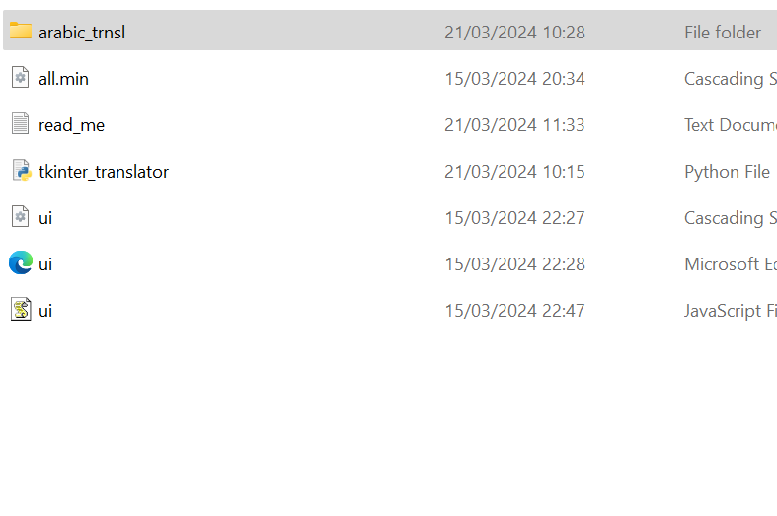
- Open it
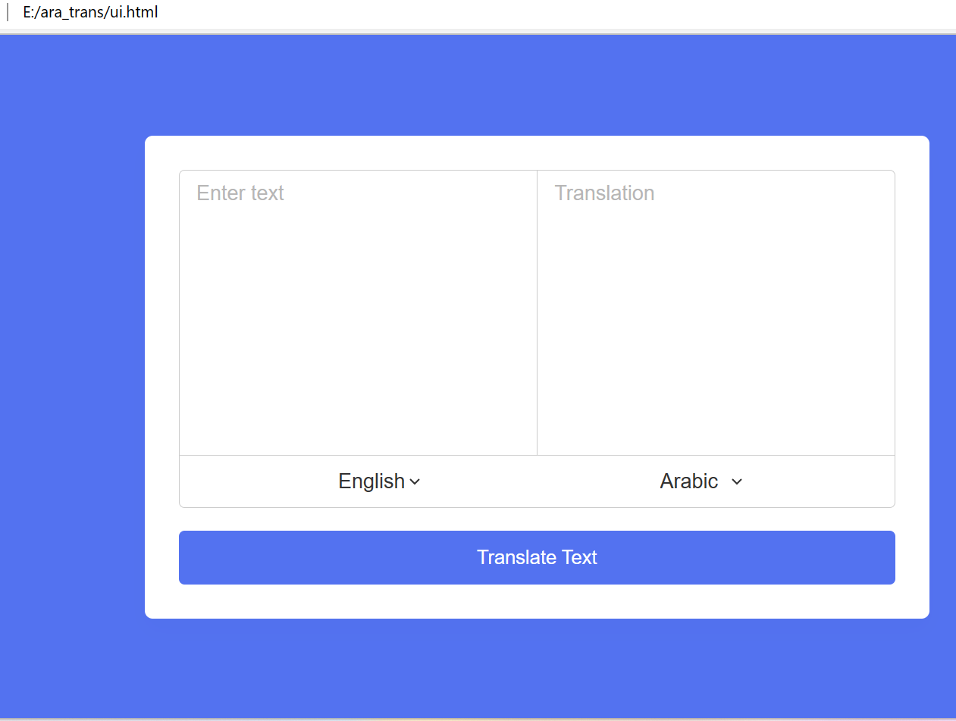

Enter Text and click Translate Text button
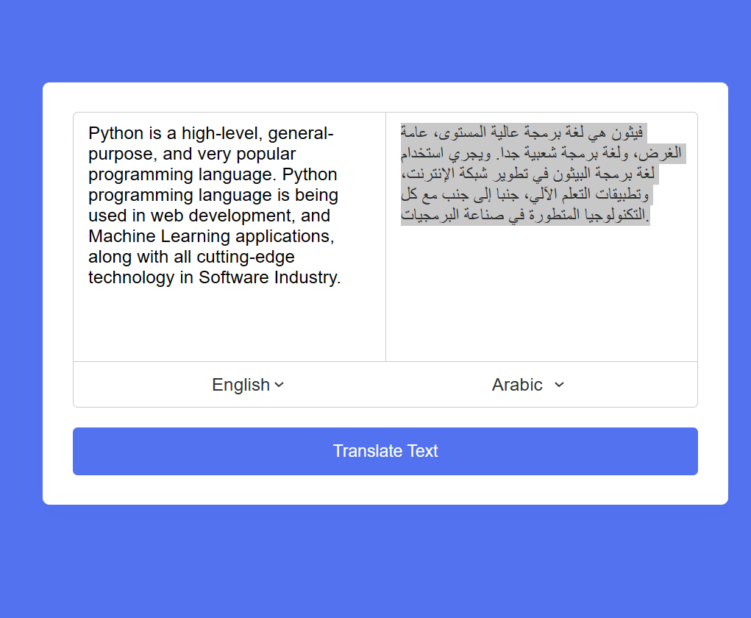

Online Verified
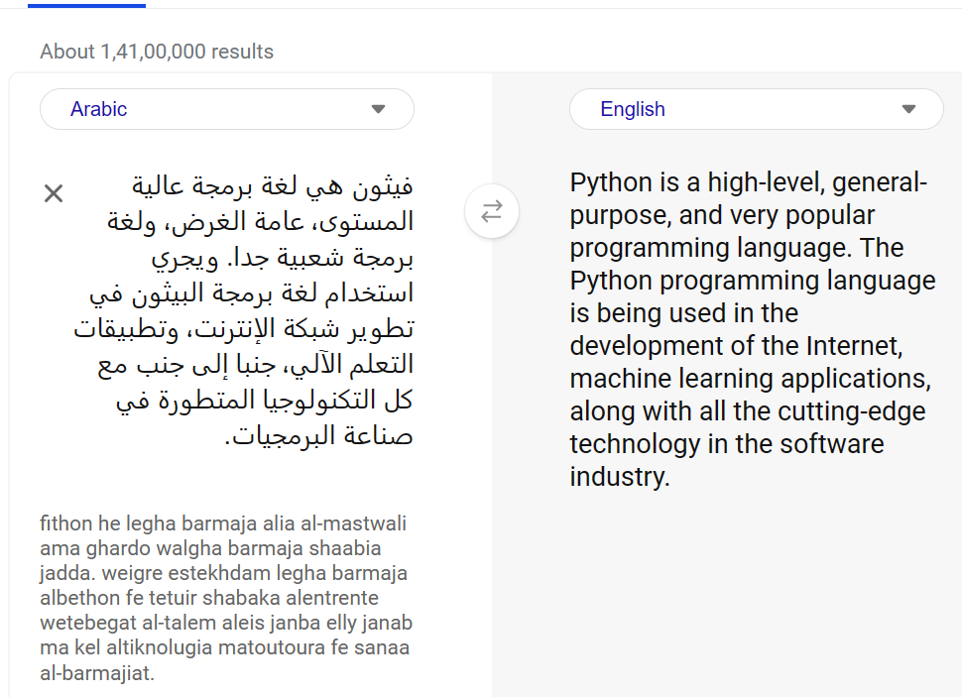

We can convert Arabic to english

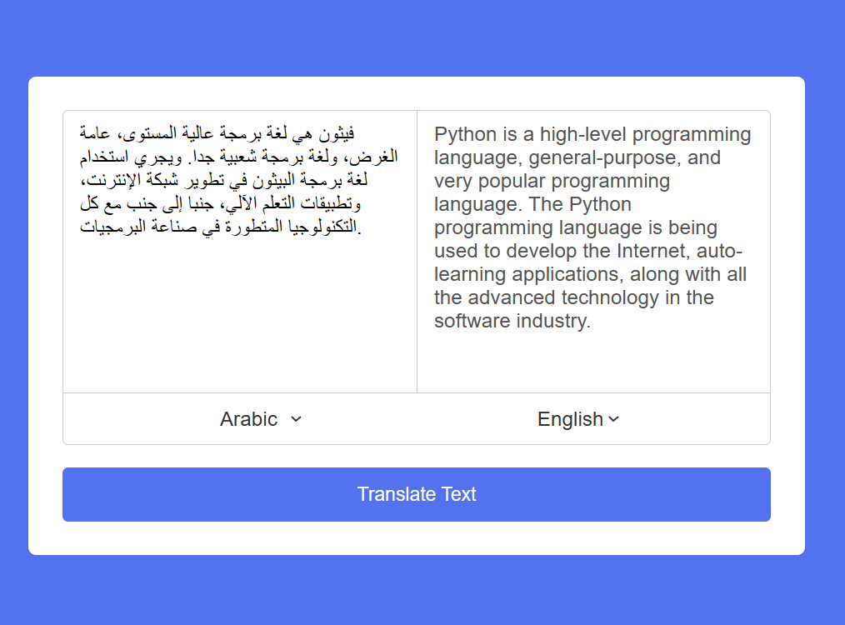

Problems:

When the people came from other country for seminar at that time they use few words of their language which cannot be understand by other people Or they don’t know other language. There is no any specific application or tools for translating them.

- It require internet first time to download the Transforms algorithm model. There is no specific path where you can store it
- Have to define max count of words. If max words reaches it throw error
- Have to download all Vosk model for speech recognition for necessary languages and paste it in specific folder and have to add condition for them.

Work Completed till now
- Created Back-end Environment for Translation and speech recognition.
- Created API for Translate text from one language to another.
- Create UI for Translate text from one language to another and integrated the API.
- Create API to convert voice to text.

Need to complete : Create UI for convert voice to text

Conclusion:
User is able to convert one language to other language using python’s Transformers library. Transformers library provide many models to convert languages. First time it require internet to download the model after that it will work in offline mode.
Vosk library is useful for speech Recognition. It provide many model for every languages just like english, hindi, french. It is work for offline mode.

Bibliography:
* https://alphacephei.com/vosk/models
* https://pypi.org/project/transformers/
* https://huggingface.co/docs/transformers/en/index

