**Exercise 1: Implementing the Singleton Pattern**

**Define a Singleton Class:**

**Code:**

public class Logger {

// Private static instance

private static Logger *instance*;

// Private constructor to prevent external instantiation

private Logger() {

System.***out***.println("Logger initialized.");

}

// Public static method to provide access to the instance

public static Logger getInstance() {

if (*instance* == null) {

*instance* = new Logger();

}

return *instance*;

}

// Logging method

public void log(String message) {

System.***out***.println("[LOG]: " + message);

}

}

**Implement the Singleton Pattern:**

**Code:**

public class Main {

public static void main(String[] args) {

// Getting the singleton instance multiple times

Logger logger1 = Logger.*getInstance*();

logger1.log("First log message.");

Logger logger2 = Logger.*getInstance*();

logger2.log("Second log message.");

// Verifying that both logger1 and logger2 refer to the same instance

if (logger1 == logger2) {

System.***out***.println("Both logger instances are the same. Singleton confirmed.");

} else {

System.***out***.println("Different logger instances exist. Singleton failed.");

}

}

}

**Test the Singleton Implementation:**

**Output:  
  
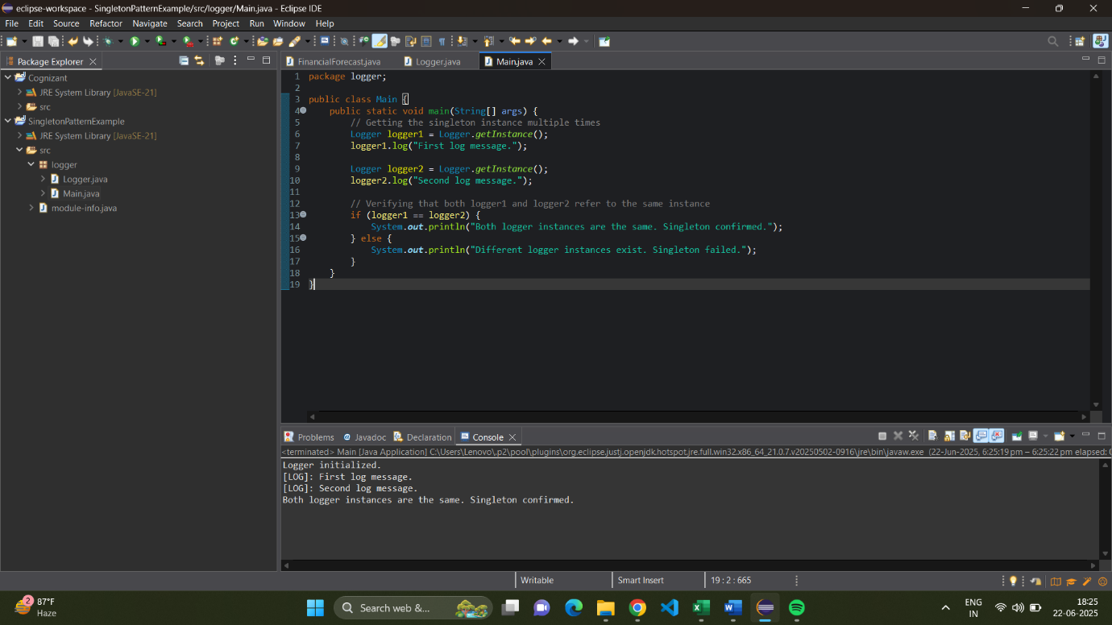**

**Exercise 2: Implementing the Factory Method Pattern**  
**Create a New Java Project:**

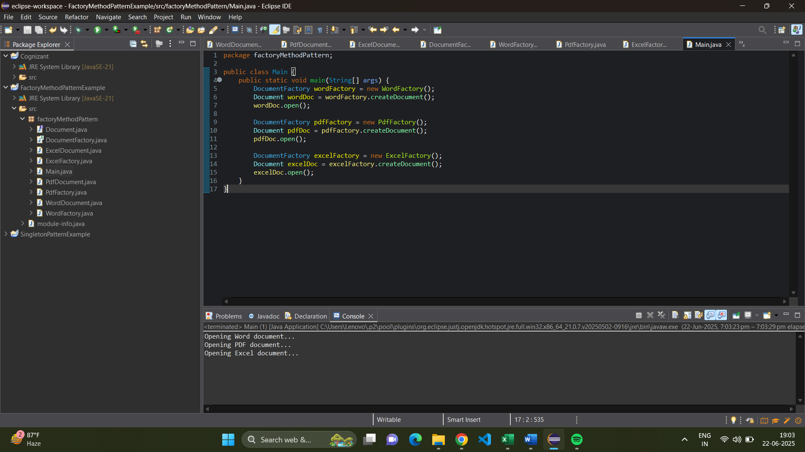

**Define Document Classes:**

**Code:**

public interface Document {

void open();

}

**Create Concrete Document Classes:**

**Code:**

public class WordDocument implements Document {

public void open() {

System.***out***.println("Opening Word document...");

}

}

public class PdfDocument implements Document {

public void open() {

System.***out***.println("Opening PDF document...");

}

}

public class ExcelDocument implements Document {

public void open() {

System.***out***.println("Opening Excel document...");

}

}

**Implement the Factory Method:**

**Code:**

public abstract class DocumentFactory {

public abstract Document createDocument();

}

public class WordFactory extends DocumentFactory {

public Document createDocument() {

return new WordDocument();

}

}

public class PdfFactory extends DocumentFactory {

public Document createDocument() {

return new PdfDocument();

}

}

public class ExcelFactory extends DocumentFactory {

public Document createDocument() {

return new ExcelDocument();

}

}

**Test the Factory Method Implementation:**

**Code:**

public class Main {

public static void main(String[] args) {

DocumentFactory wordFactory = new WordFactory();

Document wordDoc = wordFactory.createDocument();

wordDoc.open();

DocumentFactory pdfFactory = new PdfFactory();

Document pdfDoc = pdfFactory.createDocument();

pdfDoc.open();

DocumentFactory excelFactory = new ExcelFactory();

Document excelDoc = excelFactory.createDocument();

excelDoc.open();

}

}

**Output:**

