**Exercise 1: Setting Up Junit**

**Code:**

import org.junit.Test;

import static org.junit.Assert.*;

public class CalculatorTest {

*@Test*

public void testAddition() {

int result = 2 + 3;

*assertEquals*(5, result);

}

*@Test*

public void testSubtraction() {

int result = 5 - 2;

*assertEquals*(3, result);

}

}

**Output:  
  
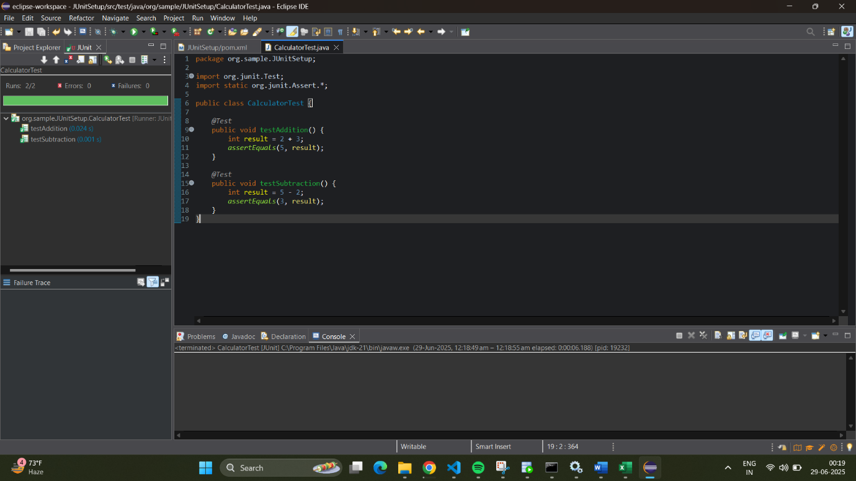**

**Exercise 3: Assertions in JUnit  
  
Code:**

import org.junit.Test;

import static org.junit.Assert.*;

public class AssertionsTest {

*@Test*

public void testAssertions() {

// Assert equals

*assertEquals*(5, 2 + 3);

// Assert true

*assertTrue*(5 > 3);

// Assert false

*assertFalse*(5 < 3);

// Assert null

*assertNull*(null);

// Assert not null

*assertNotNull*(new Object());

}

}

**Output:**

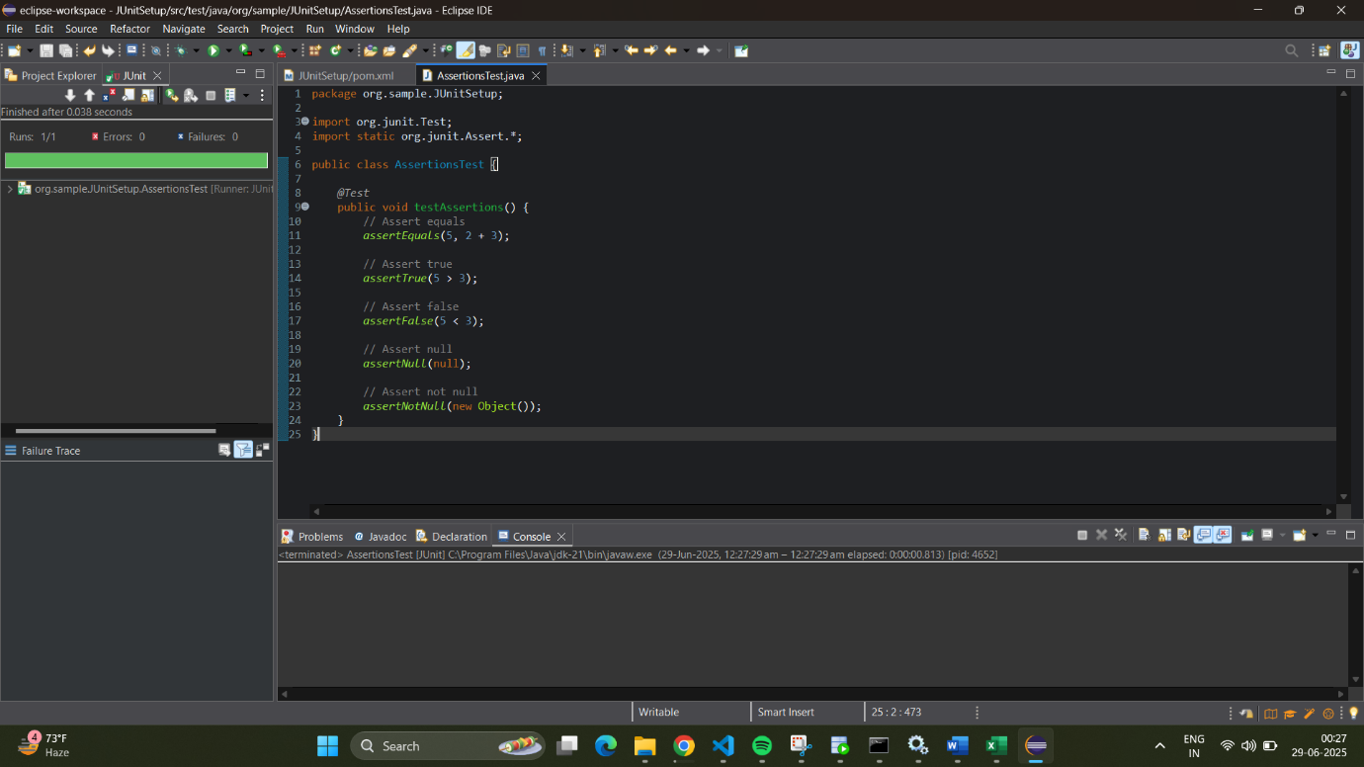

**Exercise 4: Arrange-Act-Assert (AAA) Pattern, Test Fixtures, Setup and Teardown Methods in Junit**  
**Code:**

import org.junit.After;

import org.junit.Before;

import org.junit.Test;

import static org.junit.Assert.*;

public class CalculatorTest2 {

private Calculator calculator;

*@Before*

public void setUp() {

// Setup (runs before each test)

calculator = new Calculator();

System.***out***.println("Setup: Calculator created");

}

*@After*

public void tearDown() {

// Teardown (runs after each test)

calculator = null;

System.***out***.println("Teardown: Calculator destroyed");

}

*@Test*

public void testAddition() {

// Arrange

int a = 5;

int b = 3;

// Act

int result = calculator.add(a, b);

// Assert

*assertEquals*(8, result);

}

*@Test*

public void testSubtraction() {

// Arrange

int a = 10;

int b = 4;

// Act

int result = calculator.subtract(a, b);

// Assert

*assertEquals*(6, result);

}

}

**Output:**

