**Exercise 1: Mocking and Stubbing**

**Code:**

ExternalApi.java

package mockito;

public interface ExternalApi {

String getData();

}

MyService.java

package mockito;

public class MyService {

private final ExternalApi externalApi;

public MyService(ExternalApi externalApi) {

this.externalApi = externalApi;

}

public String fetchData() {

return externalApi.getData();

}

}

MyServiceTest.java

package mockito;

import org.junit.jupiter.api.Test;

import static org.junit.jupiter.api.Assertions.*assertEquals*;

import static org.mockito.Mockito.*;

public class MyServiceTest {

*@Test*

public void testExternalApi() {

// Step 1: Create mock

ExternalApi mockApi = *mock*(ExternalApi.class);

// Step 2: Stub the method

*when*(mockApi.getData()).thenReturn("Mock Data");

// Step 3: Inject mock into service

MyService service = new MyService(mockApi);

// Step 4: Assert the result

String result = service.fetchData();

*assertEquals*("Mock Data", result);

}

}

**Output:**

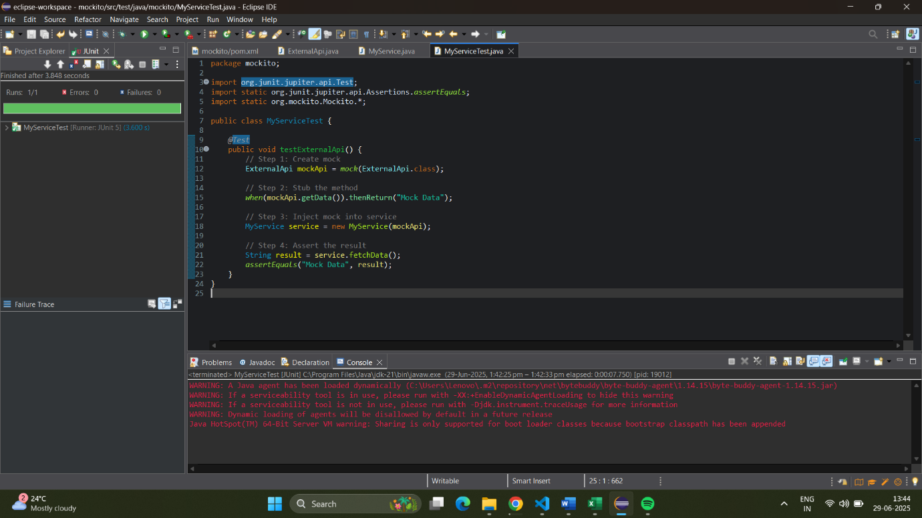

**Exercise 2: Verifying Interactions**

**Code:**

ExternalApi.java

package mockito;

public interface ExternalApi {

String getData();

}

MyService.java

package mockito;

public class MyService {

private final ExternalApi externalApi;

public MyService(ExternalApi externalApi) {

this.externalApi = externalApi;

}

public String fetchData() {

return externalApi.getData();

}

}

MyServiceTest.java

package mockito;

import org.junit.jupiter.api.Test;

import static org.mockito.Mockito.*;

public class MyServiceTest {

*@Test*

public void testVerifyInteraction() {

ExternalApi mockApi = *mock*(ExternalApi.class);

MyService service = new MyService(mockApi);

service.fetchData();

*verify*(mockApi).getData();

}

}

**Output:**

